What We Can Learn from the French About Fighting Lyme Disease
August 16, 2017 | WBUR
BY DAVID SCALES

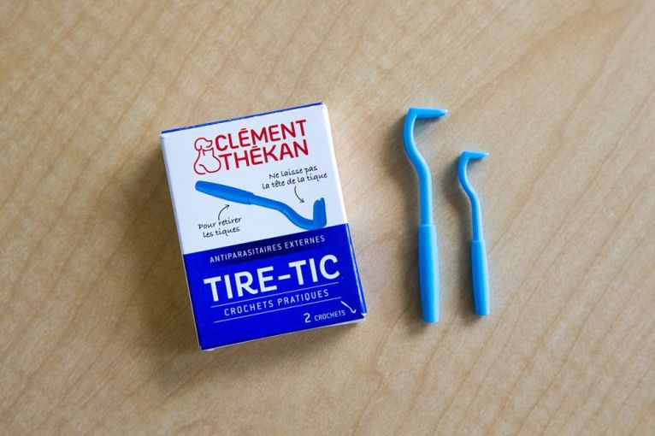
Tire-tics are available at many pharmacies in France and can be used to pull out attached ticks. Image by Jesse Costa/WBUR. France, 2017.
Most visitors go to the Alsace region of France to drink its fine white wines and to Lorraine for its ornate architecture. I went to see if the French are dealing with Lyme disease better than we are here in Massachusetts and across the U.S.
Last September, France became the first country to release a national plan to address tick-borne diseases like Lyme. It ranges from ramped-up surveillance of ticks and infections to better treatment protocols and diagnostic tests.
In May, Canada released its own federal action plan to address Lyme. In the United States, we have at least 10 times more cases of Lyme than France or Canada: over 300,000 cases annually, compared to about 33,000 in France and probably less than 10,000 in Canada. But we lag far behind on concerted national action, even as the problem of tick-borne diseases continues to grow.
So what can we learn from the French? A lot, I concluded. The officials, doctors and researchers I spoke with there emphasized that their national plan is still evolving. But already they are launching a sweeping initiative to tackle Lyme disease as a major public health problem.
An All-Hands-On-Deck Approach
Tune in to French radio this summer and you might hear this: Birds chirping, footsteps crunching on forest leaves, and a woman asking, "Ehhh, have you thought about protecting yourself against ticks?"
"C'est bon," her male companion responds jovially. "The little beast won't eat the big one."
The woman shares a few anti-tick tips to avoid catching la maladie de Lyme, and the spot finishes up with a slogan: Against ticks — tiques in French — "to be watchful is to win."
The 30-second spot from France's public health agency is one of many on the airwaves this summer; others include experts answering questions about ticks and Lyme disease itself.
You’ll also find posters detailing how to prevent tick bites in pharmacies, medical clinics and even the Alpine Club of Nancy, housed in an art nouveau building just off the famous Place Stanislas downtown.
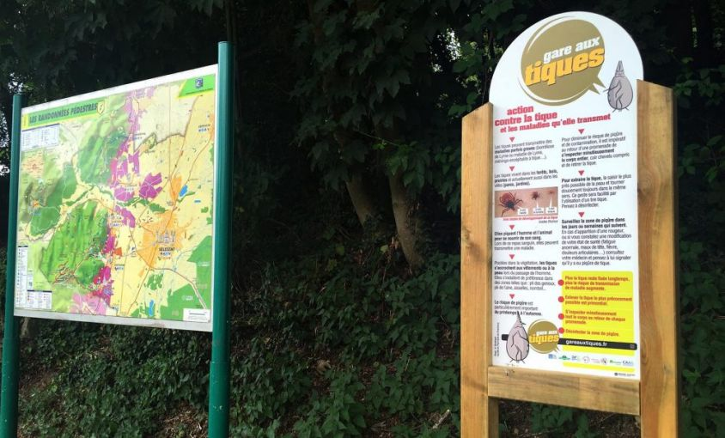
One of the new French signs warning of ticks at forest trailheads. Image by David Scales/WBUR. France, 2017.
At the entrance to forests in eastern France — in Kintzheim in Alsace, or La Haye in Lorraine — you’ll find more "beware of ticks" signs, with tips on what to look for and how to remove them.
France doesn’t have a magic prevention toolkit. In fact, much of what they’re doing -- education, tracking ticks and counting Lyme cases — is similar to what we do, some of it at the federal level and some of it piecemeal, at the local level. They’re just doing much more of it, more thoroughly and robustly, than we do.
And they don't need to rely on local public health heroes, as we often do in the United States. Here in Massachusetts, the heroes include Larry Dapsis, the entomologist for Barnstable County, who spends the spring and summer doing 70 tick-borne disease workshops up and down Cape Cod. Or Catherine Brown, the state public health veterinarian, who finds time among her innumerable responsibilities to also teach the public about Lyme. Their personal passion is key because their tick-related work runs on a shoestring.
France, in contrast, is putting strong systems in place and attacking the problem from multiple angles — coordinating between government agencies and recognizing that the complex problem of Lyme disease requires multiple simultaneous solutions.
“If we do a good job at prevention, we’ll have fewer patients who end up seeking care and struggling in the medical system,” said Lucie Chouin, a public health official for the Greater Eastern region of France. “For me, prevention is part of a package; if we only do so much, and do not do anything upstream, the problem won’t be resolved.”
And France is allotting the money to take that holistic approach. Though it does not specify a budget, the national French plan sets the priorities at high levels of government. The then-minister of health herself, Marisol Touraine, announced the release of the national plan this past September.
2,000 Forest Signs
Take education. Along with those radio spots and posters in the northeast of France, the government is paying to educate hundreds of doctors and place thousands of pamphlets in medical offices. At the cost of about 1,000 euros each it's placing 2,000 of those "beware of ticks" signs across the country.
That is a much more sweeping and energetic program than I’ve seen in the Lyme hotbed of Massachusetts, which leaves most Lyme disease issues to local officials. The state produces free educational materials, but it’s up to towns to use them. If a town wants to go beyond education — which experts think will be required to turn the tide against tick borne illnesses — they need to drum up the cash. So far, few towns do.
Compare that to what the all-hands-on-deck approach against Lyme looks like in France. Initiatives there, in addition to better educating the public, include:
- Public health "Regional Intervention Units" to track Lyme and tick-borne diseases better, including an ongoing multi-year study of the number of Lyme cases in the Lyme-heavy northeast region
- The Agricultural Social Mutual Fund, a social security system to protect agricultural workers, is supporting pamphlets and a push to pinpoint tick hot spots
- And the medical system and the public health department are doing most of the heavy lifting to carry out the national plan
Pragmatic Science
Here's something else France has that we don't: an app that lets everyone report tick bites on themselves or their pets. It's called Signalement Tique and was just released by the National Institute for Agricultural Research in July.
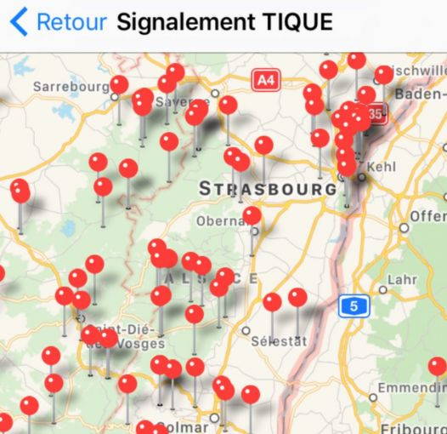
A screenshot from new French app for tracking tick encounters. Image courtesy of Joseph Koehly. France, 2017.
The app is just one of many French initiatives under way to improve research on ticks and Lyme. The national plan puts heavy emphasis on practical research, and the ecology research that is crucial for fighting Lyme does not fall through funding cracks as it does here in the U.S.
Here, about two-thirds of our annual Lyme research spending is on basic biology. Research budgets tend to be smaller in France, but the emphasis is also different — more focus on projects that have immediate practical applications, such as identifying local tick hotspots or tracking what proportion of ticks carry diseases.
“We get money from time to time, and we’re used to working with less money for basic research,” said Benoit Jaulhac, an expert on Borrelia — the Lyme bacterium — and director of the National Reference Center for Borrelia in Strasbourg, where all French Lyme researchers are located. (No, we don't have one of those either.)
But because some funding comes from the Institute for Public Health Surveillance, much of their research must yield “immediately applicable information,” Jaulhac said, such as tick-tracking and diagnostic tests. Few resources go to tick-tracking here; public health officials argue that it is because tick numbers can vary dramatically from spot to spot, but another reason is that most simply don't have the money for it.
Some particularly intriguing French research is still in the planning phase: a study on what happens to people who get tick bites, looking not just at tick-borne illness but at whether the tick bites themselves could make people chronically sick over time.
The National Borrelia Center is also working with the the National Institute for Agricultural Research on tick surveillance and ecology research to figure out what could stem the tick invasion. In the U.S., the focus on basic biological research leaves ecologists often struggling to find grants to fund their tick-borne disease research.
Months Of Medical Care In A Day
Abdel Hafiz Abid can remember the exact day he became ill: July 5, 2014. He started to feel pain in his left leg, and particularly his ankle. At first it was occasional, but soon it afflicted him every day, and extended to his knees and back. He was also beset by fatigue — "Walking 200 meters feels like I've walked 25 kilometers," he said — and by problems with short-term memory.
Family members suggested he had Lyme disease. "We vaguely talked about it, like everybody else," he said. A number of them have that diagnosis, and he lives outside the city of Metz, in the Lorraine region of northern France, which has one of the country's highest rates of Lyme.
Lyme disease clinic patient Abdel Hafiz Abid. Image by David Scales. France, 2017.
The testing began. In a 2-inch black notebook, Abid keeps multiple yellow folders from each different laboratory and clinic he's visited on his quest for a diagnosis. He’s been to clinics in France and one in Germany, spent thousands of euros outside what the national health plan covers, and tried multiple courses of antibiotics, some as long as six months. So far, nothing has worked.
So he came recently to Nancy, the biggest city in Lorraine, to spend the day at a new multi-disciplinary Lyme disease clinic run by Dr. François Goehringer, an infectious disease doctor.
"Ten years ago we used to say, 'It's not Lyme, we don’t know what it is,' and they left our clinic with us saying, 'We know you’re sick, but we don’t know what it is, au revoir, monsieur, au revoir, madam,'" Goehringer explained. Patients would then bounce from specialist to specialist getting different, confusing answers.
"We decided we could gain a lot of efficiency by trying to offer a day of hospitalization at the center of our approach," he said. "The maximum of complementary exams and specialist advice to be able to weigh in on what the patient is suffering from."
There are many specialized Lyme clinics in France and in the United States as well. What makes the Nancy clinic stand out is that one-stop shop organization. For a day, patients come to the hospital, get all the tests and scans, see various specialists and get started on treatments that fit their diagnosis.
Goehringer and his intern, Dr. Marie Geisler, go through Abid’s black folder in detail, reviewing all prior test results and consultations. Geisler sits with Abid to fill out the 10-page "Multidisciplinary Diagnostic Approach for Patients Suspected of Lyme," a standardized questionnaire. There’s a cognitive assessment as well. Geisler then does a thorough, 30-minute physical exam, an EKG, and reports her findings to Goehringer.
Almost all of Abid’s tests for Lyme and other diseases are negative, except one 100 euro test from Germany that often returns false positives. His western blots, which would confirm the presence of proteins related to the Lyme bacteria, are all negative.
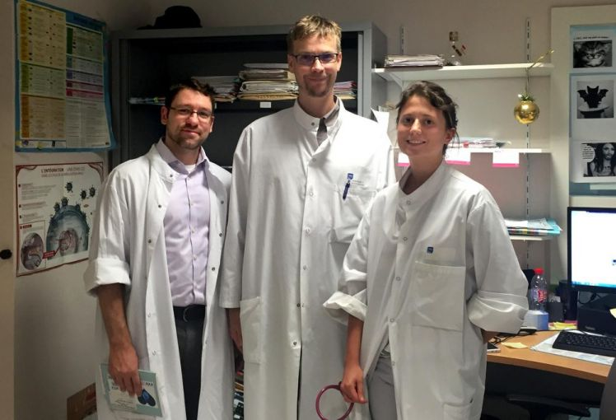
Dr. David Scales, left, with Lyme disease clinic staff Dr. Francois Goehringer, center, and Dr. Marie Geisler. France, 2017.
“He has no objective evidence of Lyme,” Goehringer said after reviewing all the files. But Abid's parathyroid hormone — which controls calcium and bone health — is elevated. It could be an explanation for some of Abid’s symptoms. Endocrinologists aren't part of the Lyme clinic, but Geisler books him for a rapid follow-up appointment to check into it.
Like all patients who come to the clinic, Abid also sees Lorraine Callins, a psychologist who specializes in chronic illness and hypnotherapy. Many of her chronic autoimmune disease or hemophilia patients “feel abandoned by medicine, so they seek other roads,” she says.
If his symptoms warranted it, Abid would also have seen a rheumatologist or neurologist — common specialties for people with suspected Lyme symptoms.
Goehringer sees only four patients every Friday and has seen about 100 patients total since the one-stop-shop program began in January. He also aims to start a monthly meeting of various specialists to develop plans for some of the most challenging patients.
Some American clinics hope to organize similar one-stop shops. But since we have a fee-for-service system, expensive specialists are difficult to organize unless there is sufficient patient volume. It's not impossible here, but it's quite a financial challenge.
France faces its own challenges: The national Lyme plan aims to improve medical care, including with clinics like Goehringer's, and sets ambitious targets to develop standardized treatment guidelines by the end of 2017. That appears unlikely, with doctors and Lyme advocacy groups still far apart on what the guidelines should be.
But while standardized guidelines are in the works, the Nancy clinic will at least offer a respite for patients who have spent months seeing myriad specialists in search of a diagnosis.
Will it improve outcomes? It’s too early to tell, but at least from the patient's point of view it's a step forward as it streamlines what is usually a months-long process into a single day.
Crossing Cultures
Maybe my starting point — What we can learn from the French? — wasn’t a fair one. We have deeply different health systems that reflect different cultures. France provides some of the best overall health care in the world and has a long tradition of viewing health care as a right, even enshrined in their constitutions.
It also has a national health system that pays for medical care. In this cultural context, spending on public health and prevention isn't just seen as the right thing to do, but a way to reduce health costs later.
In contrast, in the U.S. we spend the most money on health care per person in the world, but don't get more bang for our buck.
There are some hopeful signs of support for our fight against Lyme disease: The U.S. federal government has recently committed $40 million to create four regional centers of excellence for vector-borne diseases — which include Lyme — as part of its efforts to control the Zika virus.
But most of that money is expected to go toward fighting Zika, so it will likely do little to help fill the public health funding gaps that are leaving us far behind France in the fight against Lyme.

