South Africa: TB Community Borrowing a Page from HIV/AIDS
December 09, 2015 | Science Magazine
BY JON COHEN

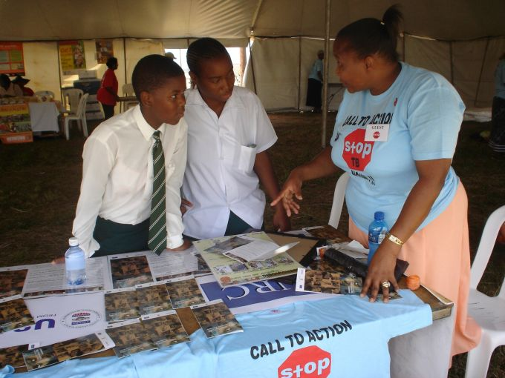
USAID South Africa: Promoting Awareness that Tuberculosis is Curable. Creative Commons.
CAPE TOWN—The international “Lung Meeting” held here last week was not your grandparents’ tuberculosis (TB) conference.
The traditionally staid 46th Union World Conference on Lung Health featured hundreds of delegates donning face masks during one session to show their solidarity against the rampant stigma that people with TB must endure. Civil society groups had their own space in the conference hall where they held public workshops, mural painting, and an indoor soccer game to “kick” TB. About 1000 TB patients, researchers, and policymakers marched through city streets demanding lower price for new TB drugs. People living with the disease and those who had recovered from it asked pointed questions and made impassioned speeches during the scientific sessions. Prominent attendees included the South African minister of health and the head of the Global Fund to Fight AIDS, Tuberculosis and Malaria.
The Lung Meeting has morphed into the type of gathering that international HIV/AIDS meetings pioneered, where advocacy and community building are as much a part of the agenda as scientific presentations. “The conference used to be nothing like this,” said Lucica Ditiu, who heads the Stop TB Partnership, a nongovernmental organization based in Geneva, Switzerland. “Being in South Africa, where there’s leadership and a community movement, it’s positioning TB for the first time in the same conversation as HIV.”
It is a fitting overlap because Mycobacterium tuberculosis and HIV feed off each other, with TB being the No. 1 cause of death in people who have AIDS. Many of the issues surrounding the response to each disease are similar, too. One-third of the estimated 9 million people who develop active cases of TB each year do not know they have the disease, which is leading to a huge push to test more people with simple, effective diagnostics. Patients have difficulty adhering to their treatments, fueling increases in drug resistance and transmission. The Stop TB Partnership issued a new global plan that calls for “targeting key populations” and ending the disease, which killed 1.5 million people in 2014, by 2030 (invoking the same “90-90-90” jargon used in plans to end AIDS by the same year). Activists have railed against drug companies for dragging their heels in development of new compounds. The search for an effective vaccine has been stymied by fundamental immunologic mysteries; as David Lewinsohn of the Oregon Health & Science University in Portland joked at the start of his update on the field, “My talk may be really short because I have no idea about the immunology of preventing TB infection.”
But, unlike AIDS, “TB has never summoned the political will, financial investment, and scientific energy equal to its outsized toll on human health and well-being,” contends a new TB report from the Treatment Action Group, a New York City–based nonprofit that grew out of the AIDS Coalition to Unleash Power (better known as ACT UP). Some 100 funders of TB R&D spent a total of $674 million last year, the report says. By contrast, HIV/AIDS R&D in 2014 received $3 billion from the U.S. National Institutes of Health alone.
And TB has one major advantage: Unlike HIV, an M. tuberculosis infection can be cured. “It’s ridiculous that we’re not eliminating [TB],” said the Geneva-based Global Fund’s director, Mark Dybul. “Imagine if in the AIDS world we had a drug that was curative in 6 months. You think we’d be accepting a 1.5% decline per year in new infections or the slow pace of scale-up of treatments?”
There have been some promising leads for drugs against both multidrug-resistant (MDR) and the even more intractable extensively drug-resistant (XDR) strains of M. tuberculosis. “There are drugs that are still on the sideline and they would make a terrific difference in the mortality of MDR and XDR TB,” says Yale University TB researcher Gerald Friedland. “Their rollout has been sluggish at best.”
For resistant strains, the standard treatment course takes 2 years and includes injections of painful medications that can cause hearing loss and other serious side effects. So hopes were high when Janssen Pharmaceutica in Beerse, Belgium, announced in 2012 that it had won “conditional approval” from regulatory agencies for a powerful new oral drug, bedaquiline. The approval was based on data from small-scale trials, and Janssen promised to conduct a full-fledged study to better assess side effects, efficacy, as well as the possibility of cutting treatment time to 9 months.
That trial has yet to launch, and, as Doctors Without Borders noted at the meeting, the result is that the drug is only registered—the process that makes it widely available—in seven of 27 countries that have a high burden of MDR and XDR TB. To date, fewer than 3000 patients have received bedaqualine; according to criteria set by the World Health Organization, it could help more than 150,000 people worldwide.
Myriam Theeuwes, who is on the Janssen team that developed bedaqualine, says it has taken longer than expected to launch the efficacy trial because of weaknesses in the health systems in the 10 countries where the study will take place.
Otsuka, a Japanese drug developer, also took some hits for offering the compassionate use of delaminid to just 200 patients while completing its own phase III trial, which is projected to end in 2017. Ample supplies exist of a third new drug, linezolid, and it’s even made by a generic company, but South Africa has had difficulty negotiating a price it can afford.
Rapid diagnosis is key for prompt treatment, but the highly touted GeneXpert machine has yet to save many people from the deadly MDR TB, said Yogan Pillay, who heads the HIV and TB program for the Africa Centre For Population Health in Mtubatuba, South Africa. The machine uses printerlike cartridges—South Africa has purchased 50% of the world supply—to analyze whether sputum samples contain genetic material from M. tuberculosis. It takes hours, as opposed to weeks needed for culturing the bug, and it can detect both drug sensitive and MDR TB. GeneXpert is especially useful in coinfections of TB and HIV that often are missed on the standard microscopy used by many labs instead of the more intensive culturing.
South Africa has more aggressively pursued GeneXpert than any other country. Pillay explained the country doubled the number of MDR TB patients it found since it started to use GeneXpert. The hope was that the machine would identify MDR patients earlier in the course of disease, when they have a better chance of being cured. Studies, however, found that mortality for MDR TB rates in South Africa remained near 50% even after the mass roll out of GeneXpert, which could be because doctors were already treating patients without a formal diagnosis.
University of Cape Town researchers proposed a simple and cheap alternative for diagnosing TB in very sick AIDS patients: a urine tests for a glycolipid that makes up the outer wall of M. tuberculosis. Known as a LAM (lipoarabinomannan, for long) test, it works much like a home pregnancy stick, and the manufacturer, Alere of Waltham, Massachusetts, sells it for about $3.50. Although the test performs poorly in the majority of HIV-infected people who have their disease under control, it works well in those with extensive immune damage possibly because many have TB in their kidneys and thus high levels of LAM spill into their urine.
The research team, led by pulmonologist Keertan Dheda, showed for the first time that adding the LAM test to standard diagnostics saved a significant number of lives in a controlled study. “The key thing is people in this group are dying, and our hospitals in Africa are inundated with these people and we can’t make the diagnosis,” Dheda says. He says the urine test could save thousands of lives per year in South Africa alone.
Dheda hopes to develop a TB urine test that can detect a half-dozen other biomarkers of M. tuberculosis his lab discovered last year with a proteomic analysis. “This opens a whole new avenue of research,” Dheda says. “What I’d like to see one day is a simple urine test for TB that you can buy at a pharmacy, just like they have for HIV.”

