‘It Became Part of Life’: How Haiti Curbed Cholera
March 16, 2020 | The Guardian | Global Development
BY JACOB KUSHNER AND ALLISON SHELLEY

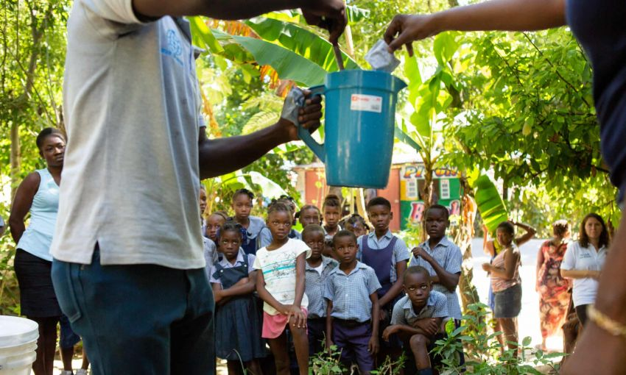
School children near Mirebalais are shown how to mix oral rehydration solution as part of an effort to head off any recurrence of cholera in Haiti. Image by Allison Shelley. Haiti, 2020.
Marie Millande Tulmé was at work in a prison when she received a call confirming her fears: the gruesome sickness spreading rapidly across her nation was indeed cholera.
The head nurse for Haiti’s Central Plateau region at the time, Tulmé was investigating rumours that prisoners were getting violently ill and that two had died. “I thought: ‘Haiti will perish,’” she says, recalling her reaction when Haiti’s national laboratory phoned with the news. “Because I knew that cholera was grave. That it spreads easily.”
Within days, hundreds of people living near the the country’s longest river, the Artibonite, which irrigates rice paddies across central Haiti, were wrapping their sick in bedsheets or carrying them on mattresses to hospitals so crowded that patients were lying head to toe on the pavement outside.
Cholera would eventually sicken 800,000 people – nearly 10% of Haiti’s population – and kill 10,000.
But against all odds, Haiti’s cholera crisis appears to be over now. No new cases have been confirmed in more than 12 months. Experts say two more years must pass in order to definitively declare Haiti cholera-free. But a year without cholera is testament to the fearless and tireless work of Haitian health workers.
Even before the confirmation of cholera, Tulmé had been trying to investigate where the sickness was coming from, tracing the early cases to the banks of the Méyé River, a tributary of the Artibonite.
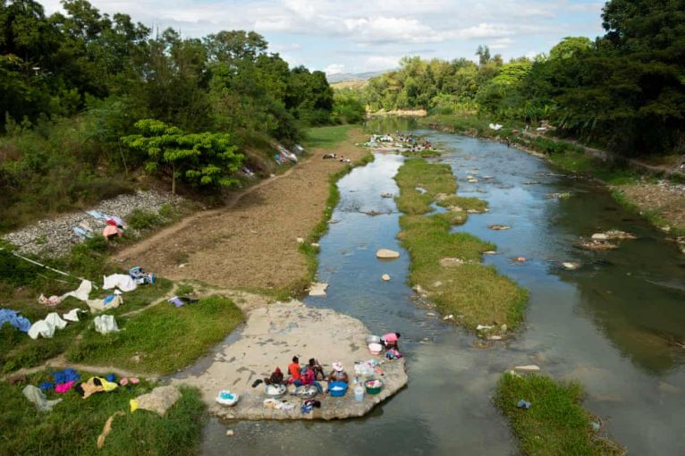
Women wash laundry along the Meille River, a tributary to the Artibonite River, the longest waterway in Haiti, which carried cholera through the country. Image by Allison Shelley. Haiti, 2020.
When Tulmé arrived here in October 2010, residents on the eastern bank pointed her to a drainage pipe across the way that delivered waste from a UN peacekeepers’ bathroom straight into the river.
“The farmers, they told me there’s a place where Minustah [the UN stabilisation mission in Haiti] is throwing poop,” says Tulmé. “It was not far from the river. Which means infiltration can happen very fast.”
Tulmé knocked on the peacekeepers’ front gate to investigate, but “they wouldn’t let us in,” she recalls. When she asked whether anyone in the base had come down with symptoms similar to those experienced by Haitians in the area, they told her: “No, we don’t have people with diarrhoea.”
“I didn’t think they were telling the truth,” says Tulmé.
They weren’t. Journalists from the Associated Press visited the site and observed waste flowing into the river. Still the UN continued to deny media reports and scientific studies that pointed to that base. It wasn’t until six years later that the UN secretary general, Ban Ki-moon, finally admitted the UN’s responsibility and apologised.
Minustah had failed to test peacekeepers from Nepal, where cholera is endemic, for the disease. When they got sick, waste from the bathroom they used flowed directly into the river. Additional waste was trucked off by a private company and deposited a few hundred metres away, where it contaminated the water there, too.
Reynold Louis Charles, a local cow-herder, says families living along the river never used to think twice about using its water. “We thought the water was clean. We used the water to cook. We washed ourselves.”
But it was causing cholera, a bacteria that spreads when infected faecal matter comes into contact with water or food.
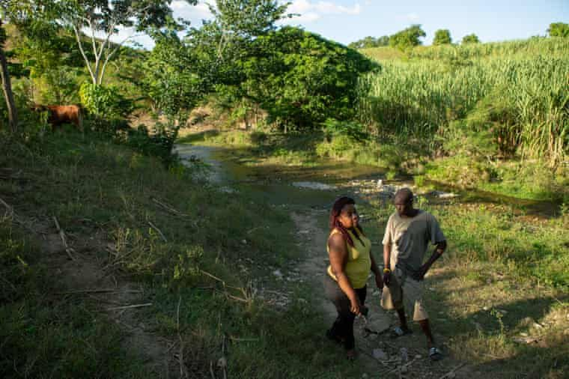
Marie Millande Tulmé, an epidemiologist, speaks with Reynald Louis Charles, a farmer, by the Meille River at the former UN base near Mirebalais. Image by Allison Shelley. Haiti, 2020.
Today, the UN base is abandoned. Minustah pulled out of Haiti in 2017. All that’s left are crumpled concrete walls painted with messages about good conduct such as: “Learn safety, teach safety, and practise safety” – an ironic reminder of the absence of basic safety practices there that caused a catastrophe.
Cholera “took everyone by surprise,” says Paul Christian Namphy, coordinator for Dinepa, Haiti’s Water and Sanitation Authority.
The timing was terrible: cholera was confirmed less than a fortnight before Haiti’s annual All Saints’ Day, when families travel to visit the graves of loved ones. Touching the tombs, touching each other, and travelling long distances in crowded public buses spread the bacteria. “This isn’t a country where you quarantine people because of a disease. The state can’t stop people from moving around,” says Namphy.
It was only 10 months after Haiti’s devastating 2010 earthquake – more than a million people were still living in displaced persons’ camps, many without proper sanitation. Namphy and his government colleagues raced to chlorinate water arriving in the camps.
And then, four weeks later, tropical storm Tomas hit, flooding Haiti. Bacteria spread with the water and, within weeks, cholera had been reported in all 10 regions of Haiti. The epidemic seemed unstoppable.
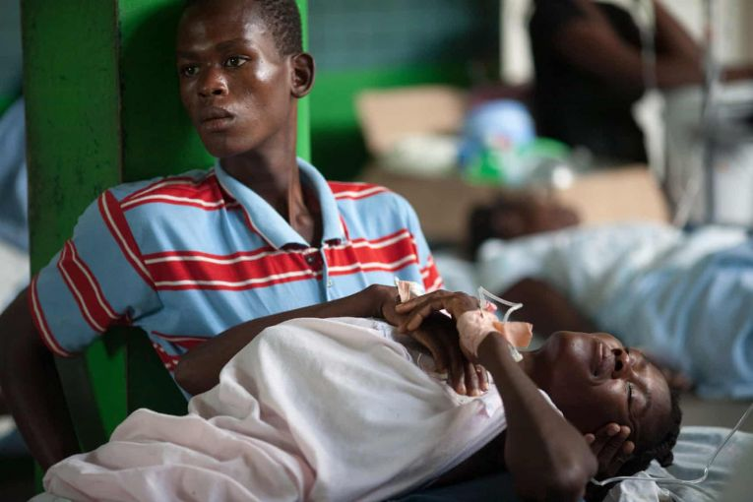
A boy cares for a relative in a ward at a cholera treatment centre run in Petite Rivière, a riverfront town in Artibonite, Haiti. Image by Allison Shelley. Haiti, undated.
A loved one would start vomiting and suffering from diarrhoea. Soon, family members and neighbours would be infected, too. “It became part of life,” says Namphy. “Life by cholera, death by cholera.
“You had huge numbers of deaths that were not reported in the system. We don’t know how many people died in those early years.”
Bodies were dumped into open-pit mass graves, their loved ones unable to give them a proper burial, fearing contamination.
“Cholera wasn’t a disease the health system here had experienced,” says Namphy. “It was a learning curve that took months, years to get a handle on.”
But Haiti did just that. Cholera clinics began popping up across the nation, funded by international donors. Nurses tested sick patients and sent samples to Haiti’s national laboratory. They gave patients oral rehydration, or an IV if necessary.
Health workers would go to the clinics, read the book with the addresses of the sick patients. “Within 48 hours they would go decontaminate the house and distribute chlorine tablets for treating the water,” Namphy recalls.
To treat patients for cholera is not complex, says Ndiaga Seck, chief of communications in Haiti for Unicef, the UN children’s agency, which coordinates the rapid response teams. “You just rehydrate the person.”
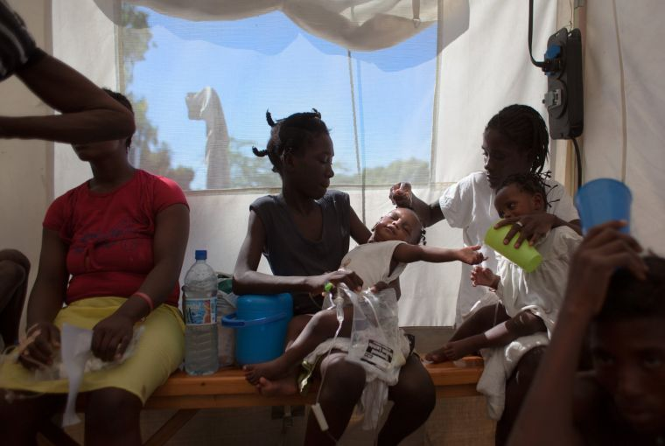
A pair of twins with cholera are held by their mother, right, and sister, centre, as they receive IV drips at a cholera clinic in Port-au-Prince. Image by Allison Shelley. Haiti, undated.
Seck grew up seeing cholera cases treated effectively in his home country of Senegal. “But if you have a collapsed health system, it can be a catastrophe.”
Yet Haiti too has come around. “We used to be 55 teams. Now we are eight,” says Seck. “The reported cases are getting fewer and fewer every day.”
In the mountains around Mirebalais, Haitian health workers from the NGO Acted load a pickup truck with chlorine-water and set off to a clinic where, the previous day, a patient had arrived with cholera-like symptoms.
When the epidemic was at its height, these clinics were so overcrowded that patients were lying, sometimes dying, on the floor. Today, they are eerily empty.
After checking the records for the address, the team set off to find the woman at her home. They asked her whether she used treated water and warned her that the open pit latrine above her home was a cholera risk because its unlined pit was overflowing. The woman, 51-year-old Antonia Macenat, explained that she hadn’t had enough money to pay to dig a new latrine.
The rapid response team split into two and set to work spraying the latrine and homes close by. They called neighbours and children walking home from school to an impromptu public sensitisation in which they showed diagrams and sang jingles that explain how cholera is spread and how it can be stopped by washing hands and treating water.
“Cholera came in 2010, right?” health worker Jennyfer Joseph asked the crowd. “Well even before cholera came, we had diarrhoea, right? So after cholera is gone we will still have diarrhoea. So we need to do these things every day to prevent it.”
Joseph was just 22 when the epidemic began. Ten years later, she is among hundreds of Haitian rapid response workers credited with stopping the disease. She says cholera’s legacy outlived the infamous 2010 earthquake.
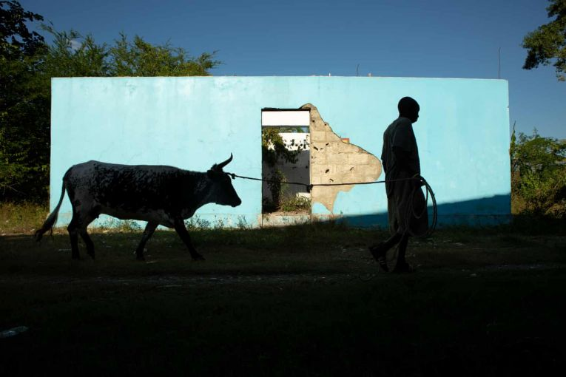
Reynald Louis Charles leads one of his cattle past a toilet by the Meille River at the abandoned UN base near Mirebalais, the centre of the 2010 cholera epidemic. Image by Allison Shelley. Haiti, undated.
“The earthquake was just one day. Cholera? Every day people would die.” At first, she recalls, “people wouldn’t want to say they have cholera” because they were afraid of being sent to a hospital with other sick people, away from their families. But by talking to people in their own communities about the urgency of getting treated, health workers began to overcome that stigma, since everyone felt like they were in it together.
“We believe this was the main factor in eventually getting the upper hand,” says Namphy. A UN official says that 840,000 Haitians benefited from the rapid response teams.
“They were quite innovative,” says Josette Sheeran, the UN’s special envoy to Haiti. “So we made sure they got the funding they needed.
“In every public health crisis, there’s not a dearth of ideas, but a dearth of strategies. You need a battle plan to tackle it. And as we put that in place, you began to see those numbers go down.”
Sheeran says the UN’s goal was “to end this chapter with dignity –and that meant stopping deaths and stopping the spread (in) the communities hardest hit.”
What’s more, says Namphy, Haiti is “the pioneer” of this novel new approach to combating cholera. “Now they’re looking at Yemen, South Sudan, eastern Congo, to use the lessons that were learned here and tailor that to those countries.”
Despite the success story, though, many feel Haiti’s cholera chapter won’t be closed until the UN compensates the 800,000 victims for the healthcare costs, the suffering and the deaths.
“Since it was Minustah that came and brought this to our country, they should pay,” says 39-year-old Tuseuier De Louis as she washed clothes in the Artibonite river in Mirebalais, just down the road from the UN base. At a nearby park, hand-painted posters demand justice: “Reparations for all Minustah crimes in Haiti!”
In 2011, the Institute for Justice and Democracy in Haiti (IJDH), a US-based legal advocacy organisation, filed a claim against the UN on behalf of 5,000 Haitian victims. The UN rejected the claim as “not receivable” and has refused to establish a standing claims commission to hear the dispute, although its peacekeeping agreement with Haiti requires it to do so.
Nor has the UN created commissions to consider any of the other claims against UN peacekeepers in Haiti, including wrongful killings and child abuse. In 2013, IJDH sued the UN in the US federal court, which dismissed the case citing legal immunity.
Some in Haiti say the UN’s actions during the cholera outbreak go beyond negligence, amounting to a deliberate cover-up that may have unnecessarily endangered lives.
“Even if we take the viewpoint most critical of the UN – that the UN was responsible for introducing cholera and it was the UN’s responsibility to admit the truth and it was the UN’s responsibility to eliminate it and save lives – in the beginning, that isn’t what happened,” says Namphy.
“The UN troops destroyed evidence at their base, including digging up leaking pipes and draining septic tanks, before scientists could examine it,” wrote the journalist Jonathan Katz, who watched as it happened. There were serious delays by US health officials in investigating the UN base.
Research by French epidemiologist Renaud Piarroux and his colleagues claimed that the UN had at first blamed cholera’s arrival on “climate change” and had manipulated data to hide early cholera cases around its base in Mirebalais.
Among those early cases in Mirebalais was that of Marieflor Charles, who lives just opposite the UN base where the outbreak began. “I was sitting in my house (when) I started feeling bad – I had diarrhoea, then I vomited,” Charles says. “I went to the hospital and spent seven days there. I felt so weak, I felt like I could die.”
Charles survived, but others who lived near the UN base did not. “There were people who died in their houses. They couldn’t even get to the hospital,” says Charles. “It would be good for [the UN] to pay. That would be justice.”
Some who work in Haiti’s water and sanitation sector are calling on the UN to furnish the full $400m (£320m) it estimated would be needed to eliminate cholera, and direct it to other water and sanitation projects instead. So far, the UN has raised just over $20m – barely 5% of the total. (A UN official said UN agencies mobilised $64m between 2016 and 2019, $10m of which was through that fund.) Funding was also used to vaccinate 1.7 million people against the disease.
But Haiti is “far from [its] objectives” when it comes to ending waterborne disease, says Namphy. “Right now, acute diarrhoea is more of a risk than cholera. Typhoid is more of a risk than cholera. Other faecal and waterborne diseases are killing people.
“If you don’t pay the sanitation bill today, you will pay the health bill later.”

