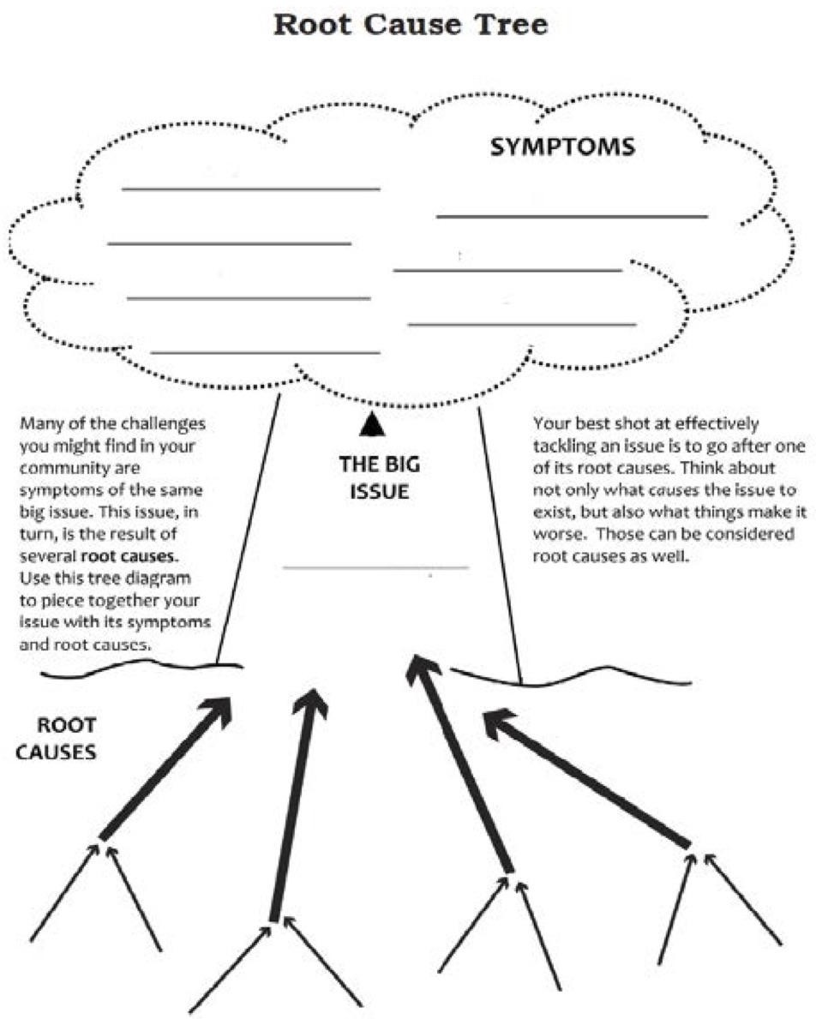

SOURCE: Chicago Public Schools Student Voice Committee Curriculum.

