Graphic Organizer: The Scientists Behind the Vaccine

As you watch the film, use the graphic organizer below to track key details about the scientists who are profiled in the film, and the steps they took to develop a vaccine to combat COVID-19.

Scientist | What approach did the scientist take in making a vaccine? How does it work? (ex: mRNA, protein, etc.) | Which company did this scientist’s organization partner with to manufacture a vaccine? | Was this vaccine shared with the public? Why or why not?
The Chinese Center for Disease Control and Prevention
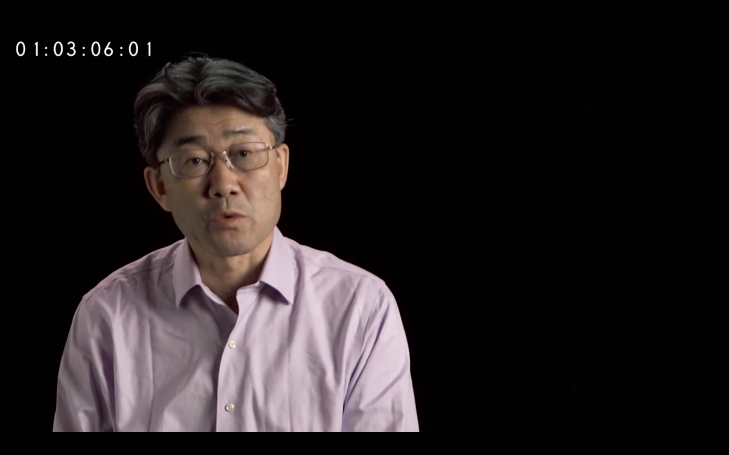
George Gao, Ph.D.
Oxford University
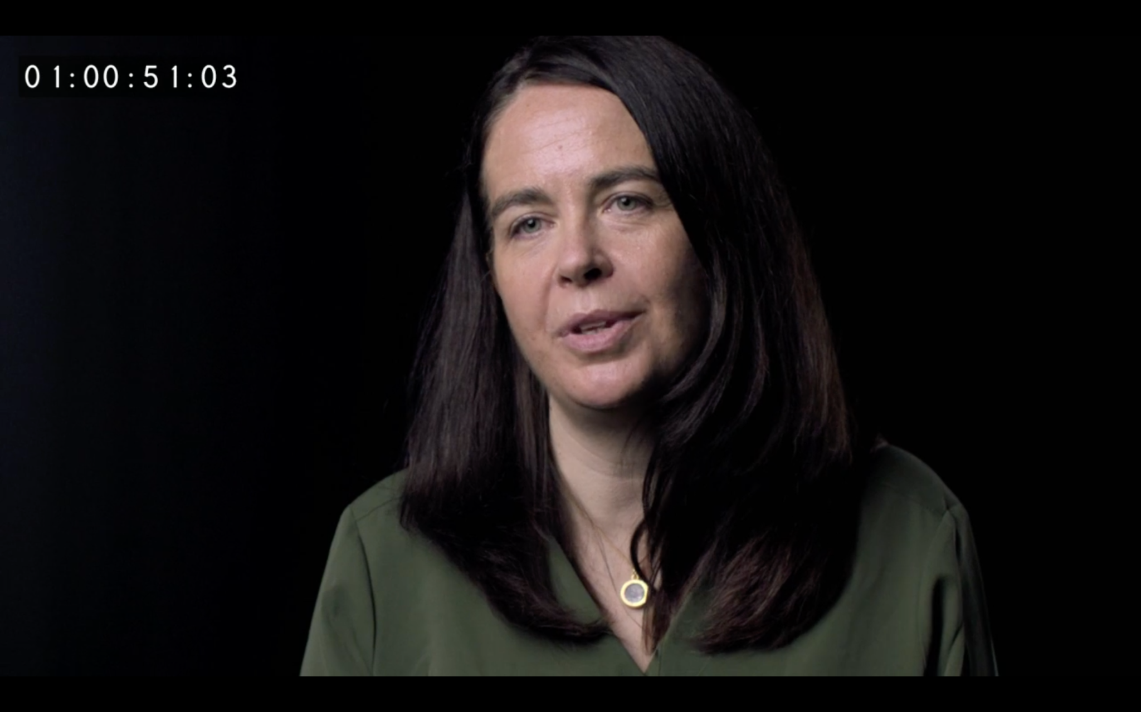
Teresa Lambe, Ph.D.
University of Queensland-Australia

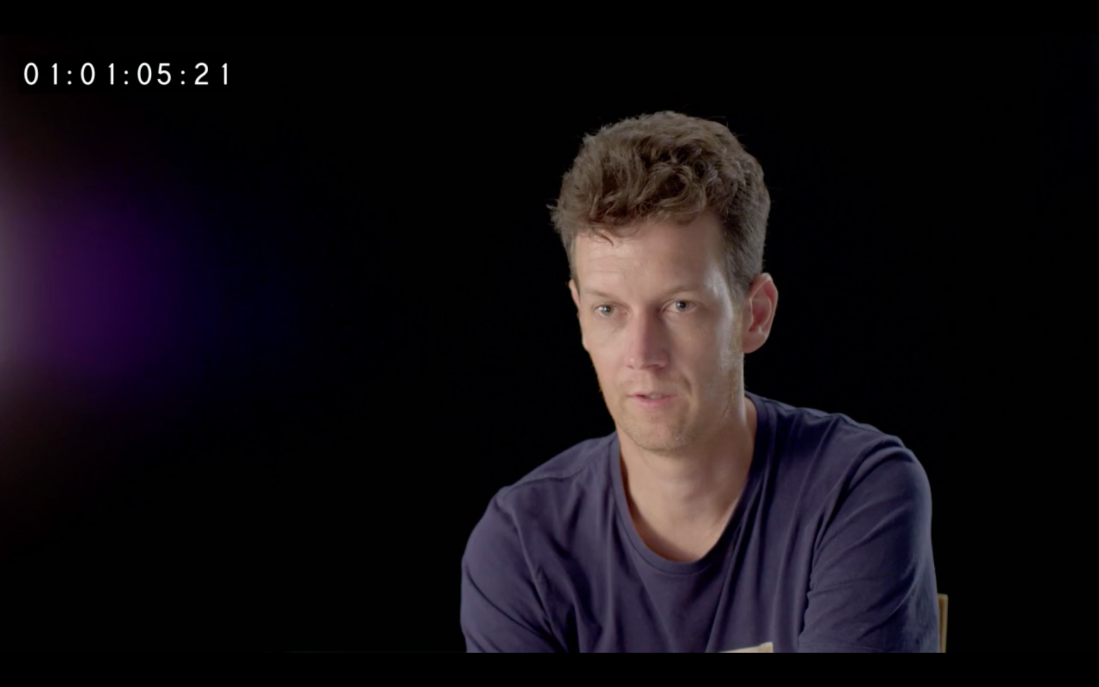
Keith Chappell, Ph.D.
Pfizer/BioNTech

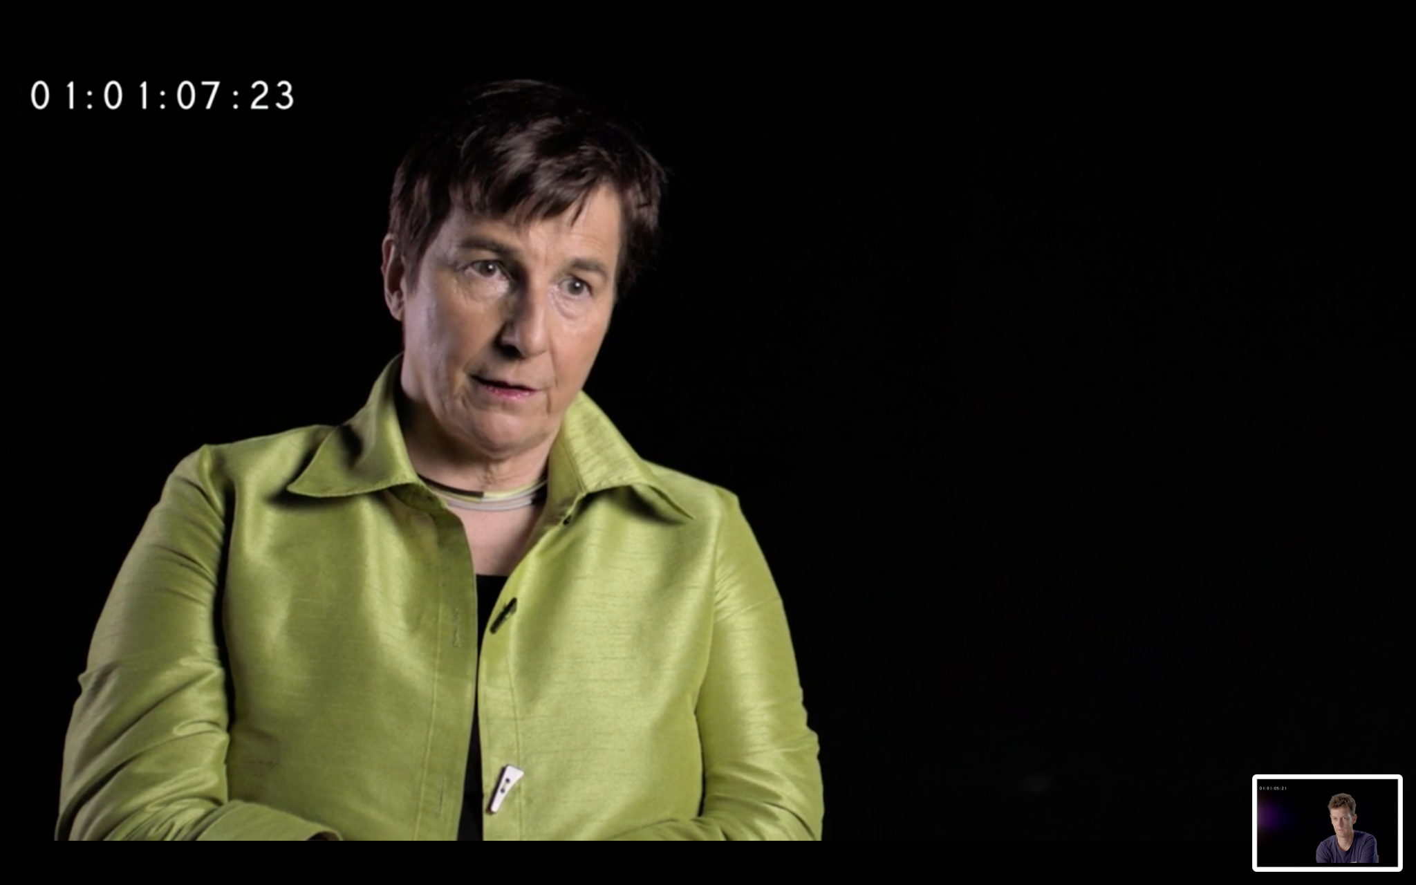

Kathrin Jansen, Ph.D.
U.S. National Institutes of Health

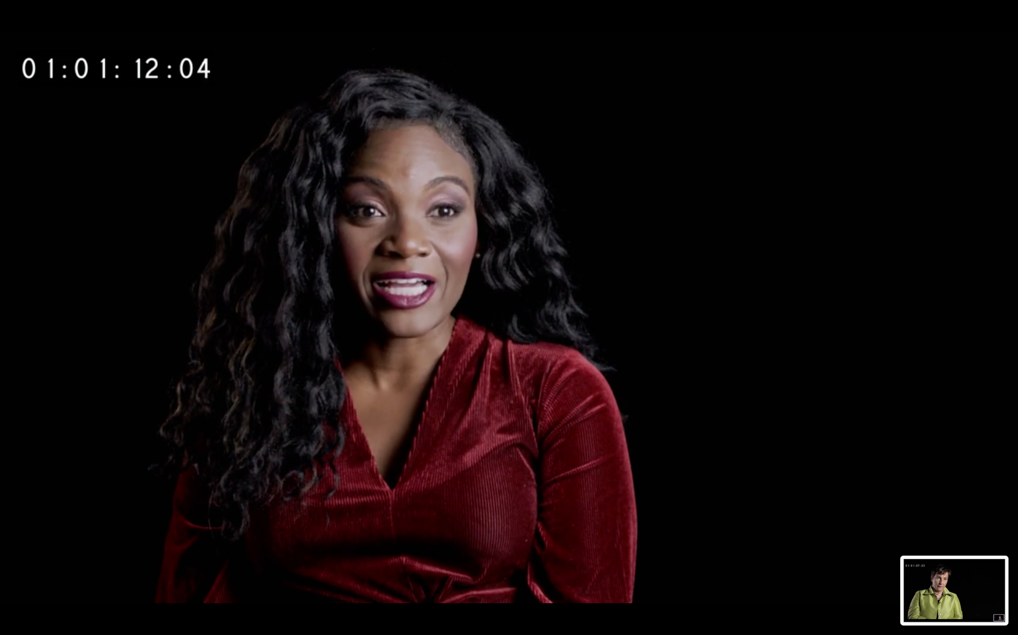

Kizzmekia Corbett, Ph.D.

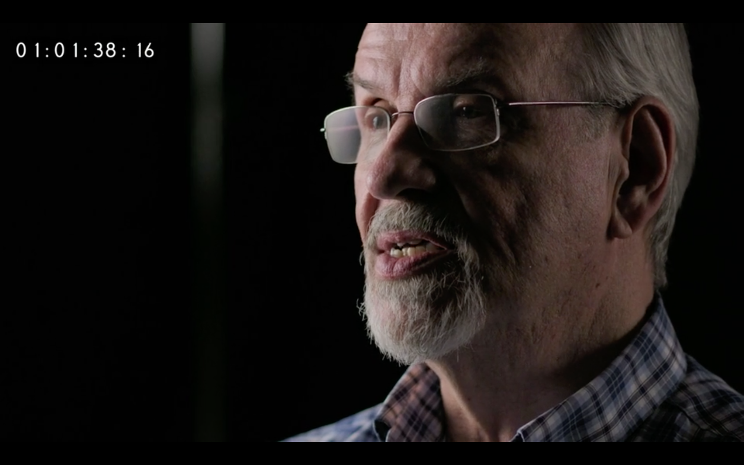

Barney S. Graham, M.D.

