Displacement in the Face of Climate Change
Unit by April Wallace

Day One

Lesson Objective / Essential Question
Essential Question: Why do people move?

Lesson Objective: Students will explore the reasons as to why people move.
Warm-up
1. Work with a partner (or in a small group) to come up with as many reasons as to why people move as you can.
- Students should write one reason per (half) post-it note.

2. Quick class discussion
- Share out some of the reasons as to why people move.
- What do these reasons have in common? Can you identify broader categories into which migrants might fall, based on their reasons for moving?
    - Possible categories: Social, Political, Economic, Environmental
    - As a whole group, write out categories on the white board. Students will place their post-it notes under the appropriate category.
      - Comment on the distribution: which category seems to have the most?
        - Possibly economics
      - What category seems to have the fewest?
        - Possibly environmental - is it underreported?
    - Discuss forced vs. voluntary migration.
      - Define what these mean - forced vs. voluntary.
      - Circle those reasons that are voluntary. Notice any patterns.
      - Remind the students (from previous work), what responsibility do countries have to migrants vs. refugees?
        - Migrants are subject to the destination country’s migration laws.
        - Refugees are protected under international law; countries should not send them back home.
Resources
- Images from Pulitzer Center articles [.pdf]
- Images from Pulitzer Center articles [.ppt]
Lesson / Activities
1. Introduce the topic of migration / displacement due to environmental reasons.

2. Brainstorm: What type of environmental disasters would cause:
- someone in your state/region to move?
- someone in other parts of your country to move?

2. On a Padlet, students will be assigned one picture from select Pulitzer Center articles to analyze, using the following questions:
- What’s going on in this picture?
- What do you see that makes you say that?
- Where do you think this is?

3. After creating their own post answering the questions above, students should comment on their classmates’ work.
- Do you agree or disagree with your classmate’s analysis on their assigned picture?
- What do you see that makes you say that?
- How do you think this picture relates to climate change?

The pictures can be found here. (Pulitzer Center sources are linked in the “comment” section of each slide.)

Examples of photo analysis by students at Luverne High School in spring 2021:

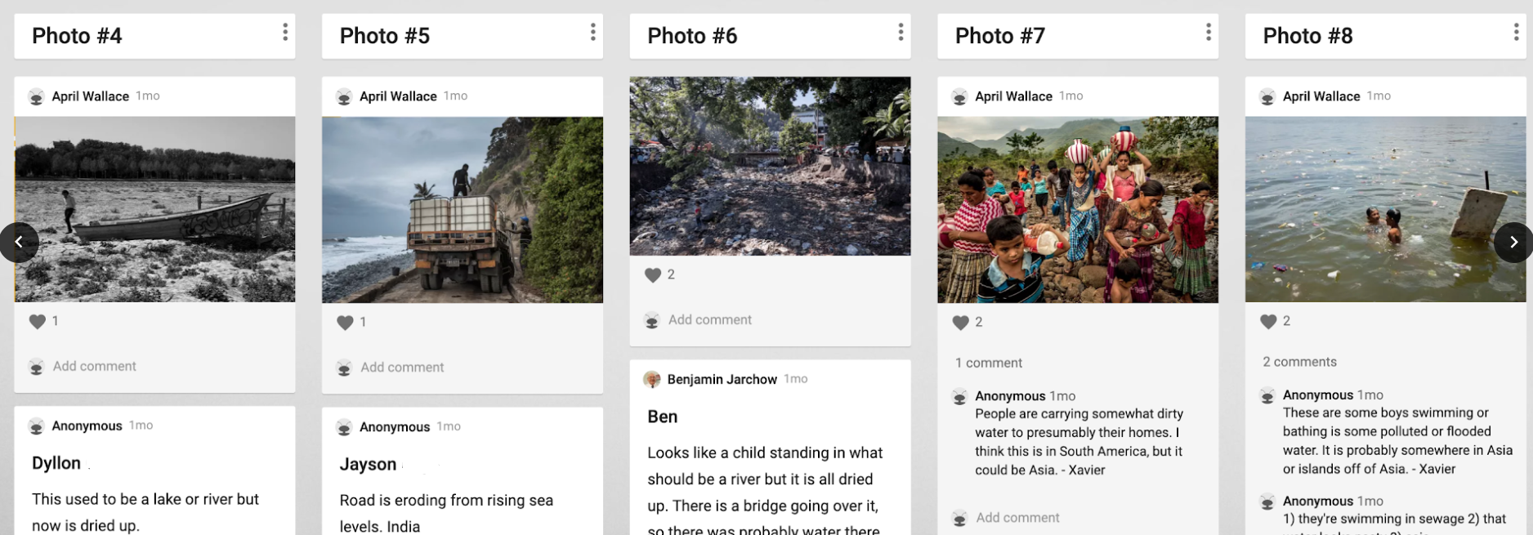
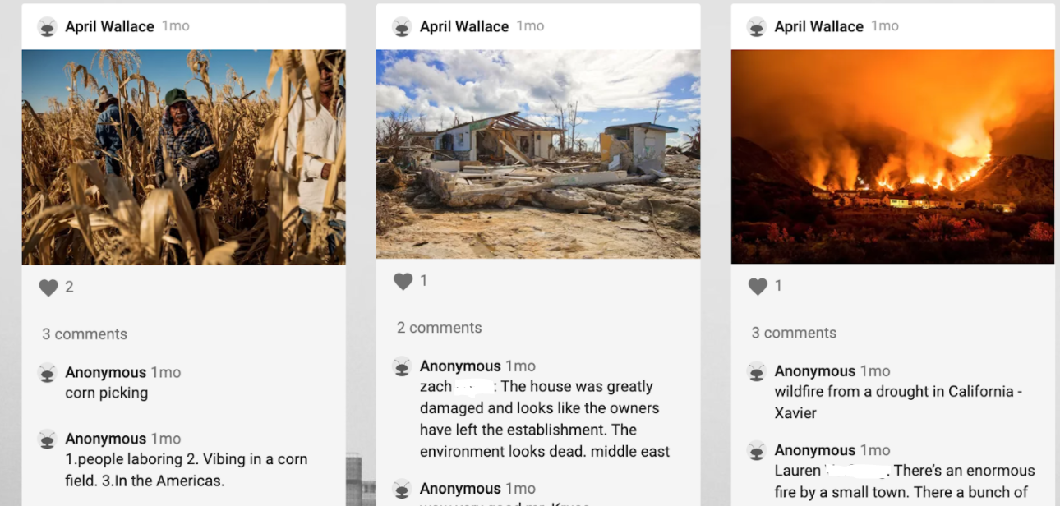
Closing or Homework
Exit ticket: Why do people move around the world? Give one example in each category:
- Social
- Political
- Economic
- Environmental

Day Two

Lesson Objective / Essential Question
Essential Question: How will climate change impact where humans settle?

Lesson Objective: Students will begin to read the article “The Great Climate Migration” to start their investigation into how climate change may impact human migration.

Warm-up
1. Opening Question: Turn to a partner and predict: What impacts do you think climate change will have on where human populations live?

2. Discuss as a class. (Possible answers: cross international borders, farms fail, strain on water resources, more people moving to cities, etc. )

Resources
- “The Great Climate Migration” by Abrahm Lustgarten and Meridith Kohut (Full article)
- Adapted version for class: Part 1: “The Great Climate Migration”
- Comprehension questions for “The Great Climate Migration” [.pdf]
- Comprehension questions for “The Great Climate Migration” [.docx]

Lesson / Activities
1. Introduce “The Great Climate Migration” by Abrahm Lustgarten and Meridith Kohut, and the data model used in the article, using this presentation:

- Day Two presentation [.ppt]
- Day Two presentation [.pdf]
2. Using the map handout, color yellow the current ‘Hot Zones’ as defined by “The Great Climate Migration” article (see slide 7).

3. Using the same map handout, color in orange the predicted ‘Hot Zones’ in 2070 (See slides 8-9).

4. Discuss as a class:
- What does this expansion of ‘Hot Zones’ mean for humans?
- How will this affect where people settle?

2. Read Part 1 of “The Great Climate Migration,” excerpted here.
- Answer these comprehension questions
- Students have the choice to work together or independently
Closing and Homework
Exit ticket: Share out something that stood out to you from the reading about the impact of climate change on migration.

Day Three

Lesson Objective / Essential Question
Essential Question: How will climate impact where people settle around the world?

Lesson Objective: Students will begin to look at case studies of climate migration around the world.

Warm-up
1. Turn to a partner and predict: What parts of the world will see the most impact of climate change? (Possible answers: coasts, high poverty areas, Southern Hemisphere, etc.)

Resources
News articles about climate migration around the world:

- Manila’s Informal Settlers Face Relocation in Exchange for Clean Bay: Extreme weather events and displacement in the Philippines
- In Black and White: How Climate Change is Affecting Iran: Desertification and displacement in Iran
- The Last Nomads of the Tibetan Plateau : Climate change and forcible displacement on the Tibetan Plateau
- Climate Change and Human Trafficking in Indonesia
- ‘There’s No More Water’: Climate Change on a Drying Island : Climate change in Comoros
- Climate Change Will Drive People Across Borders: Climate Change in the Caribbean

Graphic organizer for exploring news articles [.pdf]
Graphic organizer for exploring news articles [.docx]

One-pager assignment checklist [.pdf]
One-pager assignment checklist [.docx]

Lesson / Activities
1. Students will analyze one specific climate change migration scenario of their choice. Students will first choose an article from a list of potential Pulitzer Center articles (see resources above).
- Students should fill out this graphic organizer for the specific country featured in their chosen article.

2. Students will then create a ‘One-Pager,’ where they synthesize the information from the article of their choice using both text and images / drawings.
- Review requirements with the students
- Share out examples of one-pagers, such as those in this PDF

Examples of one-pagers by students in April Wallace’s class in spring 2021:

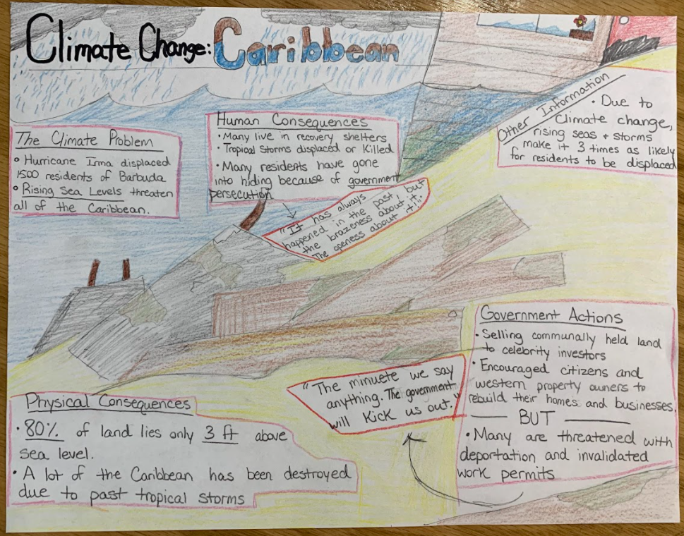
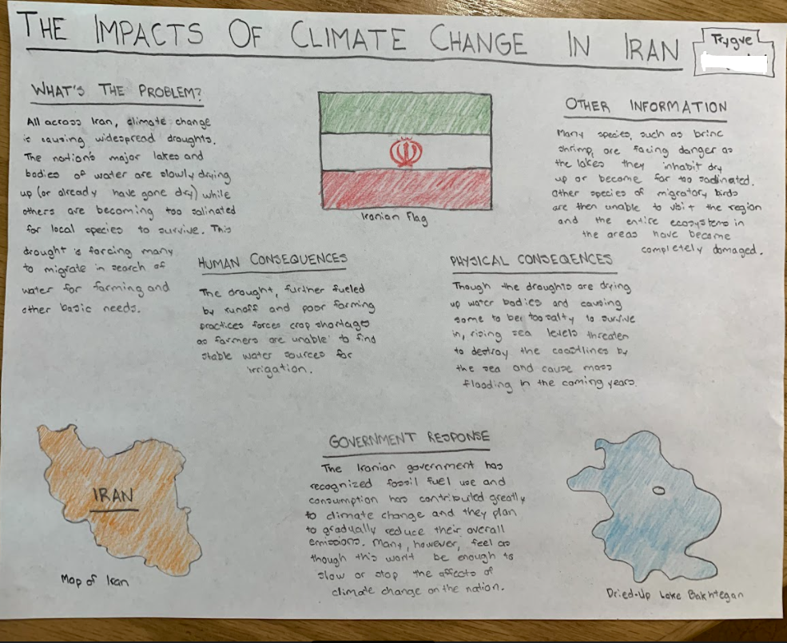

Closing orHomework
Exit ticket: Write down any questions you have so far on your climate migration scenario and hand in.

Day Four

Lesson Objective / Essential Question
Essential Question: How will climate impact where people settle around the world?

Lesson Objective: Students will finish their ‘One Pager’ activity from Day Three.

Warm-up
1. In a small group with students who read the same article. Discuss the following questions.
- What is the climate change issue occurring in your article?
- What has stood out to you the most about this scenario?
- What questions do you have so far about the article?

Resources
Same Pulitzer Center articles as Day Three.

One-pager assignment checklist [.pdf]
One-pager assignment checklist [.docx]

Lesson / Activities
Students will finish their ‘One-Pagers’ in class.

Day Five

Lesson Objective / Essential Question
Essential Question: How is climate change affecting human migration around the world?

Lesson Objective: Students will participate in a gallery walk and share information through whole class discussion on their specific climate change migration scenarios.
Resources
Presentation on local connection to climate change and climate migration issues [.ppt]
Presentation on local connection to climate change and climate migration issues [.pdf]

- Information in this presentation gathered from these Pulitzer Center resources:
  - How Climate Migration Will Reshape America
  - Homeowners Near the Great Lakes Face a ‘Very Scary’ Challenge
Graphic organizer for exploring news articles [.pdf]
Graphic organizer for exploring news articles [.docx]
Lesson / Activities
1. Students will complete a gallery walk of their classmate’s ‘One-Pagers.’ They will complete the rest of their graphic organizer as they read about other climate change migration scenarios.

2. Whole class discussion on the essential question, “How is climate change affecting human migration around the world?”
- Students will add to their map handout from Day Two
  - Plot where each of the locations are from the gallery walk.
    - Do they have anything in common? Any patterns?
    - What is the population density of these locations?
- Whole class discussion on how climate change could affect human migration in the United States and locally in students’ own state. Use this presentation.
  - How could the great climate migration affect the U.S.?
    - Megacities, Southern migration to the North, etc.
  - How could it affect your state? Examples for the state of Minnesota:
    - Agriculture, homes on the Great Lakes disappearing, etc.
    - People moving to Minnesota, challenges & opportunities of a large increase of migrants to Minnesota: infrastructure, etc.
Closing and Homework
Turn to a partner and discuss: how could your local community be affected by climate change migration?

Day Six

Lesson Objective / Essential Question
Essential Question: How could domestic and foreign policies help alleviate the climate migration issue?

Lesson Objective: Students will continue to read the article “The Great Climate Migration.” The main focus of today is policy in the face of climate change.
Warm-up
Brainstorm with a partner: How could domestic and foreign policies help alleviate the climate migration issue?
Resources
“The Great Climate Migration” (Full Article)
Adapted version for class: Part 2: “The Great Climate Migration”

Comprehension questions for “The Great Climate Migration” [.pdf]
Comprehension questions for “The Great Climate Migration” [.docx]
Lesson / Activities
1. Students read Part 2: “The Great Climate Migration”
- Students may independently read or work together in small groups.
- Read and answer these comprehension questions (questions for Part 2 are on page 2).

2. Whole class discussion
- What are some of the challenges Cortez faced, according to the article?
- How has Mexico’s immigration policies changed?
  - How is that affecting migrants now?
Closing and Homework
Exit ticket: From the reading, what stood out to you the most about climate migration?

Day Seven

Lesson Objective / Essential Question
Essential Question: What policy solutions exist for climate migration?
Warm-up
Turn to a partner and review: what were some of the initial solutions to the climate migration crisis that were discussed in the article, “The Great Climate Migration?”
Resources
“The Great Climate Migration” (Full Article)
Adapted version for class: Part 3: “The Great Climate Migration”

Comprehension questions for “The Great Climate Migration” [.pdf]
Comprehension questions for “The Great Climate Migration” [.docx]

Researching migration policy
- Migration Policy Institute
Lesson / Activities
1. The Great Climate Migration
- Read Part 3 of the article
- Answer these comprehension questions (questions for Part 3 are on page 3)

2. Whole class discussion
- What migration policies does the author support? Why?
- What is the cost of inaction?

3. Next class, we will host a virtual presentation and discussion with a Pulitzer Center journalist who has reported on climate migration issues. (To access this free resource, click here.) To prepare for this conversation, brainstorm possible questions for the journalist. Resources that may help you brainstorm include:
- The journalist guest speaker’s bio and articles (Luverne High School was visited by photojournalist Ako Salemi in spring 2021.)
- “The Great Climate Migration” article
- Migration Policy Institute
- Others
Closing and Homework
Exit ticket: What are your most pressing questions regarding climate migration and the policies that may affect this issue?

Day Eight
[Optional]

Lesson Objective / Essential Question
Lesson Objective: Capitalize on the expertise provided by a Pulitzer Center journalist.

Warm-up
1. Students should prepare for their conversation with the journalist.
- Slides 57-63 here were designed to prepare students for a virtual visit with photojournalist Ako Salemi at the end of Day Seven and beginning of Day Eight.
- Review questions and expectations.

Resources
Virtual journalist visit from the Pulitzer Center
Lesson / Activities
1. Students will visit with a journalist to learn about their experience reporting on migration / climate change and about what are some of the better policies to support regarding climate change migration around the world.

2. Students should take note of the information provided by the journalist
Closing or Homework
None

Days Nine & Ten

Lesson Objective / Essential Question
Essential Question: What policy solutions are most effective for addressing climate change migration?

Lesson Objective: Students will create a final product that will answer the essential question.
Warm-up
1. Turn to a partner:
- What solutions were provided by the journalist who visited your class?
- What solutions would you support?

2. Whole class: Debrief on journalist visit.
- What stood out most to you about our visit with the journalist?
- What are some possible solutions to the climate change migration crisis?
- What role might your state/ the U.S. / the UN (or other actors) play in these solutions?
Resources
Rubric for Letter to Representative [.pdf]
Rubric for Letter to Representative [.docx]

Template for Letter to Representative [.pdf]
Template for Letter to Representative [.docx]
Lesson / Activities
Students will create a summative product, writing a letter to the representative of their choice highlighting the problem of climate change / climate migration and advocating for a solution. Students may choose among the following options:

- Write letter to:
  - Local: City Council Representative
  - State: State Representative
  - National: U.S. Representative
  - International: United Nations

Share rubric and letter-writing template with students.
Closing and Homework
Finish and turn in summative project.

