Inquiry #1 Image Collection
How and why have Black people defended democracy?

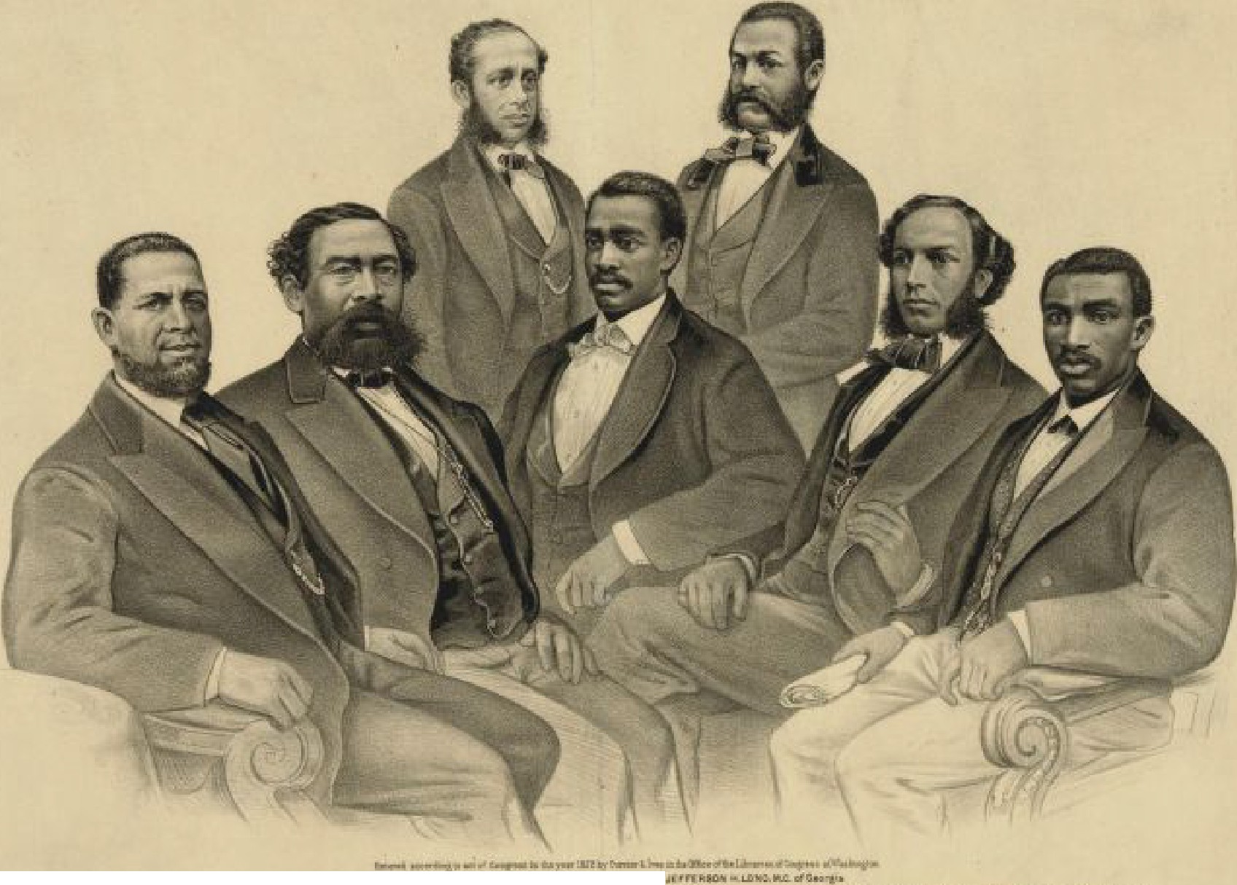
;l:[IIH"1,rD m Lllllt..111c:-'1:-••■
11.L !!,l::r.u rM111llufL11 llil1-,,l 1'!1"1'1.i!l 1'11IIIN ·11..111r, ............... .J]OIIM TWA.LU aa.,1nmuI .OICf"' N.1Ui1"''(,l1u;.,ol:!l.Carnhorl, 'I lt;li, l.l.l.JIT,MD..Ca.cu,Lr&
1}] [fD3IB'J ffi'.])l@Jj[]) .E JU®OO AfHU1I1>[RLE$[mr,rn□ I .
In lhe 41'.' and 42" Congress of the United Sta.Les.

An 1872: portrait of Afrl:can-Amerrca11s.11>ervl11g In CongreH (from left): Hiram,Re\Mlls, 1h11 first blatk manel11dad to the,Senate; Benjamin S.. Turner; Robert C. Da-l.arg,11; Josiah T. Wall i Jefferson H. Long, J011>epll H. Ralr-.y; and R. Brown Elliot.

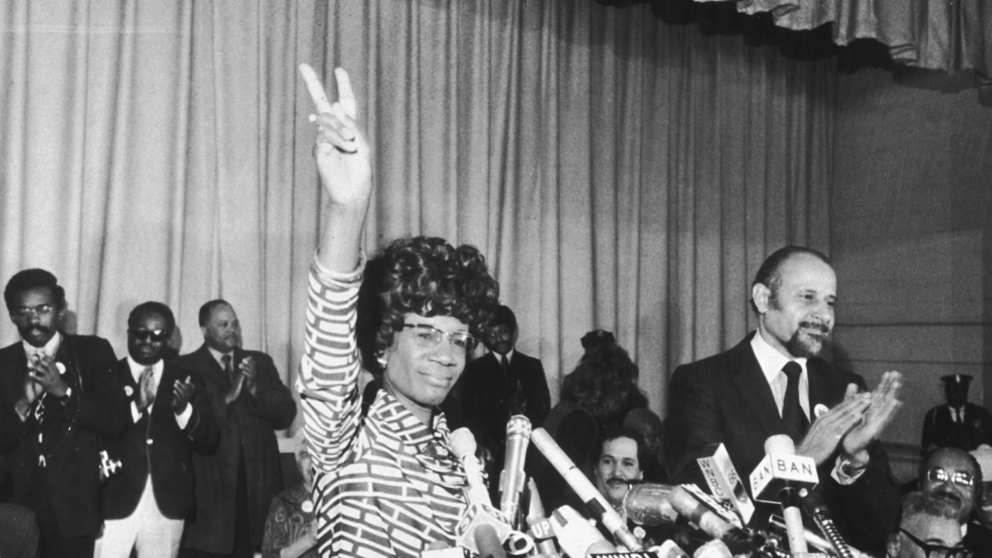

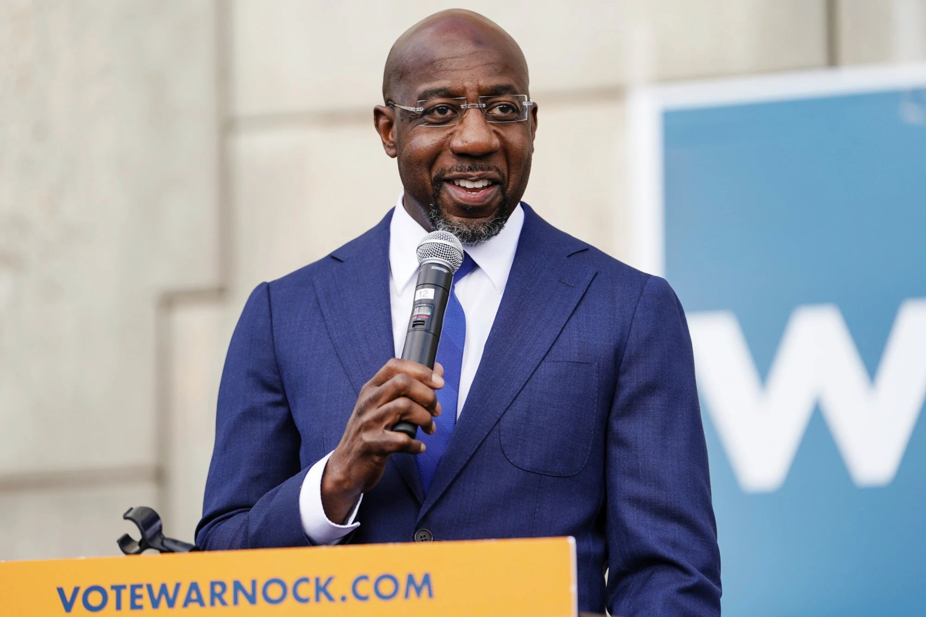

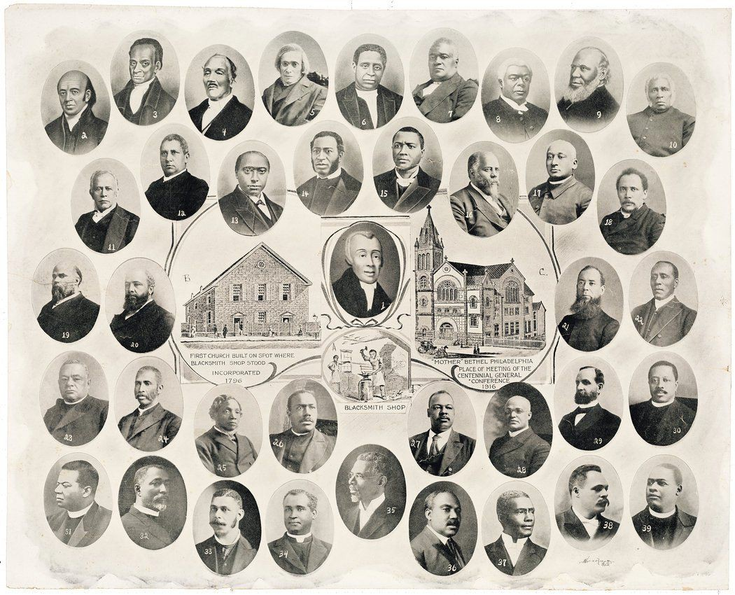

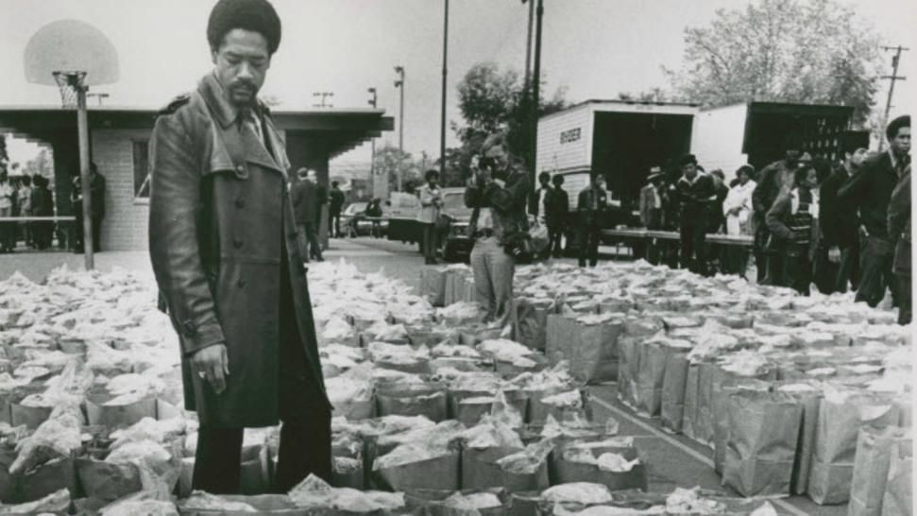

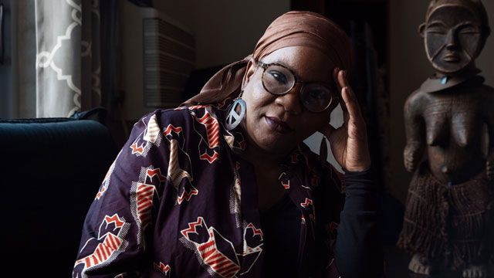

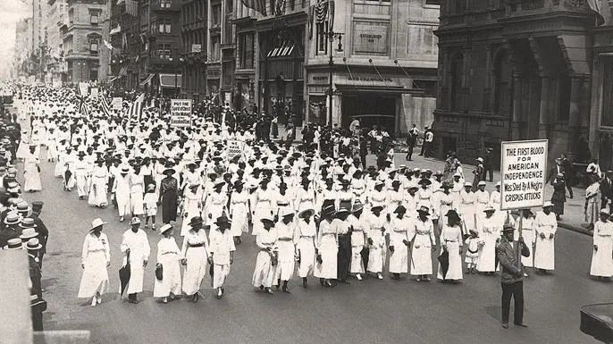

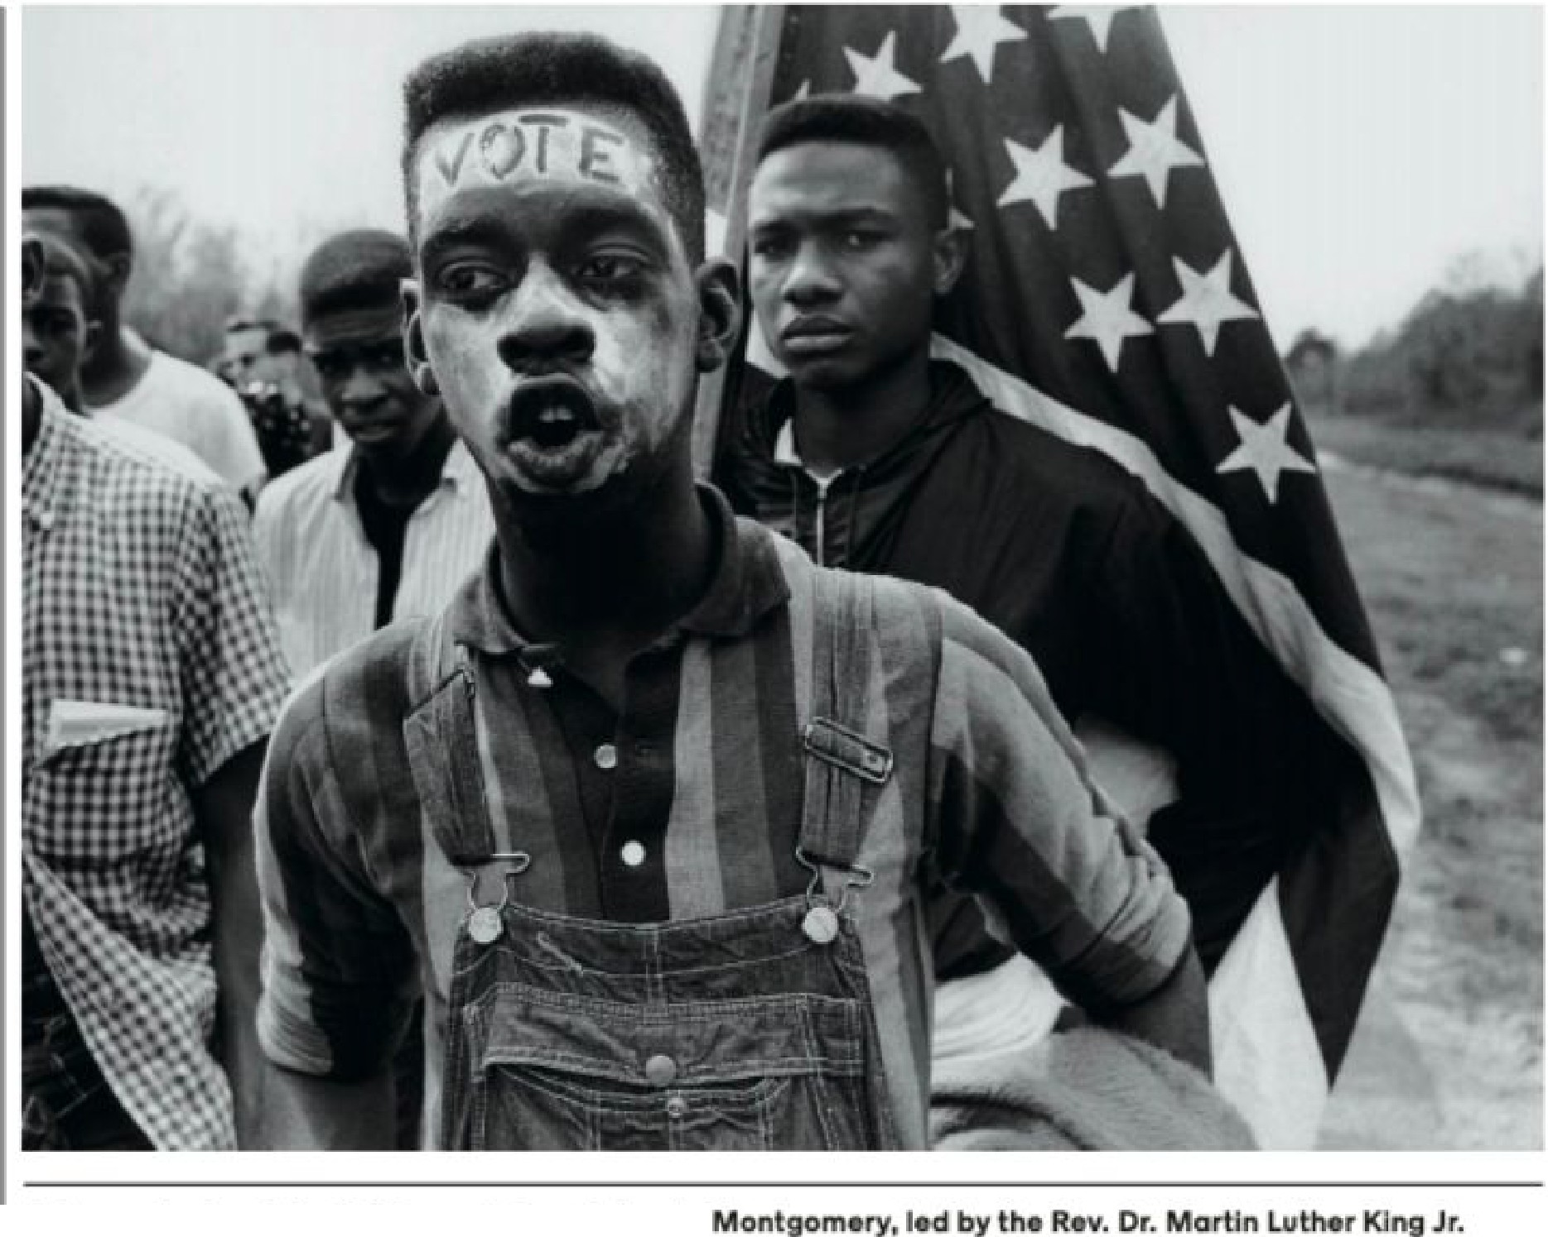

Ad _monltratoral tfl• \965 m,gr,c:h from S,lma to to flgh:lt orb ai::k s;uffrag•.

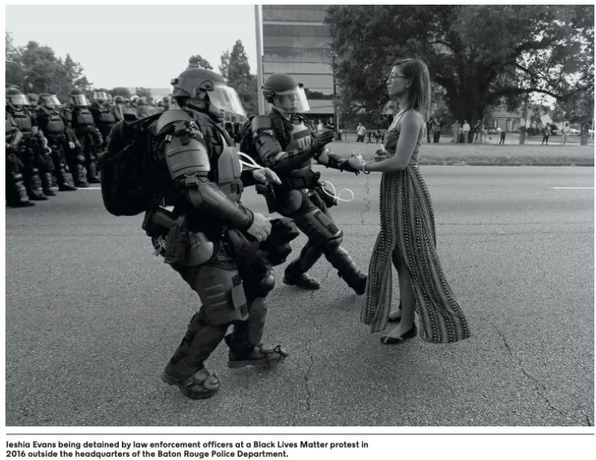

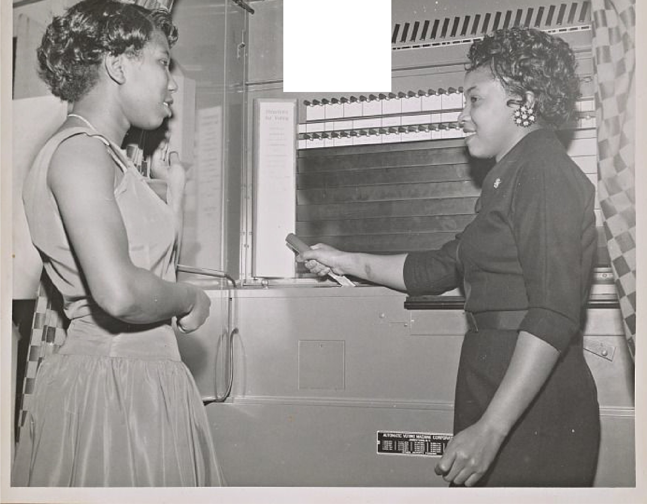
■- I-I-/·/-/-/-/-/-

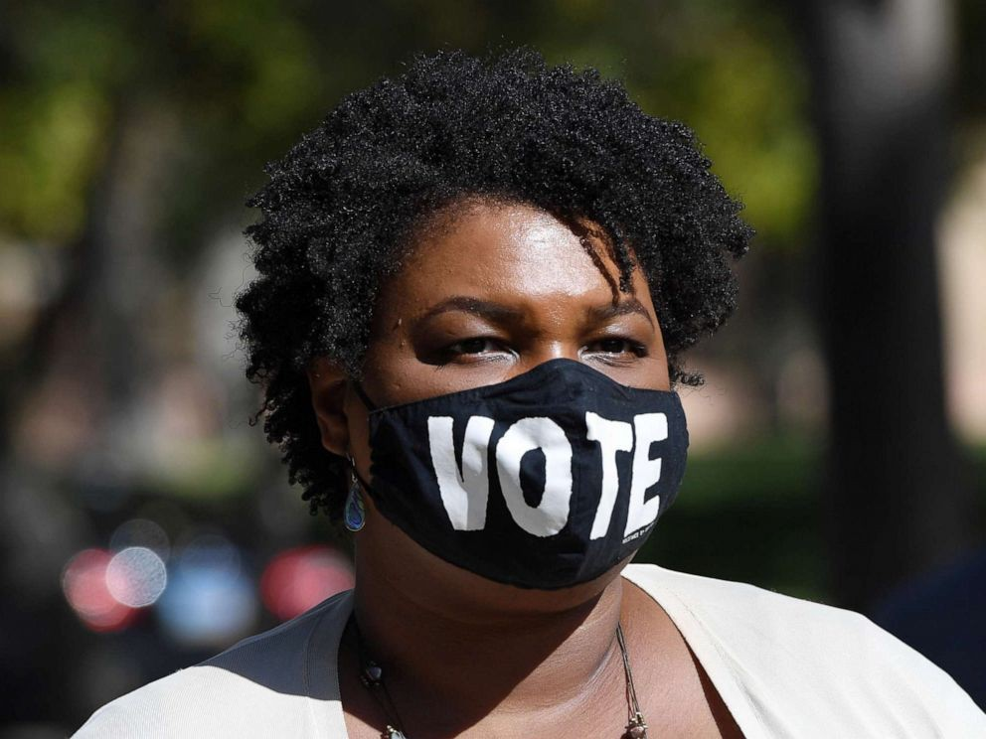

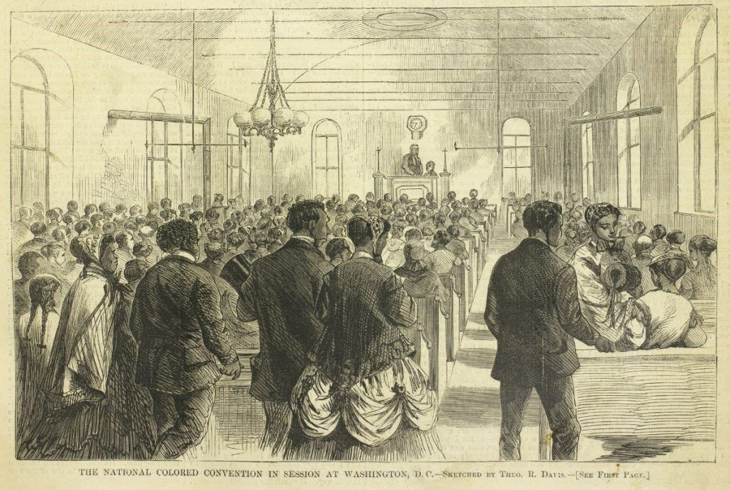

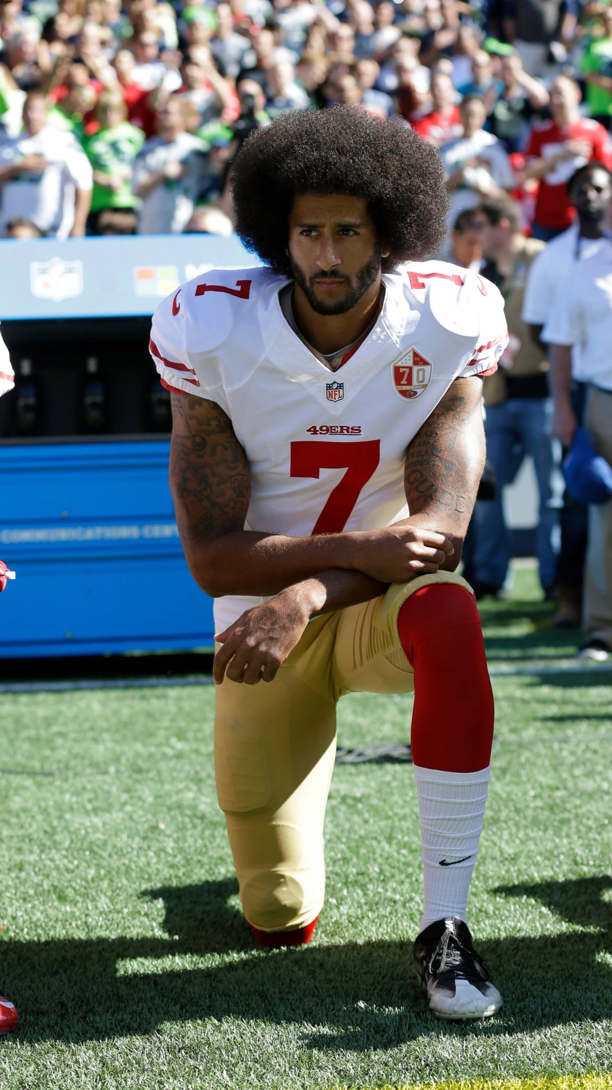

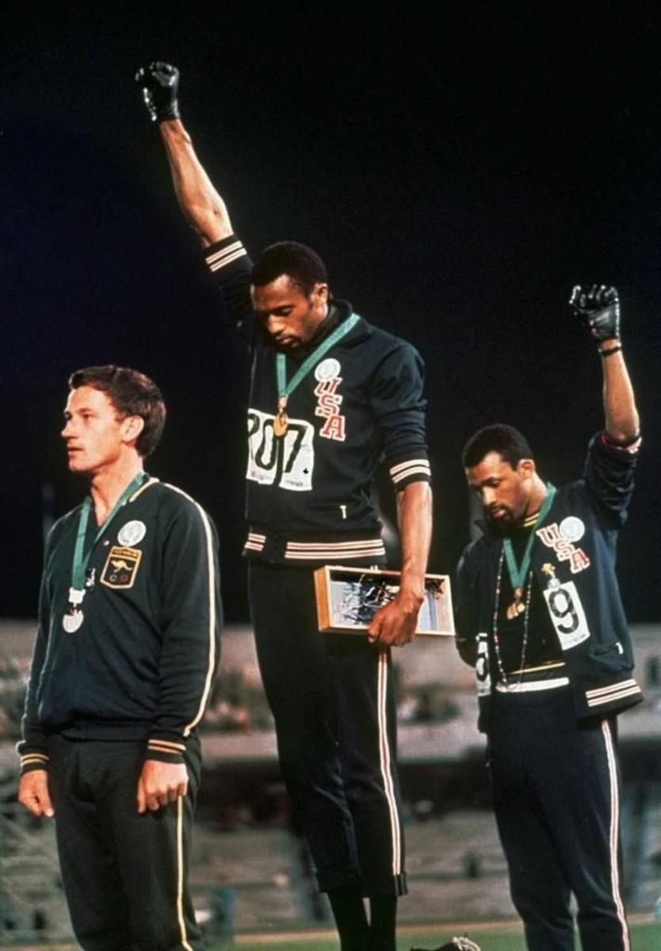

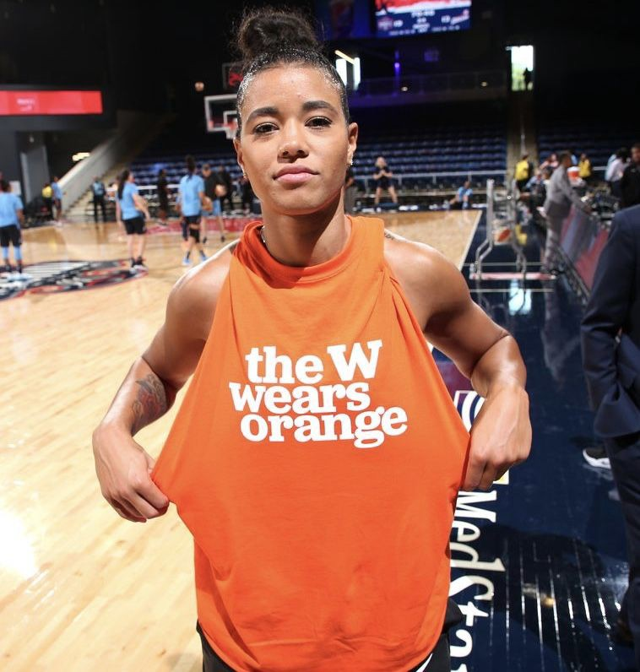

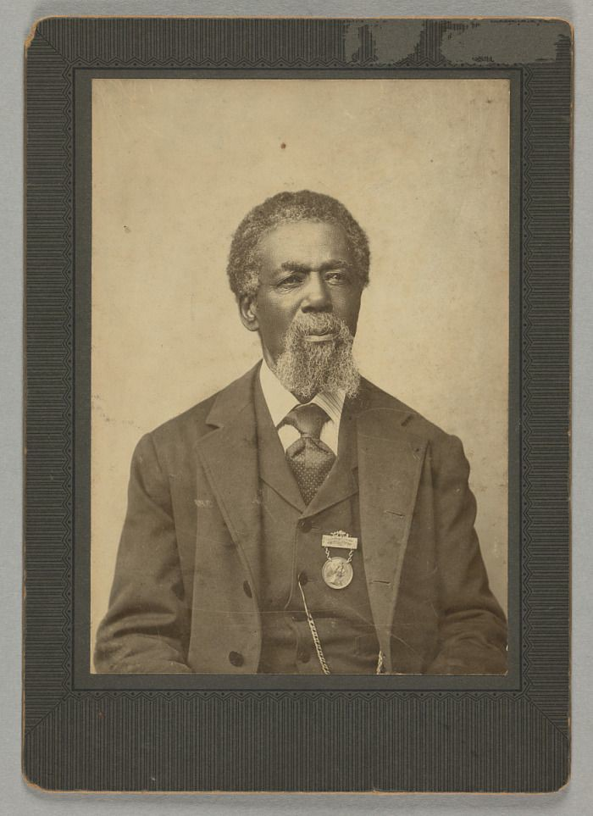

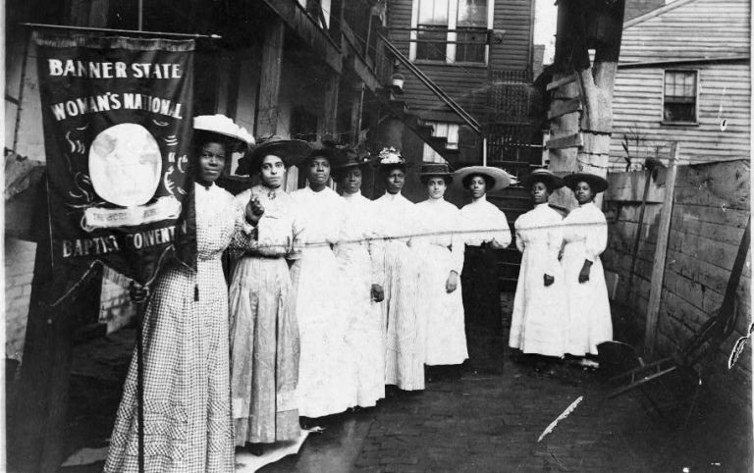

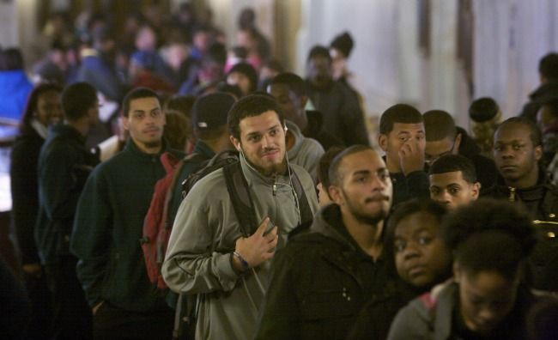

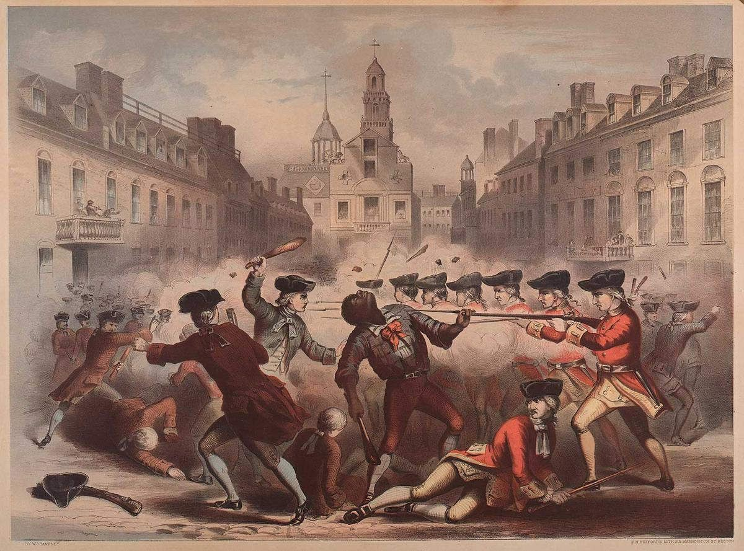

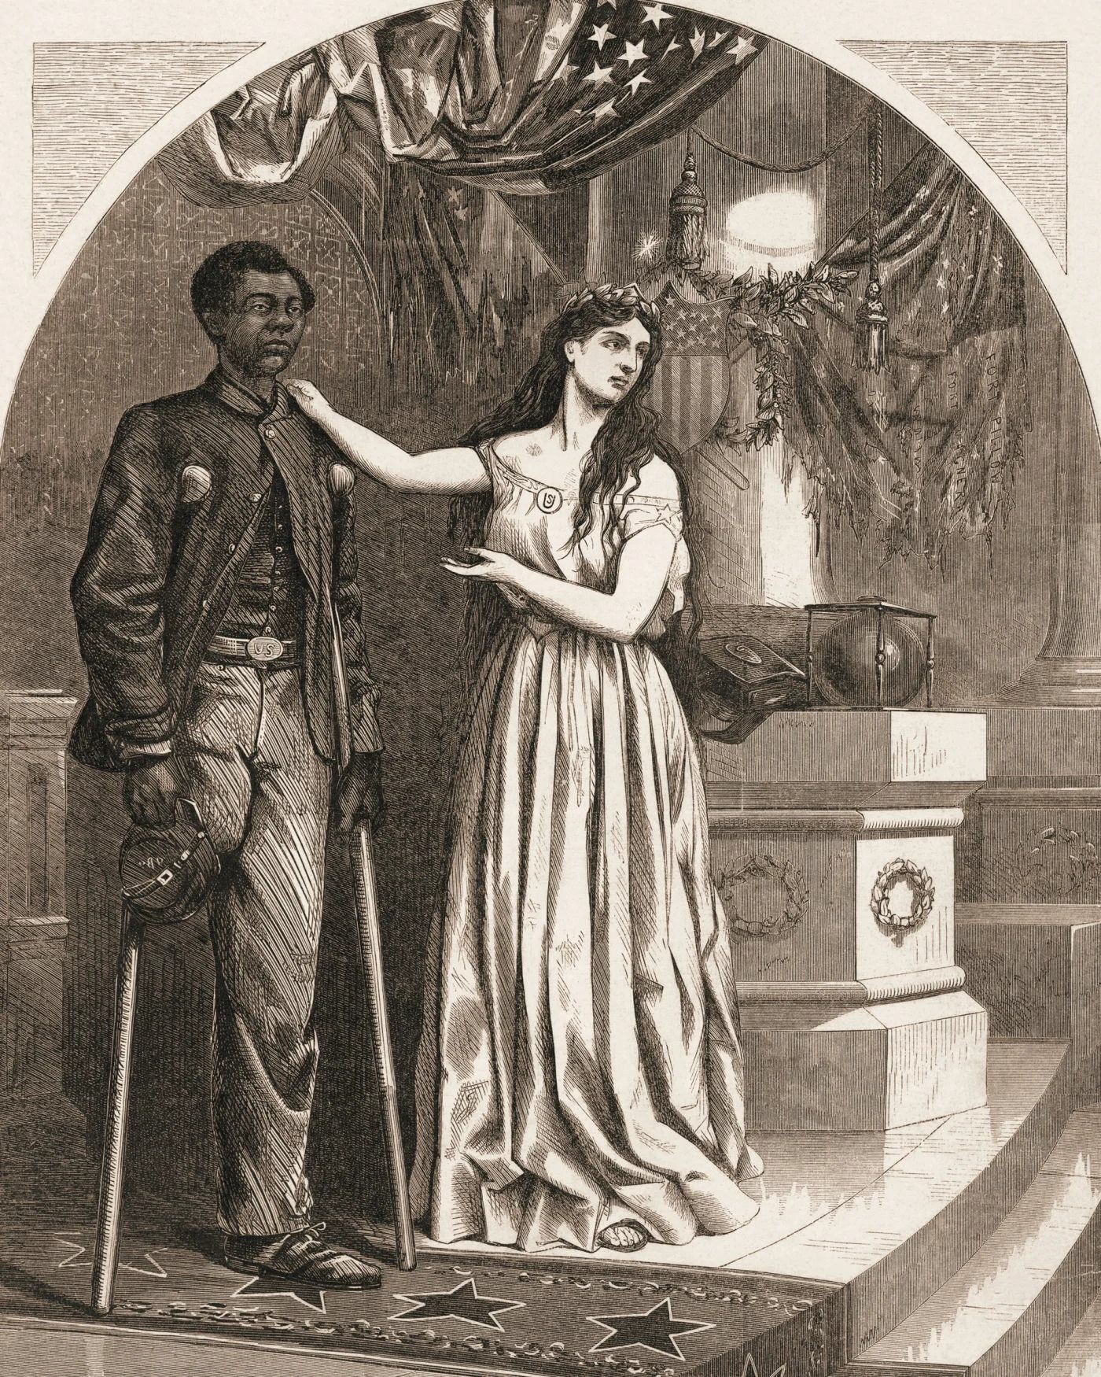

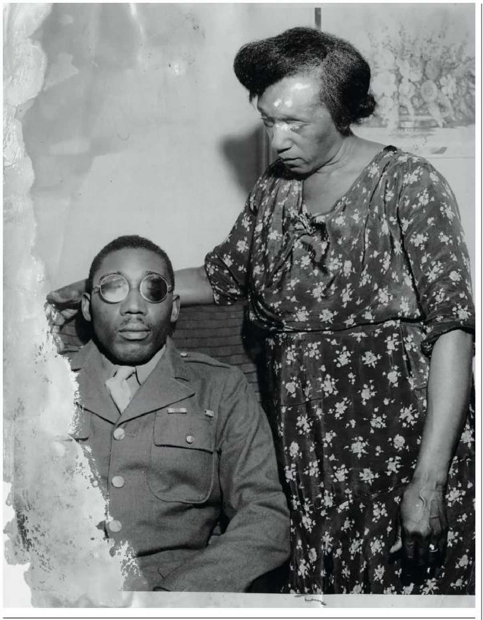
l&aa<: W-ooclard and his mother In South Carolina In 1946. In Februciry that year, Woode.rd, a decorated Army vet:eran, wa:r. H'll'erely beaten lby the IPOllce, le.-a lng him blind.,

