Your Call to Action Question (CAQ)
In the graph below, show how the issue in your CAQ affects you, your family and friends, your community, and your city (and maybe your state, the United States, and the world). If you see connections, draw lines to show those connections. If you have questions about the effects, you can write them around the outside of the circle.

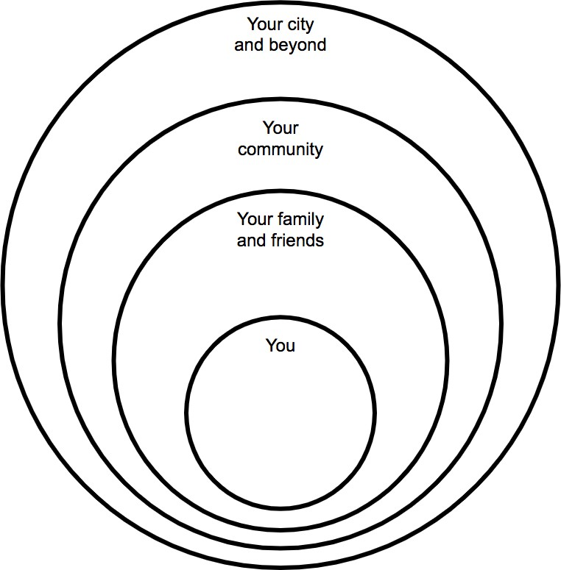

SOURCE: modified from Chicago Public Schools Inquiry to Action Framework: A guide for implementing service learning projects within course content.

