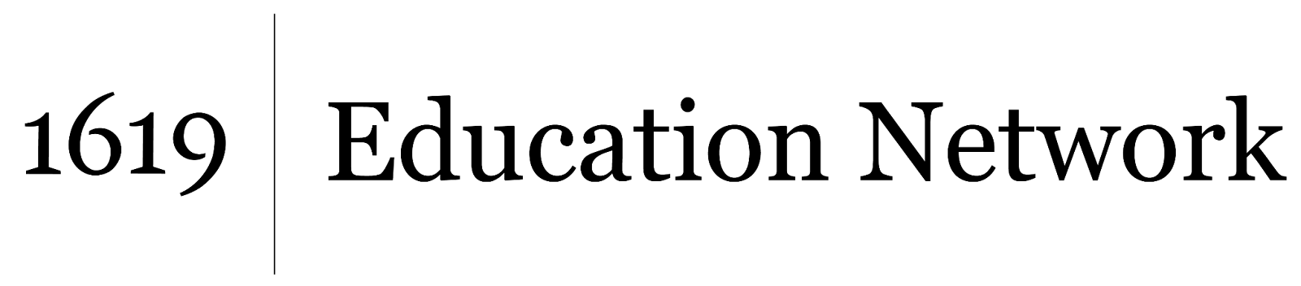
Understanding and Interrogating Dominant Culture
Unit by Friendship Public Charter School team,
part of the 2021 cohort of The 1619 Project Education Network
_

This video from ABC News focuses on a Black high school wrestler who was forced to cut his hair in order to compete in a match. Discussion questions:

- Do you feel that what happened to this wrestler was a violation of his civil rights - was he treated unfairly based on his identity (specifically his race)?

- Write down one word that best captures your emotional reaction to this story and video. Why? Explain why you feel this emotion?

- Do you think this story is about one specific referee or is it about larger issues in our society?

