Brick by Brick: Exploring and Archiving the History of the City of Newark
Unit by Jazmin Puicon

Lesson 1: What is Migration? An Introduction

Lesson Objectives and/or Essential Questions
Guiding questions: What is migration? How does it impact families and individuals? What does migration look like around the world?

Learning objective: Define key terms (migration, immigration, citizenship)

Warm-up
Share the Pulitzer Center’s Migration and Refugees issue portal with students, where they can find the most recent underreported stories of migration that the Center has supported. Explore the headlines and images on the first few pages. Have students point out:
- What do you see? What is missing?
- Who is being depicted? Who is being left out?

Focus text(s) / resource(s) for today’s lesson
Women on the Move from National Geographic
Graphic Organizer: Evaluating Details from Women on the Move from the Pulitzer Center

Lesson / Activities
1. Poll Everywhere (Word Cloud): When you think of immigration or immigrants, what’s the first thing that comes to mind?
Example from students at Bard Early College HS in Newark, NJ:

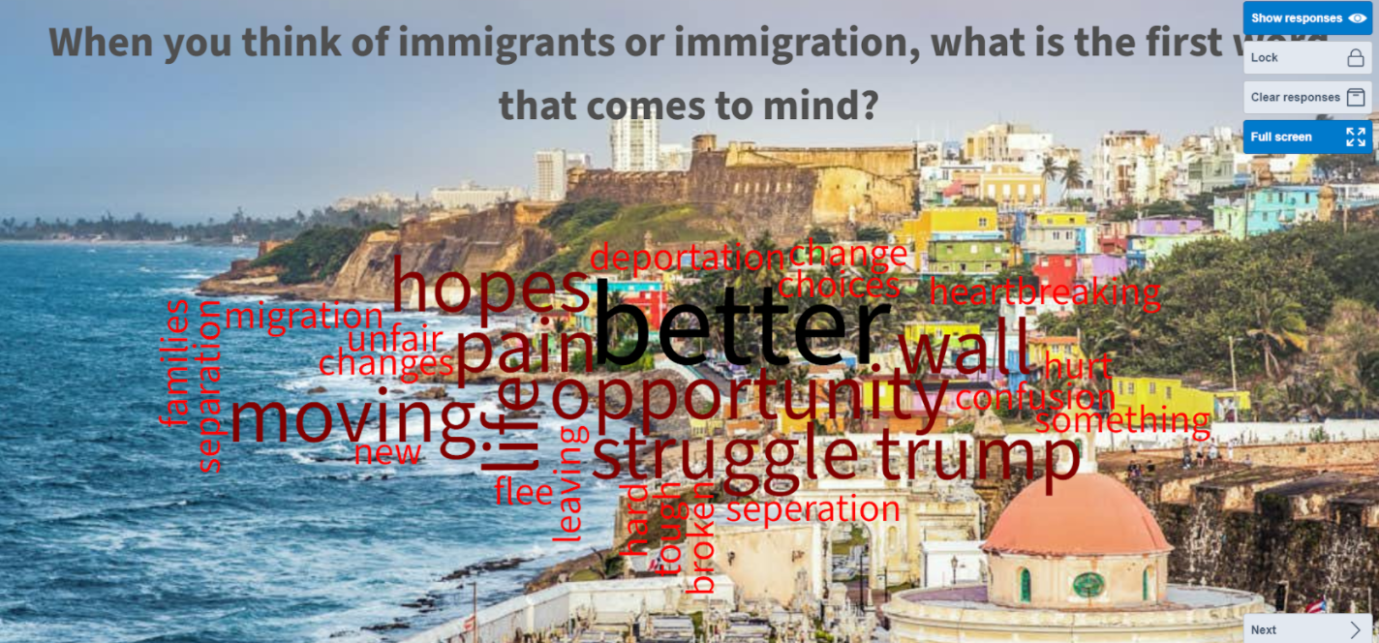

2. Go over responses as a class. Point our similarities and patterns in responses. Clear up any misconceptions and/or use them as a springboard into the lesson.

3. Examine Women on the Move, a multimedia journalism project from National Geographic that tells eight women’s stories of migration around the world. Analyze one story together as a class.

4. Split up students to analyze additional stories from Women on the Move individually or in pairs. Give students a graphic organizer to fill out only for the story they are choosing to analyze.
- Graphic Organizer: Evaluating Details from Women on the Move

Allow students to pick any story to analyze that speaks to them.

Closing or Homework
Have students respond to following questions/prompts in Jamboard:
- What is a border? (in your own words)
- Who/what defines borders?
- Borders can…

Examples from students at Bard Early College HS in Newark, NJ:

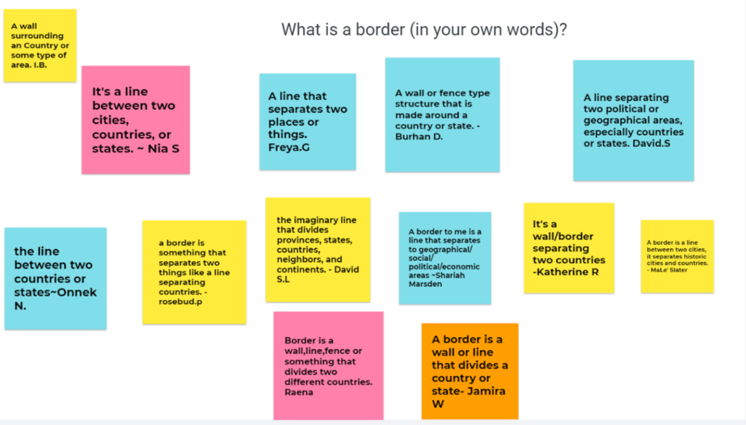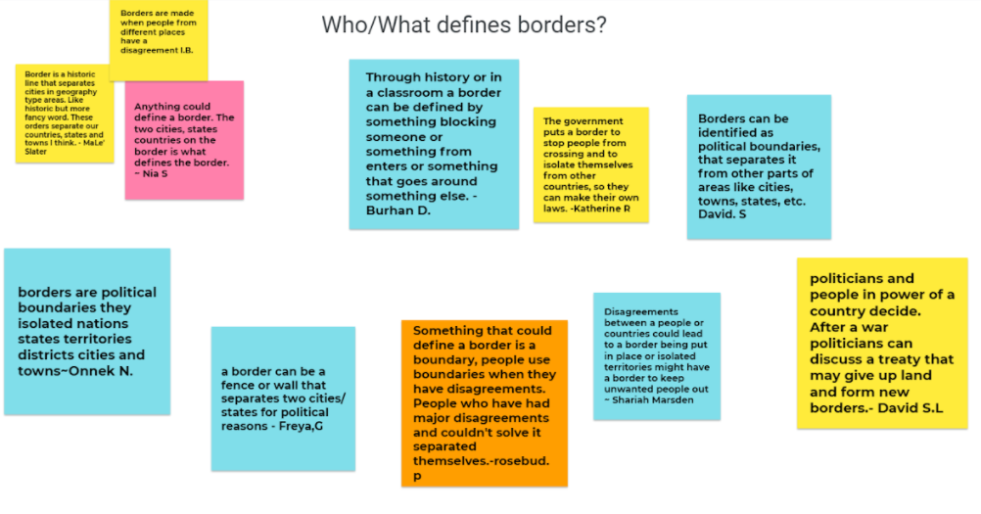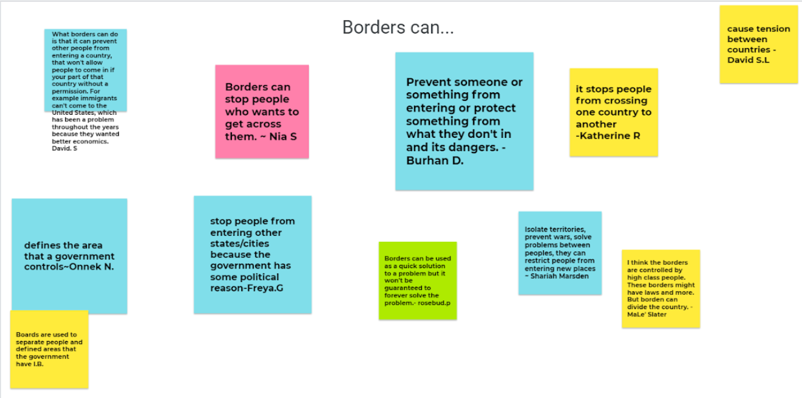

Lesson 2: Understanding Puerto Rican Community in Greater NY/NJ Area

Lesson Objectives and/or Essential Questions
Guiding Question: Why is there such a large Puerto Rican community in Newark/NYC? Why did Puerto Ricans leave their island and travel to the mainland United States?

Learning Objective: Understand the historical factors that pushed Puerto Ricans to migrate to the United States.

Warm-up
Discussion Questions (post in Jamboard): What do you know about Puerto Rico? Is it part of the United States? Why did Puerto Ricans become US citizens?

Focus texts / resources for today’s lesson
Puerto Rican Migration to the US | DPLA
Puerto Rico’s Complicated History with the United States | The History Channel
Here's Why Puerto Rico Is Part of the U.S. — Sort Of | History | The History Channel
Why Puerto Rico is not a US state | Vox
Puerto Rico Rises: Part 1, The Colony | ABC10
Puerto Ricans in the US Live in Counties With the Highest Possibility of COVID-19 Infection and Death

Lesson / Activities
Ask students to respond to the following questions individually or in pairs/small groups while exploring a series of resources. Students should respond in writing, preferably in an editable document, in order to continue adding to and revising their answers as they explore new resources.
- What did you learn about the island of Puerto Rico?
- Why did Puerto Ricans migrate to the U.S.?
- What are some of the challenges Puerto RIcans have faced in the 20th century?

Guide students in exploring the following resources in order to answer the questions above:
- Puerto Rican Migration to the US | DPLA
- Puerto Rico’s Complicated History with the United States | The History Channel
- Here's Why Puerto Rico Is Part of the U.S. — Sort Of | History | The History Channel
- Why Puerto Rico is not a US state | Vox
- Puerto Rico Rises: Part 1, The Colony | ABC10
- Puerto Ricans in the US Live in Counties With the Highest Possibility of COVID-19 Infection and Death

Closing or Homework
Students share with the class and/or write a short reflection writing on the information they learned today and the experiences Puerto Ricans have gone through.

Lesson 3: Closer Look - Afro-Puerto Rican Experience

Lesson Objectives and/or Essential Questions
Guiding Questions: What does it mean to be Black? What does it mean to be Afro-Latinx? What does it mean to be or identify as Afro-Puerto Rican? What is that experience like for individuals on the island, in the mainland United States, and specifically in Newark?

Warm-up
Ask through Poll Everywhere or Jamboard:
- What does it mean to be Black?
- What does it mean to be Afro-Latino/a/x?

Create a word cloud from responses. Compare and contrast responses to the two questions.

Focus text(s) / resource(s) for today’s lesson
Afro-Latinx Revolution: Puerto Rico (FULL DOCUMENTARY) by Natasha S. Alford for theGrio.com

Lesson / Activities
1. Watch “Afro-Latinx Revolution,” a documentary by Natasha S. Alford for theGrio.com (36:41).

2. Discussion questions:
- After watching the documentary, what have you learned about Puerto Rico? What was new information?
- What questions do you still have about Puerto Rico?
- Share your reflection on the documentary. What stood out to you while watching?

Facilitators can ask discussion questions to the group or have students write a Padlet post where their answers are shared with the entire class. If using Padlet, students should find connections to other students’ posts and comment below at least one post.

3. Have students share experiences about the Afro-Latinx experience in Newark. It can be through a written response journal for homework.

*Educator note: When doing this lesson in class, there was enough interest and discussion on the topic that we expanded the discussion to a school-wide celebration of the Black identity in Newark. It became a community-building moment where students who were Latinx or who identified as Black or African-American realized that there was more that united our community under the Afro-______ umbrella than under separated identities such as solely Puerto Rican, or Colombian, or Haitian, etc. This might not be the case for other educators and may depend on the community, but note that one lesson may not be sufficient to cover this important topic.
Homework
Next class, students will be visited by a journalist who reports on migration through the Pulitzer Center’s virtual journalist visit program. Students at Bard Early College HS in Newark, NJ in spring 2021 were visited by Zahra Ahmad.

Ideal preparation for journalist visit: Students read through several chapters of Zahra Ahmad’s reporting/personal essay nproject, “Iraq: The Journey Home,” and prepare the following to share with Ahmad during her visit:
- One question about migration
- One question about journalism
- A reflection on how you can relate to Zahra’s stories

Quick preparation for journalist visit: Students read Ahmad’s bio and this one-paragraph introduction to her project, and prepare the following to share with Ahmad during her visit:
- One question about migration
- One question about journalism

Lesson 4: Closer Look - Zahra Ahmad, Journalist

Lesson Objectives amd/or Essential Questions
We will speak with Pulitzer Center journalist Zahra Ahmad, who reported on her personal story of returning to her home country of Iraq after 20 years living in the U.S. through her project “Iraq: The Journey Home.” Students will be participating in a visit and Q&A with Ahmad.

Warm-up
Before class, students should bring their comments and questions to ask of Ahmad.

Focus text(s) / resource(s) for today’s lesson
Class visit from Zahra Ahmad
Iraq: The Journey Home by Zahra Ahmad for MLive

Lesson / Activities
Lesson will center on a presentation and Q&A with Zahra Ahmad (her personal experience of migration, her reporting process, how she conducted interviews with her own family members to tell a story about migration, etc.)

Use of graphic organizer to start thinking about conducting oral interviews of people in your life conducting_interviews_worksheet.pdf (pulitzercenter.org)

Closing or Homework
Students will reflect on the journalist visit and submit a reflection to Google Classroom.

Example reflections from students at Bard Early College HS in Newark, NJ:

“I learned that you don’t always have to fit in with people that are different from you, you can just be yourself. I also learned that journalism is a way to help people see the real news and help them explore it and make them want to learn about it more. I found interesting that there were many stereotypes about her country that turned out to not be true at all. It made me realize that everything is not what people make it out to be. The part that stood out to me was when she talked about how she changed herself to fit in with her friends. Then realized she made a mistake and went back to being the real her. Because you should always be yourself no matter what.” - Shayla

“I learned that people sometimes migrate to escape war, look for protection and safety and better opportunities. The most potent moment of Ahmad’s story to me is when she told us how her mother told her not to talk too much at the airport, so they didn’t pick out her accent. This was important to me because nobody should be so worried and afraid that they are cautious about talking just because of what would happen if somebody picks up on their accent. Another part I found powerful was when Ahmad was telling us how she traveled across the seas with her family, how she and her family migrated from Iraq to Iran to Turkey to Lansing, all because they were forced to flee. Just for them to be discriminated against and turned into villains by American minds. I can relate being a person of color, POC are very frequently experiencing racism and unjust killings. Nobody should have to suffer through any of this, immigrant or not, especially in a country that’s supposed to be built on freedom, independence, liberty, and justice for all.” - Shariah

“I learned that sometimes you have to learn your family. I can relate to her story because my family had immigrated and had to leave their family members until they could come back to get them. They thought about them a lot but they knew it was for the best, then they came back and got them. It was powerful how she took her culture with her and didn’t change it even with the new area. Also she always believed and had faith in herself and others.” - Haniyyah

Lesson 5: Intro - History of Newark

Lesson Objectives and/or Essential Questions
We will begin learning about the wave of migration into the city of Newark that was part of the “Great Migration” in the U.S.

We will examine one primary source that helps us understand this era in Newark history.

Warm-up
Ask in Poll Everywhere:
- What do you know about the history of the city of Newark?
- What would you like to know about the history of your city?

Focus text(s) / resource(s) for today’s lesson
African Americans, Pt. 3 (First Great Migration) - The North | Newark (riseupnewark.com)
Document analysis worksheets from the National Archives
Lesson / Activities
Students will be introduced to the digital archive RiseUp Newark. Teacher will explain the significance of this digital, local-historian led website. About - The North | Newark (riseupnewark.com)

Together, we will explore the chapter on “African-Americans in Newark - First Great Migration.” Students will read this chapter aloud as a class. Teacher will demonstrate how to analyze primary sources listed on the website using document analysis worksheets from the National Archives.

Closing or Homework
Closing (exit ticket):
- What are 3 facts that stood out to you and why?
- What are three questions you have after this lesson about the material/facts/persons we explored today?
- What are 3 quotes that stood out to you and why?

Lesson 6: Closer Look - Examining the Experience of One Migrant Group in Newark

Lesson Objectives and/or Essential Questions
We will take a closer look at the experience of one migrant group to the city of Newark.

Warm-up
Ask students about the different groups they may know about that live in the city of Newark.

Focus text(s) / resource(s) for today’s lesson
Chapter 1: Pre-1950s - The North | Newark (riseupnewark.com)
Document analysis worksheet from the National Archives

Lesson / Activities
Students will be able to choose one ethnic/racial group to explore who migrated to the city of Newark using the website above. The choices are: Chinese, German, Italians, Polish, Jews, Native Americans, Puritans, Irish, Greek, Puerto Ricans, Portuguese (students explored the history of African-Americans in Newark together Lesson 5). In addition, they will examine one primary source related to that group.

Students will write down the following reflections while they explore the resource from RiseUp Newark:
- What are 3 facts that stood out to you and why?
- What are three questions you have after this lesson about the material/facts/persons we explored today?
- What are 3 quotes that stood out to you and why?

Students will also fill out one document analysis worksheet from the National Archives, according to the type of primary source document they explore.

Teacher has modeled how to do this successfully in the last session (Lesson 5). Students can work in small groups or independently, with the teacher conducting check-ins with students/student groups during the class period.

Homework
Students who do not finish the closer look on one group will complete the assignment as homework.

Lesson 7: Political Activism in Newark

Lesson Objectives and/or Essential Questions
We will explore the history of political activism in Newark. We will understand the importance of voting.

Warm-up
Ask students: How many people in Newark voted in the last school board election? Voter Turnout at a Glance - The Newark Trust for Education

Focus text(s) / resource(s) for today’s lesson
Culture of Political Activism in Newark (1940s-50s) - The North | Newark (riseupnewark.com)
The Black Vote and the Commission Form of Government - The North | Newark (riseupnewark.com)

Lesson / Activities
We will read through the focus texts together. Students will again be asked to respond to the following questions:
- What are 3 facts that stood out to you and why?
- What are three questions you have after this lesson about the material/facts/persons we explored today?
- What are 3 quotes that stood out to you and why?

Teacher will stop to define terms and to explain context/background information.

Closing or Homework
Exit Ticket: Students submit reflections through Poll Everywhere (show responses as they come in live):
- Why is voting so important?
- How can it change a community?
- What does voting have to do with politics in Newark?

Lesson 8: Newark Rebellion 1967

Lesson Objectives and/or Essential Questions
We will explore the factors that led to the rebellion of ‘67 and the impact it had on migration in the city of Newark. We will think about how the ‘67 rebellion speaks to our own lives and experiences in the city of Newark.

Warm-up
Discussion questions:
- What is the difference between riot and rebellion?
- Why do you think people use one label instead of another?
- What are the impacts of these terms on everyday people?

Focus text(s) / resource(s) for today’s lesson
Revolution '67 | Kanopy
Part 2 - The North | Newark (riseupnewark.com)
Outcomes and Impacts - The North | Newark (riseupnewark.com)

Lesson / Activities
As we work through clips of the documentary and the primary/secondary documents related to the Rebellion of ‘67, students will keep track of important facts, quotes, and questions they may have related to the material.

Homework
Students will write a reflection piece that ties the Newark Rebellion of 1967 to migration out of Newark, and reflect on the legacy of the ‘67 Rebellion in current-day Newark history, politics, and culture.

Lesson 9: Exploring Our History as Migrants to Newark

Lesson Objectives and/or Essential Questions
We will use a concept map to begin mapping out our own history as citizens of the city of Newark.

Warm-up
Discuss as a class: Thinking about the material presented in the unit, which pieces were most important to you and why?

Focus text(s) / resource(s) for today’s lesson
Mural Essay performance task directions [.pdf]
Mural Essay performance task directions [.docx]
Mural Essay rubric [.pdf]
Mural Essay rubric [.docx]

Lesson / Activities
Question for students to think about: If a historian were to explore my life decades from now, what would I want them to know about my life, my family, and my history?

As a concept map, students will map out the following:
- 3 important events that shaped their lives
- 3 important people in their lives
- Document where their family comes from prior to coming to Newark, or, if students’ families have been in Newark for a very long time, students will document what ward/neighborhood their family has lived in
- 3 places in Newark that are important to them and why

Closing or Homework
Introduce students to the final project. Have them go over the directions and rubric for homework.

Note: Students in Jazmin Puicon’s spring 2021 class were given the option to choose among three different performance task options (see Lesson 9), and all chose to complete the photo/mural essay. Student work and resources reflect this choice.

Lesson 10: Documenting our History as Migrants to Newark

Lesson Objectives and/or Essential Questions
Students will be introduced to the final project: How can I document my history?

Warm-up
How would you like historians to experience your history? Options:
- Interview (with their ears/eyes)
- Photo/mural (eyes)
- Your writing/map (eyes)

Discuss: What are the advantages and disadvantages of each source?

Lesson / Activities
Students’ culminating project will be the creation of a student-led archive that documents the history of students’ families and their migration/arrival to Newark. Each student will be placing “their brick” or contribution in the archive. Students can choose among the following mediums/projects for their contribution:
- A transcribed oral history or a video oral history created through Flipgrid
- An interactive map along with captions created through Padlet
- A photo/mural essay

The culminating “bricks” will be displayed on a student-created website. The website will form a digital archive of the city of Newark from a student’s perspective. The culminating project employs student-choice in order to accommodate all learning styles and skills.

Students will choose one final project and begin crafting. The teacher will conduct one-one-one check-ins during this period.

Homework
Students will finish their project for homework

***Ideally, students will be able to work on their final projects over several sessions or at least over a weekend. This is to ensure no rushing on such an important task by the student, and for the teacher to be able to check in with each student to see progress and help with follow-up questions.***

Lesson 11: Presenting/Celebrating our History as Migrants to Newark

Lesson Objective(s) or Essential Question(s)
What is our history as migrants to the city of Newark? What can we learn about others’ stories and histories?

Warm-up
This is a celebratory sharing session of unit projects.

Focus text(s) / resource(s) for today’s lesson
Peer Critique Worksheet for mural essays [.pdf]
Peer Critique Worksheet for mural essays [.docx]

Lesson / Activities
Students will present their final “brick” - their oral history video or transcript, their photo/mural, or their map entry with captions.

While students present, classmates will fill out a peer critique worksheet.

Closing or Homework
Students will turn in peer critique worksheets. Students will put finishing touches on their projects before uploading them onto the class website.

As a closing activity for this unit, students responded to the following prompt through Padlet:

After learning about the history of the great city of Newark, what does Newark mean to you? What are your hopes and dreams for the city? What stood out to you about the history of this city? What do you want others to know about Newark and its citizens?

This prompt serves as a student reflection but also for the teacher to gauge what students learned from this unit and activities, what stood out to students, and as an informal assessment of the content learned from the unit.

Click here for example reflections written by students at Bard Early College HS in Newark, NJ
Click here for example mural essays by students at Bard Early College HS in Newark, NJ

