1619 Project Inquiry #1 Image Collection
How and why have Black people defended democracy? (Teacher Version)

Set 1 - By running for elected office
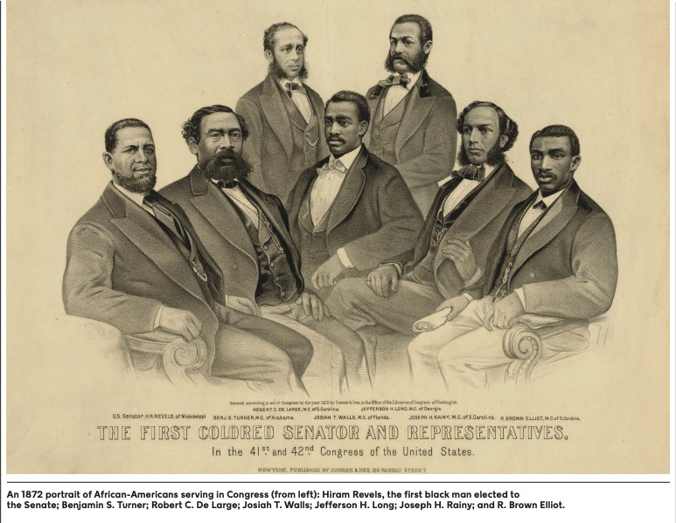 | https://www.loc.gov/pictures/item/985019 07/
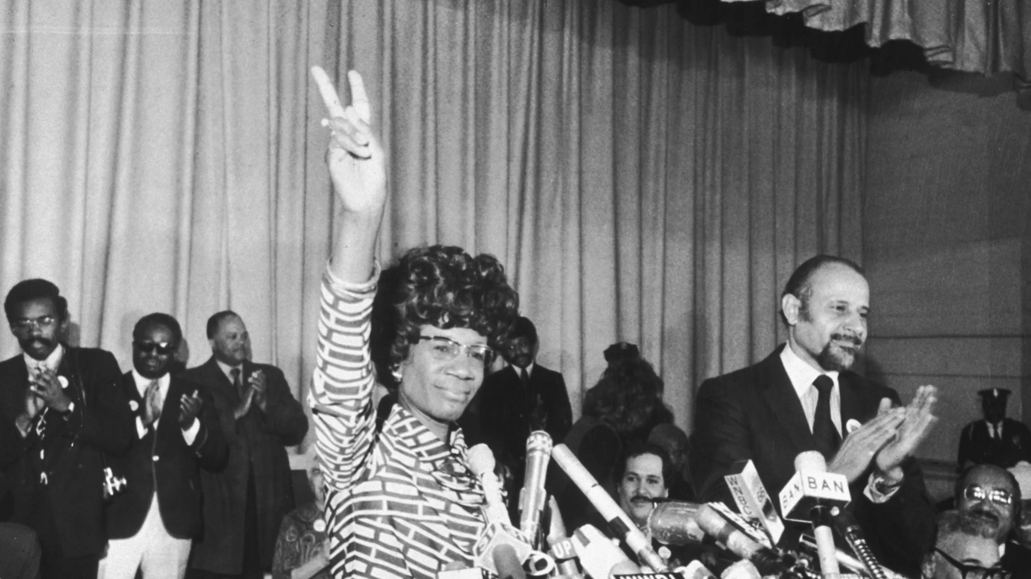 | Shirley Chisholm  PHOTO BY DON HOGAN CHARLES/NEW YORK TIMES CO./GETTY IMAGES (1972)  https://www.gettyimages.com/detail/news- photo/representative-shirley-chisholm-of- brooklyn-announces-her-news-photo/324 0579
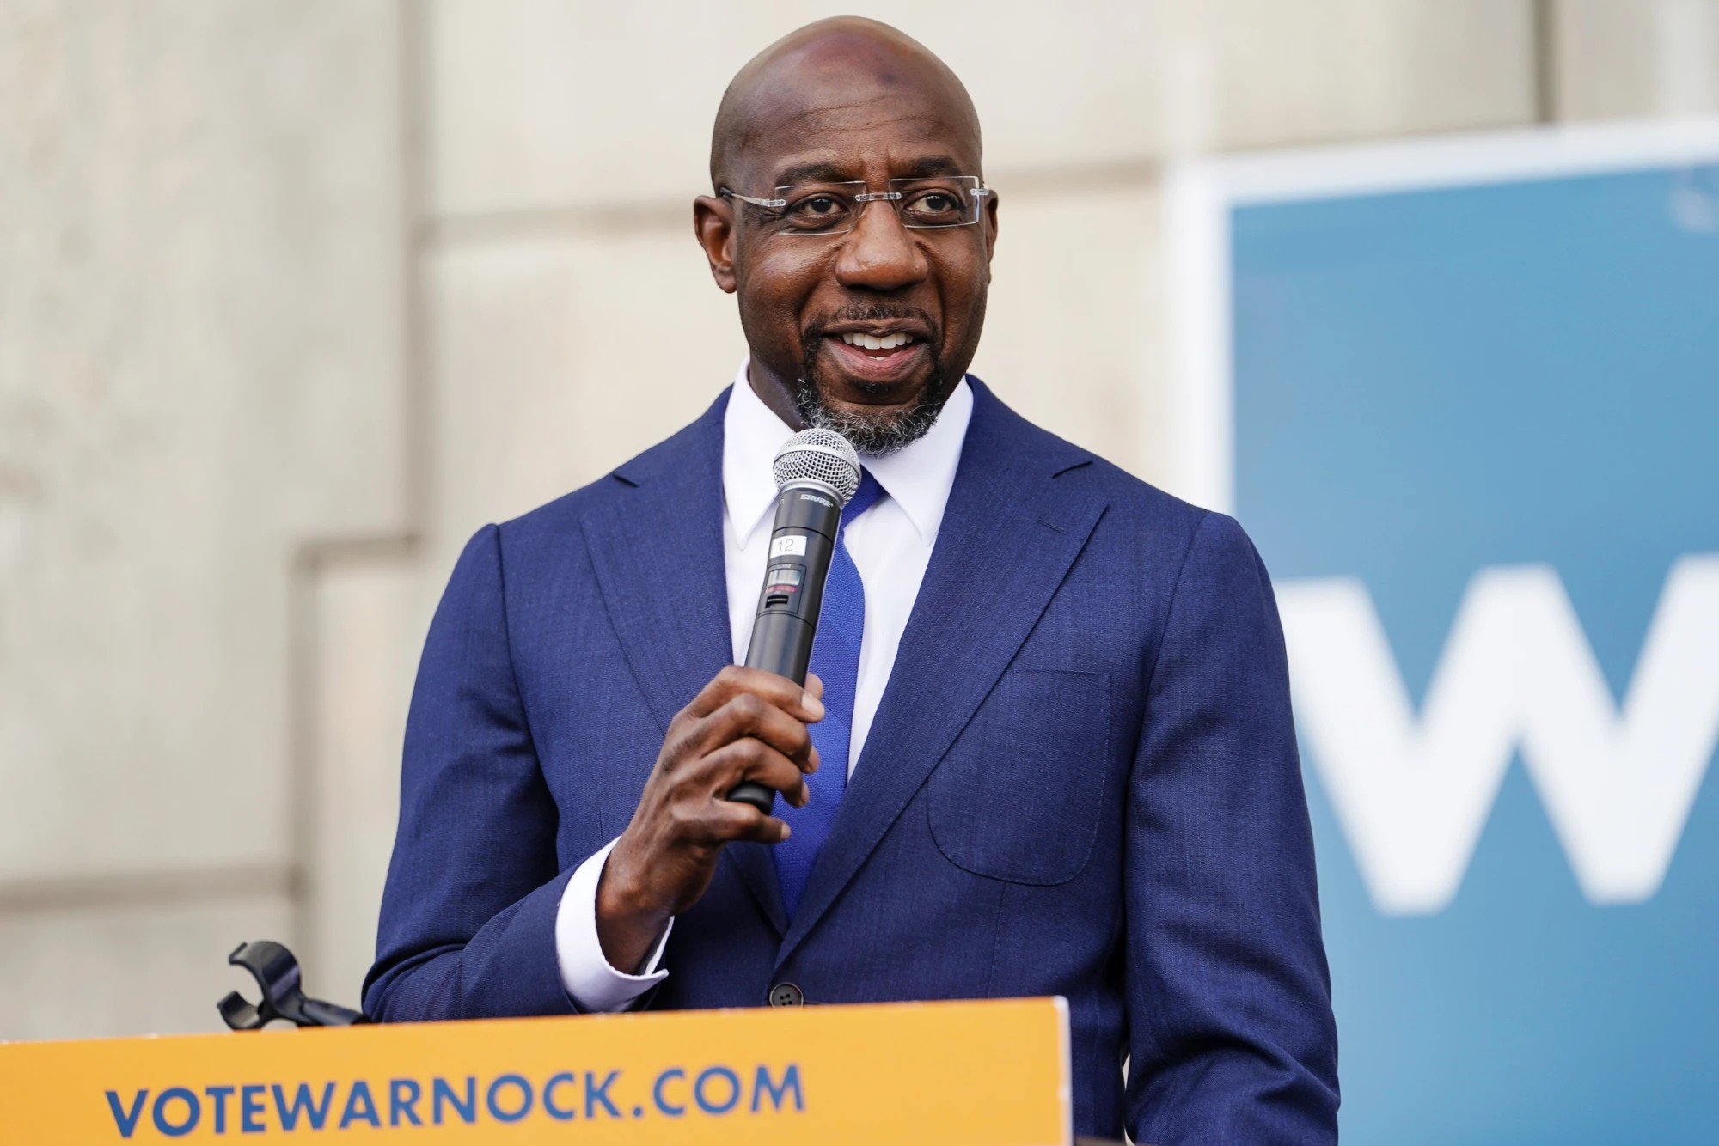 | Raphael Warnock speaks to labor organizers and the media in Atlanta on Jan. 5, 2021. Elijah Nouvelage / Reuters https://www.nbcnews.com/news/nbcblk/st raddling-senate-pulpit-warnock-highlights- religious-left-s-rise-u-n1253730

Set 2 - Through mutual aid societies (religious, political, abolitionist)
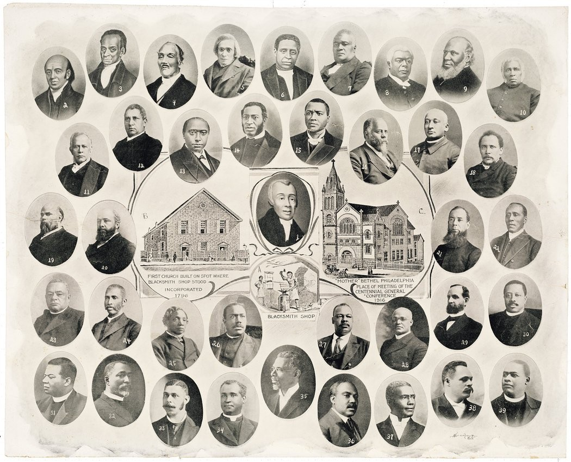 | This 1916 poster is for the Mother Bethel AME Church in Philadelphia, with founder Rev. Richard Allen in the center. https://pulitzercenter.org/sites/default/files/ 18maglabs_1619_issue_shipped_0.pdf (Page 11)
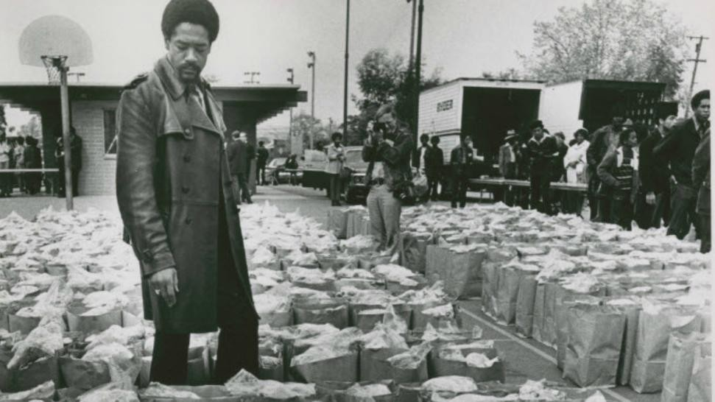 | Bobby Seale Checks Food Bags. March 31, 1972. Photo by Howard Erker. http://picturethis.museumca.org/pictures/b obby-seale-checks-food-bags
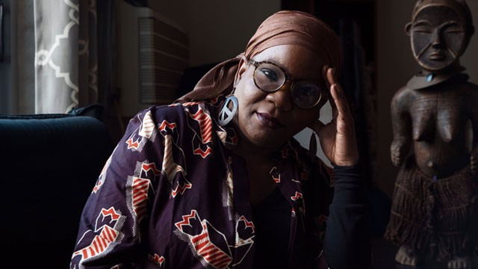 | Courtesy of Northwestern Now Mariame Kaba is an activist and  prison-industrial complex abolitionist. On Wednesday she addressed an audience of over 1,000, supporting student organizers and the campaign against University Police. https://dailynorthwestern.com/2021/01/13/ campus/activist-mariame-kaba-talks-aboli tion-and-mutual-aid-condemns-campus-p olice-in-dream-week-keynote/

Set 3 - Through direct protest
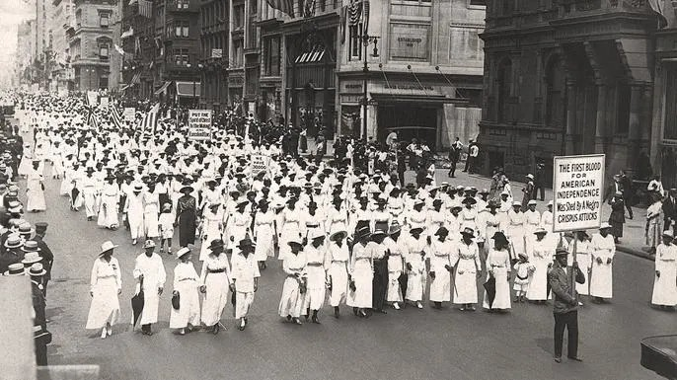 | A silent march to protest the police treatment of Blacks during riots in New York City, 1917. They marched down Fifth Avenue on that summer Saturday without saying a word. Underwood Archives/Getty Images  https://www.history.com/news/the-silent-pr otest-that-kick-started-the-civil-rights-mov ement
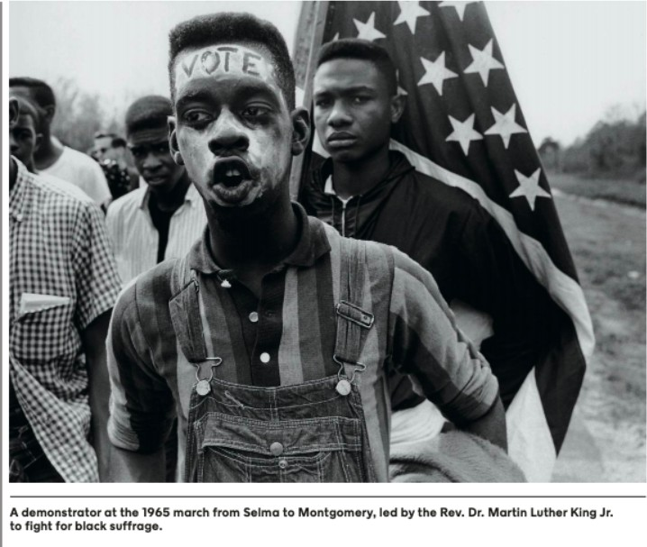 | Despite Timothy Mays being clubbed by a state trooper on "Bloody Sunday" on the Edmund Pettus Bridge, Mays refused to drop a large American flag he was carrying and marched the entire 54-mile trek from Selma to Montgomery carrying the flag.  https://www.alasu.edu/foot-soldiers-reunit e-share-stories-part-grand-opening-activiti es-asu-interpretive-center  A demonstrator at the 1965 march from Selma to Montgomery, led by the Rev. Dr. Martin Luther King Jr. to fight for black suffrage. https://pulitzercenter.org/sites/default/files/ full_issue_of_the_1619_project.pdf
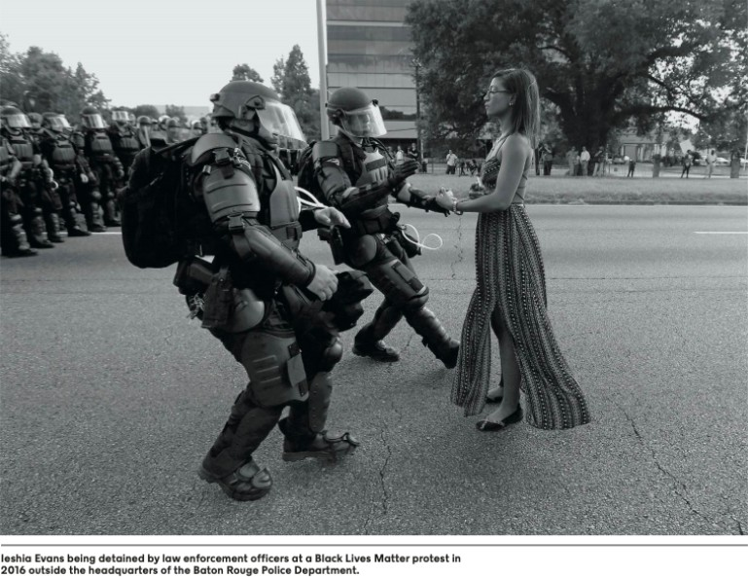 | Ieshia Evans being detained by law enforcement officers at a Black Lives Matter protest in 2016 outside the headquarters of the Baton Rouge Police Department. https://pulitzercenter.org/sites/default/files/ full_issue_of_the_1619_project.pdf  https://www.theguardian.com/us-news/20 16/jul/11/baton-rouge-protester-photo-ies ha-evans

Set 4 - By organizing to support voting rights, teaching others about the importance of voting, registering people to vote
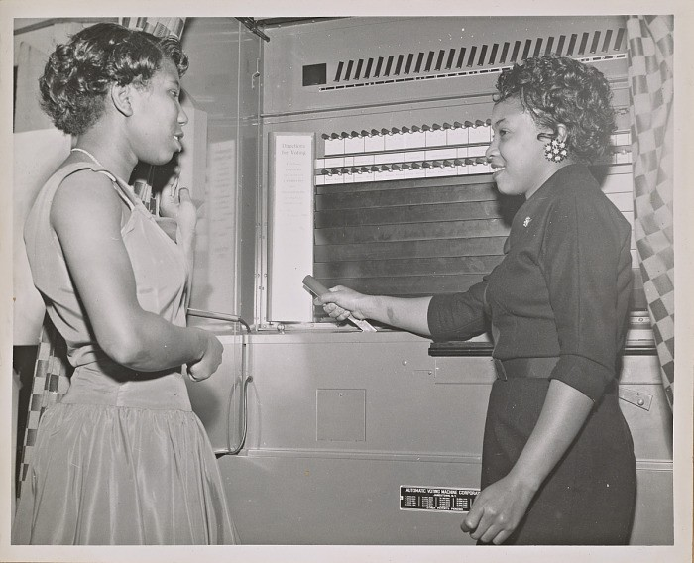 | 1956 - A black-and-white photograph of two unidentified women at the Citizenship Education Project office in San Francisco, CA. The woman on the right, a member of the NCNW Junior Council, demonstrates the use of a voting machine as the woman on the left looks on. The caption below the photograph reads, "A LESSON IN VOTING MACHINE OPERATION.”  https://nmaahc.si.edu/object/nmaahc_201 0.60.1.32
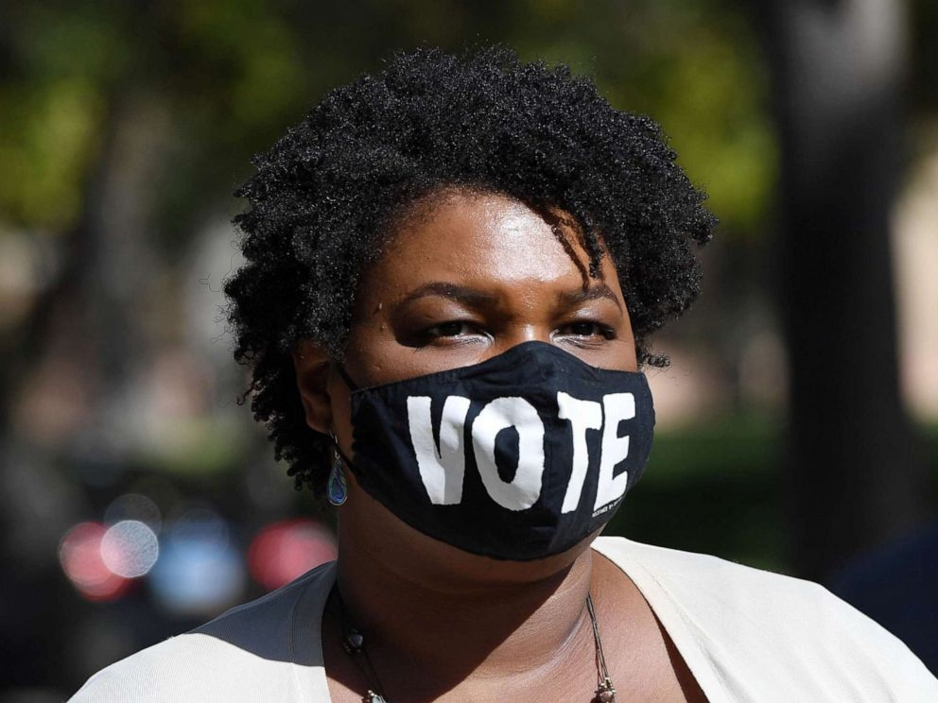 | Stacey Abrams, 2020, ABC News https://abcnews.go.com/Politics/eyes-stac ey-abrams-joe-biden-passes-donald-trum p/story?id=74039207
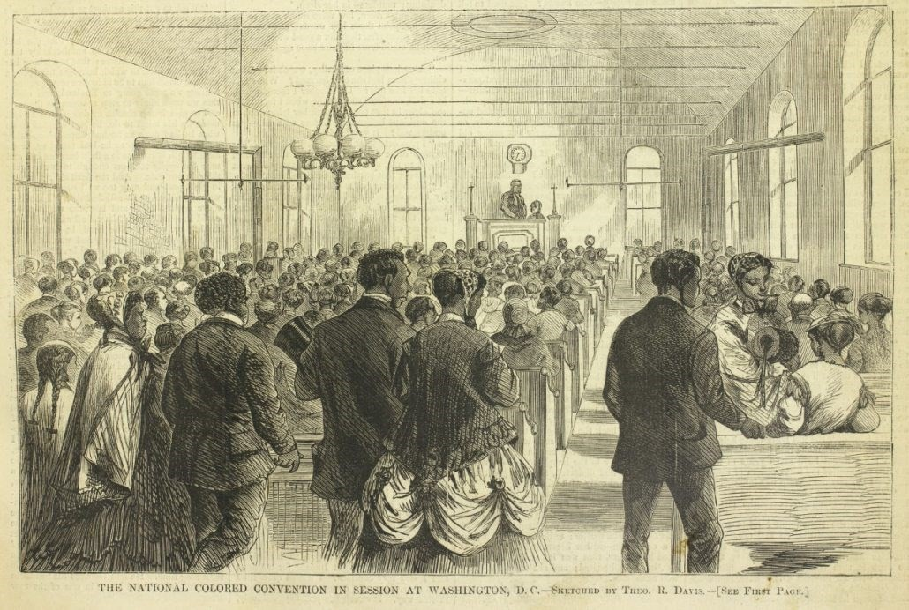 | “The National Colored Convention in Session at Washington, DC.” Harper’s Weekly (February 6, 1869).  https://www.loc.gov/item/90715756

Set 5- By using their fame/platform to raise awareness
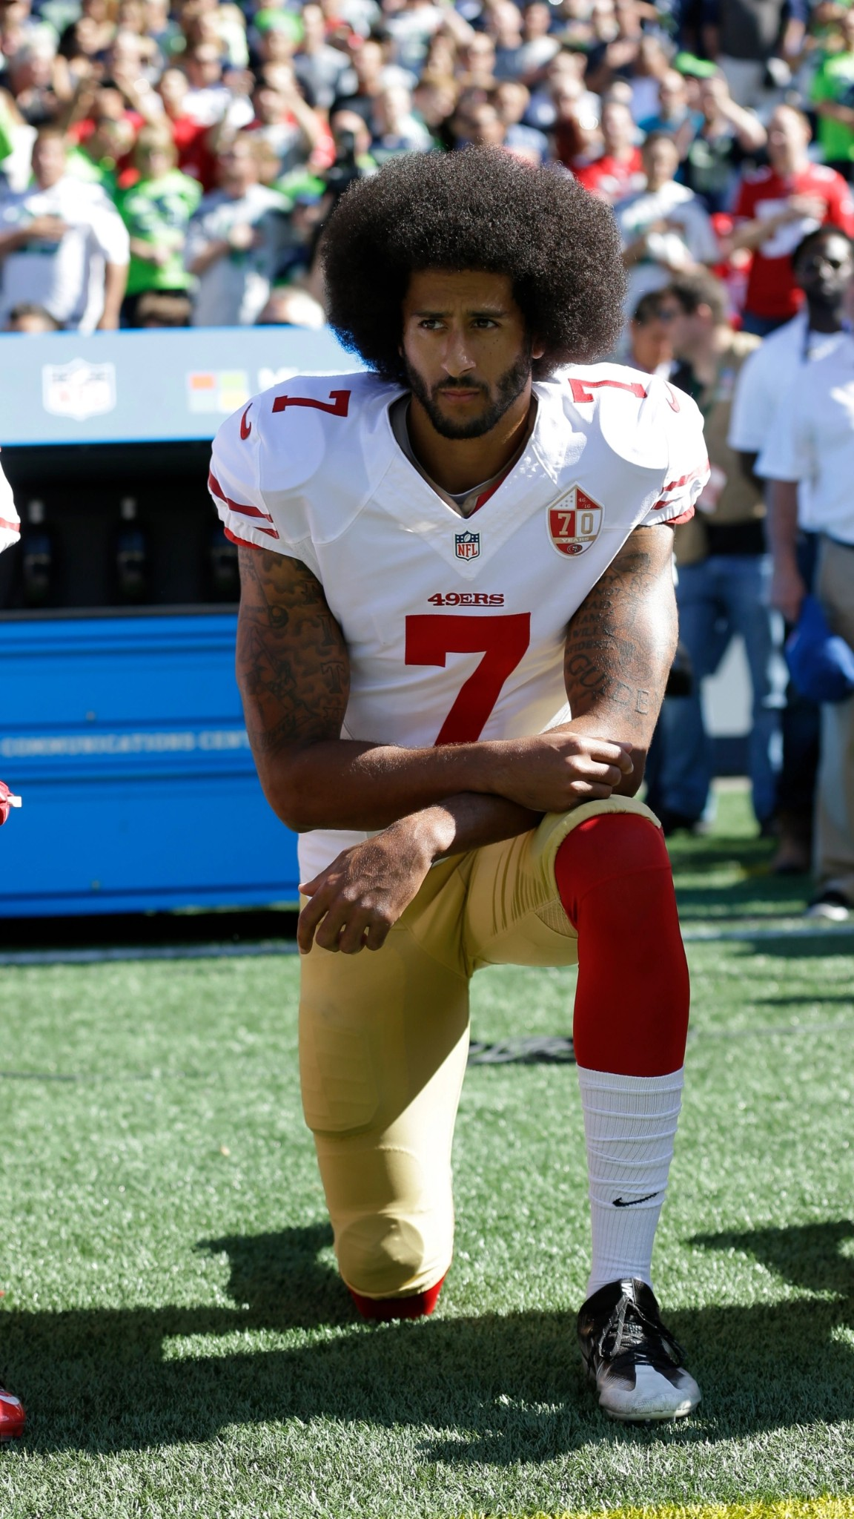 | In this Sept. 25, 2016, file photo, San Francisco 49ers’ Colin Kaepernick kneels during the national anthem before an NFL football game against the Seattle Seahawks, Sunday, Sept. 25, 2016, in Seattle. When Colin Kaepernick took a knee during the national anthem to take a stand against police brutality, racial injustice and social inequality, he was vilified by people who considered it an offense against the country, the flag and the military. Nearly four years later, it seems more people are starting to side with Kaepernick’s peaceful protest and now are calling out those who don’t understand the intent behind his action. (AP Photo/Ted S. Warren, File) https://www.pressdemocrat.com/article/sports/sup port-for-colin-kaepernick-grows-as-protests-sprea d/
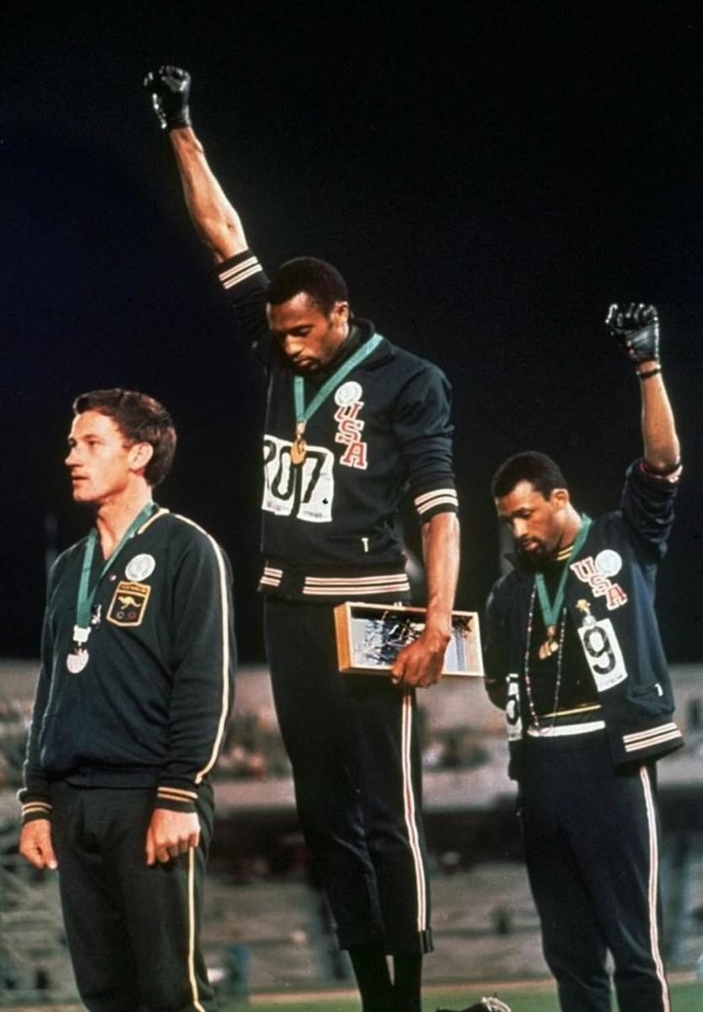 | 1968 - Tommie Smith and John Carlos - Summer Olympics https://www.history.com/news/1968-mexic o-city-olympics-black-power-protest-backl ash
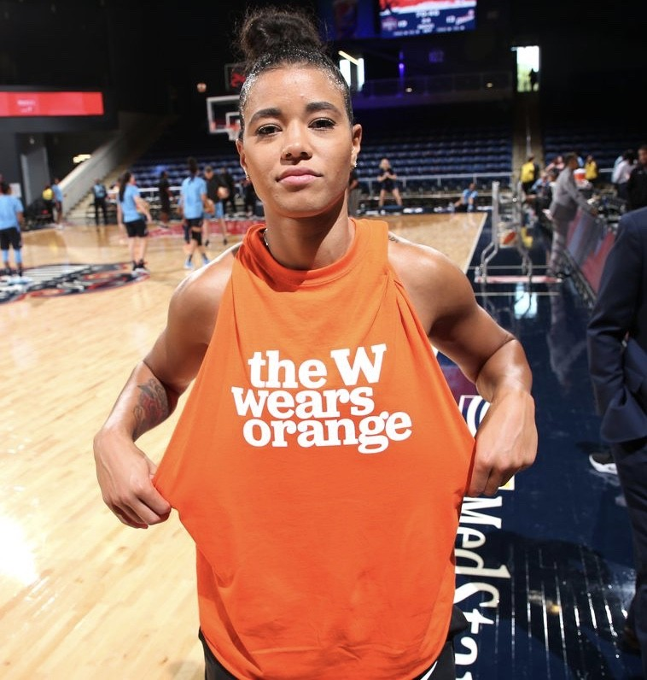 | Natasha Cloud, WNBA player for Washington Mystics, wears orange to raise awareness about gun violence, 2020  https://twitter.com/wnba/status/12688761 69685929990  https://www.nbcsports.com/washington/w ashington-mystics/washington-mystics-we ar-orange-warmups-honor-victims-gun-vio lence

Set 6 - By voting
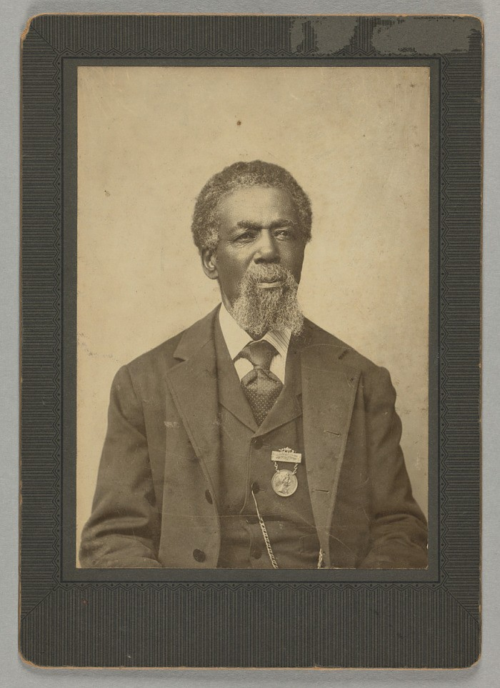 | 1884 - On March 31, 1870, one day after the ratification of the 15th Amendment, which allowed him the right to vote, Thomas Peterson became the first African American to cast a ballot in a U.S. election under the provisions of the 15th Amendment. The citizens of Perth Amboy, N.J. were voting to settle a disagreement over whether to revise the town charter or abandon it in favor of a township form of government. https://nmaahc.si.edu/object/nmaahc_201 5.190
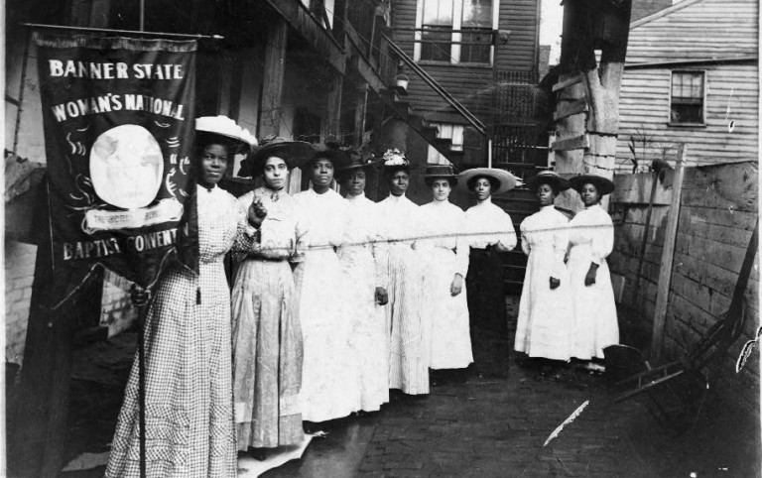 | Nannie Helen Burroughs holds a banner reading, “Banner State Woman’s National Baptist Convention” as she stands with other African American women, photographed between 1905 and 1915.  Burroughs was an educator and activist who advocated for greater civil rights for African Americans and women.  Library of Congress https://www.npr.org/2020/08/26/90473025 1/yes-women-could-vote-after-the-19th-a mendment-but-not-all-women-or-men
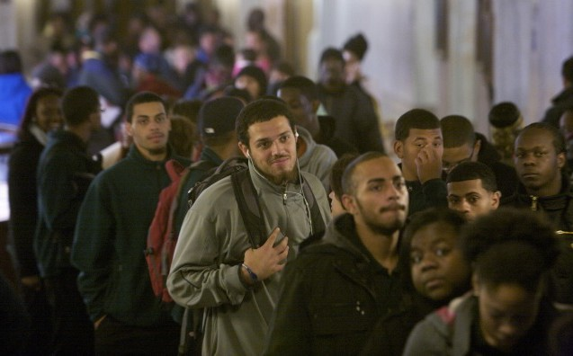 | Voters wait to cast their ballots in Hartford, Connecticut on Election Day 2012. (Reuters) https://www.theatlantic.com/politics/archiv e/2013/04/heres-why-black-people-have-t o-wait-twice-as-long-to-vote-as-whites/27 4791/

Set 7 - Through their death/military service
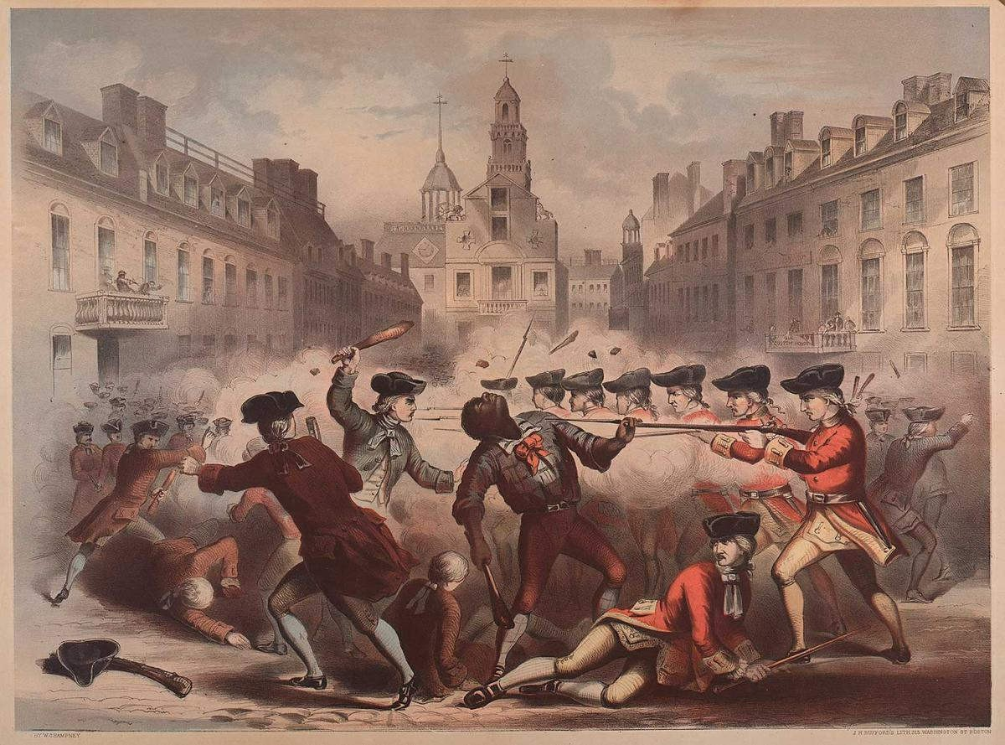 | Crispus Attucks, 1770, Boston http://www.crispusattucksmuseum.org/ho w-did-crispus-attucks-die/
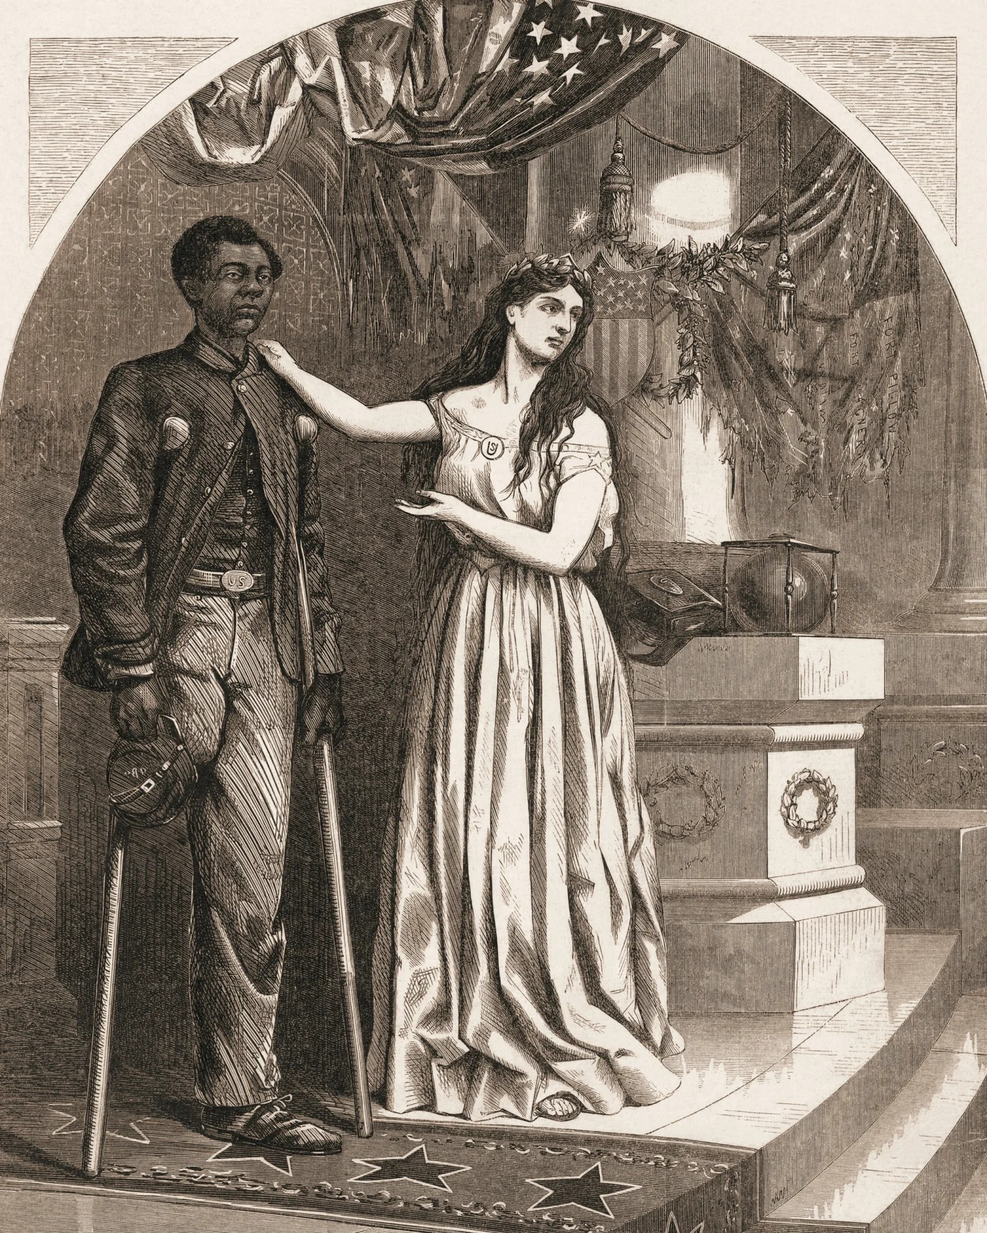 | Editorial cartoon, by Thomas Nast, commenting on denial of voting rights for Black Civil War veterans with the caption, 'Franchise, And Not This Man?', c. 1865.  Stock Montage/Getty Images https://www.loc.gov/item/2010644408/
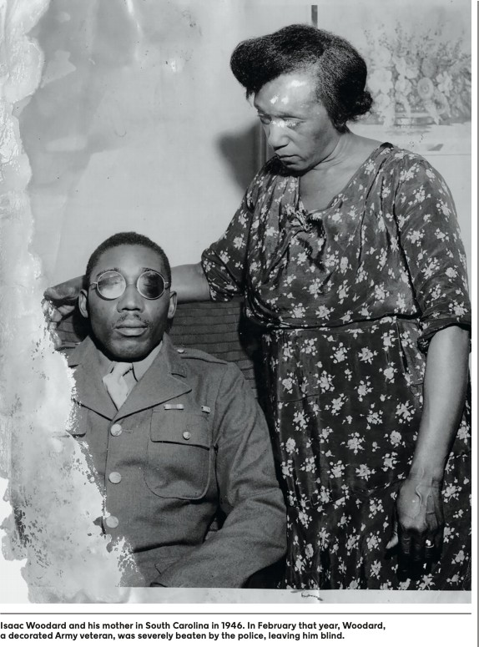 | Isaac Woodard and his mother in South Carolina in 1946. In February that year, Woodard, a decorated Army veteran, was severely beaten by the police, leaving him blind.  https://pulitzercenter.org/sites/default/files/ full_issue_of_the_1619_project.pdf  https://www.nytimes.com/2019/02/08/us/s ergeant-woodard-batesburg-south-carolin a.html

Set 8 - Through art/music
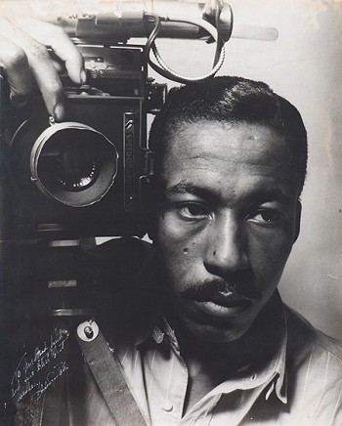 | Gordon Parks, Self-Portrait, 1941, gelatin silver print, 50.8 × 40.64 cm (20 × 16 in.), Private Collection. Courtesy of and copyright The Gordon Parks Foundation https://www.nga.gov/education/teachers/l essons-activities/uncovering-america/park s-photography.html
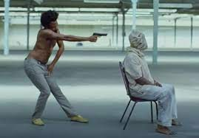 | Childish Gambino (still frame from “This is America”) https://time.com/5267890/childish-gambin o-this-is-america-meaning/
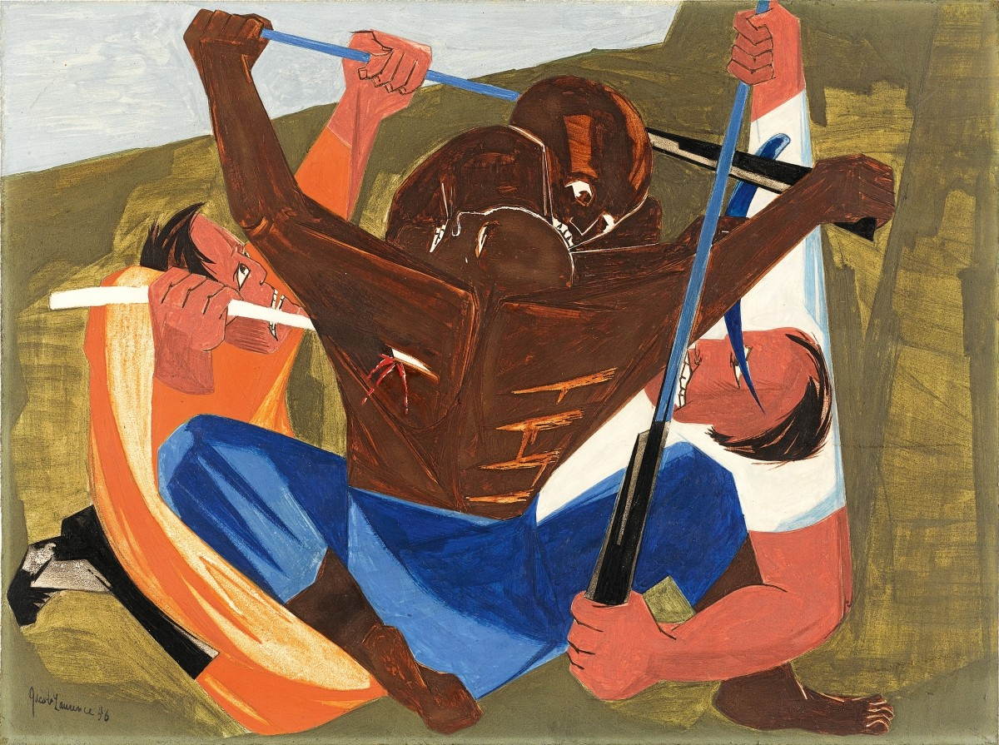 | Jacob Lawrence - The American Struggle https://www.antiquesandthearts.com/jaco b-lawrence-the-american-struggle/

