Reading Guide: *If God Is a Virus*

Index

1. All the News That’s Fit to Print … 2–3
2. Disease Is Not the Only Thing That Spreads … 4–5
3. Baby Sister Survives Ebola… / & Dies in Childbirth … 6–7
4. Ebola News Cento … 8–9
5. Hippocritic Oath … 10–11
6. What They Hear When They Listen to Your Heart … 12–14
7. Filovirus Phylogenetic Tree / Self-Portrait as Virus … 15–17
8. Forty-One Surah Yaseens … 18–19

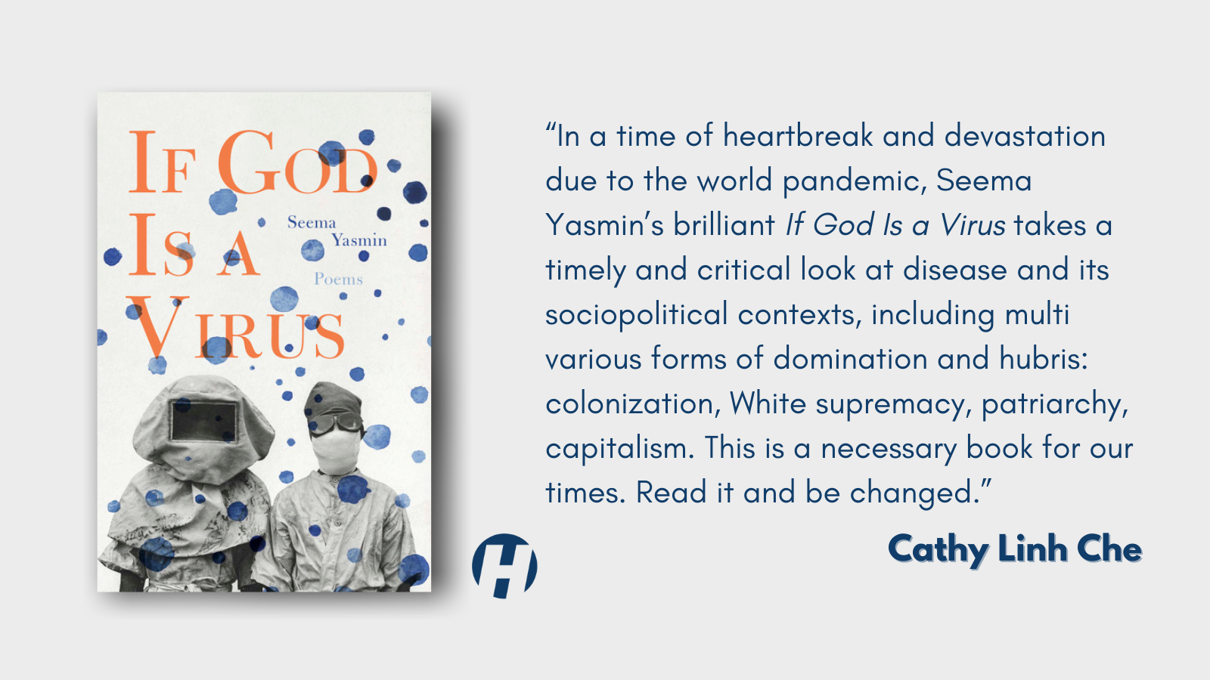

All the News That’s Fit to Print

Dark deaths matter more if they speak

English. If our nurses are sent to help and

return with trinkets, tans, and meningitis.

Editorial judgment dictates at least sixteen

Black people must die to equal one White

man’s death. Forty-three if the outbreak

is old news, does not involve profuse

hemorrhage, a former colony, or biblical

references. Subtract one dozen if our boys

are deployed to clean up their mess. Add

nine if babies are disintegrating in shallow

graves—but restrict to twelve inches

maximum. Even maple syrup tastes bitter

licked off fingers inked with destitution.

Buttercream pancakes stick in the throat

and it’s all happening so far, far away.

Follow the story with one reporter who

knows nothing of PPE, shrouds, and

ritual mourning. Send four photogs over

—use two underpaid local fixers if dead

-lines (for awards) are approaching.

Win a Pulitzer for photos of brown faces

eating expired medicines smeared in peanut

butter aid. Say, it is a gift from the American

people. Say, it was worth the ink.

Reading Guide for “All the News That’s Fit to Print”

|  |  |
| --- | --- |
| What lines, words, or phrases stand out to you in this poem, and why? |  |
| What is the central idea of the poem? What themes shine through? |  |
| How would you describe the tone of the poem? How does the tone connect to the central idea and themes of the poem? |  |
| This poem critiques several systems and stakeholders. List at least three, and identify the line(s) that critique them. |  |
| The title of the poem comes from a slogan of *The New York Times*, which has been printed in the newspaper since 1897. What do you think it means when the *Times* claims to contain “all the news that’s fit to print”? Why might that claim be a problem? |  |

Disease Is Not the Only Thing that Spreads

What else is contagious: Ellen’s long tongue.

A rumor we buried daddy in an unmarked

grave. History. Pathogens criss-crossing agar

-plated petri dishes like rebel soldiers breaching

trenches. This story: that we had it coming,

that we are good only for uncivil wars and dis

-eases. That we prayed for colonization. Blood.

Microbes escaping test tubes conquering

lab countertops slower than hearsay, she say

we burned Daddy’s corpse like bad Muslims;

like White (coated) doctors instructed. What else

is contagious: doctored death certificates. Half

-truths. Cursive. Ink. They say there is no cure

then there is a cure only for them. So. What

else spreads: knots of grief twisting bowels

into distended loops of fermenting torment. No

days of mourning. Two years of outside

intervention. Armies. Conviction. Belief that

this will spread & spread. That all contagions

wax endemic. This one will never end.

Reading Guide for “Disease Is Not the Only Thing that Spreads”

|  |  |
| --- | --- |
| What lines, words, or phrases stand out to you in this poem, and why? |  |
| What is the central idea of the poem? What themes shine through? |  |
| This poem is written in the first person plural. Who does the speaker’s “we” include? Who does it exclude? |  |
| Usually, the word *contagious* is used to refer to disease. What does it mean for an idea to be contagious? Can you think of examples of contagious ideas that have negatively or positively affected you, your community, or society? |  |
| Choose one of the words or phrases below that you find most surprising or interesting, and write a paragraph explaining: How is/are _____ contagious?   * History * This story: that we had it coming * Blood * Half-truths * Ink |  |

Baby Sister Survives Ebola…

Before your wedding day.

Before your children’s faces

greased in nut butter, hot

mouths coated with pink

syrups, released guffaws like

baby sparrows into the after

-noon sky.

After two body bags bearing your last

name were sealed betraying weary zippers,

before your big sister’s membranes

burst and your own belly swelled again and again and again.

Before your survivor money—mildewed

dollar notes were good for nothing:

not potatoes,

not ambulances.

You emerged from between tented white sheets.

Withered, guilty, new.

***

& Dies in Childbirth

A crown.

A baby girl.

A baby girl crowning.

Reading Guide for “Baby Sister Survives Ebola… / & Dies in Childbirth”

|  |  |
| --- | --- |
| What lines, words, or phrases stand out to you in these poems, and why? |  |
| What is the central idea of these poems? What themes shine through? |  |
| Read [“A Woman Survives Ebola but Not Pregnancy in Africa,”](https://pulitzercenter.org/stories/woman-survives-ebola-not-pregnancy-africa) a news article published in *Scientific American* that Dr. Yasmin wrote about the same person. What new information do you gain from this article? |  |
| How are the poems similar to the news article? How are they different? (Consider their tone, themes, and purposes.) |  |
| Analyze the second poem, “& Dies in Childbirth.” Why do you think this poem is shorter and more abstract than the first? What feelings does this poem communicate? |  |

Ebola News Cento

We didn’t see it coming

We knew it was coming

It was coming

Close the borders

Close the bridal store

It’s in Texas

In a bowling ball

It could be anywhere

Will you know you have it?

It is already too late.

Reading Guide for “Ebola News Cento”

|  |  |
| --- | --- |
| What lines, words, or phrases stand out to you in this poem, and why? |  |
| What is the central idea of this poem? What themes shine through? |  |
| What is the effect of the [juxtaposition](https://literarydevices.net/juxtaposition/) of the first three lines of this poem: “We didn’t see it coming / We knew it was coming / It was coming”? |  |
| A [*cento*](https://poets.org/glossary/cento) is a poem formed entirely from lines taken from other writers, and rearranged to create something new. In this poem, Dr. Yasmin has taken lines from headlines and news articles about Ebola. Some of these lines could be interpreted as alarming or scary. What are some reasons for why journalists and editors might intentionally write alarming headlines and news articles about public health crises? |  |
| Do you think alarming headlines are helpful, harmful, or both? Explain your answer. |  |

Hippocritic Oath

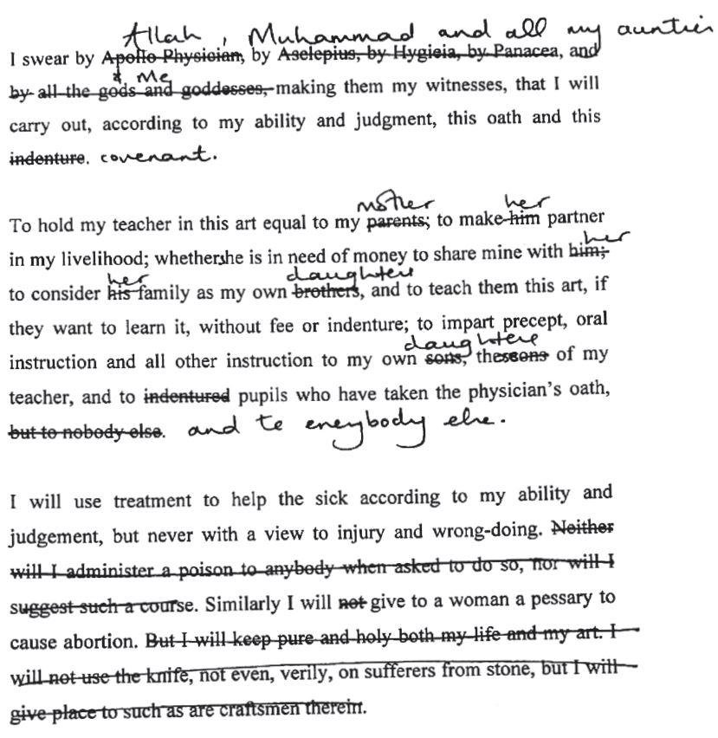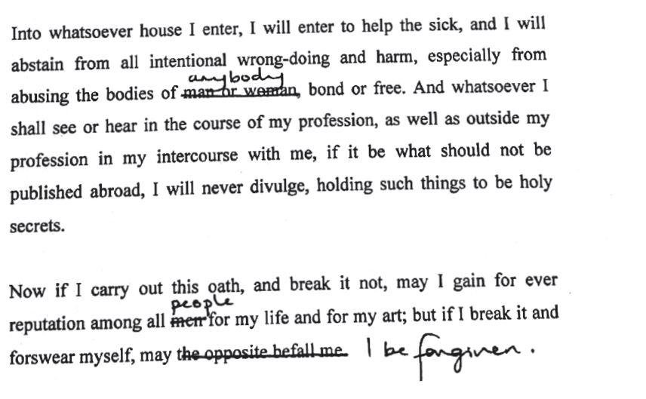

Reading Guide for “Hippocritic Oath”

|  |  |
| --- | --- |
| What is the central idea of this poem? What themes shine through? |  |
| This poem is an annotation of the Hippocratic Oath, an oath written between 500 and 300 BCE in Greece, and often attributed to Greek physician Hippocrates. Many doctors still swear this oath, or a version of it, when graduating from medical school. What are some reasons for why some medical doctors might believe it is a good idea to continue swearing this same oath? What are some reasons you can think of for why others might want to change this oath? |  |
| Analyze Dr. Yasmin’s revisions to the Hippocratic Oath in her poem. Which ones do you agree / disagree with? Do any surprise you? Reflect: how do your identity and experiences inform your response to this question? |  |
| Dr. Yasmin is a medical doctor. She is also a journalist and a poet, among other things. Do you think her revised Hippocratic Oath could be applied to journalism and/or poetry as well as medicine? Explain your answer. |  |
| Choose one of the following professions, and write an oath that lays out what you believe a person entering these fields should promise in order to do their job ethically:   * Medical doctor * Journalist * Poet |  |

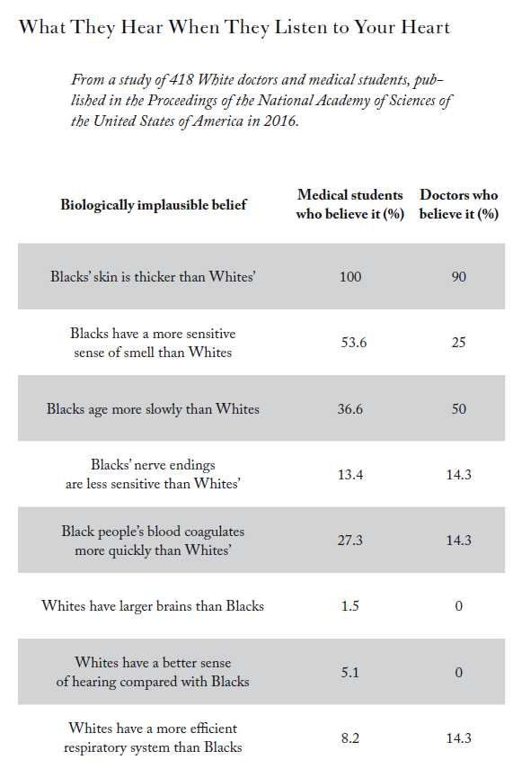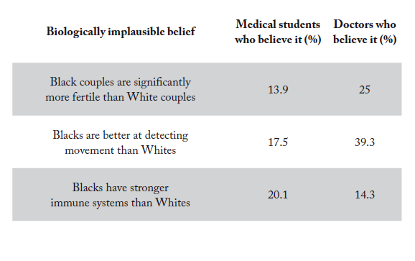

Reading Guide for “What They Hear When They Listen to Your Heart”

|  |  |
| --- | --- |
| What is the central idea of this poem? What themes shine through? |  |
| What makes the data presented in this poem disturbing? How do you think these attitudes affect people’s lives? |  |
| This poem’s text comes from the findings of a [2016 study](https://www.pnas.org/content/113/16/4296). Read the abstract of the study, and skim the rest of the article. Think about how the same information is presented differently in the study and in the poem. Why might someone prefer to read the study? Why might someone prefer to read the poem? (Consider: what purposes does each serve?) |  |
| Why do you think Dr. Yasmin chose to present this poem in the form of a data table without any embellishing language beyond the title? What is the effect of that choice? |  |
| What do the form and the content of this poem communicate about the nature of medicine and science? About the nature of poetry? |  |

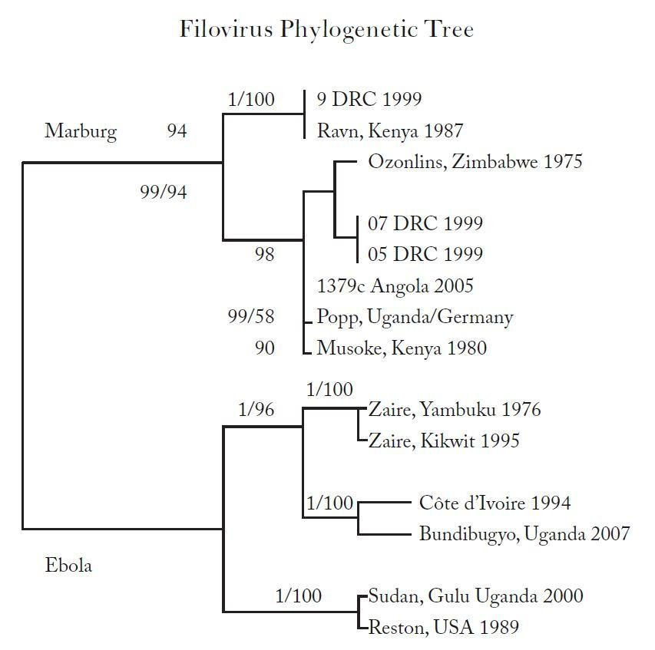

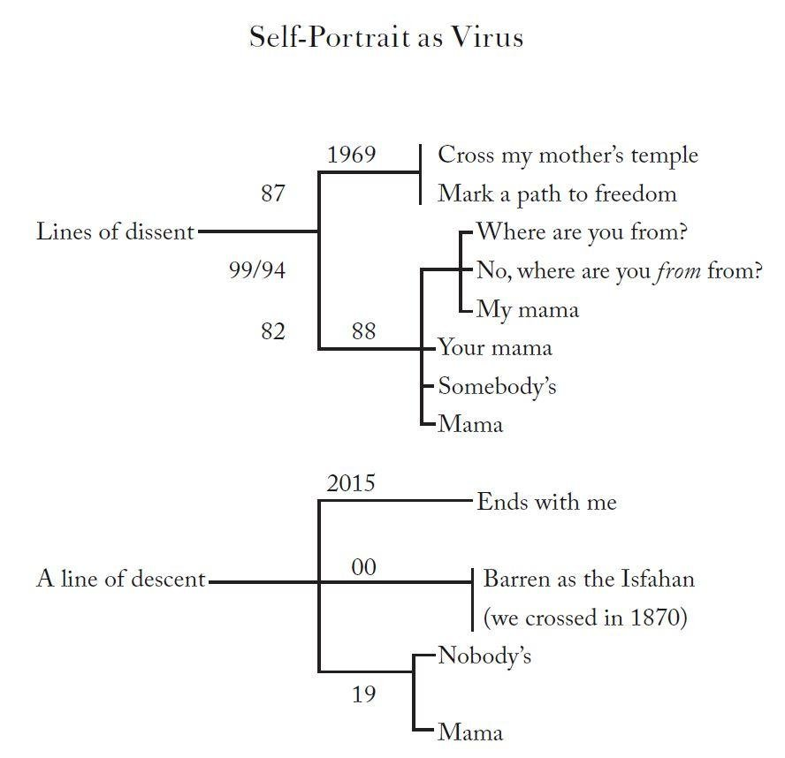

Reading Guide for “Filovirus Phylogenetic Tree / Self-Portrait as Virus”

|  |  |
| --- | --- |
| What is the central idea of these poems? What themes shine through? |  |
| “Self-Portrait as Virus” is written in an experimental form: it is structured as a *phylogenetic tree*. What is a phylogenetic tree, and what can they show us? (You can learn about phylogenetic trees [here](https://www.khanacademy.org/science/high-school-biology/hs-evolution/hs-phylogeny/a/phylogenetic-trees).) |  |
| Why do you think Dr. Yasmin juxtaposes her own “Self-Portrait” with the phylogenetic tree of the filovirus (which includes Ebola)? How do they speak to each other? |  |
| What do these poems and their form communicate about the relationship between viruses and people? |  |
| Dr. Yasmin use *polytomies* in her poem. In phylogenetic trees, polytomies usually indicate uncertainty about a certain set of relationships, and they are shown as three or more lines (*sister taxa*) branching off from a single node. What is the role of uncertainty in poetry? In science? In journalism? |  |

Forty-One Surah Yaseens

Tongues are tourniquets;

Qur’an is cautery.

In this prayer circle,

we five women sway,

staunch the flow

of three generations of bleeding.

*One: The plane didn’t make it to Heathrow we sank in the North Sea I drank my*

*way out of the ocean and carried bloated fish on my back and two babies in my*

*belly gutted those sour fish our first foreign supper tasted of mercury*

*Two: I said I do not want to leave my village I dug my hands into the earth my*

*fingers sprouted roots I spat and I spat and I watered those roots and they anchored me to my land but my children did not hold on tight and they flew away*

*to a place I cannot say its name*

*Three: I stitched baby clothes in a green factory that played Surah Yaseen on a loop*

*through a Tannoy I stabbed that cloth where a baby’s fat belly would gurgle slid it*

*through the blade of my industrial machine until I went deaf from the roar of the*

*engines and that is how I did not hear the sirens*

*Four: I made poison out of red bugs made the antidote too sold one to husbands*

*one to wives and that is how I made so much money to be called dangerous and*

*the soldiers came one night said I did not have the right eyes took all my money I*

*drank all the poison then kissed my babies on their wet mouths*

*Five: The ship sailed past Amreeka up up up north it kept going so I hurled my*

*braid out of the ship anchored my head to an iron statue and my children they*

*climbed my braid to Amreeka and that is how we survived*

They do not say this,

not with their mouths,

because tongues are tourniquets.

Qur’an is cautery.

In this prayer circle we

women sway and pray silently,

for long hair and poison,

for all of the things that help us survive.

Reading Guide for “Forty-One Surah Yaseens”

|  |  |
| --- | --- |
| What lines, words, or phrases stand out to you in this poem, and why? |  |
| What is the central idea of this poem? What themes shine through? |  |
| Dr. Yasmin writes that “Tongues are tourniquets.” What does this mean? How could poetry and journalism also be tourniquets? |  |
| How is the concept of survival explored in this poem? How do aspects of identity explored in the poem (including gender, religion, and migration) connect to survival? |  |
| How are the concepts of poisons and antidotes connected in the poem? How can journalism, poetry, and science all be poisons and antidotes? |  |