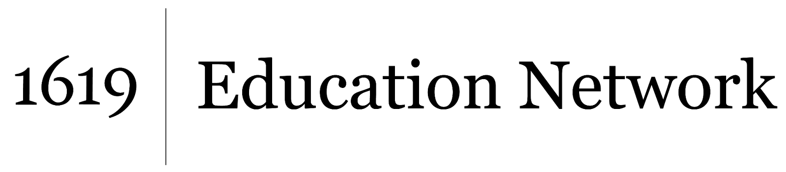Understanding and Interrogating Dominant Culture
Unit by Friendship Public Charter School team,
part of the 2021 cohort of The 1619 Project Education Network

This brief article provides an overview and examples of ways that countries like the United States have a history of supporting and doing business with companies that use modern slave labor. Text-dependent questions:

- How does the United States continue to support slavery that occurs in other countries?

- How do American consumers (shoppers) benefit from modern-day slavery that occurs in other countries?

- How are the conditions of some sugar and beef production workers in Latin American countries similar to the conditions of African American sharecroppers in the United States?

