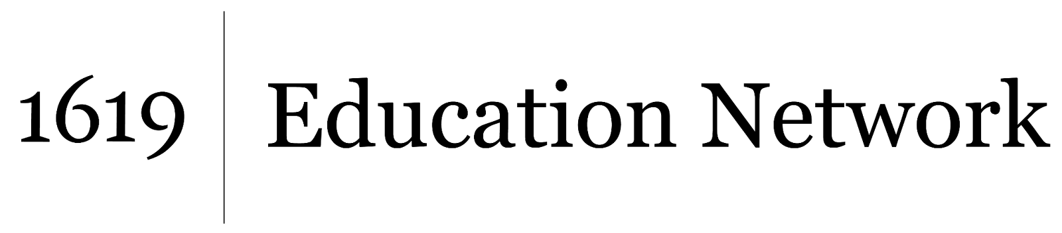Understanding and Interrogating Dominant Culture

Unit by Friendship Public Charter School team,

part of the 2021 cohort of *The 1619 Project* Education Network

The articles “TikTok Influencer Of Color Faced `Frustrating’ Obstacle Trying To Add The Word [‘Black’ To His Creator Marketplace Bio](https://www.forbes.com/sites/abrambrown/2021/07/07/tiktok-black-creators-creator-marketplace-black-lives-matter/?sh=126d800d6d24)” or “Black TikTok creators are on strike to protest a lack [of credit for their work](https://www.npr.org/2021/07/01/1011899328/black-tiktok-creators-are-on-strike-to-protest-a-lack-of-credit-for-their-work)” can introduce students to the Black TikTok Strike, as can this news [video story](https://www.youtube.com/watch?v=rncWMVEM8rc). Discussion questions for all three sources:

TikTok Influencer Of Color Faced `Frustrating’ Obstacle Trying To Add The Word ‘Black’ To His Creator Marketplace Bio

1. Summarize the immediate issue concerning social media influencer Ziggi Tyler that is central to this story.
2. What was TikTok’s explanation for the above?
3. What examples does Ziggi Tyler provide that lead him to take issue with either TikTok’s explanation or the way their algorithm was designed?
4. What larger issue do some Black influencers have with TikTok? How are they being impacted?
5. Do you think that social media companies like TikTok view groups like Black Lives Matter similar to white supremacist hate groups like the KKK or the Nazi Party?

Black TikTok creators are on strike to protest a lack of credit for their work

1. Why are Black TikTok creators going on strike?
2. How have Black TikTok creators advertised the strike and their reasons for it?
3. What examples and evidence have Black TikTok creators pointed to as proof of cultural appropriation and/or TikTok giving white creators preferential treatment?
4. Do you think that this TikTok story represents something totally new or a technological update to a larger pattern in American history? Why?