1619 Performance Task Activities:

Journalism/Podcast -
See the Pulitzer Center’s Journalism Toolbox for more resources.

Research
Start by wondering the “5W’s” (sometimes “6W’s”).
[1] Who – who had been involved?
What – what went down?
Where – where made it happen?
Why – why made it happen?
When – when did it happen?
How – how did it happen?
Outline for a newspaper article: https://ihelptostudy.com/outline-for-writing-a-newspaper-article.html
Gathering Evidence
Students may choose to interview historians in the Berkshires, read written works from a historical society/museum, and/or find quotations from a reputable book or textbook. At least two different sources will be referenced and cited.
Writing
When writing a newspaper article, authors include the most important information first. Additional paragraphs give supporting details, but a reader should know the main events just by reading your first few sentences.
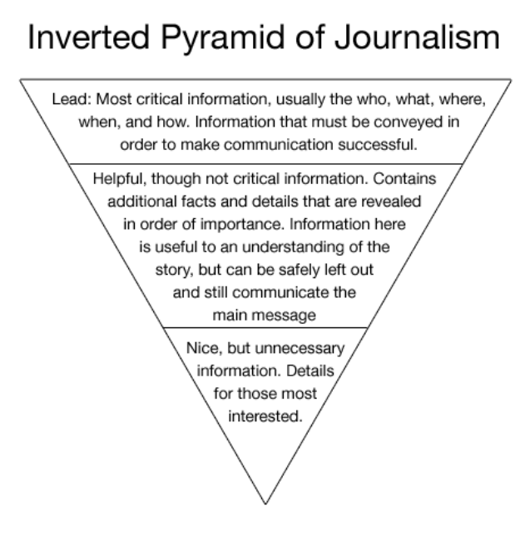

Creative Writing - A New Ending. Think about all of the experiences that African Americans endured when they reached America. If you had the opportunity to rewrite history, dating back to the period of colonization, what would you want to see happen differently?

- Your writing must be one full page typed (500 words). The plot must progress after colonists began to settle in America and vessels arrived on land carrying enslaved Africans. When they land in America, what should have happened?

Nonfiction Writing - Research an event in the history of your area (city, county, or state) that involves the treatment of African-Americans or Native Americans. Write a short summary/profile, or record a podcast about your event, of the kind that might appear in a newspaper or news podcast.

- Your writing must be one full page typed (500 words), or your podcast must be 5 minutes long. You are encouraged (but not required) to interview people who may have some knowledge about your topic (e.g. eyewitnesses or local historians). You must cite at least two reputable sources.

Geography - Create a brochure or poster to provide some information on a place in/around your city. Imagine tourists are coming to look at this location and you need to provide them with some context. Your location should be relevant to the history of African-Americans or Native Americans in your area.

- You must use a computer
- You must use color to illustrate all of your illustrations, find photographs online, or take some pictures yourself.
- Each illustration must include a description

African American Heritage Research - You will have the opportunity to interact with members of the local African American Heritage Association. You will be presented with maps and resources from the Association to research a local connection to the Unit of Study: Mapping, and Researching Race in the Early Colonies. You will then select one of the options included in the research organizer. Following your research, you will develop a thesis and write a mini-research paper connecting these historical figures to the past.

Blast from the Past [.pdf]
Blast from the Past [.docx]

Art - The Art of the Matter. Illustrate four scenes from one of the periods studied in the unit.

Whether you decide to draw, make a collage, or stage a photograph, try to capture the ideas and feelings expressed in the depiction that you are doing.
- Your artwork must be in full color.
- For drawings, you must outline everything with a thin black marker.
- You should take your time and think about the illustration - and the scene that you are creating. It should have details from the story - and more importantly, the illustrations should be identifiable by your classmates.
- 