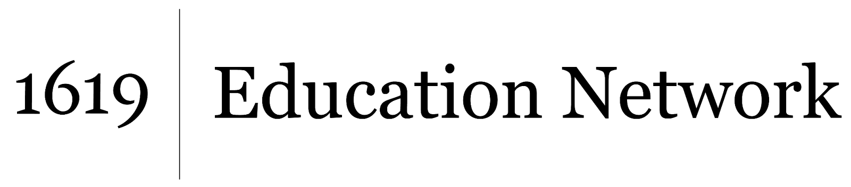
Understanding and Interrogating Dominant Culture
Unit by Friendship Public Charter School team,
part of the 2021 cohort of The 1619 Project Education Network

The article “Popular Music” and/or the related 1619 podcast, episode 3: “The Birth of American Music” can be used in full or the teacher may provide excerpts.

Excerpt
“When we’re talking about black music, we’re talking about horns, drums, keyboards and guitars doing the unthinkable together. We’re also talking about what the borrowers and collaborators don’t want to or can’t lift — centuries of weight, of atrocity we’ve never sufficiently worked through, the blackness you
know is beyond theft because it’s too real, too rich, too heavy to steal.” Discussion Questions
- How has popular music throughout history used traditions and styles developed by Black Americans?
- How does the author/podcast describe Black music and blackness in music? What’s the difference?

Extension Idea: Can you think of or find your own examples in which a popular, mainstream song or artist was appropriated or taken without credit from Black Americans?

