1619 Project Inquiry #1 Image Collection
How and why have Black people defended democracy?
(Student Version)

Set 1
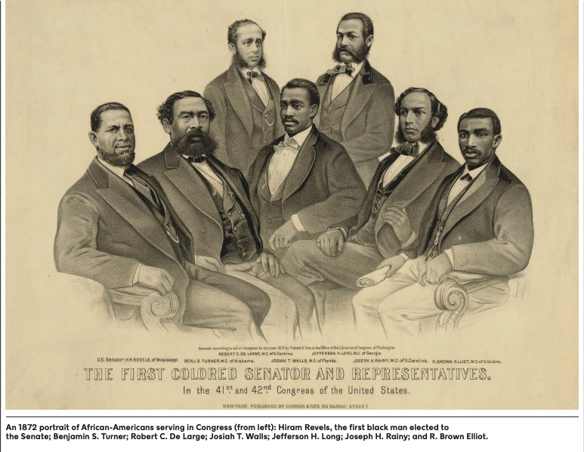 | Congressional Reconstruction 41st and 42nd Congress of the United  States  first colored senator and representatives
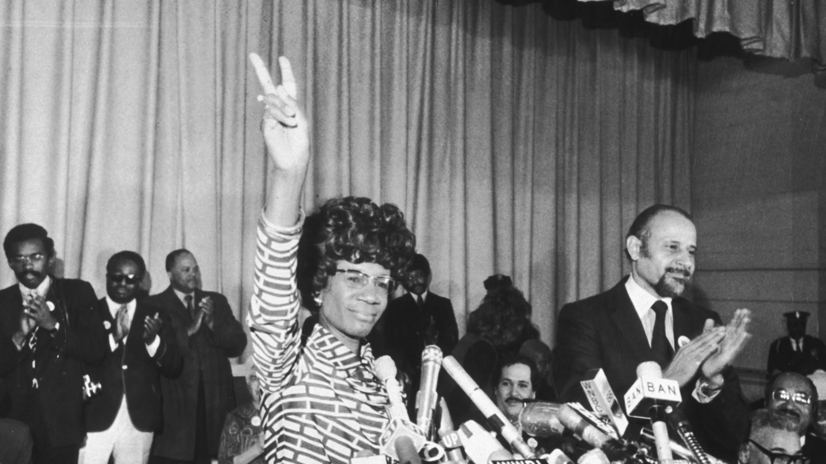 | Shirley Chisholm runs for president First Black Woman to run for president Unbought and Unbossed
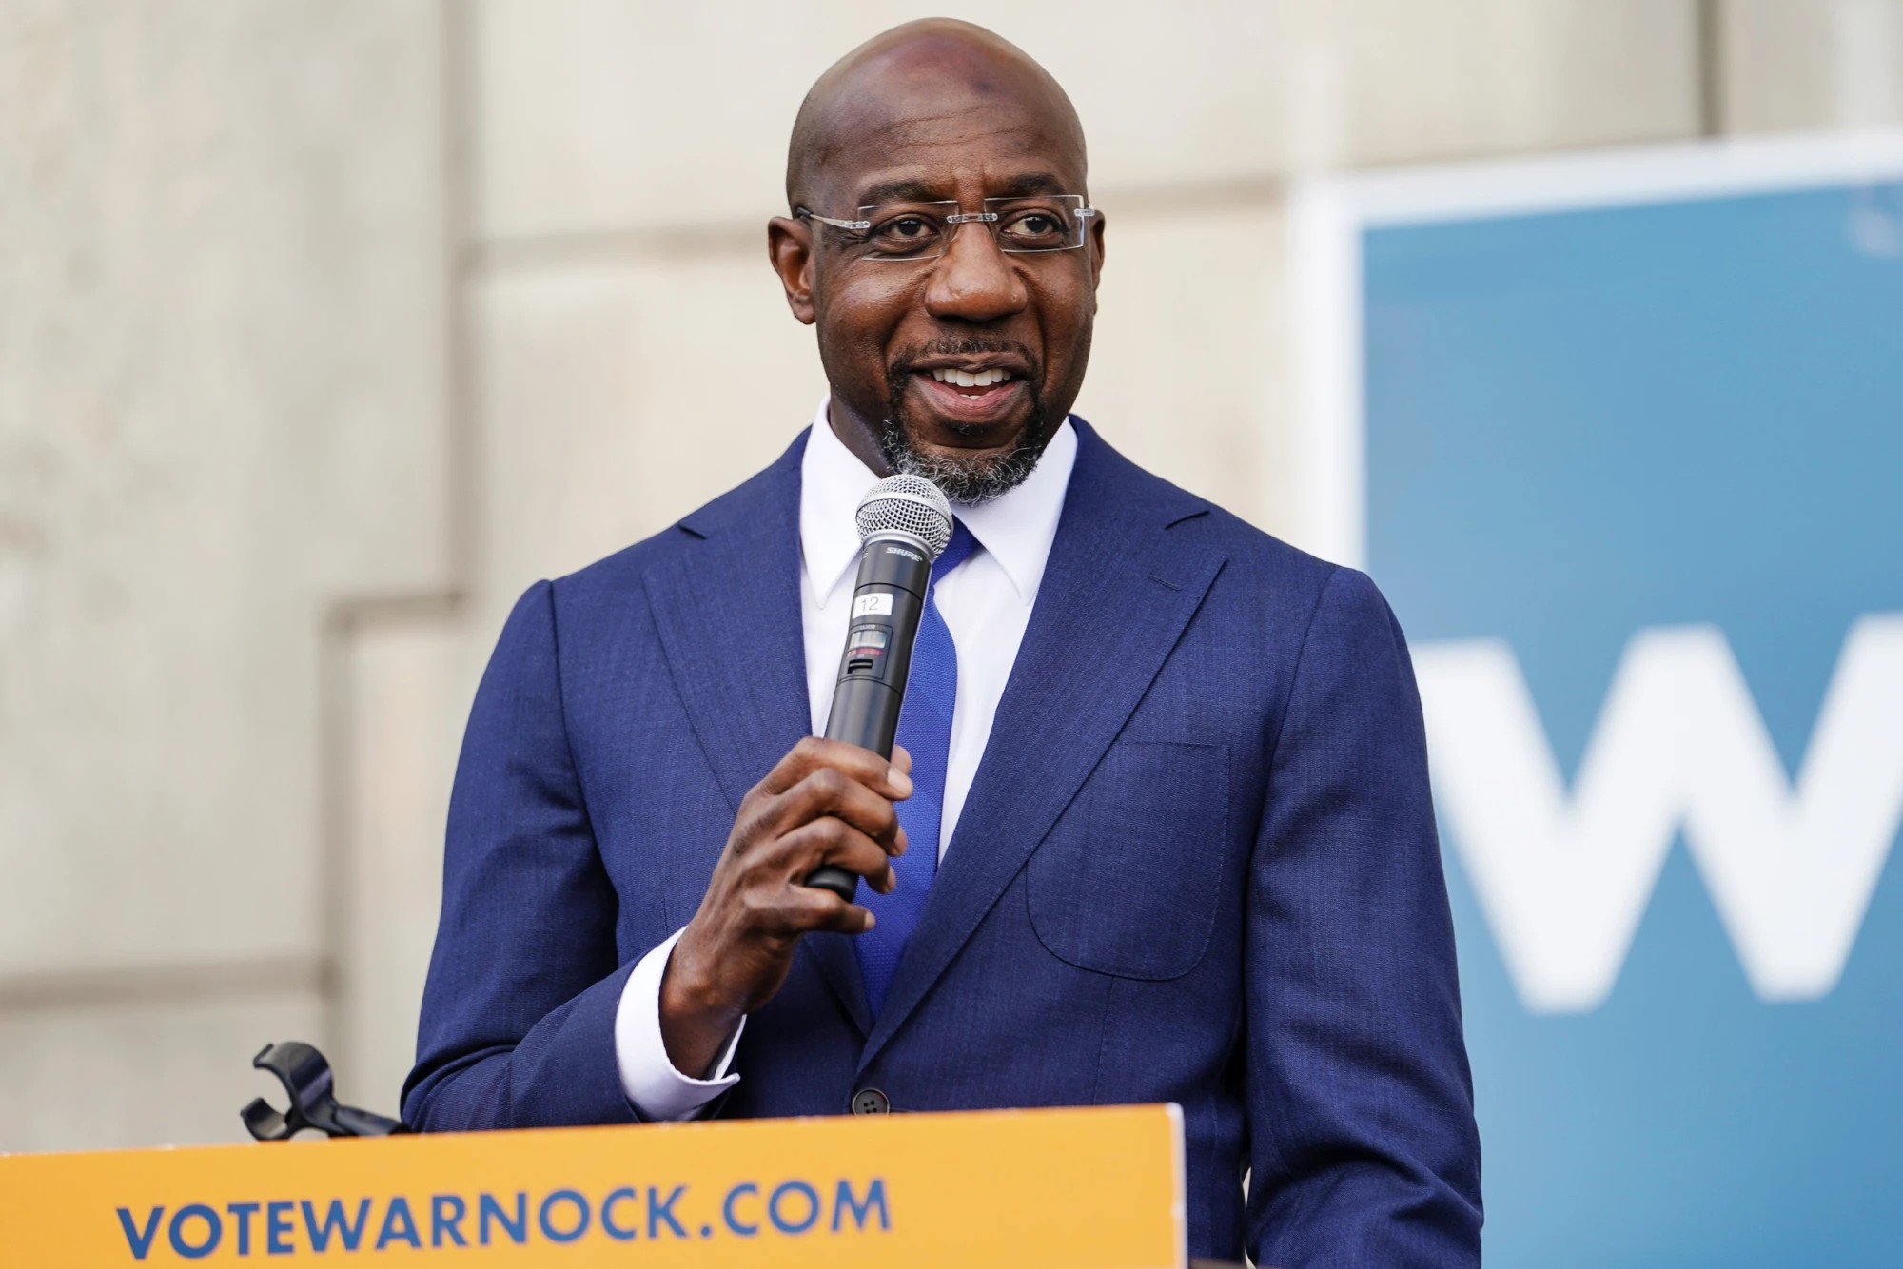 | Raphael Warnock Reverend Warnock for U.S. Senate first Black U.S. senator from Georgia

Set 2
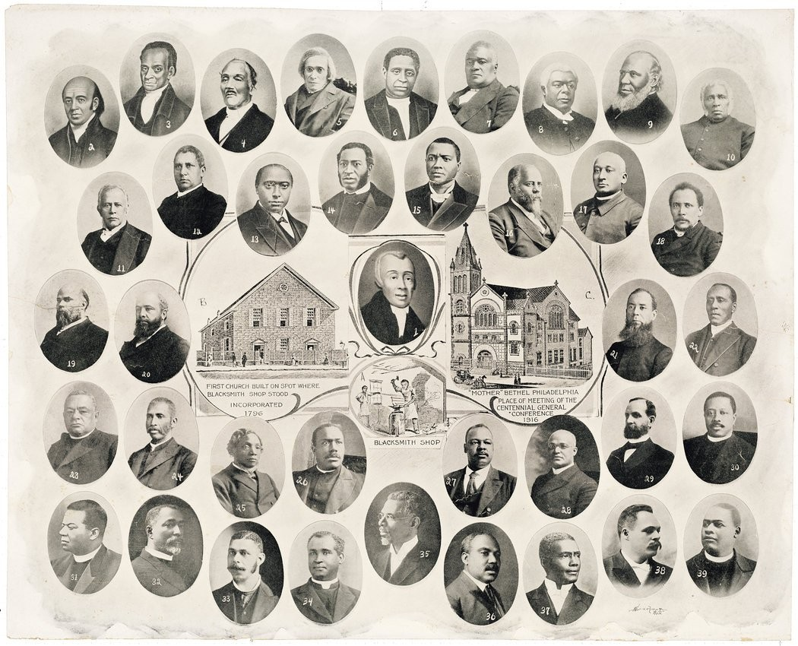 | Mother Bethel African Methodist Episcopal Church  Richard Allen Free African Society
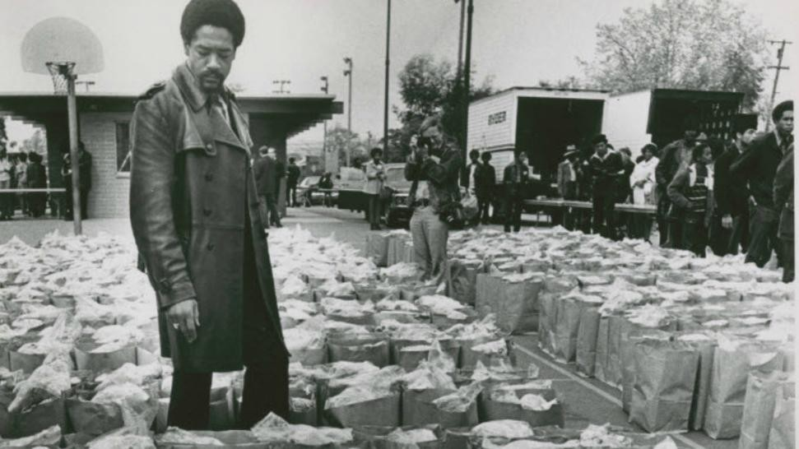 | Black Panther Party food program Bobby Seale  “To serve the people”
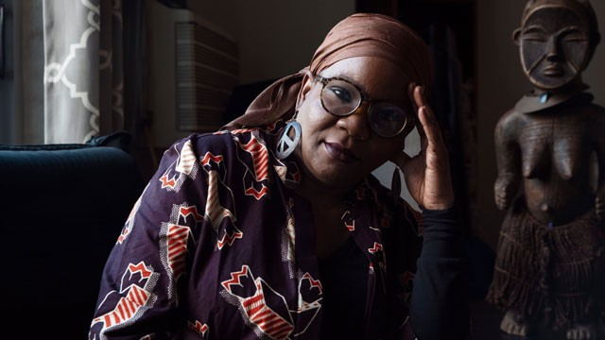 | Mariame Kaba Project NIA Mutual Aid

Set 3
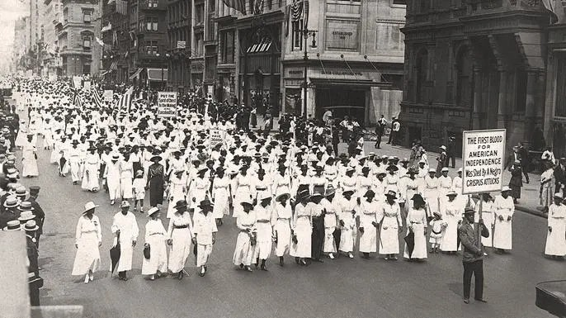 | Silent Protest New York City, 1917  NAACP
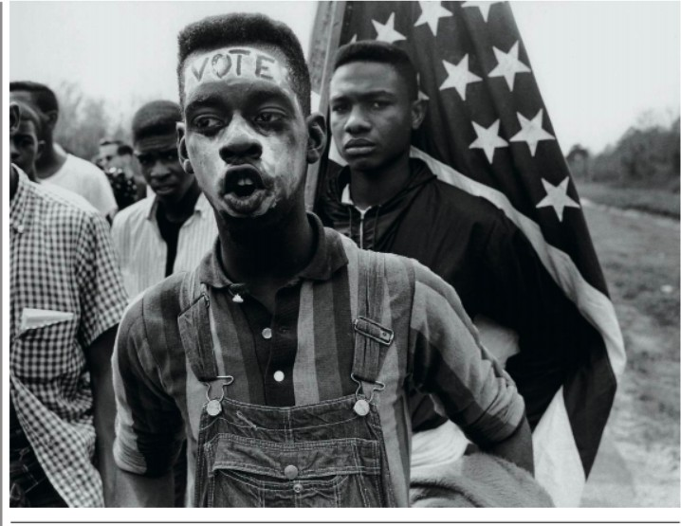 | Timothy Mays “Bloody Sunday” Selma to Montgomery
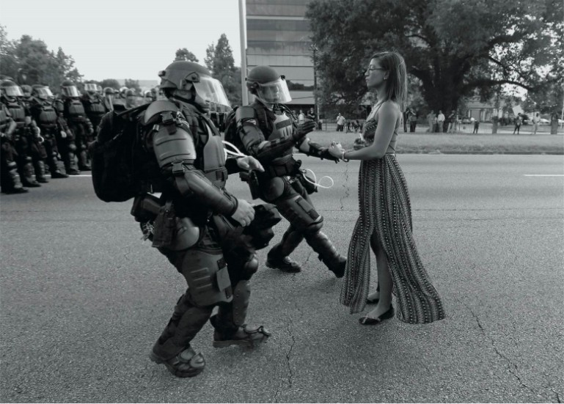 | Ieshia Evans Black Lives Matter  Baton Rouge Police Department

Set 4
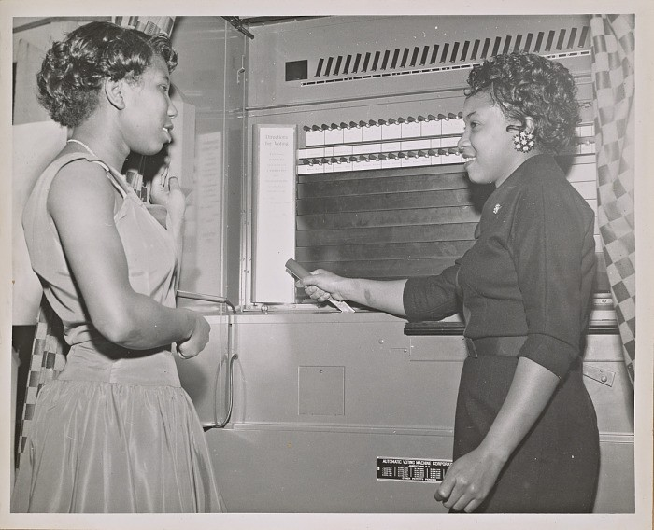 | Citizenship Education Project National Council of Negro Women Voting Machine
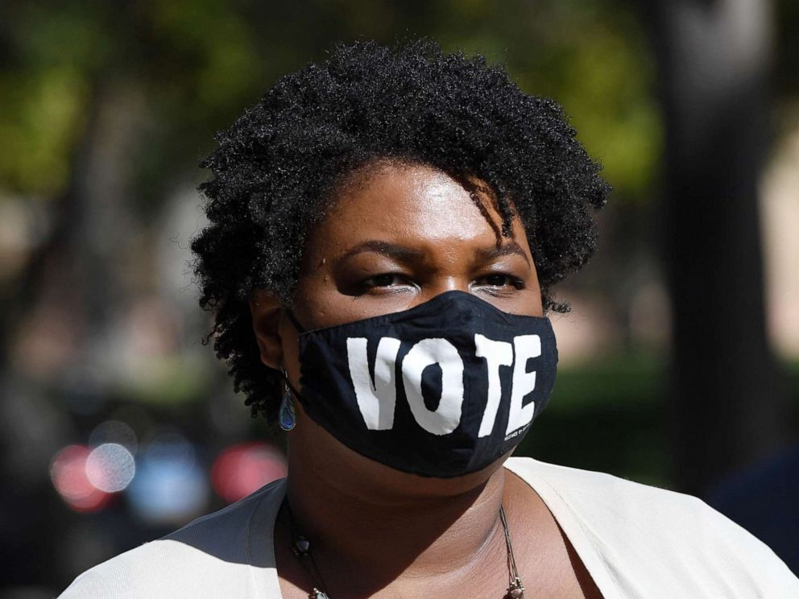 | Stacey Abrams Voting rights  The New Georgia Project
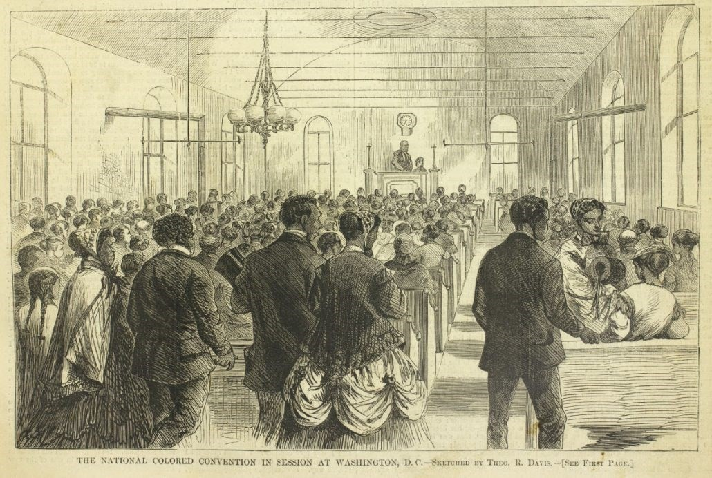 | National Colored Convention Washington, DC  1869

Set 5
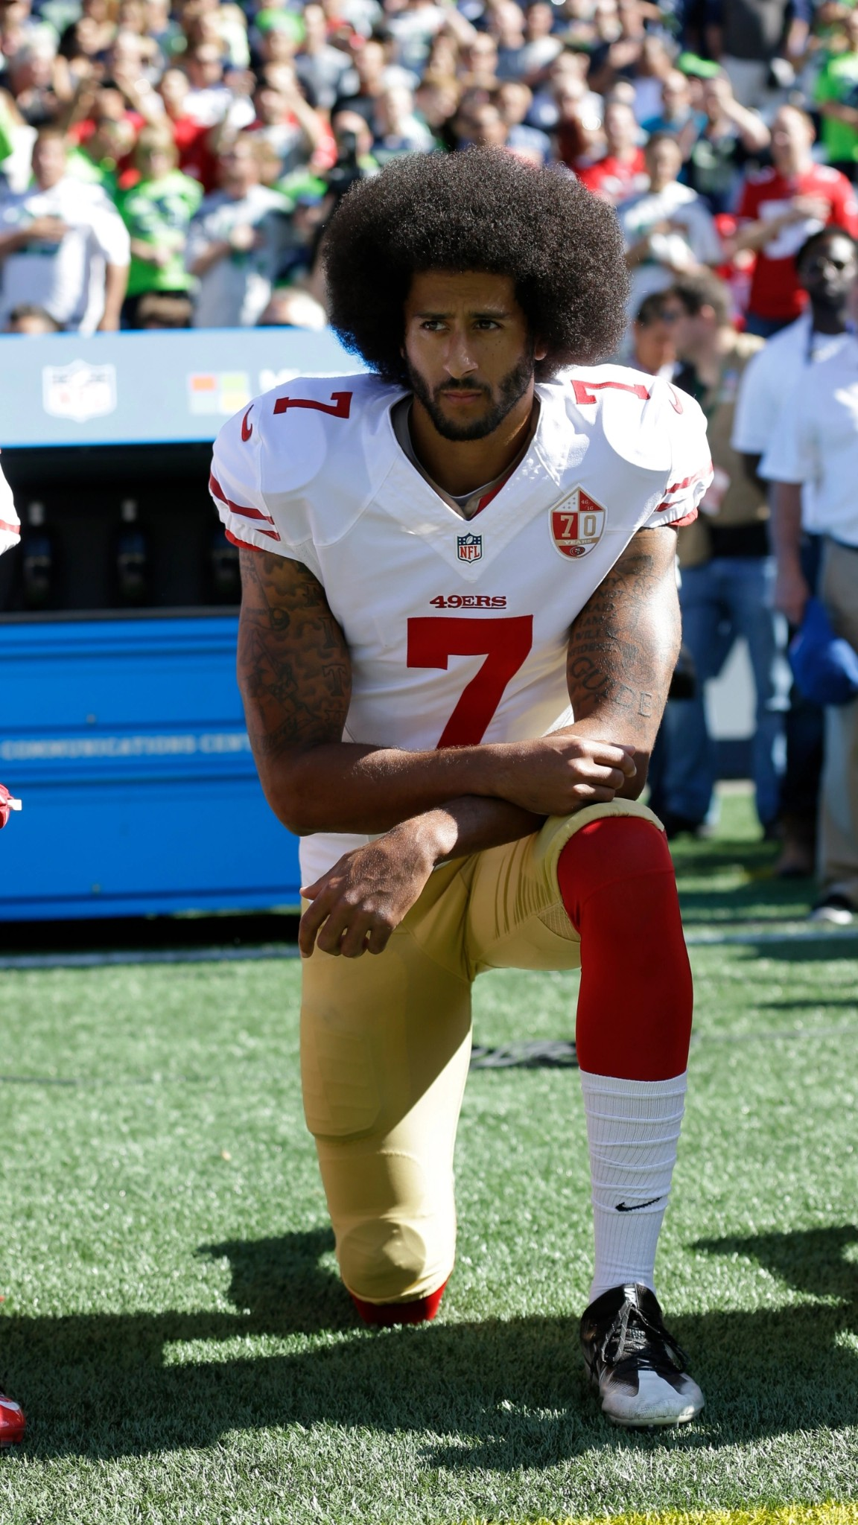 | Colin Kaepernick National Anthem Police brutality
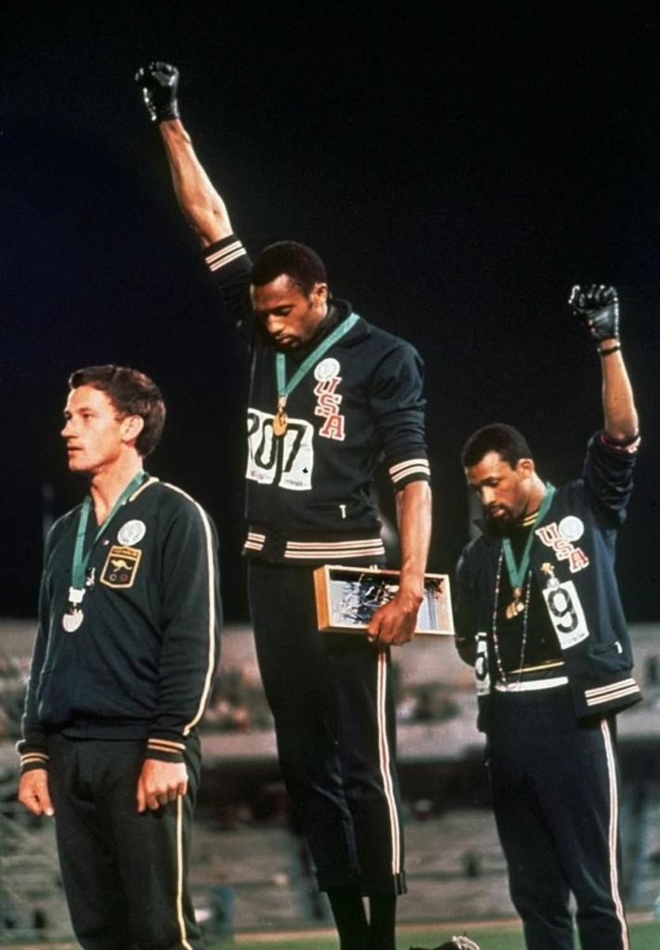 | Tommie Smith and John Carlos 1968 Summer Olympics  Black Power
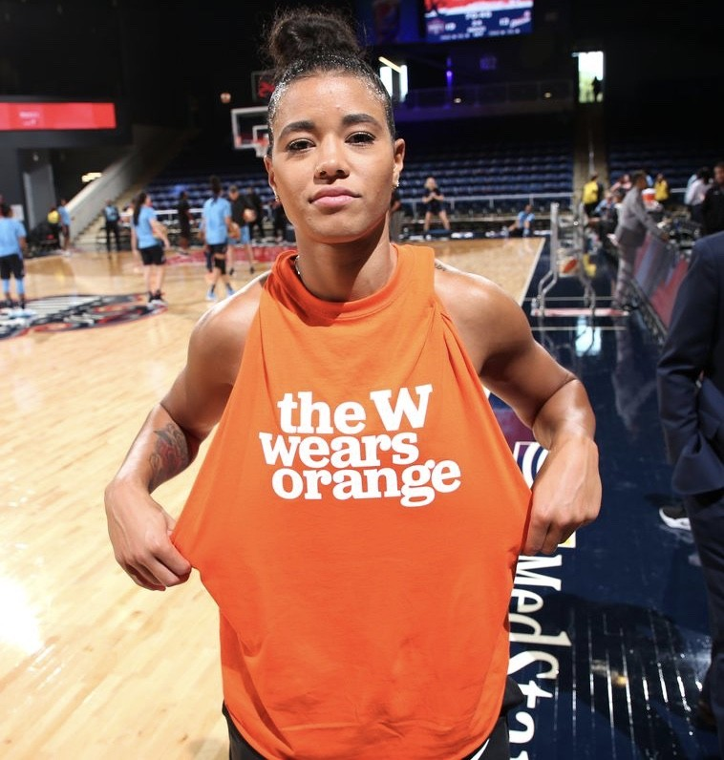 | Natasha Cloud Washington Mystics Wear Orange

Set 6
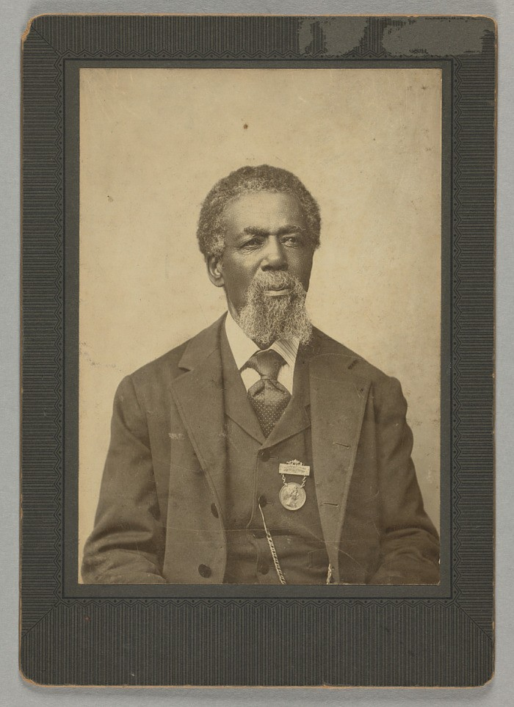 | Thomas Peterson 15th Amendment March 31, 1870
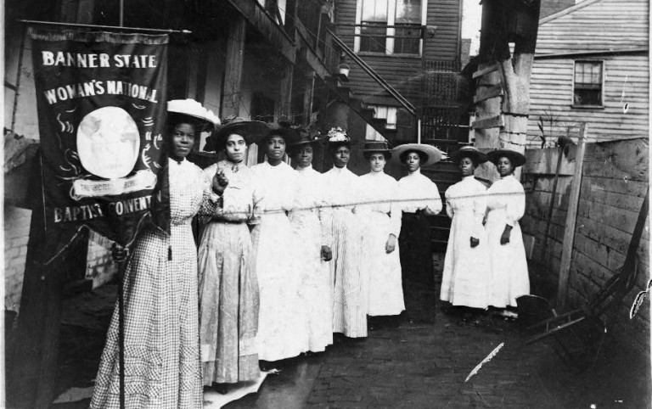 | Nannie Helen Burroughs “Banner State Woman’s National Baptist  Convention” Suffrage for Black Women
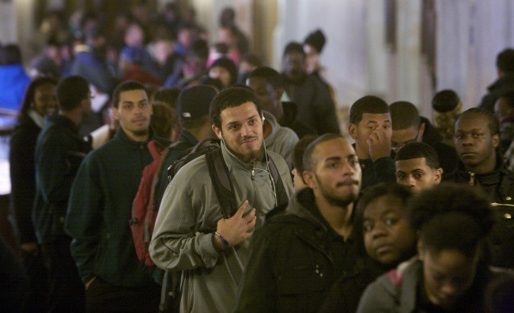 | Hartford, Connecticut Election Day 2012 Waiting to vote

Set 7
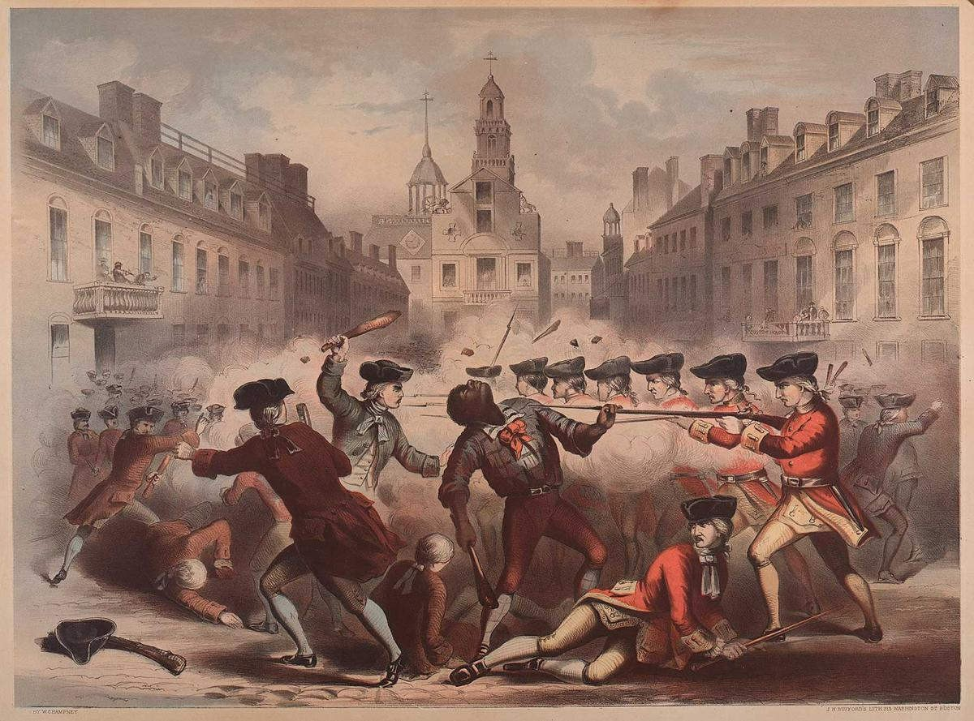 | Crispus Attucks Boston Massacre 1770
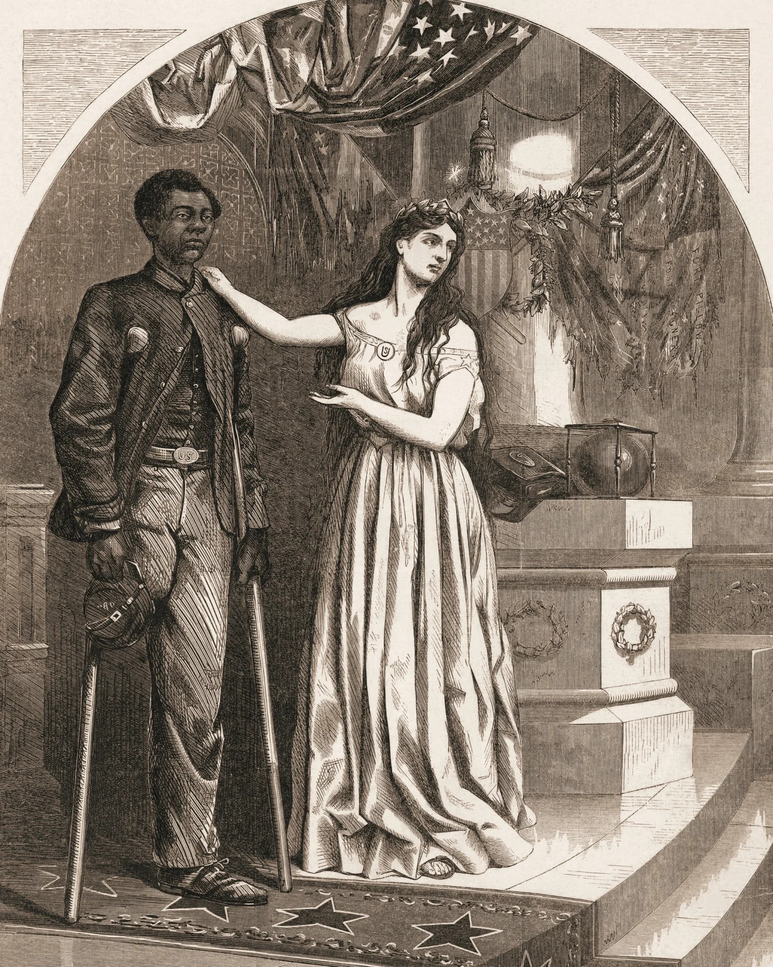 | Black Civil War veterans 1865  Thomas Nast
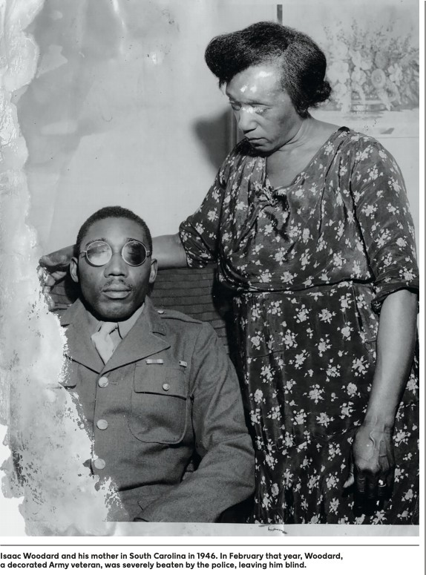 | Isaac Woodard  South Carolina 1946

Set 8
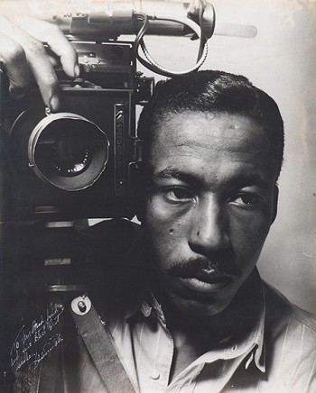 | Gordon Parks 1941  Self-Portrait
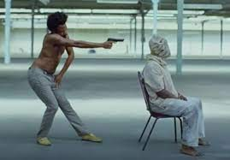 | Childish Gambino “This is America” Symbolism
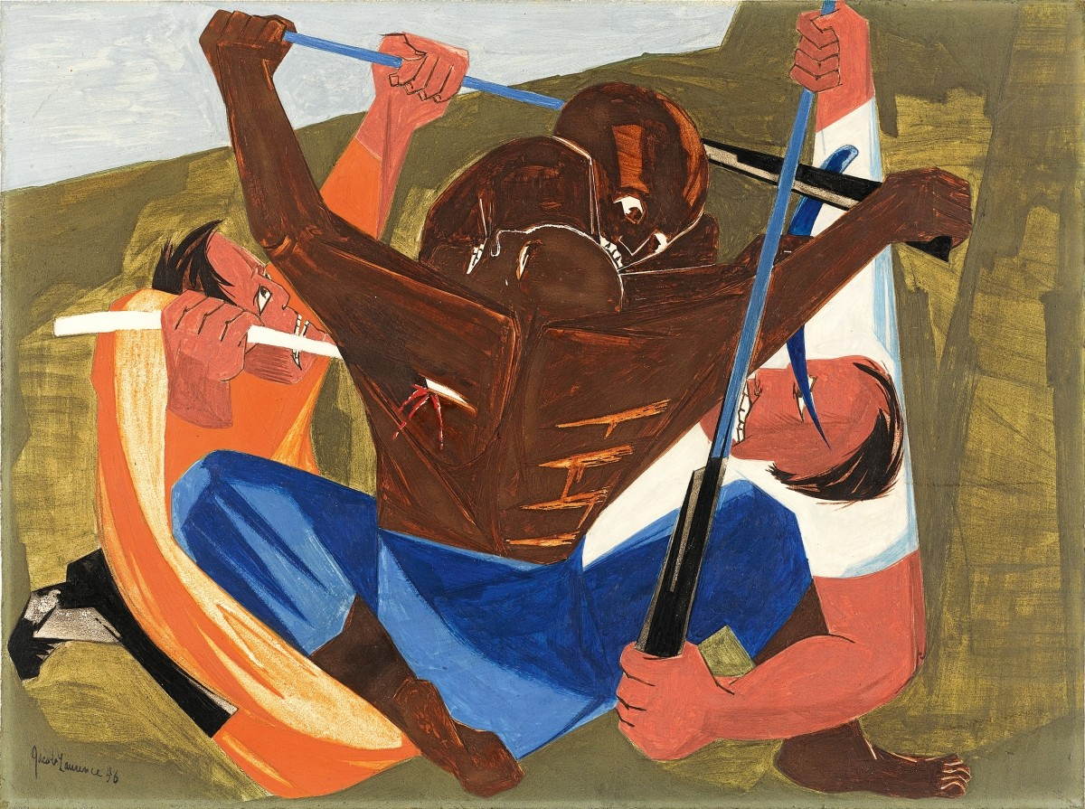 | Jacob Lawrence “The American Struggle”  Great Migration

