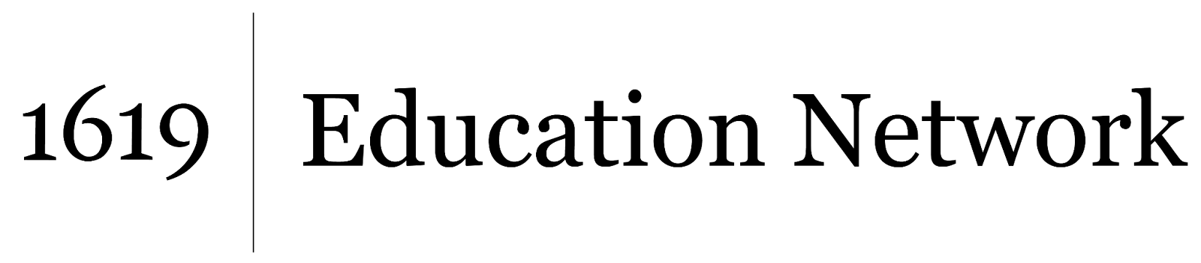Understanding and Interrogating Dominant Culture

Unit by Friendship Public Charter School team,

part of the 2021 cohort of *The 1619 Project* Education Network

[This article](https://www.antislavery.org/shell-makes-deal-cosan-brazil-despite-slave-labour-claims/) describes a 2010 multibillion-dollar deal between the oil giant Royal Dutch Shell Company and a sugar producer that has been shown to use slave labor. Text-dependent questions:

1. How do you know that the Brazilian company Cosan is a large sugar producer?
2. Why has Cosan been accused of using slave labor?
3. Cosan produces *sugar cane ethanol*, which like gasoline allows cars to run. What effect will Cosan’s deal with the huge oil company Dutch Shell Oil have on the amount of ethanol it produces and the number of workers it uses?
4. What effect do you think the growth of Cosan will have on the number of enslaved persons working for the company? Why?
5. How many enslaved persons were imported to Brazil from Africa by 1888, the year slavery was outlawed in Brazil?
6. In 2009 alone, how many enslaved persons were rescued from sugar plantations in Brazil?