In Their Shoes: Understanding Forced Displacement Around the World

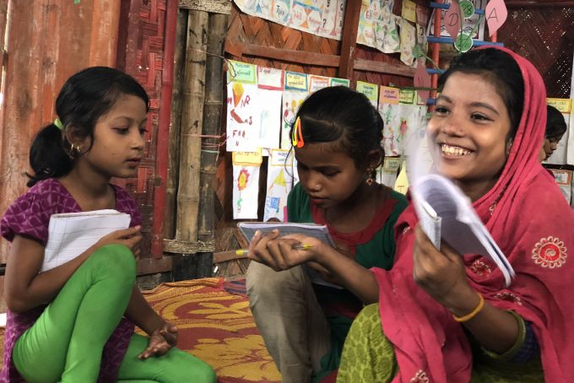
In Bangladesh, many Rohingya children are going to school
for the first time. Image by Jaime Joyce. Bangladesh, 2018.

Today, you’ll learn about Njema, Rose, Amena, and Elizabeth, children much like you who go to school every day, only in a different place and at a different type of school. By the end, you’ll understand how they got to where they are, and what challenges they face.

Table of Contents:

Warm-up: What is a refugee? …………………….…………………….…………………….………………. Pg. 2-4
Reading and Comprehension Questions …………………….…………………….……………………... Pg. 5-9

Reflection …………………….…………………….…………………….…………………….……………………… Pg. 10

Extension Activities …………………….…………………….…………………….…………………………… Pg. 11-14

Warm-up
1. Observe the room you’re in and notice the objects, clothes, etc. in the room. What would someone looking at a picture of you and your family or friends learn about how you live from the objects in the room?

2. Look at the slideshow of images, and write down the following:
- What do you see?

- Where do you think these children are?

- What do you learn about them from the image?

3. These children are refugees.
1. What is a refugee?

2. What does that word mean? Think of a definition, then read the legal definition below* and compare.

3. What experiences do you associate with that word? What do you think these children have gone through as refugees?

*A refugee is someone who has been forced to flee [their] country because of persecution, war or violence. A refugee has a well-founded fear of persecution for reasons of race, religion, nationality, political opinion or membership in a particular social group.” (UNHCR)

Worksheet: Fleeing to the United States
Directions: Read the following story from Akon and Laer, his seven-year-old brother. Their family fled their home in Honduras a few years ago for a safer life in the U.S., and were held in detention in Mexico while claiming asylum.

Since October 2018, at least 900,000 migrants and people seeking asylum have arrived at the southwestern U.S. border. Most come from one of three Central American countries: Honduras, Guatemala, or El Salvador.

Some people come to escape poverty. In Honduras, more than half of the population lives in poverty. Akon’s mom supports her family by cleaning houses and selling homemade pan de coco (coconut bread). Akon, his mom, and his 7-year-old brother, Laer, left for the U.S. in April to reunite with the boys’ grandfather in New York City.

“Most of the time, we traveled by bus,” Akon says. “In Guatemala, we walked part of the way.”

Other people are fleeing violence. In parts of Honduras, gangs control entire neighborhoods. Gang members demand money from citizens. “If I don’t pay, there are consequences,” one woman said.

Often, it’s a combination of factors that pushes someone to leave home.
(Source: “Tough Choices” by Jaime Joyce for TIME for Kids)

Directions: When their parents decided that the family would move, Akon and Laer had to pack their things in a hurry. Below, draw a picture of the suitcase or bag you would bring with you if your parents told you that your family was moving with little notice.

Now, let’s hear from the children themselves about what their lives are like. One way that people can share their stories with others living far away is through a journalist. Jaime Joyce, a journalist with TIME for Kids and a Pulitzer Center grantee, reports from Kenya, Bangladesh, and Mexico on what life is like for children like Njema, Amena, or Elizabeth. Here is a video where you can meet Jaime and find out why she went to report in Kakuma refugee camp.

Read: "Kids of Kakuma” by Jaime Joyce”
Read Jaime Joyce’s story from TIME for Kids and write down your answers to the following questions.
According to the story, why did Njema and Rose leave their homes in South Sudan?

What do they bring with them, and what do they leave behind?

What information does the article provide about what life is like for children who are refugees in this place?

What surprises you about what life is like there?

Think about your everyday life — what might you have in common with students like Njema and Rose? What might be different?

Go back to the picture of Njema and Rose’s school from the warm-up. What new information do we have about them?

Now, let’s hear from a few more children living in temporary situations around the world. Some of you will travel to Cox’s Bazar, Bangladesh to meet Amena, and some will go to Tijuana, Mexico to meet Elizabeth.

Read: “A Safe Place to Learn and Grow” (Bangladesh) OR “Holding onto Hope” (Mexico) by Jaime Joyce
Choose one of the two stories to read, and write down your answers to the questions on the corresponding reading guide worksheet.

Amena, Bangladesh:
Why did these children leave their homes in Myanmar?

What information does the article provide about what life is like for children in this place?

What surprises you about what life is like there?

How does Amena’s life compare with Rose and Njema’s?

Think about your everyday life — what might you have in common with students like Amena?

OR
Elizabeth, Mexico:
Why did these children leave their homes in El Salvador and Honduras? Think back to the warm-up if you’re not sure.

What information does the article provide about what life is like for migrant children in this place?

What surprises you about what life is like there?

How does Elizabeth’s life compare with Rose and Njema’s?

Think about your everyday life — what might you have in common with students like Elizabeth?

Reflection:
Write down your answers to the following questions in the space below.
1. How have these children’s lives changed?

2. Who and what is helping these kids adapt to these new situations? How are they adapting?

3. Do the experiences of Njema, Amena, Elizabeth, or Rose remind you of the experiences of characters from movies, TV shows, or books that you know? How are they similar and/or different?

4. What do you learn about the kids’ hopes for the future? How do they compare with yours?

Next, we’ll think about some projects that we can do together with the information that we learned from Njema, Amena, Elizabeth, and Rose. Before we do that, though, it’s important to know that by knowing their names and learning their stories, you’ve done so much already. Learning these stories, and telling people you know about what you learned, helps to build empathy and understanding for children living in uncertain conditions around the world.

Activity:
Option 1: Journalism project

Jaime Joyce, who wrote about the children and their schools, is a journalist. Take a second to think about what a journalist does — what is their job? As a journalist, Jaime is an editor for TIME for Kids, the outlet that published the stories you read, and reports news by doing research, asking questions, and writing about what she learns.

Now, you’re going to take on a journalism project like Jaime’s with your class and follow the same process. She travelled far away to tell the stories you read, but you don’t have to travel far to tell the stories of refugees like Njema, Amena, Elizabeth, and Rose.

Step 1: Research

Most communities around the country have former refugees living in them, meaning people that were refugees but have now found permanent new homes. Find out what organizations are working to help refugees and displaced children and their families settle into your community.

Step 2: Ask questions

Next, think about what questions you could ask the newest members of your community in order to get to know them and tell their stories. Brainstorm as a class, and make a list. Some examples: Where have they come from in the world? What do they think of their new home? What is difficult, and what isn’t as difficult as they thought? Fill out this list of questions, and then send them to your teacher.

Step 3: Writing

Once you have your answers back, it’s time to write your story. Look back at Jaime’s writing that you read — how does she structure her writing? What words does she use? Then, write your own story using the space provided to help people in your community learn about each other.

Finally, send your finished story to education@pulitzercenter.org for us to put on our website.

Option 2: Letter writing

Now that you’ve learned about the lives of migrant children around the world, and reflected on how their lives compare to yours, think about the challenges they face that you learned about.
- What are they?
- How can you, your community, or your country help them?

With these ideas in mind, write a letter to your representatives in Congress or your state capitol, or to a community group that can take steps to support migrant children from afar. Make sure to include:
- Details from the reporting that stuck out to you
- Your ideas about what your community can do to support your peers in refugee camps and migrant shelters

Below is a template to get you started. Send your letter to education@pulitzercenter.org to have it published on our website!

Dear [Congresswoman/man _____/Representative/etc.]

[body]

Sincerely,
[Your name]
[grade, school]

Option 3: Create a graphic novel or picture book

Individually or as a class, plan out and create a graphic novel or picture book showing the journey that children make to safety in other countries when they become refugees, and what life can be like once they get there. Make sure to use both quotes from Jaime Joyce’s news stories and your own words to narrate your novel or picture book.

Use the space below to begin your illustrations.

