A Different Lens: Reclaiming Our Stories with Counter Narrative Photojournalism
Big Ideas
How can photojournalism be used as a tool to humanize those who are often dehumanized?
How can photojournalism tell a more complete story of people impacted by migration?
How can we use photojournalism to push back against false or incomplete narratives of our community?

Vocabulary
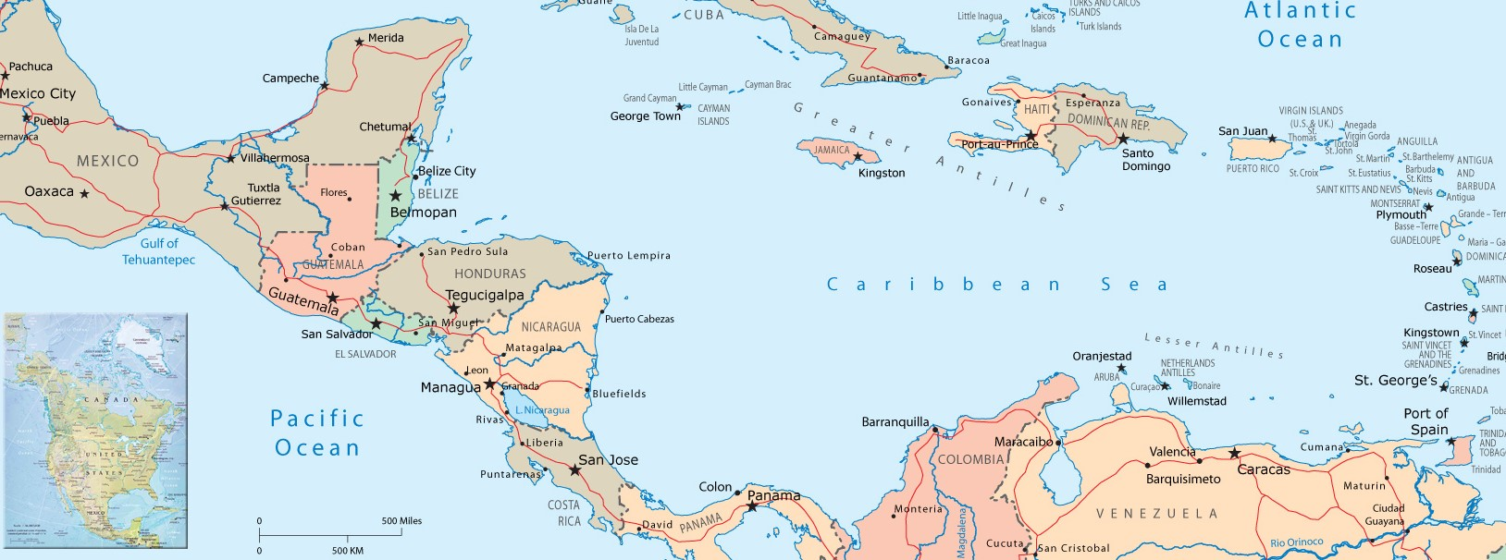
empathy

migrant

xenophobia

marginalization

humanization

dehumanization

photojournalism

counternarrative

Part 1: Text and Photo Analysis of Reporting on Migration to Colombia and Chicago, IL
Walking to the United States Reporter Chip Mitchell Photographer Anthony Vazquez Lead Editor Kate Grossman Design and Development Jesse Howe
News Outlet Chicago Sun Times
Click on the link Walking to the United States.
Turn the volume on in the upper right corner.
Click anywhere on the screen to start.
Look at the images. Read the text. Listen to the voices.

Image | What details in the photograph stand out? | What emotions are conveyed by the image and text? | What is photojournalist Anthony Vazquez trying to communicate in the photograph? | What thoughts, feelings, or questions do you have? Why does this image and the text matter?
1
2
3
Image | What details in the photograph stand out? | What emotions are conveyed by the image and text? | What is Anthony Vazquez trying to communicate? | What thoughts, feelings, or questions do you have? Why does this image and the text matter?
4
5
6
7
8
9
Choose one of the photographs and give it a title that matters.

“What Columbia Can Teach Chicago About Managing a Migrant Wave” by Chip Mitchell and Anthony Vazquez for WBEZ 91.5
“Lo que Chicago puede aprender de Columbia sobre cómo manejar una ola migratoria” por Chip Mitchell y Anthony Vazquez, Chicago Sun Times

Through photography, how does Anthony tell a story about migrants that is different from others you often hear?
List at least three specific details in the photos to support your thinking.

Text Analysis
Section Heading: The xenophobia Venezuelan migrants face/La xenofobia que enfrentan los migrantes venezolanos
Focus on the story of Desiré. What is significant about her story? How does her story highlight xenophobia in Columbia?

What are some of the strategies to combat xenophobia?

Section Heading: Integration in the face of marginalization/La integración ante la marginación
How does Columbia’s Temporary Protection Permit work? How many have accessed this permit?

How have Venezuelan migrants benefitted Colombia?

Return to the photography of Anthony Vazquez.
How does Vazquez humanize his subjects? Provide specific examples from the images.

How does Vazquez’s work help us empathize with his subjects? Provide specific examples from the images.

Part 2: Text and Photo Analysis of Local Reporting in Woodburn, OR
What individuals or groups of people in our community do we want to humanize?
What individuals or groups of people would benefit if others would empathize with them? Respond below.

On April 1, 2025, a Google search with the words “Woodburn immigration” delivered these stories:

Woodburn School Board rejects ‘Safe and Welcoming Schools’ resolution that would have reaffirmed support for immigrant students

Fear, confusion in Woodburn s Trump takes office

Choose one of the stories.
Do the photographs add meaning to the story? Explain why or why not.

What is present?

What is missing?
How are Anthony Vazquez’s photos different?

If you were the photojournalist assigned to cover either Woodburn story, what photographs would you include?

Using the work of Anthony Vazquez as a model, brainstorm different photographs you could take in our community to tell a story that humanizes our community to the world and serves as a model for OPB and other news outlets on how to tell a fuller story about a community often marginalized, helping others empathize with us.

Part 3: Creating Local Photojournalism Projects Visualizing Counternarratives to Stories Often Told About Our Communities
Now, you become a photojournalist.
- Take lots of photographs that strive to be counternarratives to the stories that are often told about our community.
- Choose three of your favorites.
  - Give each a tagline.
  - Write at least a paragraph highlighting your purpose in including this photograph.
  - Give your collective body of work a title that matters.
  - Combine the title, photographs, tag lines, and writing in one document.

Part 4: Self Reflection

What do you love most about your photojournalism?

If you had more time or access to other locations or people, what else would you want to highlight?

What do you hope your photojournalism will teach people about our community?

What does the photojournalism of your peers make you think, feel, realize, or wonder?

