Food System Map
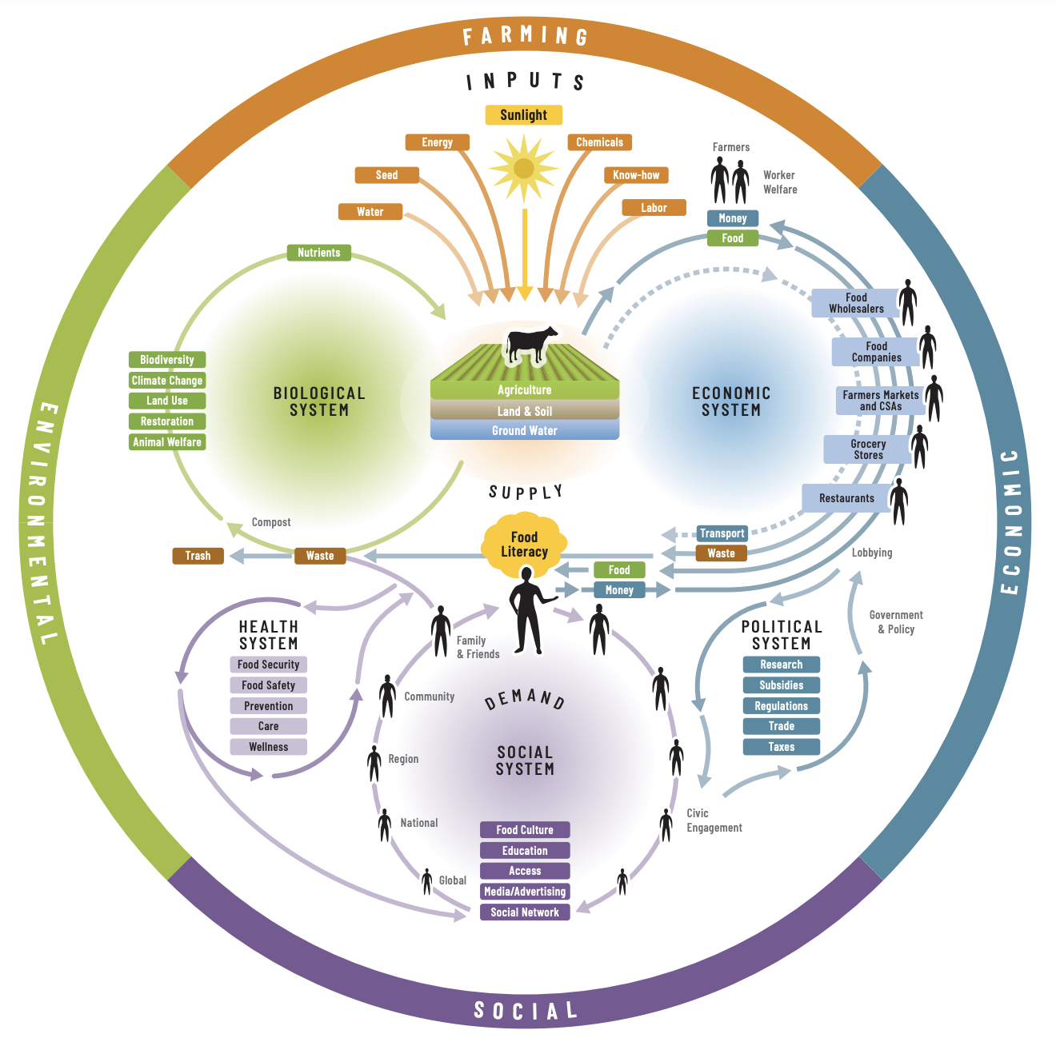
Source: https://www.nourishlife.org/teach/food-system-tools/

- Who do you think has the most power to influence our food? Why?

- Where in this food system map could a person’s health be affected positively or negatively?

- If you were to focus on the health of individuals, which part of the food system would you focus on?

- How can communities exercise more control over the food they eat?

Ted Talk Video: Re-Thinking Food: Transforming Food Systems for People and Planet
- What issues exist in our current food system?

- How does the food system impact the environment?

- According to Frank Eyhorn, what solutions could help improve the food system?

- How does our current food system impact our health?

