Climate Change & Its Impact on Communities — Podcast Worksheet
This worksheet will help you understand how climate change affects people, jobs, and communities.
Listen to the podcast “Climate Change and Worker Voices: Understanding Our Changing World” and answer the questions as you listen.

1. Define Climate Change
Climate change is defined as:

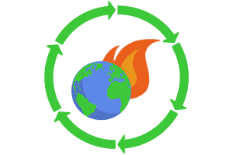

2. Define Gig Economy
Gig economy is defined as:

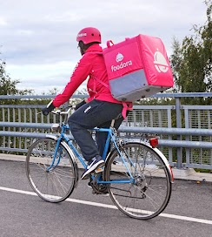

3. Define Heat Stress
In your own words:



4. Define Op-ed
In your own words:



5. Climate Change & Economic Vulnerability — Key Point 1
What is one way climate change affects people’s jobs or income?

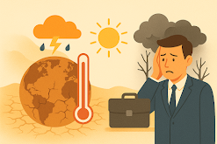

6. Climate Change & Economic Vulnerability — Key Point 2
What is another key point the podcast makes about climate change and workers?

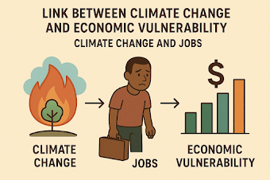

7. Effects of Heat Stress on Workers
How does heat stress affect workers’ health or productivity?

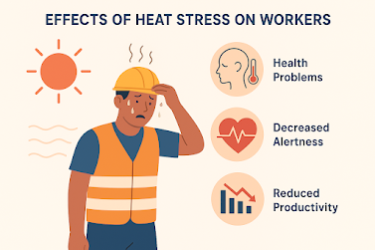

8. Using Our Voices for Change
What actions can people or communities take to support positive change?

