**The Complexities of Global Healthcare Access**

| How many days are needed to teach this lesson? | 3-4, 50-minute class periods |
| --- | --- |
| Grade Level(s) | 11/12 |
| Subject(s) | World Geography/International Baccalaureate Geography |
|  | As part of a larger unit on Global Development, students will consider how access to and the quality of healthcare has enormous implications for individuals, families, communities, and countries. As a significant portion of each country’s overall score on the Human Development Index (HDI), countries are individually measured on three elements:   1. *The ability of individuals to achieve a decent standard of living* 2. *The ability to access education* 3. *The ability to live a long and healthy life*   In this lesson, students will explore examples of limited healthcare access in rural America and rural Nigeria, focusing on the disparities that exist between the two contexts.  They will begin by identifying key factors contributing to these differences, such as socioeconomic status, infrastructure, government policy, and cultural attitudes toward health. After engaging with a Pulitzer Center article and video, students will complete an analysis on each, with the lesson ending in a whole-class Padlet post or Fishbowl Discussion, where students can engage in a structured conversation about the barriers, challenges, and potential opportunities for improving healthcare access in rural areas. These formats will encourage students to share their insights from the Pulitzer article and videos, listen to diverse perspectives, and collaboratively explore solutions.  By the end of the lesson, students will not only have a deeper understanding of how healthcare disparities impact development within a global context but also the ability to think critically about global health issues. |
|  | [Minnesota State Social Studies Standards](https://education.mn.gov/mde/dse/stds/soc/)  ***Geography:***  9.3.15.2 Compare the population characteristics of places at a range of scales using population pyramids, birth and death rates, and other key demographic variables in major world regions.  9.3.17.4 Evaluate the impact of spatial decisions on policies affecting historically marginalized communities of color and Indigenous nations and take action to affect policy.  [International Baccalaureate Geography Guide](https://mail.google.com/mail/u/0/?tab=rm&ogbl#inbox/QgrcJHsTkxjgprbwtjgVCzrQGZBXCRBGZzQ?projector=1&messagePartId=0.1)  ***International Baccalaureate Geography Requirement:***  Option F: Food and Health  - Ways of measuring disparities in food and health between places.  - The power of different stakeholders in relation to influence over diets and health.  - Future possibilities for improved health. |
| Pulitzer Center news story/stories | [“Rural Women Hit Hardest By Nigeria’s Worsening Health Care Crisis](https://pulitzercenter.org/stories/rural-women-hit-hardest-nigerias-worsening-healthcare-crisis),” by Taiwo Adebulu for *The Cable*  “[The Health Care Challenges Pregnant Women of Color Face in Rural Areas](https://pulitzercenter.org/stories/health-care-challenges-pregnant-women-color-face-rural-areas),” by Stephanie Sy and Maea Lenei Buhre for *PBS NewsHour.*  Optional:  “[West Virginia Doctors Work to Bridge Healthcare Gap in Rural Areas](https://pulitzercenter.org/stories/west-virginia-doctors-work-bridge-healthcare-gap-rural-areas),” by William Brangham, Janet Tobias, Caleb Hellerman and Courtney Norris for *PBS NewsHour* |
| Content Advisory | Discussions of healthcare topics, including childbirth and patient care. |
| Notes on Context | This lesson was developed for upper-level (junior/senior) advanced Geography course students. |

# 

# 

# Lesson Plan

| **Lesson Objectives** |
| --- |
| Students will…   * Understand the connection between health to global development levels * Compare and contrast healthcare access in rural America and rural Nigeria * Identify factors that contribute to healthcare disparities between the two countries * Analyze the impact of these disparities on individuals and communities and evaluate their impacts on countries, communities, and individuals * Contribute to a whole-class Padlet post or Fishbowl Discussion on the barriers, challenges, and opportunities for rural communities regarding healthcare access |
| **Focus Pulitzer Center News Story/Stories** |
| [“Rural Women Hit Hardest By Nigeria’s Worsening Health Care Crisis](https://pulitzercenter.org/stories/rural-women-hit-hardest-nigerias-worsening-healthcare-crisis),” by Taiwo Adebulu for *The Cable*  “[The Health Care Challenges Pregnant Women of Color Face in Rural Areas](https://pulitzercenter.org/stories/health-care-challenges-pregnant-women-color-face-rural-areas),” by Stephanie Sy and Maea Lenei Buhre for *PBS NewsHour.*  Optional:  “[West Virginia Doctors Work to Bridge Healthcare Gap in Rural Areas](https://pulitzercenter.org/stories/west-virginia-doctors-work-bridge-healthcare-gap-rural-areas),” by William Brangham, Janet Tobias, Caleb Hellerman, and Courtney Norris for *PBS NewsHour* |
| **Lesson Steps** |
| Warm-up:  Have students discuss the following questions in partners or small groups and then out to the entire class.   1. Imagine living in a place where you couldn't easily access a doctor or hospital when you were sick. How would that affect your life and the lives of your family? 2. What are some barriers to accessing healthcare for anyone in any country in the world?   **Educator note: Students could write their responses on Post-its and post them on a wall in the classroom as a collection of thoughts. The teacher could then choose some to highlight for the entire class.  Introduce the lesson:   1. Discuss that the goal of this lesson will be for students to understand the impacts that healthcare access on global development levels through the lens of two contrasting countries, Nigeria and the U.S. 2. Make certain that students have a firm understanding of the following vocabulary words:    * Disparity    * Rural    * Maternal mortality    * Obstetrical care    * Midwives    * Postpartum    * Prenatal/antenatal care 3. Challenge students to consider: *“How would living in a rural area in the world present challenges for pregnant mothers?”* Allow students time to share their ideas with the entire class or again, use the post-it note method introduced in the warm-up. 4. Have students build background information on global health terms before reading articles on maternal health.    1. Handout, Data Deepdive: Nigeria and the U.S.[[.pdf](https://pulitzercenter.org/sites/default/files/inline-images/Data%20Deepdive.pdf)][[.docx](https://pulitzercenter.org/sites/default/files/2025-08/data_deepdive_0.docx)] Direct students to complete the activity using two websites, [CIA World Factbook](https://www.cia.gov/the-world-factbook/) and [Human Development Index](https://hdr.undp.org/data-center/country-insights#/ranks) from the United Nations Development Program website.    2. Using the worksheet, have students gather data on the following topics to provide background context prior to using the Pulitzer articles.  * Maternal mortality rate * Physician density rate * Hospital bed density rate * Infant mortality rate * Drinking water source, * Sanitation facility access * Electricity access   1. Have students discuss their findings in relation to the following questions:      + How might this data relate to human development levels?      + How might this data relate to healthcare quality for citizens in both Nigeria and the U.S.?   Analyze Reporting:   1. Introduce students to the article, “[Rural Women Hit Hardest By Nigeria’s Worsening Health Care Crisis](https://pulitzercenter.org/stories/rural-women-hit-hardest-nigerias-worsening-healthcare-crisis)”, and have students fill out the title, author, and date published questions on the “Geographic Case Study Using Pulitzer Center Resources”[[.pdf](https://pulitzercenter.org/sites/default/files/inline-images/Case%20Study_%20Pulitzer%20Center.pdf)][[.docx](https://pulitzercenter.org/sites/default/files/2025-08/case_study_pulitzer_center.docx)] 2. Have students read the article independently. 3. After students are done reading the article, have students complete the “Geographic Case Study Analysis” worksheet in partners. Allow students time to discuss and work together. 4. Have students share their findings and reflections from the article with the whole group. 5. Screen “[The Health Care Challenges Pregnant Women of Color Face in Rural Areas](https://pulitzercenter.org/stories/health-care-challenges-pregnant-women-color-face-rural-areas)” (9:06). 6. Have students conduct another analysis of the reporting by completing another “Geographic Case Study Using Pulitzer Center Resources” but this time, individually. |
| **Performance Task** |
| Students will participate in a Padlet post or Fishbowl Discussion engaging with the question: *“In what ways should communities, governments, and international organizations take action to prioritize healthcare access in rural areas?”*   1. Students join a [Padlet](https://padlet.com/bcarlson/global-health-care-challenges-a5skt450i8fvn2ea) where they will post responses and add comments to their peers’ posts, to the question: *“In what ways should communities, governments, and international organizations take action to prioritize healthcare access in rural areas?”* 2. Give students directions for the [Fishbowl Discussion](https://docs.google.com/document/d/1bA87zvNGMf_JvGjLyIleln8RVK-ceM9COZLJr6WAi-s/edit?usp=sharing) [[.pdf](https://pulitzercenter.org/sites/default/files/inline-images/Global%20Health%20Care%20Challenges%20Fishbowl%20Discussion_%20Pulitzer%20Center.pdf)][.[docx](https://pulitzercenter.org/sites/default/files/2025-08/Final%20Lesson%20Plan%20and%20Teaching%20Material_Genetically%20Modified%20Organisms%20%281%29.docx)]that they can participate in within the next few days. Teachers should allow at least 1-2 class periods for students to prepare for the discussion. Allow an entire period for the Fishbowl Discussion. |
| **Assessment** |
| Students will be assessed on their learnings with the following formative assessments:   * + The completion of the Data Deep-dive: The Nigeria and the U.S. [[.pdf](https://pulitzercenter.org/sites/default/files/inline-images/Data%20Deepdive.pdf)][[.docx](https://pulitzercenter.org/sites/default/files/2025-08/data_deepdive_0.docx)] with discussion   + The completion of the Geographic Case Study Using Pulitzer Center Resources [[.pdf](https://pulitzercenter.org/sites/default/files/inline-images/Case%20Study_%20Pulitzer%20Center.pdf)][[.docx](https://pulitzercenter.org/sites/default/files/2025-08/case_study_pulitzer_center.docx)]; one from “[Rural Women Hit Hardest By Nigeria’s Worsening Health Care Crisis](https://pulitzercenter.org/stories/rural-women-hit-hardest-nigerias-worsening-healthcare-crisis)” and one from “[The Health Care Challenges Pregnant Women of Color Face in Rural Areas](https://pulitzercenter.org/stories/health-care-challenges-pregnant-women-color-face-rural-areas)”   Students will be assessed on their learnings with one of the following summative assessments:   * Padlet posts participation * Participation quality in the Fishbowl Discussion. The rubric is included in the assignment sheet [[.pdf](https://pulitzercenter.org/sites/default/files/inline-images/Global%20Health%20Care%20Challenges%20Fishbowl%20Discussion_%20Pulitzer%20Center.pdf)][.[docx](https://pulitzercenter.org/sites/default/files/2025-08/Final%20Lesson%20Plan%20and%20Teaching%20Material_Genetically%20Modified%20Organisms%20%281%29.docx)]. |

**Closing Reflection**

**About Brielle Carlson**

Brielle Carlson is a high school social studies educator at Grand Rapids High School in rural, northeastern Minnesota. She taught “The Complexities of Global Healthcare Access” to a class of 38 students.

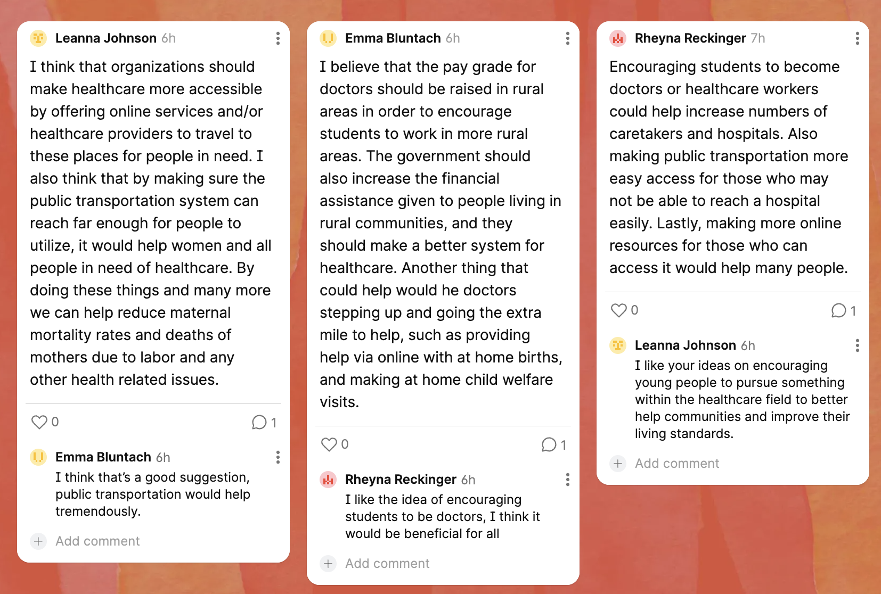

*Teacher Fellow Brielle Carlson's students explore solutions to gaps in healthcare access for rural populations. Image by Brielle Carlson, 2024.*

**Tell us about you, your students, and your community.**

I teach in northern, rural Minnesota in a predominantly white, Christian community with various socio-economic levels. As a social studies educator, I designed this lesson for an 11/12 International Baccalaureate World Geography class.

**Tell us about your lesson.**

As part of our Food and Health unit in World Geography, my students spend a substantial amount of time learning about disparities in food and health systems globally as well as the role of international organizations, governments, and communities in managing and addressing complications within these systems. We live in a rural community where, although a local hub of healthcare exists, many people struggle to access specialized medical care and have to travel long distances to receive services. This challenge is a tremendous barrier, especially for people who lack economic resources and/or reliable transportation. Additionally, our community struggles to attract young medical providers to the area. We also simply do not have enough doctors available for our local population, including OBGYNs.

I wanted to incorporate this local issue, which is very relevant to my students, into the Pulitzer Center reporting on rural healthcare access for women and families in Nigeria. Being able to capture and understand the struggles here in rural America, juxtaposed with those in Nigeria, is an opportunity for students to become aware of how significant accessible healthcare is for all people. Furthermore, I am hopeful that engaging with these two pieces of journalism can motivate students not only to identify the barriers to healthcare in rural spaces but also to seek solutions to these issues.

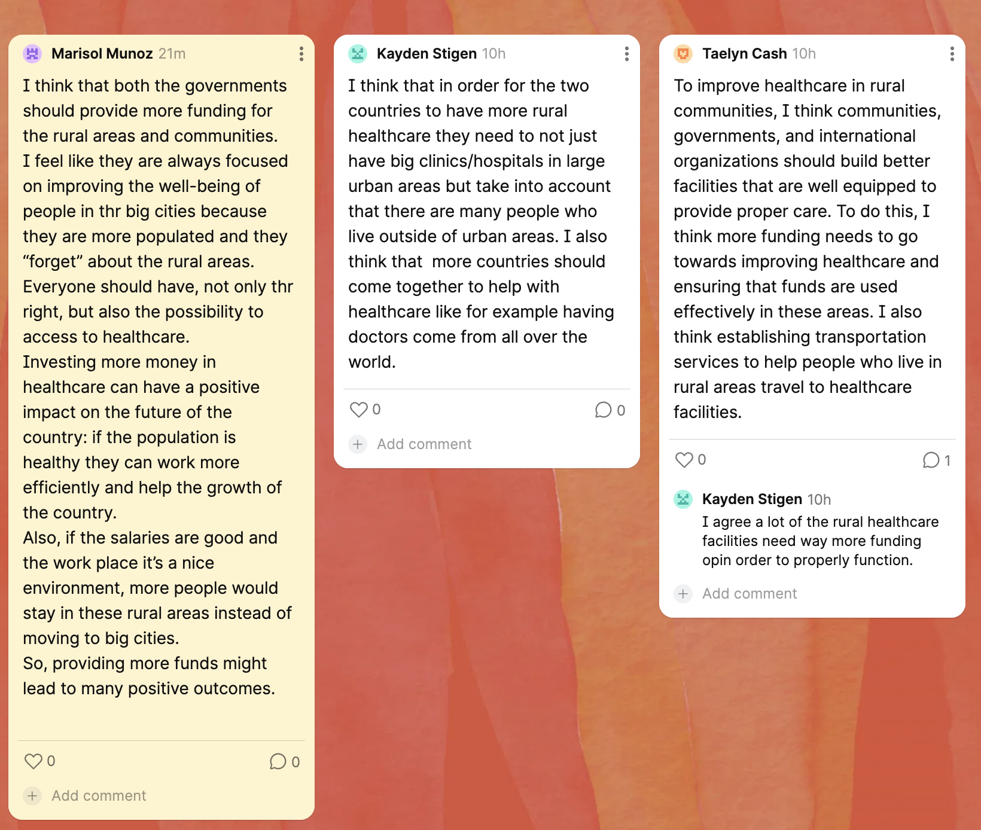

*Students discuss equity in healthcare access for rural populations. Image by Brielle Carlson, 2024.*

**Tell us about what your students learned while engaging with the lesson.**

For our cumulative task, students responded to the question, “In what ways should communities, governments, and international organizations take action to prioritize healthcare access in rural areas?” The following responses demonstrate the impact the lesson had on their understanding of healthcare access.

“I think that if the government were to give easier access to care with women’s prenatal and postpartum the maternal mortality rate would go down whether it’s a support group/person, online or in person. Another thing that should improve is the transportation and the access to it. Many mothers are not able to get the care they need or even get to the hospital on time due to their car broken down or limited access to bussing systems because they live in rural areas within the US.”

“One idea that I agreed with was the tele visits online. This helped the women that don’t have transportation to their appointments. I believe that Dr. Lavender could also create a program to help all pregnant low-income women have access to prenatal and postpartum care that they need.”

“In rural areas, I believe that hospitals and or governments should create a hospital bus service. This bus service will work with and communicate with patients on giving rides to the hospital during need and routine checkups”.

“They should take action by actually helping women no matter the color of their skin. The government should make sure every county has a doctor for these pregnant women.”

“Encouraging students to become doctors or healthcare workers could help increase numbers of caretakers and hospitals. Also making public transportation more easy access for those who may not be able to reach a hospital easily. Lastly, making more online resources for those who can access it would help many people.”

“I think that governments, especially in countries with large rural populations, should make a point to make healthcare accessible in rural locations. It’s difficult to find funding for these services, but I’m sure there are tons of people that would be willing to start a nonprofit to help. More hospitals could also implement things like the online prenatal checkups.”

“I think that organizations should make healthcare more accessible by offering online services and/or healthcare providers to travel to these places for people in need. I also think that by making sure the public transportation system can reach far enough for people to utilize, it would help women and all people in need of healthcare. By doing these things and many more we can help reduce maternal mortality rates and deaths of mothers due to labor and any other health-related issues.”

**Tell us about what you learned by creating and teaching this lesson.**

Through teaching this lesson, I have come to understand how undervalued access to excellent healthcare is. By engaging in the video and article from the Pulitzer Center, I became more aware of health barriers for people in rural America even though I *thought* I knew what many of them were. Teaching this lesson challenged my perceptions of the American healthcare system and made me think deeply about how health equity for anyone in the world has enormous impacts far beyond a person’s physical health. I’m hopeful that my students were able to at least start to comprehend the barriers to healthcare in the world and want to be part of the solution to work towards improving global health equity.

I learned that I needed far more time than I originally planned for my lesson (3 days). We could have spent at least 5, 50-minute class periods exploring this issue within our Geography course. For teachers that intend to teach this lesson, allow yourself more time than you think to answer student questions, to more deeply discuss things like unconscious bias in healthcare and the role of government in providing basic health necessities like electricity and medicines.

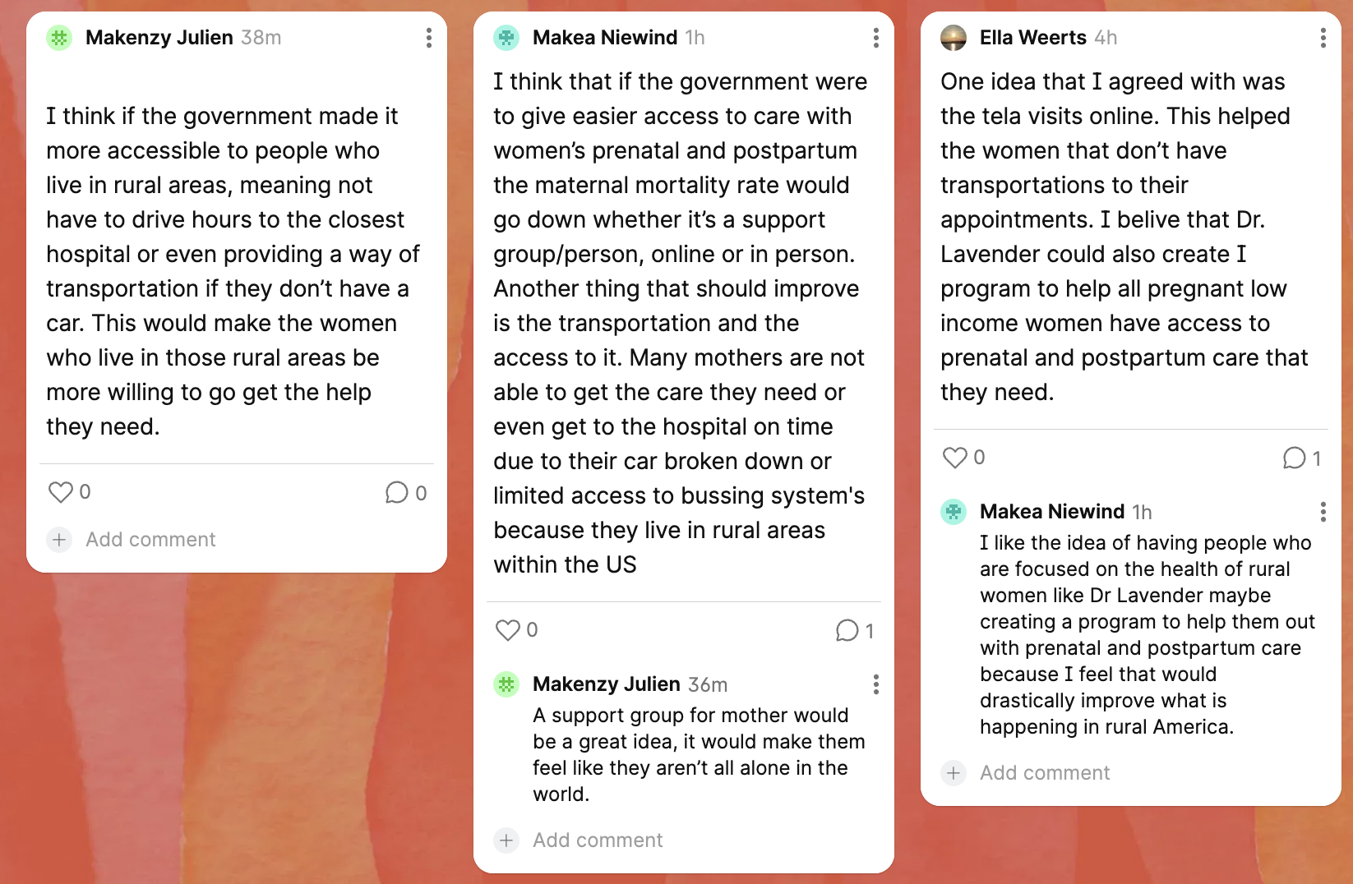

*Students from Minnesota use Padlet to explore the issue of healthcare access. Image by Brielle Carlson, 2024.*