READ TOGETHER

Ignorance and Apathy: Why One Indian Woman Dies of Cervical Cancer Every Seven Minutes
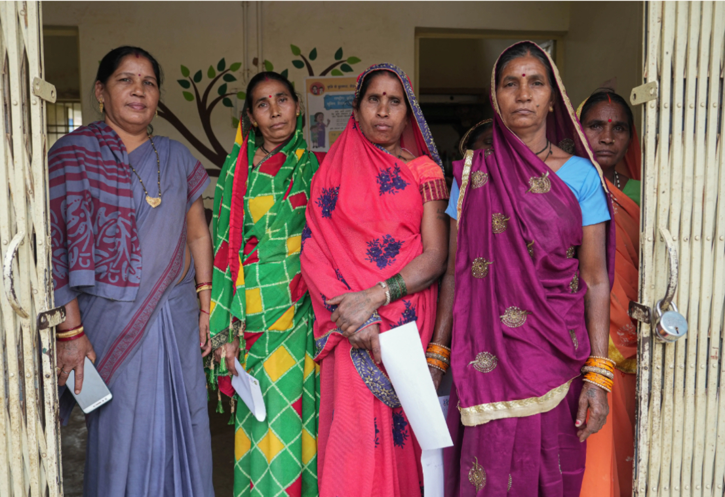
Photo: Women from Nayagaon village with an auxiliary nurse midwife (ANM) gathered for a cancer screening camp by BALCO Medical Centre near Raipur, Chhattisgarh. Image by Afzal Adeeb Khan. India.
The flow of patients is incessant at the outpatient departments of the Gujarat Cancer Research Institute [GCRI]. The tertiary cancer centre caters to 25,000 patients annually from across the state, Rajasthan and Madhya Pradesh, and the treatment is mostly subsidised under various government schemes.

In the gynaecology OPD, on the ground floor, nurses call out patients and a team of two doctors examines the patient. Between seeing patients, Chetna Parekh, professor of gynaecological oncology at the institute, explains that unlike most other cancers, cervical cancer is fully preventable and treatable, yet it has poor outcomes in India. “Most of our patients come in the third and fourth stage and die within six months to a year of diagnosis,” she told BehanBox.

These tragedies are unacceptable because unlike most cancers that lack a clear cause, we know that cervical cancer is caused by the human papilloma virus [HPV], and there exists a vaccine to prevent HPV infections. Yet, in 2023, 123,000 Indian women were diagnosed with cervical cancer and almost 80,000 of them died. India bears one-fifth of the global burden of cervical cancer and the highest number of deaths.

Every seven minutes, one woman dies of cervical cancer in India. Yet, screening rates remain abysmal, the HPV vaccine available for more than two decades is yet to be included in India’s free vaccination programme and there is very little awareness about the disease.

A

Mridu Gupta, who heads a non-profit for cancer awareness, prevention, and early detection [CAPED], believes it to be a gendered crisis. “If it were a cancer that affected men and killed one man every seven minutes, do you think it would take so long for the [HPV] vaccine and the screening to be available for all of them?” Women’s health is simply not backed by political will, and there is no urgent effort to increase awareness, she said.

I met many cervical cancer patients from rural India at the GCRI, mostly between the ages of 40 and 60. About 80% of them were diagnosed when they were at stage 3. Jassuben is one of them.

The 30-year-old from a farming family in Amreli, 270 km from Ahmedabad, sat with her back against the wall in Parekh’s cabin alongside her husband. She has stage-3 cervical cancer and the prognosis is poor. She was diagnosed two years ago and treated, but by February this year, the cancer had spread. She will soon be initiated into palliative care.

Women with cancer also face more stigma, neglect and abandonment than men. That is why BehanBox, in a three-part series, sought to explore gendered cancer care for women and the additional barriers women face.

In this first part, through visits to cancer centres in Mumbai, Ahmedabad and Raipur, I search for reasons why India lags behind in cervical cancer screening. I found that it needs to fill certain systemic gaps, start a universal HPV vaccination programme, and take some lessons from the robust cervical cancer screening programme of neighbour Bangladesh.

B

80% Cervical Cancer Cases in Poorer Countries
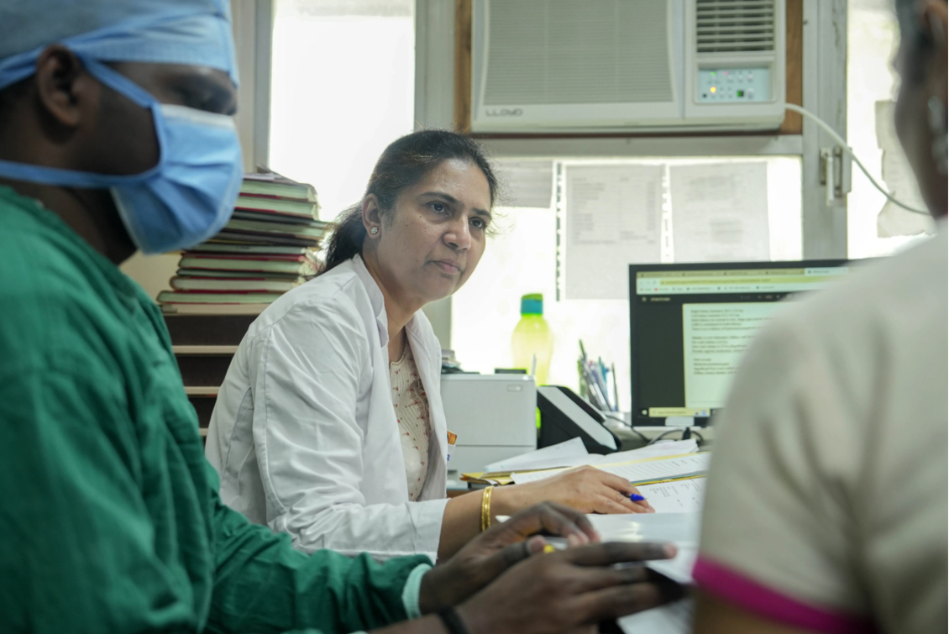
Photo: Gauravi Mishra, professor of preventive oncology, is shown at Tata Memorial Hospital, Mumbai. Image by Afzal Adeeb Khan. India.
An HPV infection can cause cervical cancer. “Many women will get infected with it, but only a few actually go on to developing cervical cancer,” explains Gauravi Mishra, professor of preventive oncology at Tata Memorial Hospital, Mumbai, the country’s largest public tertiary cancer care centre.

Like in other countries, the prevalence of HPV infection in India is about 7%, she told me. In most women who are infected, the infection will clear on its own and without any symptoms. But in some who do not, precancerous lesions may develop in a few years and some of the patients may progress to cervical cancer over 10-15 years. If women are screened regularly, they will be detected when they are still in the precancerous stage, which is completely curable.

In 2020, the World Health Assembly set a 90-70-90 target for the elimination of cervical cancer in its 194 member states: 90% of girls fully vaccinated against HPV by the age of 15; 70% of women screened twice using a high-performance test by the age of 35 and again by 45; 90% with pre-cancer treated and 90% with invasive cancer managed. If all countries met this target by 2030, cervical cancer could be eliminated by the next century.

However, while developed countries are seeing a decline in cervical cancer, low- and middle-income countries are lagging. A major reason for this imbalance is poverty: Data from the International Agency for Research on Cancer show that 80% of cervical cancer cases are in low- and middle-income countries, mostly from sub-Saharan Africa as well as China and India — both these countries together account for 40% of the world’s burden of cervical cancer cases.

Though it is the second-most-common cancer among women in India, cervical cancer screening (along with oral and breast cancer) was recommended in national guidelines only in 2017. Given limited funds, inadequate infrastructure and acute shortage of trained technicians, India opted for visual inspection with acetic acid (VIA) conducted by trained health workers as a screening method. But the screening programme is inadequate.

Some of the risk factors for cervical cancer include weakened immunity, such as those with HIV infection, other sexually transmitted diseases and infection due to certain types of HPV, giving birth to multiple children, early pregnancy, hormonal contraceptive use, and smoking.

“By the time most patients come to us, the cancer has grown large and often spread to other organs like the kidney. They are then beyond curative treatment and suffer greatly before death,” said Chetna Parekh from GCRI.

In advanced stages, the cancer spreads to the ureter, the tube connecting the kidneys to the urinary bladder, and this causes pressure on the kidneys and subsequently renal failure. Patients are then fitted with artificial stents for removal of urine and have to undergo dialysis. In other cases, the cancer spreads to the anus, resulting in the leakage of stool, odour and infections.

C

Pregnancies, Hygiene and Poverty: Jassuben’s Story

Jassuben is dressed in a grey shawl and the traditional ghagra-choli ensemble. She looked tired but managed a smile when I spoke to her.

Jassuben was 13 or 14 when she was married off. She doesn’t remember her age, the oldest of her three kids is 12, which means she first gave birth at 18. The family has 7 bighas or 4 acres of land on which they grow cotton. The family income is about Rs. 60,000 annually, falling in the bottom of most income quintiles in India.

In July 2022, Jassuben complained of continuous bleeding for three-four months. Her husband, Bhopat, took her to a private centre and then she was referred to GCRI. The initial diagnosis was stage 1 cervical cancer but later tests showed that the cancer had spread to the lymph nodes. Jassuben received chemotherapy and radiation therapy, which stalled the disease. The white discharge stopped but she has to wear a urine bag as her ureter has been affected.
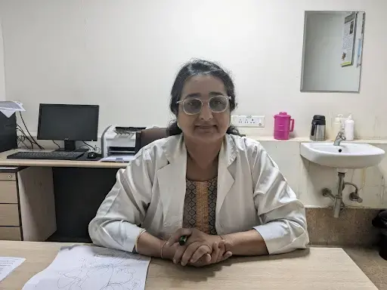
Photo: Chetna Parekh, professor of gynaecological oncology at Gujarat Cancer Research Institute (GCRI). Image by Swagata Yadavar. India.
During a follow-up visit in February 2024, tests revealed the cancer had spread to her other nodes and even lungs. When I met her, she was soon to be admitted for a biopsy and would be initiated on palliative chemotherapy. But the prognosis is poor. “Patients in her condition live up to one and half to two years but the last six months are very bad,” Parekh told me.

D
The Indian government’s 2016 operational guidelines on cancer specify that women above the age of 30 should undergo cervical, breast and oral cancer screening, with cervical screening with VIA to be conducted every five years. The screening is supposed to be conducted by auxiliary nurse midwives (ANMs) at the sub centres and staff nurses at primary health centres (PHCs). The positive cases are supposed to be referred to Community Health Centres (CHCs) or district hospitals for further evaluation and management by medical officers or gynaecologists.

According to the 2016 guidelines, 80% of the population was to be covered by screening in three years. But, according to the National Family Health Survey-5 (2020-21), among women 30-49 years, only 1.9% have undergone cervical cancer screening while 0.9% of women have undergone screening for breast cancer and 0.9% for oral cancer. While the global pandemic played a part in the abysmal performance, there are several implementational challenges that are not addressed by the government.

ASHAs, designated ‘volunteer-workers,’ have already been tasked with implementing maternal and child health and other infectious and NCDs programmes with a meagre pay of Rs 4000-7000 per month. ANMs also have very high workloads, and cancer does not seem very high on their priority list.

“If the government is saying thousands of women have been screened for breast or cervical cancer, then it is false, it is only on paper,” says an ASHA worker from Haryana in a 2022 article in Cancer World on the implementation of the cervical cancer screening. In Madhya Pradesh, Lakshmi, another ASHA, told Cancer World that they have not been properly trained on cancer: “Even after breast or cervical screening of a woman is done, she is not told if there is something abnormal or even what symptoms to look out for. We ourselves do not know; how will we tell her?”

E
A 2019 study among frontline healthcare providers, staff nurses and physicians pointed to several challenges in implementation of the screening programme — the lack of adequate healthcare personnel, overworked staff unaware of their roles in cancer screening, and the absence of clear guidance on referral pathways. Half of the participants, most of them frontline workers, said that they would not be able to conduct screening along with their existing workload. One-third of the participants said that the screening should be conducted by specialist doctors. A 2020 study found most primary health centres had inadequate infrastructure, inadequate infection prevention measures and were short of staff, thus ill-prepared for screening and treating cervical cancer.

Research shows the urgent need to assess the availability of equipment like speculum and dilute acetic acid in PHCs to establish robust referral systems to diagnose and treat women who screened positive. “We will need to have colposcopy, biopsy and treatment facilities at least at the district level. Treatment facilities need to be within accessible distance and should be affordable and acceptable to the people,” said Gauravi Mishra. All of these are currently lacking in many regions in India. “With the increasing burden of cancer cases, we need to take this as a priority,” she said.

BehanBox reached out to Union health secretary Apruva Chandra and Shalini Singh, director of the National Institute of Cancer Prevention and Research, about the main challenges mentioned here on April 2, 2024, and followed up with them. We will update the copy when we receive their response.

F

Reporting Not Robust

Since health is a state subject in India, implementation of the screening programme is up to state governments under central guidance. The government claims 20 million women have undergone cervical cancer screening in 2021 but the reporting is not robust.

The format currently used only “collects the number of cervical cancers detected, along with other cancers, and does not include the number of women screened, the number testing positive on VIA, or the outcomes of those testing positive,” said a November 2020 study of cervical cancer screening in India and Bangladesh undertaken by researchers from India, Bangladesh and WHO’s International Agency for Research on Cancer. It further said that the budget allocated for the required amount of activity and the average target population to be served by each level of health facility is “grossly inadequate.”

Tamil Nadu was the first and among the only few states that have implemented cervical screening in a systematic manner. A 2017 presentation by the state’s National Health Mission director shows that between 2012 and 2017, 14.5 million women were screened by VIA and 430,000 or 3% of the screened women were found to be VIA positive. However, no further information is available since. Other states like Punjab, Himachal Pradesh and Uttar Pradesh have started VIA screenings but the screening figures have not been shared.

G

Hesitation Over Cervical Exam
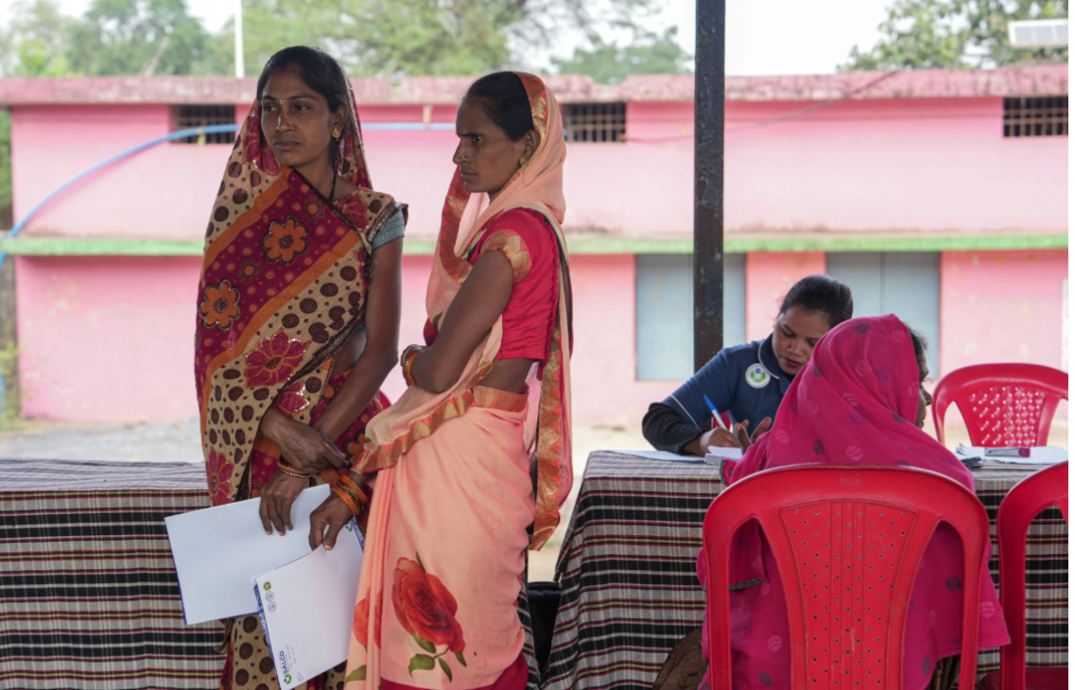
Women waiting to be examined by a nurse during the cancer screening camp at Nayagaon, Chhattisgarh, by BALCO Medical Centre. Image by Afzal Adeeb Khan. India.
Other than programmatic effectiveness, one of the major challenges to cervical cancer screening is the hesitation and anxiety surrounding cervical screenings. “There is a lot of stigma around cervical cancer screening in India. Even educated women are hesitant about a vaginal exam,” said Parekh of GCRI. She recalled that at a recent cancer camp organised by the Gujarat government, there were about five women who had come for the screening but when they realised that there would be a vaginal examination, three left the centre.

While cervical cancer screening is often coupled with other screenings like breast, oral etc, the approach has to be more nuanced and context specific for cervical exams, said Gupta of CAPED India. The word ‘cancer’ brings forth images of death in rural India and rural women face many barriers in seeking care — lack of agency, primary care-giving duties, lack of access and low priority for their health and are overcome with shyness. “We work in earning the trust of the community through conversations and engagement with men, community leaders and women. Only then do women turn up for screenings,” said Gupta.

Urban and educated women too have similar fears. Gupta recalled a recent free cancer awareness and screening drive held for 40-45 corporate companies and less than 5% of women employees opted for cervical screening, she said.
However, with more education and knowledge, social norms around screening do evolve, a 2014 Ugandan study shows.

H

Why Bangladesh Succeeds
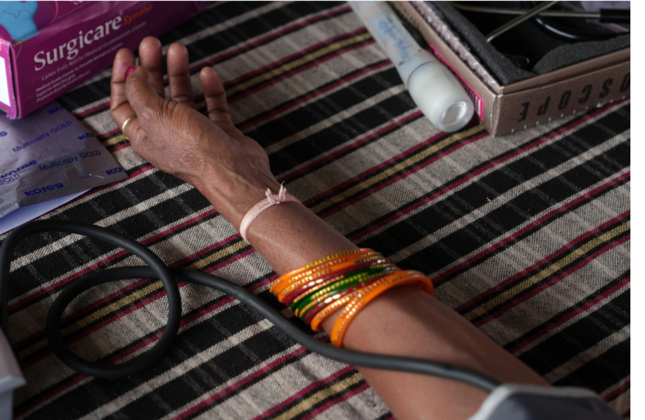
Like India, Bangladesh chose VIA because of its “simplicity, low cost, potential for immediate linkage with investigations/treatment and the possibility of rapid training to the service providers”. But unlike India, it has implemented the programme nationwide, conducting 3.36 million VIA tests in 465 government hospitals in 8 years (2014-2022) with systematic data on screening and treatment. The testing saw an 83.3% increase from 2014 to 2022.
Bangladesh set up a National Centre for Cervical and Breast Cancer Screening and Training (NCCBCST) at the Bangabandhu Sheikh Mujib Medical University (BSMMU), its premier medical university, to train service providers, and improve the quality of screening. The programme was gradually extended to sub-district health centres.

The women who are found VIA positive are referred to colposcopy clinics at designated hospitals across the country. There are now about 600 VIA and clinical breast examination facilities at primary, secondary and tertiary level health care facilities of 64 districts of Bangladesh. The loss to follow up is only about 20%. The programme’s success can be attributed to the government’s financial support to the development of nationwide screening centres and training programmes, says Ashrafun Nessa, professor, department of gynaecological oncology, BSMMU.

Indigenous HPV Vaccine

HPV vaccination to prevent cancer in girls has been adopted by over 100 countries for more than two decades. India’s neighbours Bhutan, Indonesia, Sri Lanka, Thailand, Myanmar, Maldives have included it in their universal immunisation schedule, and some have included it even for boys. In April 2022 WHO’s expert committee on immunisation said that evidence shows that single-dose HPV vaccination gives as much protection as two or three dose HPV vaccines — welcome news for countries with limited health budgets like India. Also, India’s indigenously developed quadrivalent vaccine Cervavac by Serum Institute of India and the department of Biotechnology is priced at Rs. 2000 per dose, far cheaper than other brands (priced Rs. 3000-3500).

India may announce the national rollout of the HPV vaccine soon. But in the past, the HPV vaccination in India had a bumpy ride. In the public sector, bivalent and quadrivalent vaccines were licensed in the country in 2008. However, after media uproar and investigation into the deaths of seven girls in 2009, which revealed many lapses in HPV vaccines observation studies in Andhra Pradesh and Gujarat, the Parliament shut down the projects. Delhi, Punjab and Sikkim had pilots of cervical cancer vaccination but only Sikkim scaled up and implemented cervical cancer vaccination in universal immunisation.

The Sikkim government introduced HPV vaccines for 9-13-year-old girls primarily through school-based vaccination, targeting approximately 25,000 girls. The government reached out to the public through targeted efforts and achieved coverage of 95% of its targeted population, with minimal refusal and with no adverse events. “Factors identified for successful vaccine introduction included strong political commitment, statewide mandatory school enrollment, collaboration between health and education departments at all levels, and robust social mobilisation strategies,” said a 2022 study published in the journal Vaccine.

Newer, Better Prevention Solutions

Recent evidence also points that while training health workers to do visual inspection using acetic acid works for low-resource settings, an HPV DNA test is a more sensitive test. In 2021, WHO changed its guidelines from recommending VIA for low-resource settings to HPV DNA testing as the first choice as a screening method for cervical cancer prevention. It said that HPV DNA testing is more efficient than both pap smears and VIA and more objective and less prone to human errors. WHO has recommended HPV DNA testing for women above 30 years every 5-10 years.
Kanan Desai from the National Cancer Institute, US, says HPV DNA tests are more accurate in detecting pre-cancers. “They can be done in a simple way using a self-sampling approach where women will use a specific brush to collect vaginal samples. This simple, acceptable, and nonpainful approach is used in many countries worldwide.”

While the cost of conducting an HPV test (Rs. 1000) seems high for population-level screening, it is the only way that cervical cancer will be eliminated. “VIA can lead to early detection of cancer but HPV test detects infection that can prevent lesions and thus cervical cancer,” said Mridu Gupta of CAPED India. But first, we need women’s health to be a matter of priority, she said.
[Correction: The earlier version of the story had mentioned WHO recommends HPV DNA testing twice in a lifetime; it’s been corrected to once every 5-10 years.]

