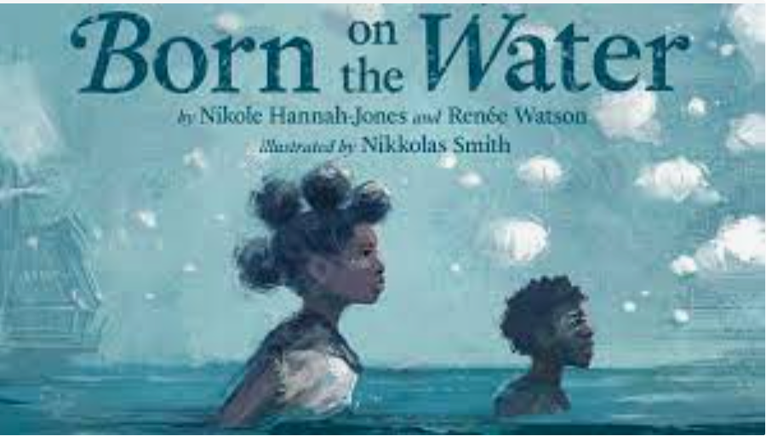

Artists from _____’s class painted personal stories about **the themes of head, heart and hands**, inspired by the book, *Born on the Water*.

They created **story quilts**, inspired by the artist, Faith Ringgold.

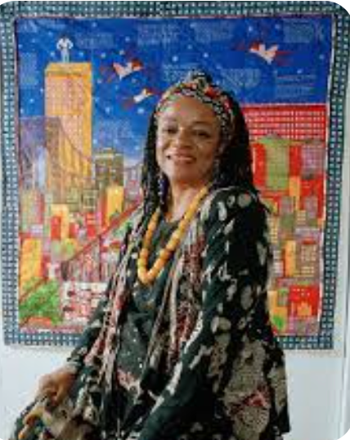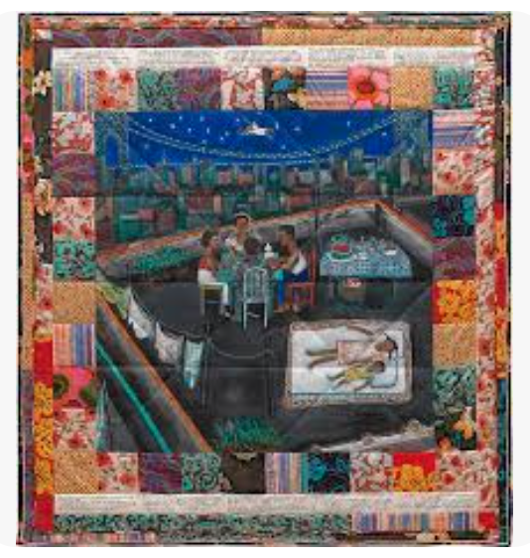

Sources:

https://www.britannica.com/biography/Faith-Ringgold

https://philamuseum.org/collection/object/86892