Name: ______________________________ Date: ___________ Period #: _________

World Studies
Unit 5 - Our Water, Our Ways
Socratic Seminar Prep

Driving Question: What do people in Chicago and the surrounding areas need to know about their drinking water?

Directions: Identify quotes that will help you answer each of the driving questions.

Question 1: How did the reversal of the Chicago River impact the quality of freshwater from Chicago to St. Louis?
Quote | Your Thoughts
“Justice Oliver Wendell Holmes wrote that the Mississippi was…foul - but the putrid waters couldn’t be blamed entirely on Chicago, since several other cities much closer to St. Louis were also discharging their waste into the river.”
Conditions in the summer of 1911 of the Illinois River: “The water…was grayish and sloppy, with foul, privy odors distinguishable in hot weather”

Question 2: Why did Chicago decide to re-reverse its river in 2023? What are some possible impacts of that decision?
Quote | Your Thoughts
“…after heavy rain over the weekend caused the district to make a rare and hazardous condition allowing untreated floodwater from Chicago River into Lake Michigan to relieve pressure on the system.”
“Need to protect the public from flooding”

Question 3: What do people in Chicago and the surrounding areas need to know about their drinking water?
Quote | Your Thoughts

Your Questions
Directions: Write at least two questions you would like to try to answer during seminar. Your questions should be based on any of the sources we have looked at related to Chicago’s water supply.

Question 1 | Question 2

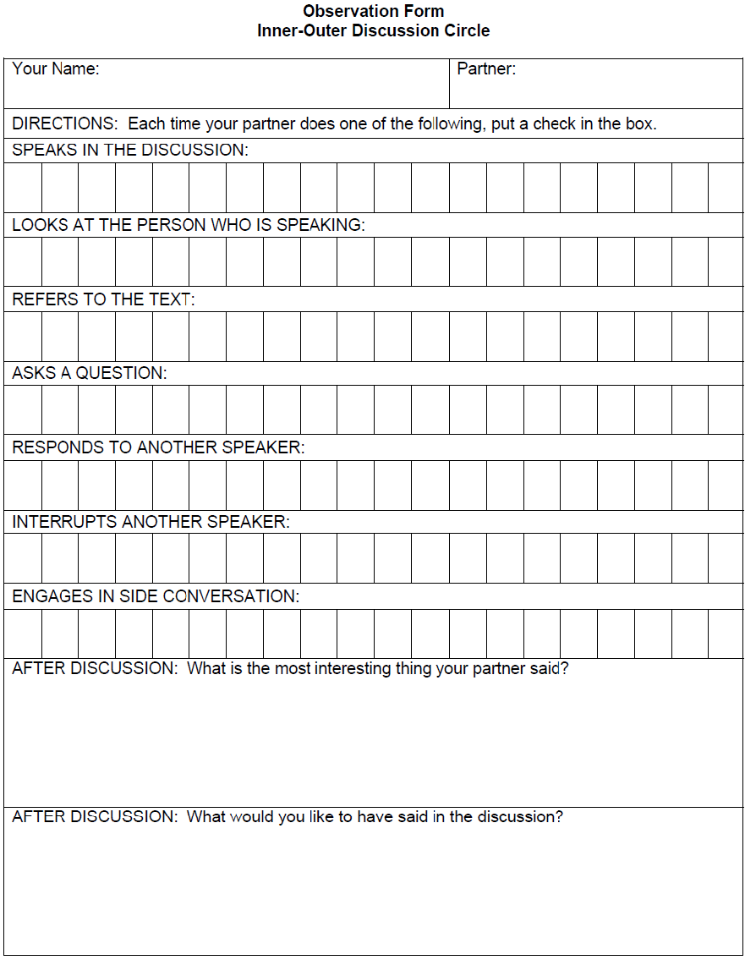
After Seminar…

Score yourself on the Seminar rubric!
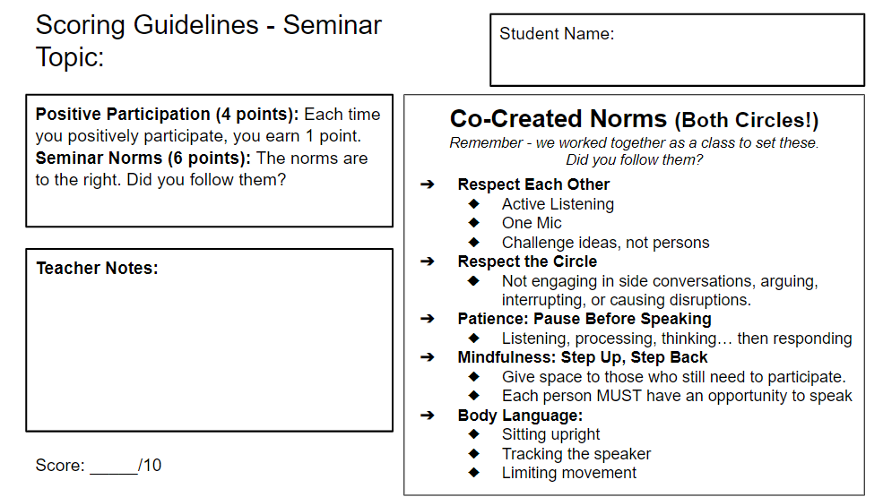

Explain the score you gave yourself:

____________________________________________________________________________________________________________________________________________________________________________________________________________________________________________________________________________________________________________________________________________________________________________________________________________________________________________________________________________________________________________________________________________________________________________________________________________________________________________________________________________________________________________________________________________________________________________________________________________________________________________________________________________________________________________________________________________________________________________________________________________________________________________________________________________________________________________________________________________________________________________________

