Reading the News Through a Public Health Lens

Almost any story you encounter in the news can be read as a story about health if you apply a public health lens. While you read, think about questions like: How do the events, decisions, or circumstances described in this story impact people’s health and wellbeing?

By answering this question, you are identifying social determinants of health, which the CDC defines as “conditions in the places where people live, learn, work, and play that affect a wide range of health and quality-of life-risks and outcomes.” The graphic below offers an incomplete list of social determinants of health, visualized here as the roots of a tree. If these roots are strong, health outcomes are more likely to be positive. If the roots are weak, health outcomes will suffer.

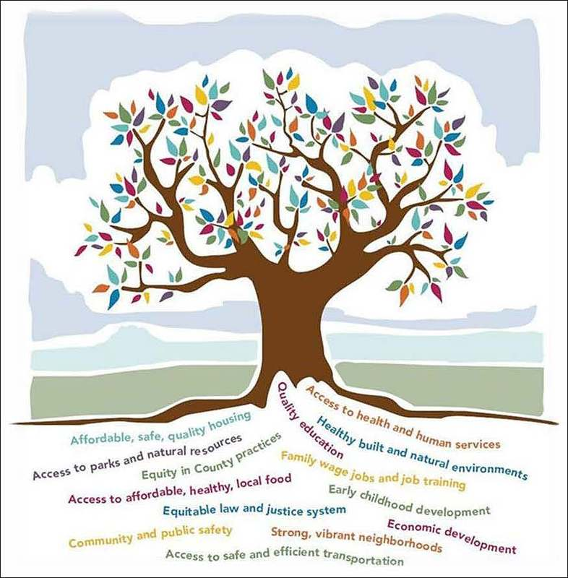
Courtesy of the Equity and Social Justice Initiative, King County, Washington
Activity Directions

Step 1. Select a story from the list below.
Step 2. While you read, use the graphic organizer (page 3) to record what social determinants of health you can identify the story.
Step 3. After you read, use your public health lens to evaluate how each story could be considered a story about health, and to brainstorm public health approaches to addressing the issues in the story.

- Milwaukee Evictions Spurred by COVID-19, Longstanding Racism, and Poverty
  - Issues: Housing, racial justice, pandemics
- Portraits of Drought: Farmers Struggle To Adapt to Arid Conditions in Kunene
  - Issues: Food security, environment and climate change
- The Future of Labor Advocacy is as Diverse as Workforce
  - Issues: Workers’ rights, racial justice
- Looking to Women To Shape the Future of Berlin’s Transportation
  - Issues: Infrastructure, gender equity, environment and climate change
- How Three States in the U.S. Made College Illegal for Undocumented Students
  - Issues: Education, migration
- NYC’s Trees: A Natural Defense Against Heat, but Not Equally Shared
  - Issues: Air pollution, housing, race relations, U.S.
- New Drone Technology Could Make It Easier To Clear Bombs, Mines in Ukraine [Video]
  - Issues: Conflict, technology
- ‘People of the Forest’: Indigenous Indonesians Stake Claim to Land
  - Issues: Land rights, Indigenous rights, environment and climate change
- A Crisis of Connectivity: Internet Access in Rural Pennsylvania
  - Issues: Technology, infrastructure
- Police Violence Against Dominicans in Puerto Rico Suggests Systemic Problem
  - Issues: Policing, racial justice, migration
- Queer Lives in India: Long Shadows in the Sunset
  - Issues: LGBTQIA+ rights, aging, housing
- How Denmark’s Welfare State Became a Surveillance Nightmare
  - Issues: Technology, governance
- Mexican Government Vows To Continue Legal Fight Against U.S. Gun Manufacturers
  - Issues: Gun violence, trade, governance
- In Venezuela, Women in Prison Awaiting Trial Endure Crowded Conditions
  - Issues: Criminal justice
- The Hidden Costs of Flooding in D.C.’s Poorest Wards
  - Issues: Environment and climate change, infrastructure, racial justice
Story Notes

Story title: _______________________________________________________

Issue(s) in this story: _______________________________________________

________________________________________________________________

What social determinants of health can you identify in this story? | 1. _______________________________________  ________________________________________  2. ______________________________________  ________________________________________  3. ______________________________________  ________________________________________
What makes this a story about health? (How do the events, decisions, or circumstances described in this story impact people’s health and wellbeing?)
What public health approaches to the issues in this story can you imagine? (Think about solutions that would prevent negative health effects for large groups of people.)

