CULTURAL DIVERGENCE
Despite the concept of the “melting pot” in the United States, there are specific celebrations that diverse groups of people enjoy. Kwanzaa is an annual celebration of African-American culture from December 26 to January 1, culminating in a communal feast called Karamu, usually on the sixth day.It was created by activist Maulana Karenga, based on African harvest festival traditions from various parts of West and Southeast Africa. Kwanzaa was first celebrated in 1966.
Kwanzaa celebrates what its founder called the seven principles of Kwanzaa, or Nguzo Saba (originally Nguzu Saba – the seven principles of African Heritage). These seven principles are all Swahili words, and together comprise the Kawaida or "common" philosophy, a synthesis of nationalist, pan-Africanist, and socialist values.
Each of the seven days of Kwanzaa is dedicated to one of the principles, as follows:
- Umoja (Unity): To strive for and to maintain unity in the family, community, nation, and race.
- Kujichagulia (Self-determination): To define and name ourselves, as well as to create and speak for ourselves.
- Ujima (Collective work and responsibility): To build and maintain our community together and make our brothers' and sisters' problems our problems and to solve them together.
- Ujamaa (Cooperative economics): To build and maintain our own stores, shops, and other businesses and to profit from them together.
- Nia (Purpose): To make our collective vocation the building and developing of our community in order to restore our people to their traditional greatness.
- Kuumba (Creativity): To do always as much as we can, in the way we can, in order to leave our community more beautiful and beneficial than we inherited it.
- Imani (Faith): To believe with all our hearts in our people, our parents, our teachers, our leaders, and the righteousness and victory of our struggle.
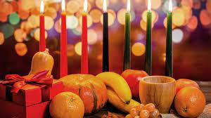

Kwanzaa is celebrated the day after Christmas. There are many people in the United States who celebrate both holidays. How are they different?

CULTURAL CONVERGENCE
Popular culture is widespread, global scale, and a mixture of many different cultures in one place.
One of the most important parts of culture is food! Food is also one of the first parts of culture to be shared and to spread. Food is a big part of holidays, traditions, religions, and everyday life for all cultures.
The United States has more cultures than any other nation on Earth! This nation of immigrants was built of cultures from all over converging here, and living together.
Another rice-based food that Americans like eating is Rice pudding. But did you know rice pudding also originated in Africa? Rice pudding is a versatile food since it can be enjoyed as a main dish, the dessert, or even just as a snack throughout the day. Ever since rice pudding arrived in the US, it’s become a favorite food for many Americans. It’s a fast dish that you can easily prepare at home. In addition to rice, it also includes ingredients such as milk, cinnamon, water and raisins. You can find this dish in a variety of flavors, adding or taking out ingredients depending on how you intend to consume it.

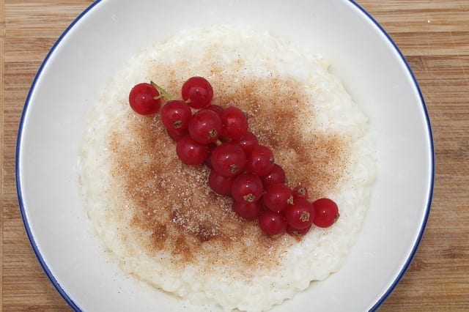

American Rice Pudding

Ingredients
- 2 1/2 cups (600ml) whole milk
- 1/3 cup (66g) uncooked short grain white rice (see Recipe Note)
- Pinch salt
- 1 large egg
- 1/4 cup (50g) dark brown sugar, packed
- 1 teaspoon vanilla extract
- 1/4 teaspoon cinnamon
- 1/3 cup (40g) raisins

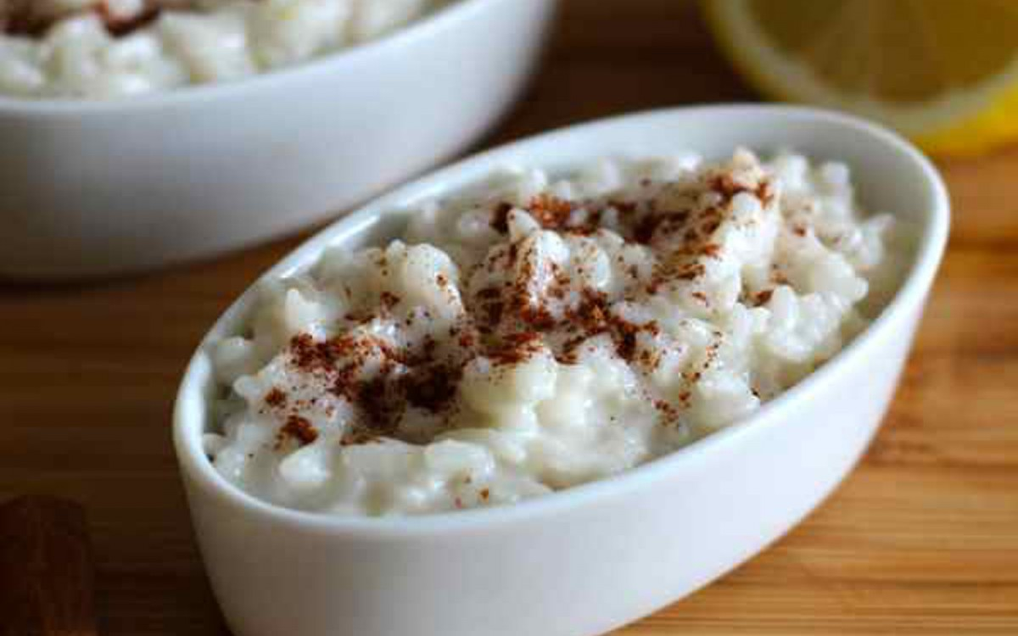
African Version of Rice Pudding
- 5 cups coconut milk
- Zest of 1 large lemon
- 1 cup sugar
- 1 cinnamon stick
- 1 1/4 cups white rice
- A pinch of salt
- Ground cinnamon, to taste
Examine the two recipes and explain why you think the recipe for rice pudding has been modified since arriving in the United States
Sources:
Kwanzaa Definition
https://en.wikipedia.org/wiki/Kwanzaa
American Rice pudding recipe
https://www.simplyrecipes.com/recipes/rice_pudding/
African Sweet Rice
https://www.onegreenplanet.org/vegan-recipe/african-sweet-rice/

