UNIT OVERVIEW

Unit Title | Whole Book Approach to Born on the Water
Unit Length | 2+ weeks/ 11 lessons
Grade Level(s)/Subject(s) | Kindergarten (Can be used in any of the primary grades K-3)
Unit Overview | Read-aloud storytime is a treasured part of Kindergarten. Too often young learners are “read to” instead of “read with.” This unit uses the Whole Book Approach which treats the picture book as an art form and invites children to analyze and critique all the physical elements of a picture book to help make meaning of rigorous text. This approach to story time was developed by Megan Dowd Lambert, in association with The Eric Carle Museum of Picture Book Art. We encourage teachers to read her book Reading Picture Books To With Children: How to Shake Up Storytime and Get Kids Talking About What They See for examples of techniques to use. Many picture books about enslavement and resistance contain difficult text for 5- and 6-year-old students. Using the illustrations as a springboard, these concepts are more accessible to understand.  The unit uses a text set that addresses enslavement and themes of resistance, resilience and hope, which is also developmentally appropriate for the target age (5–7-year-old’s). The daily lessons introduce various elements of picture book design and provide an opportunity to discuss the importance and impact of these elements for the respective stories. The book elements include: the jacket and covers, endpapers, front matter, typography, page design, gutter, frames, trim size, orientation, and back matter. The second week of the unit concludes with a detailed analysis of these elements in Born on the Water by Nikole Hannah-Jones and Renée Watson. Students will complete text reflection responses for each story in the text set and each poem in Born on the Water. The reflections will ask students to use details from the stories to identify the emotions of the characters, describe why characters act in particular ways, and make text-to-self connections.  The culminating lesson (Day 11) involves a class discussion to review each of the books in the text set to make some syntheses of their learning about enslavement, resistance and resilience. Students then create their own collage posters to illustrate their understanding of what it means “To be born enslaved” and “To be born on the water”…  One word about the lesson plan design: The Whole Book Approach focuses on student discussion of the illustrations and the connection of the art to text. The approach encourages students to drive the discussion. Given their young age and limited experience discussing such weighty topics, questions in bold are written for potential use to help guide the discussion, as needed. After implementing the lessons as written, it became clear that the writing component of the Performance Tasks should be completed in a separate time slot later in the day. The story discussions are invaluable and will take a while. Don’t skimp—and do the writing later when the children’s energy is fresh.
Objectives & Outcomes | I can tell the difference between an author and illustrator—and name them for a story. Students will complete a two-column notes chart for the set of picture books.  I can look at various elements of the book art and tell why they are important. Students will help the teacher label a poster of book parts.  I can analyze an illustration and talk about the connection of the picture to the text.
Standards | Common Core Standards:  CCSS.ELA-LITERACY.RL.K.6  With prompting and support, name the author and illustrator of a story and define the role of each in telling the story.  CCSS.ELA-LITERACY.RL.K.7  With prompting and support, describe the relationship between illustrations and the story in which they appear (e.g., what moment in a story an illustration depicts).  CSS.ELA-LITERACY.RL.K.10  Actively engage in group reading activities with purpose and understanding.  CCSS.ELA-LITERACY.RL.K.3  With prompting and support, identify characters, settings, and major events in a story.  CCSS.ELA-LITERACY.RF.K.1  Demonstrate understanding of the organization and basic features of print.  CCSS.ELA-LITERACY.RF.K.1.A  Follow words from left to right, top to bottom, and page by page.  CCSS.ELA-LITERACY.W.K.1  Use a combination of drawing, dictating, and writing to compose opinion pieces in which they tell a reader the topic or the name of the book they are writing about and state an opinion or preference about the topic or book (e.g., My favorite book is...).  CCSS.ELA-LITERACY.W.K.3  Use a combination of drawing, dictating, and writing to narrate a single event or several loosely linked events, tell about the events in the order in which they occurred, and provide a reaction to what happened.  CCSS.ELA-LITERACY.L.K.4  Determine or clarify the meaning of unknown and multiple-meaning words and phrases based on kindergarten reading and content.
Facilitation Resources | Texts from The 1619 Project  Born on the Water by Nikole Hannah-Jones, Renée Watson, Nikkolas Smith  Additional focus texts:  The Year We Learned to Fly by Jacqueline Woodson, illustrated by Rafael Lopez  The Oldest Student: How Mary Walker Learned to Read by Rita Lorraine Hubbard; illustrated by Caldecott Honor Winner Oge Mora  Your Legacy: A Bold Reclaiming of Our Enslaved History by Schele Williams; illustrated by Tonya Engel  Dave the Potter: Artist, Poet, Slave by Laban Carrick Hill; illustrated by Bryan Collier  A Birthday Cake for George Washington by Ramin Ganeshram; illustrations by Vanessa Brantley-Newton  Teaching Materials:  Graphic organizers: After teaching the unit, we concluded the Performance tasks should be implemented in a separate writing block. To help students better understand and remember key details, we created graphic organizers that can be filled out in the whole group during or after the read aloud session.  The Year We Learned to Fly Graphic organizer[.pdf][.docx]  The Oldest Student: How Mary Walker Learned to Read graphic organizer [.pdf][.docx]  Your Legacy: A Bold Reclaiming of Our Enslaved History Graphic organizer [.pdf] [.docx]  Dave the Potter: Artist, Poet, Slave Graphic Organizer [.pdf][.docx]  Performance Task—Reading Response Journals for all lessons [.pdf] [.docx]  A Birthday Cake for George Washington Performance Task Graphic Organizer [.pdf][.docx]  Book Model: It is highly recommended you make a book model to help teach the vocabulary for elements of book design. The resources section includes PDF for vocabulary words and a PDF with an example model. We used foam poster board for the covers and posterboard for the pages. The vocabulary words are attached with Velcro dots, so they can be added to the model as introduced in various books. Choose pictures to match the vocabulary words.  Images with whole-book approach vocabulary that will be used throughout the unit [.pdf]  Book model vocabulary [.pdf][.docx]  Performance Task Reading Response powerpoint for all lessons [.pptx]  Performance Task rubric for all lessons [.pdf][.docx]  Images with whole-book approach vocabulary that will be used throughout the unit [.pdf]  Additional readings to prepare for this unit:  “When are children old enough to learn about slavery?” by Joe Heim for The Washington Post  Dowd Lambert, Megan. (2015) Reading Picture Books To With Children: How to Shake Up Storytime and Get Kids Talking About What They See  “Amid Controversy, Scholastic Pulls Picture Book About Washington's Slave : The Two-Way” by Eyder Peralta for NPR  “NOT Recommended: A Birthday Cake for George Washington” by Allyson Criner Brown for Teaching for Change  “A Birthday Cake for George Washington: The Problem with Banishing Books” - National Coalition Against Censorship
Performance Task(s) | Students engage with text reflection responses for each book in the text set. Performance tasks appear at the end of each daily lesson.  Performance Tasks for each lesson [.pdf] [.docx]
Assessment/Evaluation | Performance Tasks rubric [.pdf][.docx]  Rubrics for each performance task are also located at the end of each lesson.

DAILY LESSONS AND RESOURCES

Day 1:

Students analyze The Year We Learned to Fly using the whole-book approach in order to open up a discussion about the history of enslavement and students’ connections to their ancestors.

Lesson Objective(s) or Essential Question(s)
I can tell the difference between an author and illustrator—and name them for a story. Students will complete a two-column notes chart for the set of picture books.
I can look at various elements of the book art and tell why they are important. Students will help the teacher label a poster of book parts.

I can analyze an illustration and talk about the connection of the picture to the text.
Lesson Materials & Resources
The Year We Learned to Fly by Jacqueline Woodson, illustrated by Rafael Lopez
Graphic organizer_Lesson 1 [.pdf][.docx]
Performance Task—Reading Response Journal page 1 [.pdf] [.docx]
Performance Task Reading Response powerpoint slide 1 [.pptx]
Performance Task rubric [.pdf][.docx]
Images with whole-book approach vocabulary that will be used throughout the unit [.pdf]
Lesson Activities
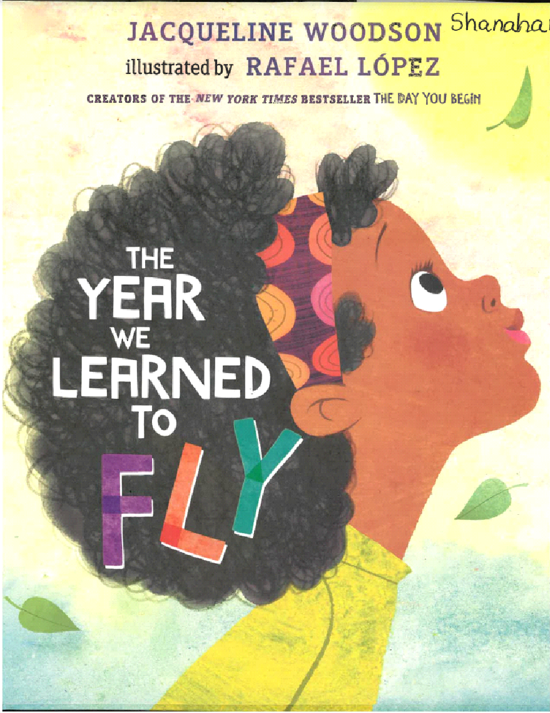
The Year We Learned to Fly is the newest children’s book from Jacqueline Woodson and illustrated by Rafael Lopez. One concern for teaching slavery to especially young children is the content can be traumatizing. The use of this text to introduce the unit is purposeful. The story focuses on resilience—using one’s voice to be oneself—within a backdrop of using what we learned from our ancestors.

- Guide students in a discussion about the jacket of the book using the instructions below. Questions for students are in bold:
- Introduce the jacket as the protective paper or cloth covering over a hardcover book.
- Front cover: What do you see? Why do you think the girl is looking up? Introduce typography as the style and appearance of text on the page. How are the letters in the title different? (Fly is larger and colored.) Why did the illustrator choose to set off the idea of flying? All the title words are on the girl’s hair—Why?
- Front jacket flap: Why does the bird have a chain on its leg? What does it mean that the chain is broken?
- Guide students in a discussion about the endpapers for the book using the prompts below:
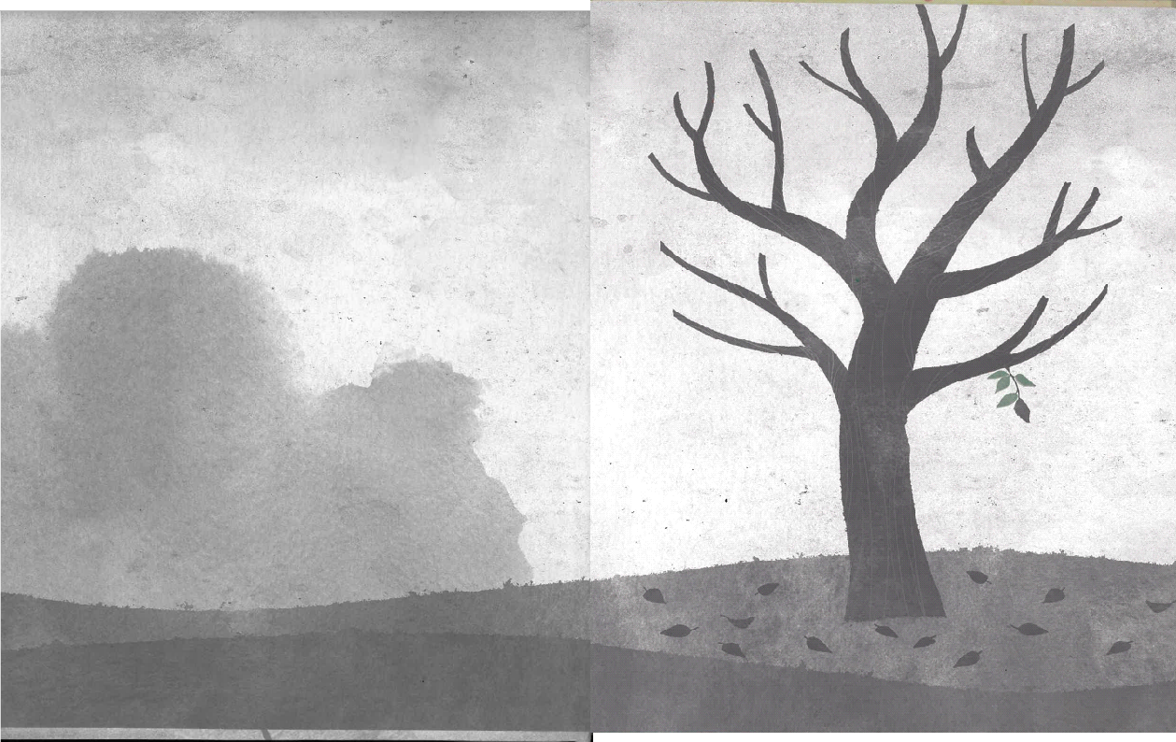
- Introduce end papers as the pages glued onto the inside of the front and back boards of a hardcover book. The end papers can be decorated or solid colors. They usually connect to one or more themes in the story.
- Front: What do you see? (dreary grays; tree bare) How does it make you feel? (connect to dreary, stuck-inside, kind of house)

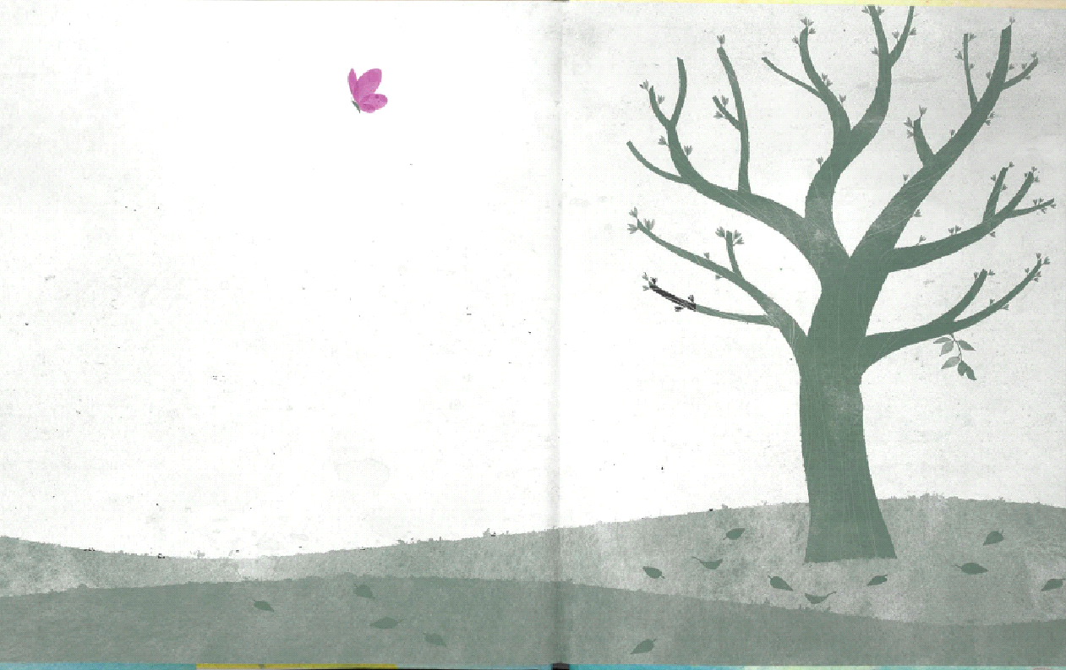
- Back: What do you see? (green hues; blossoms on trees) How does it make you feel?

Title page:
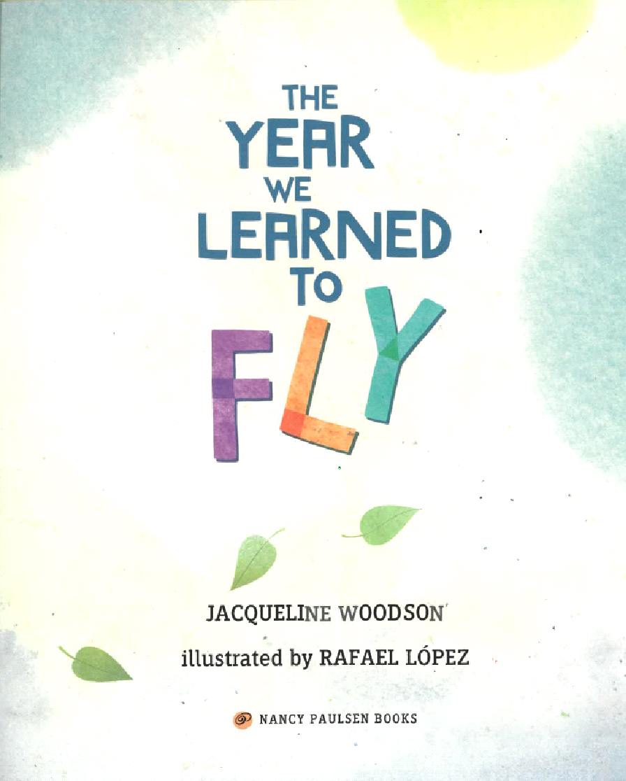
- Note the leaves on the title page. What do these leaves remind you of earlier in the book? (leaf motif on jacket and end papers)
- The type on the title is blue on white (except Fly)—while the jacket cover is white type on black. Why did the illustrator make this choice?

3. Continue to use the instructions below for each page in the book. The opening line for the page referenced is written in italics.

That was the year…
- What is hanging from the tree? (chrysalis) Why did the illustrator choose this as a symbol?

That was the spring…
- Introduce names of pages—verso is the left side of a book; recto is the right side. What is happening in the story? How does it make you feel?
- Introduce double page spread as an illustration that crosses the gutter (the vertical seam between the verso and recto pages). The double page spread invites the reader into the picture. Why are all the kids looking up at the sky?
- Introduce full bleed, an illustration where the color extends all the way to the edges of the pages—either verso, recto, or double page spread.
- Introduce knock-out type as white text located on black or dark background. This type provides a contrast that can be dramatic or help us to see more. Why do you think the sky is purple?
- Introduce italics as slanted text used to emphasize a word or phrase. It also can denote a character’s thoughts. What is Grandma trying to tell the kids?

So my brother and I closed our eyes…
- Note the full-bleed, double page spread with knockout type on the apartment wall.
What do you see in the picture? What is happening? Why are the bird and the butterfly flying over the kids?
- Note the scale of the pictures—big buildings and very small flowers. (The children are small compared to the buildings.)

We were flying…
- Read the text first. The text says, “We were flying.” Where are the children? (Be sure they connect the bird and butterfly to the children.)

That was the summer…
- Note this is the first time the text is on both verso and recto pages.
- What do you think it means, “That was the summer we learned to fly.”?

My grandmother said…
- Note the italics again. Grandmother is talking again. Connect the text to the ancestors—somebody, somewhere, at some point.
- What do you see? (bird on brother; butterfly on sister)

So we did…
- What’s going on in this picture? Why are the children in the window looking at them with those expressions?
- Why do you see the bird and not the boy?

That was the autumn…
- Note the knock-out type again. What page does this remind you of in the story?
- Note the book the children are reading—it is another Jacqueline Woodson-Rafael Lopez book (The Day You Begin). What similarity does this book have to the one we are reading?

My grandmother had learned to fly…
- What is going on in this illustration? Why are the boats in the girl’s hair? Introduce the ships that came from Africa bringing ancestors across the Dark Passage. Why does the bird have a chain on its feet? Review the italics as grandmother’s words that describe the process of enslavement in the transatlantic slave war. What does it mean that “nobody can ever cuff your beautiful and brilliant mind”?

So our people learned to fly…
- Who are on the leaves? Why are they looking up? Note the recurring leaf motif.

That was the winter…
- Note full bleed, double page spread with knock-out type on the roadway.

…to a street…
- What’s going on in this picture? How do the children feel?
- Note the italics—this time the words are coming from sister, rather than grandmother.

So like the people…
- What do you see in this picture? (picture matches text—"lift arms, close eyes, fly”)
- What do the birds and the butterflies represent? (connect to aunts, uncles, cousins, and minds)

For a long time…
- What’s happening now? (Come full-circle—others learn to fly from brother and sister.)

Back Matter: Review the note from author Jacqueline Woodson, where she speaks of her experience learning about enslavement. A different book from her youth showed the author and gave her wings to fly.

Endpapers: Refer to front endpapers. How do these end papers differ from those in the front? Why do they change?

4. After reading, students use the graphic organizer for The Year We Learned to Fly to analyze three images from the book.
5. At the end of the lesson, students make a text-to-self connection by responding to the prompt “Something I learned from one of my ancestors is…” in the performance task graphic organizer.

Day 2:

Students analyze The Oldest Student: How Mary Walker Learned to Read using the whole-book approach in order to open up a discussion about the challenges faced by Black Americans post-Reconstruction, the ways that Black Americans persevered in the face of these challenges, and the feelings student experience as they engage with Mary’s story

Lesson Objective(s) or Essential Question(s)
I can tell the difference between an author and illustrator—and name them for a story.

I can look at various elements of the book art and tell why they are important.

I can analyze an illustration and talk about the connection of the picture to the text.
Lesson Materials & Resources
The Oldest Student: How Mary Walker Learned to Read by Rita Lorraine Hubbard; illustrated by Caldecott Honor Winner Oge Mora
The Oldest Student: How Mary Walker Learned to Read graphic organizer [.pdf][.docx]
Performance Task—Reading Response Journal page 2 [.pdf] [.docx]
Performance Task Reading Response powerpoint slide 2 [.pptx]
Performance Task rubric [.pdf][.docx]
Lesson Activities
The Oldest Student: How Mary Walker Learned to Read is a biography of Mary Walker, written by Rita Lorraine Hubbard and illustrated by Caldecott Honor Winner Oge Mora. Mary was born enslaved in 1848, at a time when it was against the law to teach people of color to read. The story tells about Mary’s journey out of bondage, through marriages, and into old age—all without learning to read until she was 116 years old.

- Use the text in bold to engage students in an analysis of The Oldest Student: How Mary Walker Learned to Read using the whole-book approach. Start with the front and back covers of the book.

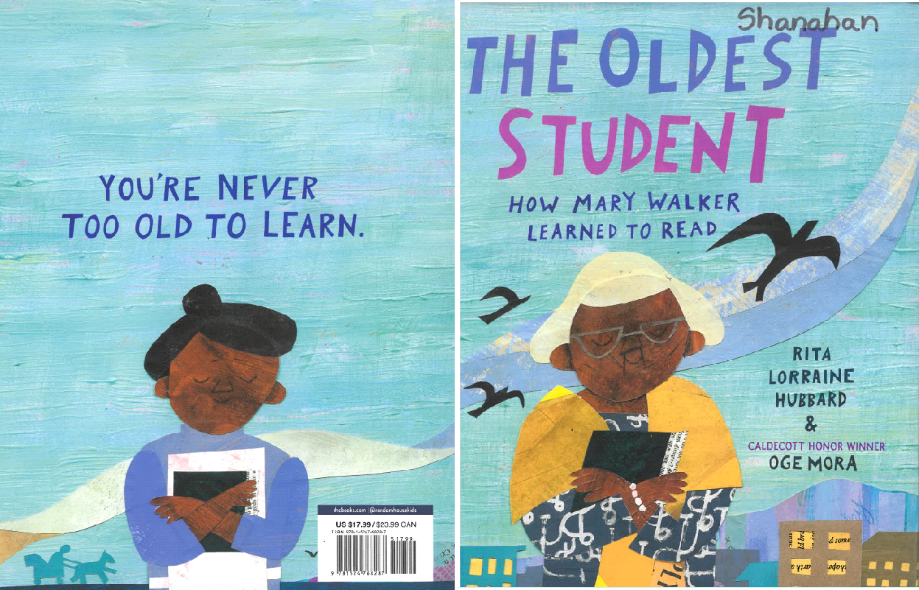
Jacket: Introduce wrap-around design.
- What do you see on the jacket? Who do you think the two women are? (same woman just at different ages)
- Why do you think the birds are important on the jacket cover? Do they remind you of something? (previous book talked about “flying” and freedom)

The Jacket Inside Flap gives a brief chronology of some important events in Mary’s life.
Read the chronology to preview what will happen in the story.

Remove the jacket to show the difference between the cover of the book itself and front cover.
- Note the front and back covers are not the same as the jacket art.
- How are the jacket and front/back covers different?
- Note the continuation of the bird motif. How do the birds relate to Mary’s life? Make a prediction.
- Introduce collage as an art form that uses different materials (paper, textiles, newspaper clippings, and other objects.

Endpapers: Note the collage with several photos from Mary’s real life.
- Why is she so old in all the photos? Why are there no photos when she is young? (Share that the focus is on when she is learning to read at an old age; cameras were not widely available for family photos until Mary was in her 50’s)
- Note end papers in back are the same photos.

- Title page: Read the title—teach about the subtitle as adding more information about the title—this subtitle names the oldest student, Mary Walker.
- Why do you think the word “STUDENT” is a different color from all the other words?

- Continue to use the instructions below for each page in the book. The opening line for the page referenced is written in italics.

Whenever young Mary Walker was tired…
- Note Full-bleed art (extends all the way to the edge of pages); double pages- cross the gutter to draw the reader into the full picture.
- What is going on in the picture?
- Why do some of the pieces in the collage include words and music?
- Note the italics—review that the italics can be words or thoughts spoken by a character. Mary says about the birds, “That must be what it’s like to be free.”

But Mary didn’t watch for long…
- Note that on some pages the gutter separates two different pictures on verso and recto pages—this slows the pacing of the story.
- Typography: Note the knock-out print on verso side. Why are the words “Keep Working!” in a different color, size, and all in capital letters? (It is the first rule of the plantation; It describes Mary’s life.)
- Note words in the fireplace on the recto page.
- Italics—more of Mary’s words—“When I am free, I’ll go where I want and rest when I want. And I’ll learn to read, too.” (Remind students of the 2nd Rule of plantation—the enslaved are not taught to read.)

When she was fifteen…
- Explain the Emancipation Proclamation as an order by President Lincoln that announced that all enslaved persons shall be free.
- What is going on in this picture? Where are the people going?
- Why do you think the illustrator changed the type, size, and font for “Freedom Road! Freedom Road!”?

Others, like Mary…
- On the verso page—What do you think Mary is feeling? Why do you think that?
- Why is life so hard in freedom?

One day, Mary met a group of evangelists…
- What is coming out of the preacher’s mouth? (a physical representation of the preacher’s sermon)
- What book is Mary holding? Can she read it?
- Note the italics—Mary’s words—“I’m going to learn to read those words”

And tomorrow, too…
- Note the words printed as part of the sky on the verso page.
- Recto page—note more words on the wall. Read text—What does it mean to “make her mark?” (She wanted to read and write—but could only make her mark.)

One day, Mary’s husband…
- Note words on the ground.
- Why does Mary look so sad?
- Note the italics—Mary’s words—"More money, That’s what we need”
- Note that 50 years after Emancipation, there is still no time for Mary to learn to read/

By now Mary was sixty-eight…
- What is happening in the picture? (everyone has a book-reading & singing)
- Why is Mary holding the book if she cannot read it?

When Mary was well past ninety…
- On the verso page--Why do all the men have blue faces?
- On the recto page—Why does Mary look so sad?
- Note that the places that should have words (billboards) have squiggles. Why does the illustrator NOT have real words in places that should have words?
- Note Mary’s words in italics—“All this time…and they still look like squiggles.”

Mary had heard about a new reading class…
- Note the posters in the picture have more squiggles.
- What is happening in these pictures?
- Mary did not accept help from the man—why do you think that is?

For the next year and more…
- What is happening in this picture?
- What did Mary write?
- Note that her words are not squiggles.

One fine day Mary’s hard work paid off…
- Why do you think there are words on Mary’s dress?
- What do you notice about the sign on the wall? (The words are finally readable) Why are they real words and not squiggles?

Mary felt complete…
- What do you see in the picture? Why are there real words on the buildings?

Mary received many gifts…
- What do you see in this picture? Why is Mary flying?
- Read text—story comes full circle to feeling “as free as a bird”.

Each year, before her birthday…
- Why are all the words on Mary?

When she finished…
- Verso page—Why do you think the text is so much bigger, all capital letters, and a different color?
- Recto page—Back Matter—Author’s note gives details of Mary’s life.

- Students use the graphic organizer for The Oldest Student: How Mary Walker Learned to Read to identify and analyze details from the story.
- Students synthesize their discussion about the book by responding to the prompt “Mary made me feel _____ when she ______” using the performance task for lesson 2.

Day 3:

Students analyze Your Legacy: A Bold Reclaiming of Our Enslaved History using the whole-book approach, analyze the nine values presented in the book, and describe why one value is important to them.

Lesson Objective(s) or Essential Question(s)
I can tell the difference between an author and illustrator—and name them for a story.

I can look at various elements of the book art and tell why they are important.

I can analyze an illustration and talk about the connection of the picture to the text.
Lesson Materials & Resources
Your Legacy: A Bold Reclaiming of Our Enslaved History by Schele Williams; illustrated by Tonya Engel
Your Legacy: A Bold Reclaiming of Our Enslaved History Graphic organizer [.pdf] [.docx]
Performance Task—Reading Response Journal page 3 [.pdf] [.docx]
Performance Task Reading Response powerpoint slide 3 [.pptx]
Performance Task rubric [.pdf][.docx]
Lesson Activities
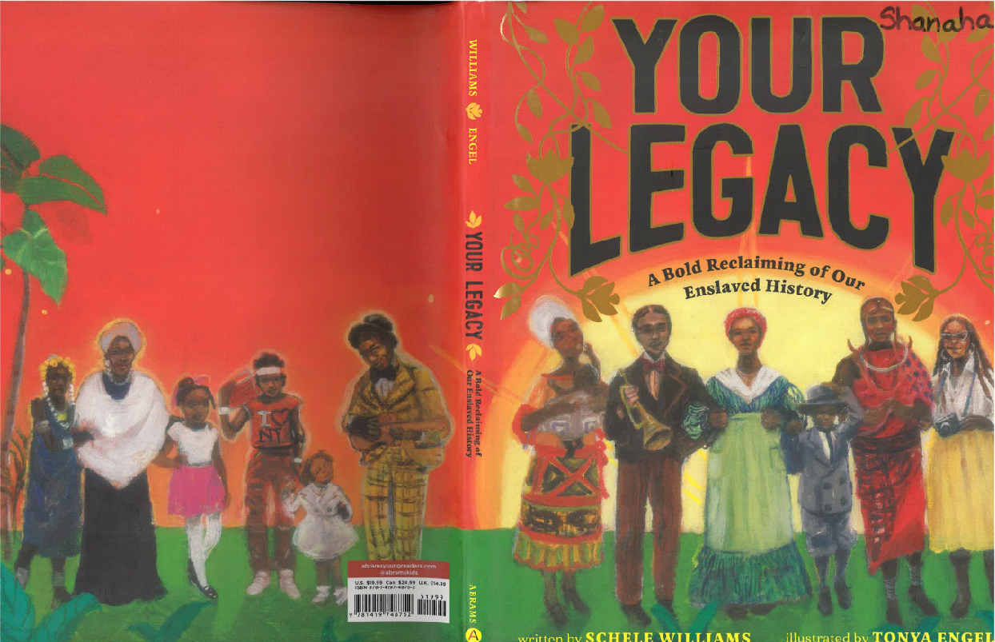
Your Legacy: A Bold Reclaiming of Our Enslaved History is a new book (2021) from author Schele Williams and illustrator Tonya Engel. The story serves as an introduction to African history that explains the enslavement of people 400 years ago in a manner that honors those enslaved and proffers an opportunity for today’s children to see their legacy in terms of 9 values of Love, Intellect, Courageous, Determination, Brilliance, Strength, Ingenuity, Grace, and Dignity.

- Introduce students to the book by reviewing the Jacket: Note the wrap-around design that denotes the length of time—such as a journey.
- What do you notice about the people on the jacket? Do they look like they belong together? Why or why not?
- Inside flap: Read and note that the text matches the story---Your story begins in Africa.
Clear statement of History begins in Africa before 1619.
- Front and Back Cover: Note the cover art differs from the jacket. What is going on in this picture? What do you see that makes you say that? Who is the blue lady? What is near her hands? Why do we see the roots of the trees?

- Guide students in an analysis of the Endpapers of the book: Why are there plants on the end papers? How are the end papers connected to the jacket and the front/back cover art?
- Front: Note green plants with yellow/gold background—What do you think about this design?
- Back: Note teal flowers and leaves with cantaloupe colored background—Why do you think there is a change? What does it mean?

- Continue to use the instructions below for each page in the book. The opening line for the page referenced is written in italics.

Title Page:
- What do you notice about the title and the subtitle? Why do you think the title is so much larger?
- What are the children doing? What are the circles around their heads?
- Note the symbolism of dandelions (wishes) and butterflies (symbol of flying and freedom)

Your story begins in Africa…
- What shape is around the people? (Match to text of Africa)
- Note the flowers match the end papers.

They believed their skin was blessed…
- What are the large words around the people? (Various words for hello in different African languages)
- What are the circles around people's heads? (Connect to the circles in previous pictures)

In the Summer of 1619…
- Review the knockout type that provides dramatic contrast.
- Note the use of “slave traders” language. Initiate discussion of alternate phrase “slave war”.
- Other stories refer to enslaved people in chains being forced onto boats. Does this idea match the illustrations on this page? Why do you think the illustrator chose dignified clothing and people choosing to enter?

When they finally landed in the Americas…
- Introduce frames to free the visual barriers between the reader and the book. Instead of drawing a reader into the story, the picture zooms into the situation.
- Note the knock-out text to provide the starkest contrast from previous colorful pages.
- Why is the text of LOVE so large? Introduce the idea of “values” as our beliefs that cause or motivate us to act in certain ways. Note that there are 9 values that will be highlighted throughout the story. As we read, students can discuss which values are important to them.

They needed to find a way to communicate…
- What is happening here? What are the people doing? (Explain the connection between the enslavement of people and the cultivation of cotton—especially for the use in textile mills in Lowell, where this unit was originally taught.)
- Note the large font for the second value of Intellect.

For some enslaved people…
- What do you see in this picture? Why are the people in the flowers? What do they remind you of?
- Note the use of words and musical notes embedded in the pictures.

Sometimes, escaping meant running away…
- What do you notice about the text on this page? Why did the illustrator choose to use the knock-out type?
- Why are there more musical notes here? (Refer to the text about the songs used to help enslaved people seeking freedom.)
Harriet Tubman
- What is going on in this picture? Why is there a train? Who is on the train? (Refer to the Underground Railroad and connect to work being done in Unit 2 in World Cultures class.)
Your ancestors were brilliant…
- What is this picture about? If the value is “Brilliance”, what do you think these people did that was brilliant?
- What are those circles with the people in them? What do they remind you of?

That innovation has never stopped…
- Why are there numbers all over the buildings? (Note the hidden people who built so many of the shops and images that we see everyday—compare to the text list)

Your ancestors never forgot…
- Who are these ladies?
- Why are they looking at the butterfly? (Refer back to the butterfly as a symbol of flight and freedom.)
Love…
- Why is there only one word on both pages?
- Do the vines on the verso page remind you of something?
- Why is there a broom there? (Teach about “jumping the broom” as a marriage tradition within the community of people who were enslaved.)
- What about the picture on the recto page connects to the value of Love?

Determination and Courage…
- What is happening across this double page spread?
- (Note that the Edmund Pettus Bridge was named after a Confederate Soldier and Alabama Senator. The name of the bridge was changed to Foot Soldier Bridge—although not changed on the actual bridge)

Brilliance, Dignity, Intellect, and Strength…
- Who do you think these people are and what do they do?
- Do you recognize anyone? (Note that we will be learning more about several of them as the year goes on.
- Why are some pictures with many people for one picture and others with many small pictures for one idea?

Ingenuity, Grace
- What do these people do?
- Do you recognize anyone?

Your ancestors passed down the best of themselves.
- What is happening in this picture? Where have you seen it before?
- What do you think the pods represent now at the end of the book?
- Who is the blue lady?
- How does the picture make you feel now?

Now take a deep breath…
- What is happening in this picture?
- Do any of the parts of the picture look familiar or connect to other pictures?
- Note the circular shape around the girl’s head.
- Connect the 9 values to the ancestors.

You are meant to do great things…
- What do you see here?
- Who is on that statue? Why is he on this page?
- What do you see on the trees?

Tree & Roots…
- What is here on this page?
- What are the words? Why are they there?

Back Matter: note from author Schele Williams—A descendant of enslaved Africans, the author talks about the lack of education about slavery during her early childhood. She writes that she authored this book so her two daughters would not feel shame as they learn about slavery.

4. After reading, students use the graphic organizer for Your Legacy: A Bold Reclaiming of Our Enslaved History to analyze examples of the nine values outlined in the book.
5. At the end of the lesson, students describe a connection to one of the values described in the book by responding to the prompt “The value of ______is important because…” in the performance task graphic organizer.

Day 4:

Students analyze Dave the Potter: Artist, Poet, Slave using the whole-book approach, analyze details from the true story of a potter who was enslaved, and describe a detail from the story that interested them.

Lesson Objective(s) or Essential Question(s)
I can tell the difference between an author and illustrator—and name them for a story.

I can look at various elements of the book art and tell why they are important.

I can analyze an illustration and talk about the connection of the picture to the text.
Lesson Materials & Resources
Dave the Potter: Artist, Poet, Slave by Laban Carrick Hill; illustrated by Bryan Collier
Dave the Potter: Artist, Poet, Slave Graphic Organizer [.pdf][.docx]
Performance Task—Reading Response Journal page 4 [.pdf] [.docx]
Performance Task Reading Response powerpoint slide 4 [.pptx]
Performance Task rubric [.pdf][.docx]
History File | Dave The Potter | CFile - Contemporary Ceramic Art + Design
“The Enslaved Artist Whose Pottery Was an Act of Resistance” by Jori Finkel for The New York Times

Lesson Activities
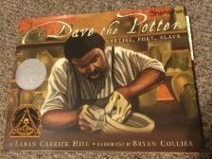
Dave the Potter: Artist, Poet, Slave is a non-fiction picture book written by Laban Carrick Hill and illustrated by Bryan Collier. The book earned both the Caldecott Honor Book medal (most distinguished American picture book for children—awarded to illustrator Bryan Collier; and the Coretta Scott King Award (most distinguished portrayal of African American experience in literature for children) in 2011.

- Introduce students to the book by reviewing the Jacket and Endpapers.
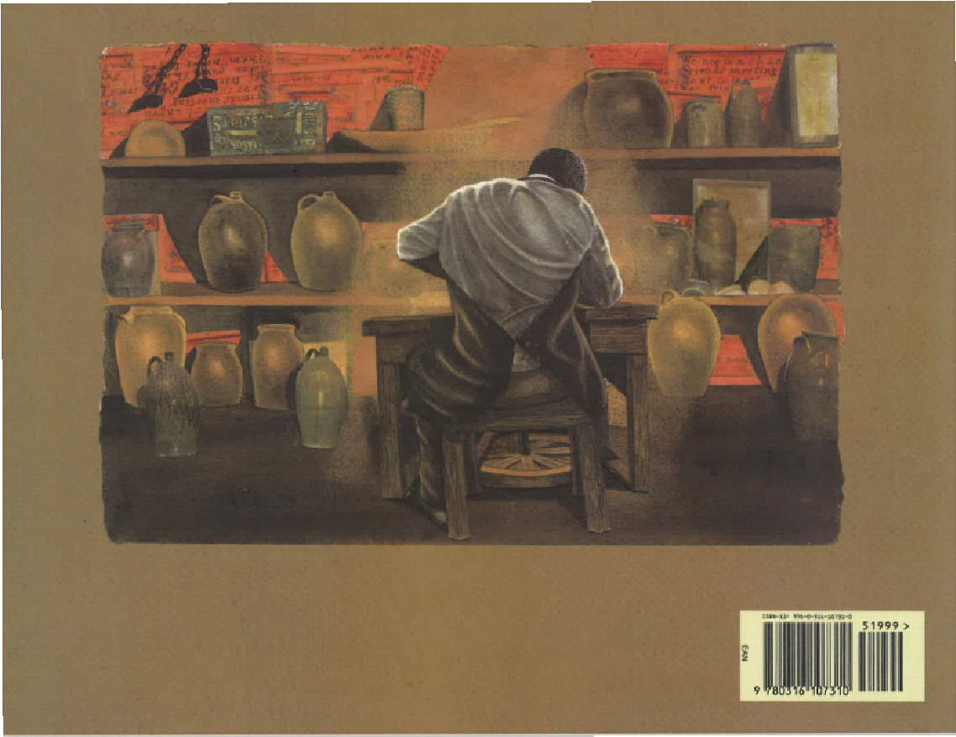
Jacket: It matches the dual page front and back cover of the book proper—except the award medals only appear on the jacket—What are these medals on the jacket? What do you think they are for?
- Front cover—It shows a picture of Dave the potter-from the front molding clay into a pot. Questions can focus on the importance of Dave’s artistic knowledge to make the pot, as well as the importance of skills for people who were enslaved that use one’s hands.
- Back cover is a separate picture of Dave-from the back-molding the same pot.

Endpapers: What is different about these end papers? (solid color—dark brown)
- Front and Back: Why do you think the illustrator chose this solid brown? What does it represent? (Dark brown to symbolize the dark brown clay)
- Introduce students to the orientation and title page of the book.

Orientation and Title page:
- Introduce landscape orientation—compare this to the three previous books with portrait orientation. Landscape lends itself to show the process (journey) of making clay art.
- Typography of the title: How does the typography of the text look different? (Old fashioned type because it is a book from the past—1800’s)
- Sub-title: “Artist, Poet, Slave”—Why is the “poet” part especially important? (People who were enslaved were not allowed to read and write)
- Continue to use the instructions below for each page in the book. The opening line for the page referenced is written in italics.

To us it is just dirt…
- How does this page look different from the illustrations in previous books? (These are full bleed pages that cross the gutter, but the picture is not full-page. Crossing the gutter invites participation, but the text is sectioned off with solid color background—Note that the picture is framed with more light brown edging on far recto side)
- How does the picture make you feel?
- Review collage as a form of media—Look at the grass—what do you notice? (Real grass in the picture.)

On wet days…
- What is going on in this illustration? (The collage has real pictures of pottery and real pictures of trees)
- Some clay is brown, but other clay can be red—note the background of the verso text with knock-out type.
- Make note of the fact that the text, “…learned to form a life as a slave” is similar to forming a pot from clay.

To us it is just a pot…
- What is different about this page? (Picture crosses gutter, but there is text on both verso and recto pages. This symbolizes that the pot means different things to different people over time—"to us” and “to Dave”.)
- Note text on verso speaks to modern audience—text on recto is about the past—Dave’s life
- Note the text is still framed on edges with those light brown fibers.

Each one began…
- Text is on the verso page only--but not a solid color—why do you think the illustrator made the change?
- What could the different shades of brown mean? (Different kinds of clay for Dave)
- Note the same collage for trees—real pictures of wood for the barn—makes the pictures realistic and help the audience know this really happened.

With a flat wooden paddle…
- Note the same collage aspects of trees, pots, wood—
- Frame on the recto edge adds wood accents to the light brown fibers.

He threw the clay…
- Same aspects of wood and pots from the collage

Dave kicked…
- Note the words on the walls—this is called intraiconic text –Why do you think the words are there?

Like a magician pulling…
- How is the type different? (Text descends on the page like stairs to contrast with opening the page flap and showing how the pot rises upward from the clay. Children have a physical way to see the contrast)

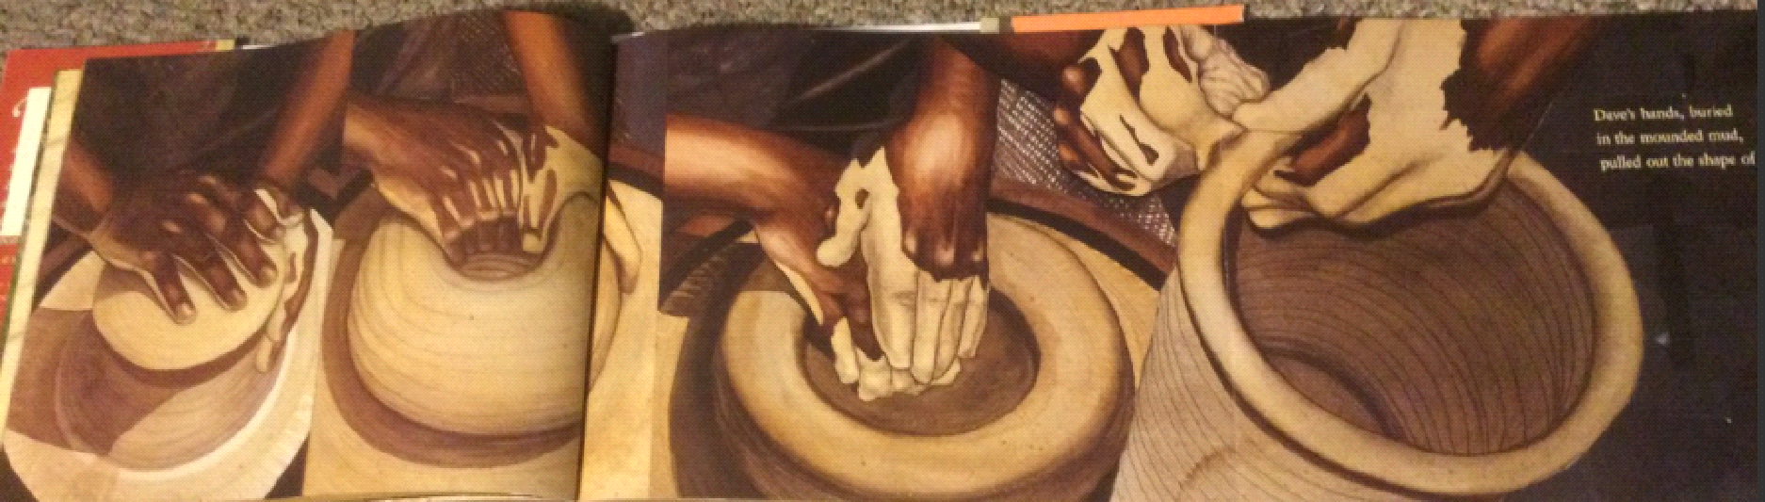
Open the flap: How does the extended picture make you feel as you open the flap? Why do you think the illustrator chose this format?

His chapped thumbs…

As the wheel spun…

The jar grew so large…
- What do you see on the tree?
- Who do you think the people are?
- Note that Dave holds out his arms to match the text for an embrace.

Only then did he stop…
- What do you see in the background behind Dave? (People who are enslaved picking cotton—Although this book is not about using enslaved people in cotton production, this picture can connect students to one of the major reasons for enslavement—It can also connect to Unit 2’s study of Lowell, MA’s relationship to enslavement and cotton)
- Why does the illustrator include these images? (Never forget the rationale for enslavement)

Dave mounded these coils of clay…

The shoulder and rim…

While the clay dried…
- What is Dave doing in the picture? (Grinding the wood ash)
- Note how the shades of greenish brown match the greenish brown glaze of the pots

But before the jar completely hardened…
- Dave is writing on his pot. Why is this important? (People who were enslaved were forbidden in most places, especially in the South, from learning to read and write.)
- Typography: Review the importance of italics. In the text, the words in italics are Dave’s words from his poem on the pot.

Back Matter:
- Afterword: “Dave: A Life—photo of Dave’s real work and pieces of his poetry from the clay pots. There are descriptions of how we know some of his history.
- Note from author Laban Carrick Hill.
- Note from Illustrator Bryan Collier—Be sure to read this, as the illustrator notes his use of “certain images to remind the reader that Dave was a slave…(and) Dave’s artistry may have served as his own glimpse of freedom, and a way of carving out a life under the brutal and dehumanizing conditions of slavery. Dave’s noble jars and verses blaze through the ages and speak profoundly of dignity…”
- Bibliography; Websites
- Dedication
4. After reading, students use the graphic organizer for Dave the Potter: Artist, Poet, Slave to analyze details from the book about different parts of Dave’s identity and experience.
5. At the end of the lesson, students describe a connection to one of the values described in the book by responding to the prompt “Something that interested in Dave’s story was…” in the performance task graphic organizer.

Day 5:

Students analyze A Birthday Cake for George Washington History using the whole-book approach, evaluate details from the book, compare details from the book to details explored in other books throughout the unit, and describe one thing they found interesting from the story.

Lesson Objective(s) or Essential Question(s)
I can tell the difference between an author and illustrator—and name them for a story.

I can look at various elements of the book art and tell why they are important.

I can analyze an illustration and talk about the connection of the picture to the text.

Lesson Materials & Resources
A Birthday Cake for George Washington by Ramin Ganeshram; illustrations by Vanessa Brantley-Newton
A Birthday Cake for George Washington Performance Task Graphic Organizer [.pdf][.docx]
Performance Task—Reading Response Journal page 5 [.pdf] [.docx]
Performance Task Reading Response powerpoint slide 5 [.pptx]
Performance Task rubric [.pdf][.docx]
“Amid Controversy, Scholastic Pulls Picture Book About Washington's Slave : The Two-Way” by Eyder Peralta for NPR
“NOT Recommended: A Birthday Cake for George Washington” by Allyson Criner Brown for Teaching for Change
“A Birthday Cake for George Washington: The Problem with Banishing Books” - National Coalition Against Censorship
Lesson Activities
A Birthday Cake for George Washington by Ramin Ganeshram and illustrated by Vanessa Brantley-Newton is a controversial book. After criticism about the presentation of enslaved people as happy people who have pride in helping a great man, Scholastic publishing pulled the book from distribution. The choice to include A Birthday Cake for George Washington in this unit is purposeful—the book serves as an object lesson to discuss how enslavement can be presented in a manner that can perpetuate misperceptions and misunderstandings. It is strongly recommended that teachers read the Resource articles listed prior to implementing the Day 5 Lesson. Arguments for and against the book are discussed, as well as a question of whether banning the book was justified. Lots of areas exist in this book for deep discussions about the portrayal of Delia, Papa, and the other enslaved people depicted. The back matter includes a discussion of the fact that Papa (Hercules) and one of his sons escape Mount Vernon less than a year after the birthday event that is the topic of this picture book. This is an important historical fact to note in discussion with students, especially in a book that shows the enslaved people as always happy with their role in the Washington household. One note: The book was created by a diverse group of people who make some strong arguments in defense.

- Based on your analyses of the resources above, introduce the book to students and describe what you hope students will ask themselves as they review the story. Introduce the jacket and endpapers.

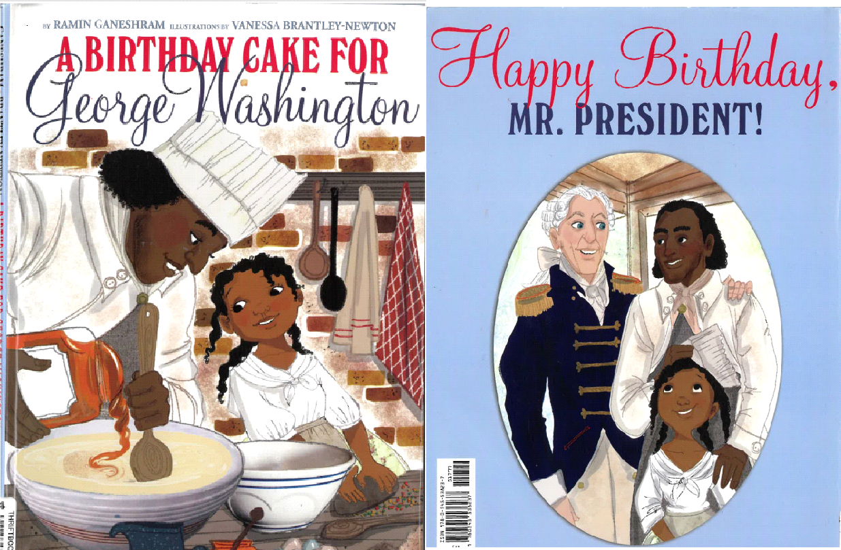
Jacket: matches the Front and back cover of the book proper
- Dual page (not wraparound) separates the Front and Back
- Front cover—Picture of Hercules and daughter Delia making the birthday cake (note that they are enslaved)
- Back cover is a separate portrait of Hercules and Delia (note that they are enslaved) with President Washington (note that Washington is the master on the plantation where the story takes place)—Made in the shape of a frame, like a formal portrait of family

Inside Flap: Read the inside flap. Note the phrase “faced with an unspoken bittersweet reality. No matter how delicious the president’s cake turns out to be, Delia and Papa don’t have the sweetness of freedom.”

Endpapers:
- Front and Back: sold navy blue : Why do you think the endpapers are solid blue? (Blue is part of red, white and blue—blue is presidential.)

- Introduce students to the title page and opening of the book.

- Title page: Color scheme of red, white, and blue is continued on the verso page
Note: Time is a difficult concept for young learners. The time frame for this story is 1796
- Background to share with students: Enslaved people had been on what would become “American” land for 170 years. This is 75 years before the signing of the Emancipation Proclamation. This takes place in Philadelphia, PA—which is in the North.

- Continue to use the instructions below for each page in the book. The opening line for the page referenced is written in italics. Guiding questions for students are in bold.
All over the streets…
- What is happening in the picture?
- Review collage—Lots of sections of this illustration have print/text on it. Why do you think the illustrator made this choice?

Today he is very upset…
- What is happening in this illustration? Why do you think Papa (Hercules) is upset? Note the empty burlap bag that held the sugar.
- How does this page make you feel?

Only when Mrs. Washington…
- How is this illustration different? (warmer colors, people smiling)
- Note: Lady Washington “owns” most of the people in the picture—Why do you think the people look so happy?

Me and Papa…
- How do the illustrations of Delia and Papa differ from Dave, in Dave the Potter, or the illustrations of the people who were enslaved in Your Legacy? Why do you think they are depicted this way?
- Note the collage of textiles to add richness to the clothing.

All the important people…
- What is happening in this picture? What is all the food for?
- Do you think Delia, Papa, and other enslaved people will get to eat any of this food? If not, what do you think they eat?

Papa marches to the pantry…
- What do you see in this illustration? How is Papa feeling now?

Papa takes out several bowls…
- Note some of the historical kitchen items—grinding stone, burlap bag for sugar or spice, lack of electrical tools.

“You! Separate these…”
- Why are there dancing feet on top of Hercules and the other enslaved people? (It shows the differences between the “upstairs” people and the “downstairs” people.)

While we are waiting…
- What do you see here? (The focus is on Papa)
- Why is Lady Washington checking in?

When it is finally time…
- What do you see in the picture?
- How is this kitchen like your kitchen? How is it different? (Note the beehive oven, black cauldron, no electrical appliances)

Soon it is time…
- Why are there three Papas on the page? (It shows movement.)

And now we all must move quickly…
- What is happening in this picture?
- Why are all the fancy-footed and clothed people above the heads of the enslaved people in the kitchen?
- Contrast the upstairs (free) people and downstairs (enslaved) people. Do you think the people who are enslaved would be dancing?

Papa brings the cake…
- What do you see in this picture? (The gutter separates Papa and the cake from Delia and the others. They look on in admiration.)

No one seems to breathe…
- What is happening in this illustration? (Gutter separates people from the cake prep items.)
- Do you think President Washington would have his arm around Papa? Why or Why not? (Enslavement was dehumanizing—focus discussion on the relationship enslaved people had with the people who held them in bondage.)

Back Matter:
Afterward: Hercules and President Washington—author Ramin Ganeshram gives details about the relationship between Hercules and George Washington
- Hercules liked his fancy clothes.
- Hercules and his son were sent back to Mount Vernon to “reset” the clock for Pennsylvania law that set enslaved free if they lived in the state for more than six months at a time
- Hercules and his son eventually escaped from Mount Vernon in Virginia—leaving his daughter Delia behind in enslavement.
Back Matter: Martha Washington’s Great Cake recipe and Artist’s Note:
- Note from illustrator Vanessa Brantley-Newton—This note tells some details of researching historical accuracy of kitchen items and clothing and explains the reason for mixing with modern references.
- She intentionally mixed historical artifacts with some contemporary images.
- She makes her argument for depicting Hercules and Delia as happy people.

4. After reading, students use the graphic organizer for A Birthday Cake for George Washington to analyze details from the story.
5. At the end of the lesson, students describe a connection to one of the values described in the book by responding to the prompt “One thing I found interesting in the story was…” in the performance task graphic organizer.

Day 6:

Students analyze the title page and first three poems in Born on the Water using the whole-book approach, compare details from the story with other stories explored during the unit, and ultimately use details from the book to describe the lives of the Ndongo people before enslavement.

Lesson Objective(s) or Essential Question(s)
I can look at various elements of the book art and tell why they are important.

I can analyze an illustration and talk about the connection of the picture to the text.
Lesson Materials & Resources
Born on the Water by Nikole Hannah-Jones and Renee Watson; illustrated by Nikkolas Smith
Performance Task—Reading Response Journal page 6 [.pdf] [.docx]
Performance Task Reading Response powerpoint slide 6 [.pptx]
Performance Task rubric [.pdf][.docx]
Lesson Activities
Introduction: Share with students that they have looked at several picture books that have a connection in some way to ideas of enslavement, resistance, and empowerment. The complementary text set lessons provided an opportunity for Kindergarteners to learn many book parts and elements of visual design in the illustrations. Students will now use this knowledge and experience to help determine meaning and understanding of illustrations and text from Born on the Water by Nikole Hannah-Jones and Renee Watson; illustrated by Nikkolas Smith.

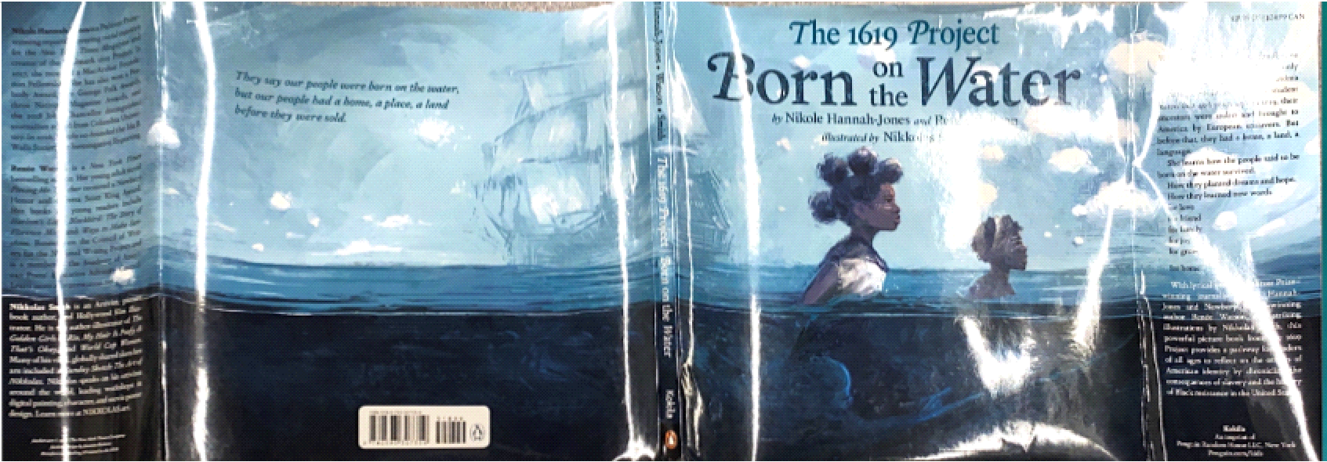
- Introduce students to the jacket and endpapers for the book.
Jacket: Read the title “Born on the Water”—What do you think it means? Where are people usually born? Read the jacket information and connect to the themes from The Oldest Student and Your Legacy. Open the jacket and note the wraparound design (which denotes a dramatic moment). Why are the people in the water? Where are they going? What do you think it means to be born in the water?

Endpapers: Remind students that the end papers can create a visual reminder (or backstory of the narrative.) Introduce the important motif of scarification. In many African communities, scarification was used to identify people from various clans. After the people were stolen from their homes, and families were separated, the scarification marks helped to provide an identifier among peoples who were enslaved. Scarification also can represent the wounds that many enslaved people endured during their capture and the voyage across the Atlantic Ocean.

- Guide students in an analysis of the title page, trim, and orientation of the book.
Title page, trim, and orientation: Review the orientation of the complementary text set books (all were portrait style, except Dave the Potter. Ask Is the orientation style for Born on the Water portrait or landscape? This is a trick question—Born on the Water is a square orientation—which invites a circular resolution (The story ends similarly to that of the start—with pride for the culture and hope for the future. Sometimes the square design can be cozy or claustrophobic. The many double-page spreads minimize this feeling.

- Continue to use the instructions below for each page in the book. The opening line for the page referenced is written in italics. Guiding questions for students are in bold.
Poem: Questions
The full-bleed page design encourages students to join the girl. How is the girl feeling? Why do you think she feels this way? Although the colors from the verso to recto pages seem to blend—note the gutter separates the two pictures—the girl’s feelings about the school assignment on the verso page compared with the warmth of the family as Grandma gathers everyone to answer the questions. Do you see the scarification pattern on the verso page—where is it? Why do you think the pattern is on her clothes?

Poem: What Grandma Tells Us
This page is a full-bleed double page spread that entices students to become a part of the community. The text is on both pages to show the fullness of life in the community. What do you see? What is the woman holding? How do the colors on the page make you feel? Do the people’s faces match that feeling—what is the mood? Is this a place you would like to be? Some of the answers to these questions can be used to contrast with how the White enslavers felt about the people of color, allowing them to feel okay about enslaving people.

4. At the end of the lesson, students summarize their understanding of the opening of Born on the Water by responding to the prompt “The Ndongo people’s lives in Africa…” in the performance task graphic organizer.

Day 7:

Students analyze the title page and next three poems in Born on the Water using the whole-book approach, compare and contrast details from the story with other stories explored during the unit, and ultimately use details from the book to describe skills demonstrated by the Ndongo communities in these poems.

Lesson Objective(s) or Essential Question(s)
I can look at various elements of the book art and tell why they are important.

I can analyze an illustration and talk about the connection of the picture to the text.
Lesson Materials & Resources
Born on the Water by Nikole Hannah-Jones and Renee Watson; illustrated by Nikkolas Smith
Performance Task—Reading Response Journal page 7 [.pdf] [.docx]
Performance Task Reading Response powerpoint slide 7 [.pptx]
Performance Task rubric [.pdf][.docx]
Lesson Activities
- Review the beginning of the story. Have we answered the question of what it means to be “born on the water?”
- Continue to use the instructions below for each page in the book. The title of the poem referenced is written in italics. Guiding questions for students are in bold.

Poem: They Had a Language
The page continues the full-bleed page design to make the reader feel like s/he is a part of the action. While the coloring makes it appear to be a double-page spread, the verso and recto pages are truly separate pages. What is the shape on the recto page? (Africa) Why do you think the illustrator put Africa here? The text explains where the people originated. Do you see the scarification patterns anywhere? Why do you think they are there?

The second page of the poem is a double-page spread that continues to pull the reader into full village life. Identify the various buildings, posts, and elements, so students can compare with the illustration changes on the “Stolen” poem page. The colors on the spread are getting darker. Why do you think that is—and how does it make you feel?

Poem: Their Hands Had a Knowing
The color palette continues to darken. How does the darker brown color change the mood of the story? The gutter separates the verso and recto pages—the verso includes all of what “hands” know, while the recto page describes “hearts and minds.” Where do you see the scarification patterns this time? Why do you think they are there?

Poem: And they danced…
This full-bleed double page spread draws the reader back in. How does this picture make you feel? The color pattern brightens –why do you think the illustrator chose to do this? There are a lot of swoosh lines on the page. What do you think they are for? (movement) Why do you think there is so much movement in this picture? (Be sure students understand this is a focus on the people’s bodies—so they can compare this later in the book.)

- At the end of the lesson, reference details from Born on the Water to respond to the prompt “The people were good at many things. Describe one thing.” in the performance task graphic organizer.

Day 8:
Students analyze the three poems in Born on the Water related to the Transatlantic slave trade using the whole-book approach, compare imagery and text from these poems to the previous three poems in the book, and ultimately use details from the book to describe the lives of the Ndongo people before enslavement.

Lesson Objective(s) or Essential Question(s)
I can look at various elements of the book art and tell why they are important.

I can analyze an illustration and talk about the connection of the picture to the text.
Lesson Materials & Resources
Born on the Water by Nikole Hannah-Jones and Renee Watson; illustrated by Nikkolas Smith
Performance Task—Reading Response Journal page 8 [.pdf] [.docx]
Performance Task Reading Response powerpoint slide 8 [.pptx]
Performance Task rubric [.pdf][.docx]
Lesson Activities
- Review the beginning of the story. Have we answered the question of what it means to be “born on the water?”
- Continue to use the instructions below for each poem in the book. The opening line for the page referenced is written in italics. Guiding questions for students are in bold.
Poem: Stolen
The illustrations on this page continue the full-bleed double page spread. How are the colors of these pages different from the pages before them? How do they make you feel? Compare the pages to the previous page on “They Had a Language.” Note that it is the same village scene—but after it is destroyed by “the white people.”

Define “knock-out type”—white words on a dark page.
This type provides a stark contrast on the page—matching the stark contrast in the village. First there was freedom –and then the people were stolen.

Discuss the line, “Ours is no immigration story.” Define “immigration” as a voluntary movement from one place to another to live. Do you think what happened here in this village is immigration? Help students make a connection, if any, as to how they or their families moved to Lowell. The author will repeat
“Ours is no immigration story.” Have you ever gone on a trip? What did you take? What did the people from Ndongo get to take? Check with the text.

How does the coloring of this background make you feel? What is the bright color in the middle? Why do you think it is there? Note there is still knock-out type.

Note in the text—the poem is talking about what the people did bring (minds, old ways, harvest songs, bodies, bloodlines, and seeds). These match themes in earlier poems.

Page without text: Ship without a poem
Introduce “wordless spread”. The double page spread does not have any words. Why do you think there is a page with no words? What are the author and illustrator trying to “say”?

Poem: The White Lion
The full-bleed double page spread continues the dark coloring palette. How do these pages make you feel? What about the facial expressions? Remember the scarification patterns—where do you see them? Why do you think they are there?

The pages are still full-bleed, but here verso and recto pages are separated by the gutter to show the contrast. On the verso page the blue water showed one kind of resistance—tossing themselves into the water. Why is the picture blue? Why are the people in the water?

The recto page returns to the bottom of the ship—a return to blackness. Notice the various designs of scarification on the people’s faces—all different from different clans—but now they form a new people –those who were “born on the water.” This shows the second form of resistance—resolving to live.

Poem: Point Comfort
This full bleed double page spread opens the story after the dark underbelly of the ship. The gutter separates the text from the dark silhouettes of the people. Why are these pages so bright and white? How does it make you feel? Coming into the light is often thought of as comforting—does this seem comforting?

Poem: Tobacco Fields
The full bleed double page spread continues the contrast between dark and white. Despite the double-page spread, the gutter separates the text from the enslaved person. Who are the people in the sky? Why are they there? Match the answers to the text.

The text talks about the importance of songs—songs of freedom.

- At the end of the lesson, students describe the challenges presented in the poems about the Transatlantic slave trade by responding to the prompt, “The trip across the ocean was hard. Write about one thing.” in the performance task graphic organizer.

Day 9:
Students analyze the next three poems in Born on the Water using the whole-book approach, compare images and details from the story to the poems they previously explored, and ultimately use details from the book to describe a way that the characters in the book who were enslaved in the U.S. demonstrated hope during the period of enslavement.

Lesson Objective(s) or Essential Question(s)
I can look at various elements of the book art and tell why they are important.

I can analyze an illustration and talk about the connection of the picture to the text.
Lesson Materials & Resources
Born on the Water by Nikole Hannah-Jones and Renee Watson; illustrated by Nikkolas Smith
Performance Task—Reading Response Journal page 9 [.pdf] [.docx]
Performance Task Reading Response powerpoint slide 9 [.pptx]
Performance Task rubric [.pdf][.docx]
Lesson Activities
- Guide students in a review of the previous poems in Born on the Water, ensuring that they remember where they left off in reading.
- Continue to use the instructions below for each in the book. The opening line for the page referenced is written in italics. Guiding questions for students are in bold.

Poem: How to Make a Home
Full-bleed double page spread invites readers to be in the fields with the people. What is going on in the picture? What do you see that makes you say that? (Be sure to note the sadness of the boy. Match to text of longing for home and family.) The sky is still white—and not blue—what do you think that means?

Typography on the recto page is italicized. Look at the words on the recto page. How do they look different? Define italics and teach that these are the people’s voices (own words) of resistance.

Turn to the next page:
These pages are full-bleed, but verso and recto pages are separate pictures blended by the color scheme.

The knock-out type returns…Why do you think the illustrator returned to the dark picture with white words? Be sure to note that this time the black represents the secret “dark of night” resistance enslaved people promised to keep living.

The recto page returns to italics to show more of the words of the people for resistance. The sky is now purple. Why do you think that is? What is the word being written on the paper? Why is that important? Remind students that reading and writing among people who were enslaved was often illegal behavior.

Poem: The Tuckers of Tidewater, Virginia
Verso and recto pages are separated on this full-bleed double page spread by the gutter, but color the palette joins the images. How does the light color of the background differ from the previous pictures? How does it make you feel?

Refer to text—What does “the start of a new people” mean? Do you see the scarification patterns? Why do you think they are there?
Poem: William Tucker
Refer to text-- Talk about the importance of “hope” for the people. What is the blue at the bottom of the page? (water) Why do you think the water is there? Why is the text “But a child of the new people formed on the water” so important to the story? Note the scarification pattern on the face of the child.

- At the end of the lesson, students synthesize their analyses of three poems from Born on the Water by responding to the prompt, “The people born on the water were hopeful because…” in the performance task graphic organizer.

Day 10:
Students analyze the final three poems in Born on the Water using the whole-book approach, compare images and details from the story to the poems they previously explored, and ultimately use details from the book to analyze how the main character in the story feels after hearing the story her grandmother shared.

Lesson Objective(s) or Essential Question(s)
I can look at various elements of the book art and tell why they are important.

I can analyze an illustration and talk about the connection of the picture to the text.
Lesson Materials & Resources
Born on the Water by Nikole Hannah-Jones and Renee Watson; illustrated by Nikkolas Smith
Performance Task—Reading Response Journal page 10 [.pdf] [.docx]
Performance Task Reading Response powerpoint slide 10 [.pptx]
Performance Task rubric [.pdf][.docx]
Lesson Activities
- Guide students in a review of the previous poems in Born on the Water, ensuring that they remember where they left off in reading.
- Continue to use the instructions below for each in the book. The opening line for the page referenced is written in italics. Guiding questions for students are in bold.
Poem: Resist
The full-bleed double page spread is a picture that shows a progression over time—from being stolen—to breaking free from the chains—to escape in the water—to fighting in the Civil War and resistance. How has the color palette changed? (There is dark coloring but it blends the blues of the ocean with dark of resistance.)

How does it make you feel? What do you see that makes you think that?
Note the flag near the gutter—Does the flag look familiar? What is different about the flag from what you are used to seeing? Talk about how this is the flag from a long time ago when the United States was smaller and had fewer stars. Why do you think the illustrator used knock-out type for these pages? (Is it for the contrast between the lies of slavery and the resistance of people to live?) Why do you think the woman is in the water?

Poem: Legacy
Another full-bleed double page spread, but this one is a collage with “heroes”—famous people of color who resisted in their own ways and time. What do you see in the background ? (Building of a nation—Capitol, Statue of Liberty—representations of freedom) Who do you recognize? How did they resist and help build our country? Why are they all standing in the water?

Poem: Pride
Final full-bleed picture on verso page with poem. Compare the girl’s facial expression here with her face on the first page. How is the girl’s face different in this picture from the first one? Why do you think it changed so much? Note the text—the story of history is connected to phrases children know from today—Black Lives Matters, Black Girl Magic, etc. Why do you think the picture ends on the verso page? Why not keep it a double spread?
- Review the Back Matter and Author and Illustrator notes—Be sure to read and ask What do you think about Nikkolas Smith’s explanations for his illustrations and how they match the poems written by the authors?
- At the end of the lesson, students synthesize their analysis of Born on the Water by responding to the prompt, “Write about how the girl feels after hearing Grandma’s story,” in the performance task graphic organizer.

Day 11:
Students review details from Born on the Water and the other books in the unit text set to create word clouds and collages as a class in response to the prompts, “To be enslaved…” and “To be born on the water….”

Lesson Objective(s) or Essential Question(s)
I can look at various elements of the book art and tell why they are important.

I can analyze an illustration and talk about the connection of the picture to the text.
Lesson Materials & Resources
A Birthday Cake for George Washington by Ramin Ganeshram; illustrations by Vanessa Brantley-Newton
Born on the Water by Nikole Hannah-Jones and Renee Watson; illustrated by Nikkolas Smith
Dave the Potter: Artist, Poet, Slave by Laban Carrick Hill; illustrated by Bryan Collier
The Oldest Student: How Mary Walker Learned to Read by Rita Lorraine Hubbard; illustrated by Oge Mora
The Year We Learned to Fly by Jacqueline Woodson, illustrated by Rafael Lopez
Your Legacy: A Bold Reclaiming of Our Enslaved History by Schele Williams; illustrated by Tonya Engel
Performance Task Collage poster for what it means “To be enslaved…” and “To be born on the water…”
Culminating project template [.pdf][.docx]
Culminating Lesson Unit 1 LCCPS 1619 PowerPoint [.pptx]
LCCPS Unit 1 Culminating project posters [.pdf]
Lesson Activities
- Use Culminating Lesson Unit 1 LCCPS 1619 PowerPoint to display covers of the books in the text set and Born on the Water. Tell students that at the end of the discussion they will create their own collage posters that will help show their understanding of two concepts from the unit—“To be enslaved…” and “To be born on the water…”
  - We suggest doing this in two parts—one session for each concept/collage. This will focus the discussion to manageable chunks and keep the two ideas separate from one another.
  - “To be enslaved…” will include all six picture books in the text set, while the second collage “To be born on the water…” will focus attention on Born on the Water.
- Ask students to share various story themes and book elements for “To be enslaved…” You can use the Culminating project posters located in the Resources folder to remind students and spur discussion.
  - Use the second slide of the PowerPoint to chart various words the students use. Be clear with students that the final collage will not have complete sentences—they will use key words and pictures to share their ideas. When discussion is complete, give students time to make their collages.
- In another time slot later in the day or the next, ask students to share various story themes and book elements for “To be born on the water…” You can use the Culminating project posters located in the Resources folder to remind students and spur discussion. Use the third slide of the PowerPoint to chart various words the students use. Remind students that the final collage will not have complete sentences—they will use key words and pictures to share their ideas. When the discussion is complete, give students time to make their collages.

