What is an American? Cultural Project

Over the past month, you have completed an extensive study of the effects of African culture on American cultural formation. Now you are going to investigate different cultures that have impacted the development of the United States. You will be required to investigate other cultures who helped develop the United States. Some examples include but are not excluded to: Irish, Polish, French, Spanish, Greek, Chinese, Mexican, Japanese, etc

Requirements for the Project:

On a powerpoint or a Google Slide Deck, you will create a virtual scrapbook. You must locate at least five images of separate ethnic groups and make connections to the concepts that we covered in the unit

Concepts to be covered:
- Cultural Landscape
- Sequent Occupance
- Relocation Diffusion
- Stimulus Diffusion
- Language (words that are part of standard English now, started out as ethnic words)
- Religion (what religious practices were brought by ethnic groups)
- Clothing styles
- Food
- Music

Your virtual scrapbook will have separate sections for each category. Each category should have a title page. You should also have a table of contents giving the page number for each section and image. You will locate at least five images for each category. Under each picture, you will give a brief explanation of the concept you are covering and identify the ethnic group it is associated with. You must use five separate ethnic groups represented in each section (not necessarily the same five groups in each section). You should put one image on each page in order to leave room for the explanation.

Example: Food



This is pierogi. This dumpling was brought over by Polish immigrants. This type of food was created by Polish settlers to use up leftovers. So pierogis come in a variety of flavors, such as potato, cheese, and sauerkraut. The food has become so popular that every year in Whiting, Indiana, there is a pierogi fest that attracts thousands of people. It has been adapted by Americans and new flavors offered included pizza and taco

Example: Stimulus Diffusion
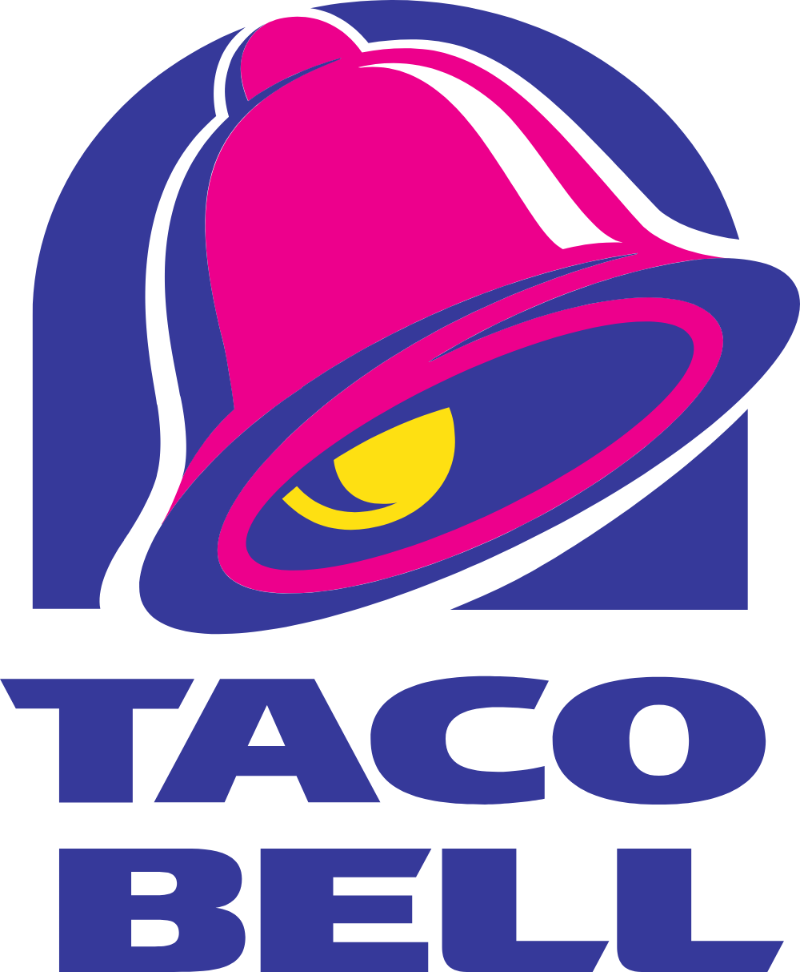

Taco Bell is a chain restaurant based in the United States. The restaurant serves Mexican style fast food, such as taos and burritos. This is an example of stimulus diffusion because even though tacos are Mexican in origin, the restaurant has changed the recipes to suit American audiences.

