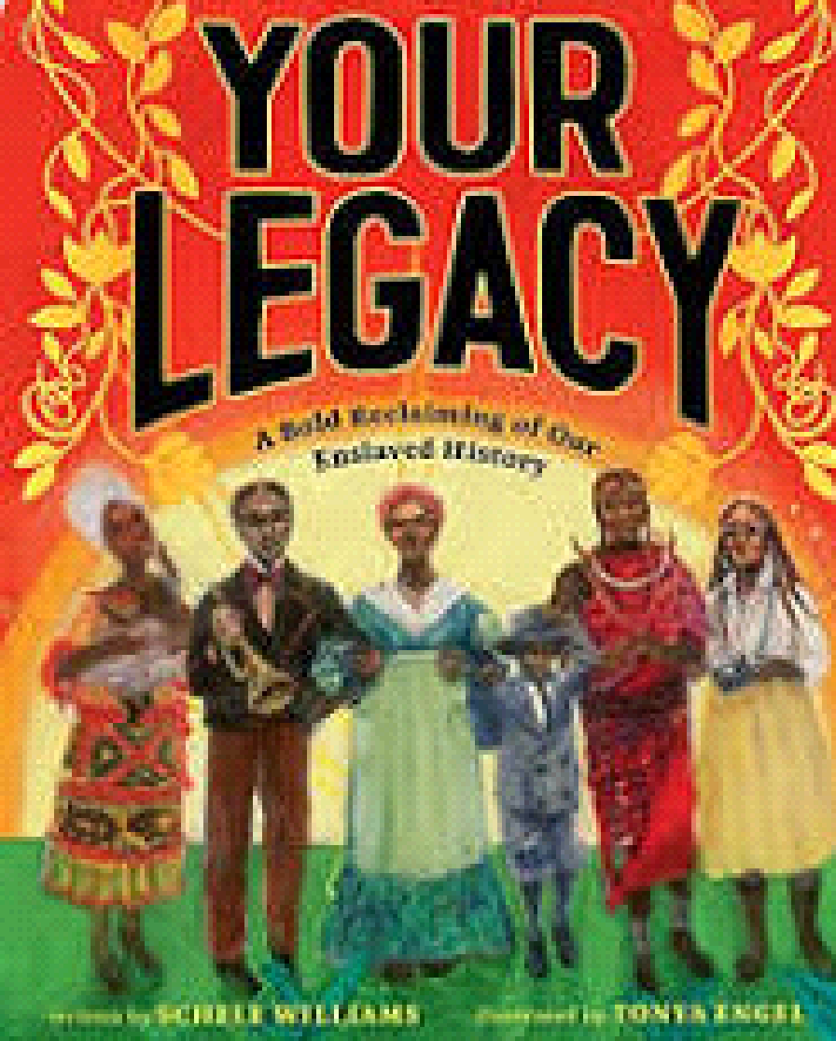
Name __________________________
Your Legacy: A Bold Reclaiming of Our Enslaved History
Love | Intellect | Determination
Courage | Brilliance | Strength
Ingenuity | Grace | Dignity

