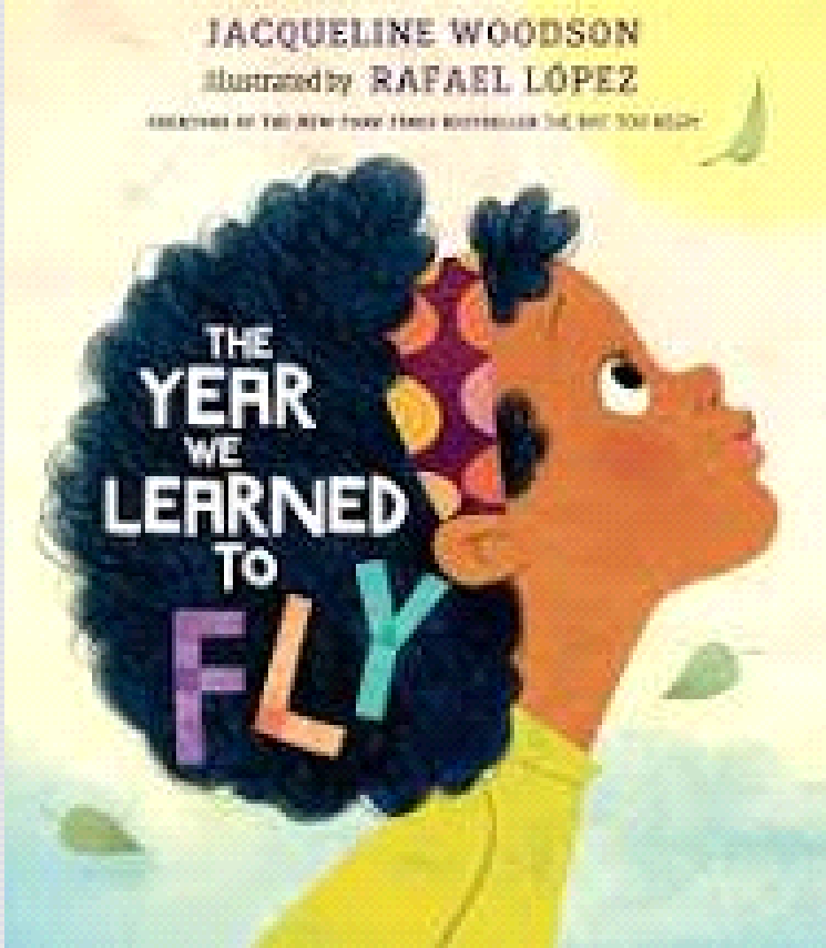
Name __________________________
The Year We Learned to Fly
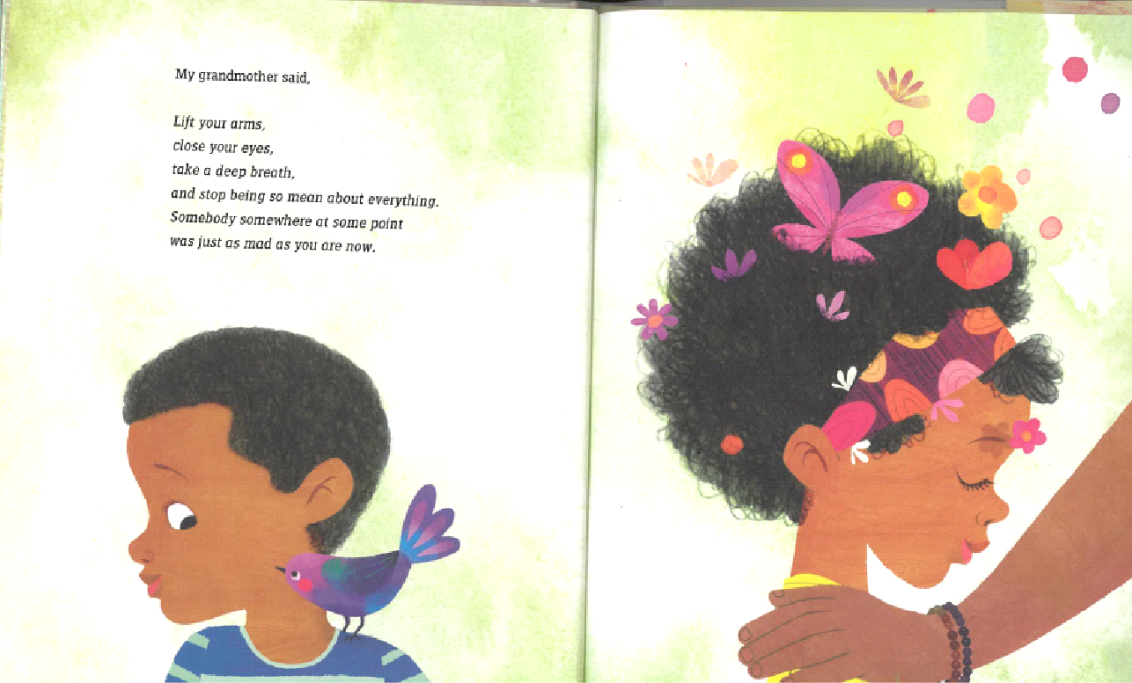 | Symbols of flying
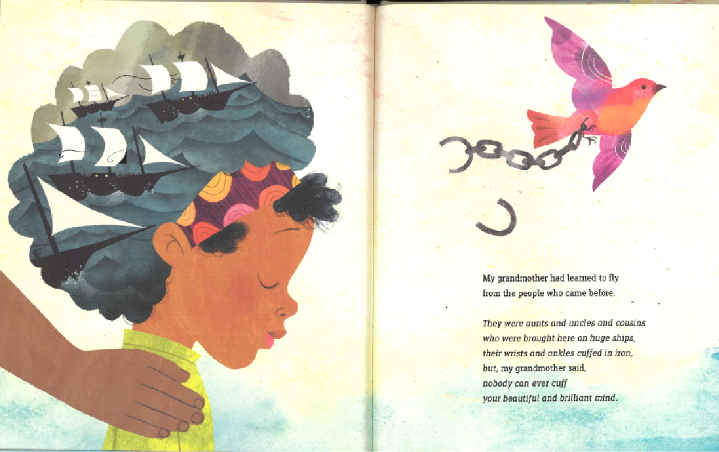 | Ships and chains
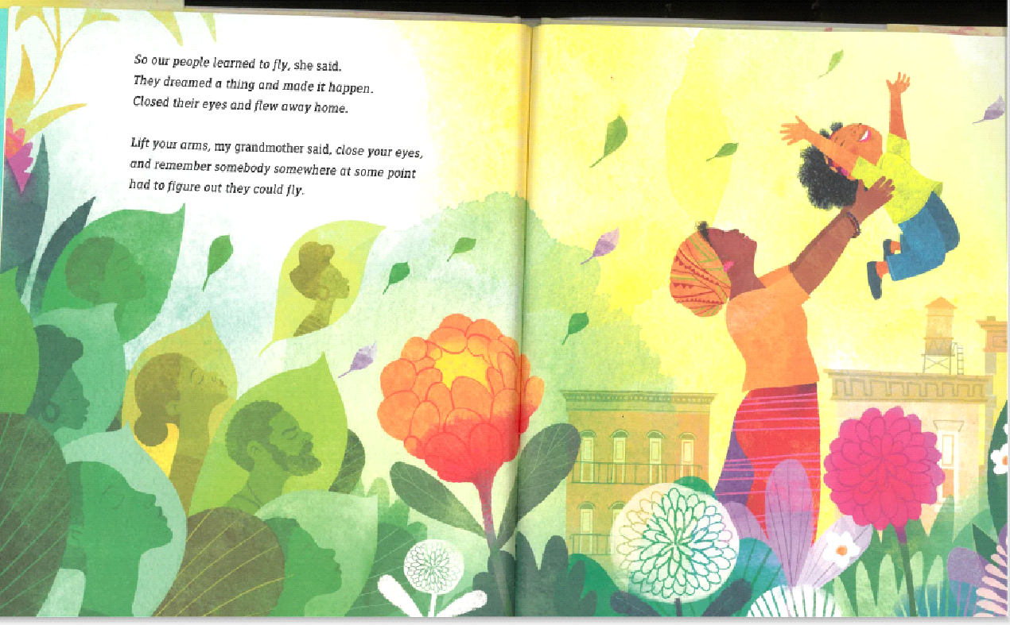 | Learning to fly
My own notes

Source: The Year We Learned to Fly by Jacqueline Woodson (Author), Rafael López (Illustrator)

