Name __________________________
Dave the Potter: Artist, Poet, Slave
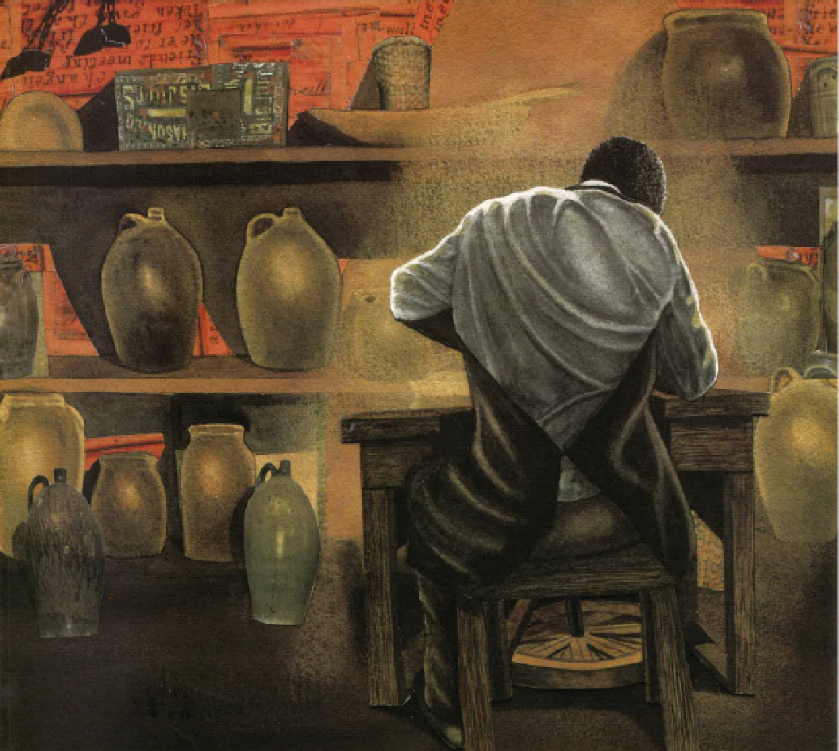 | 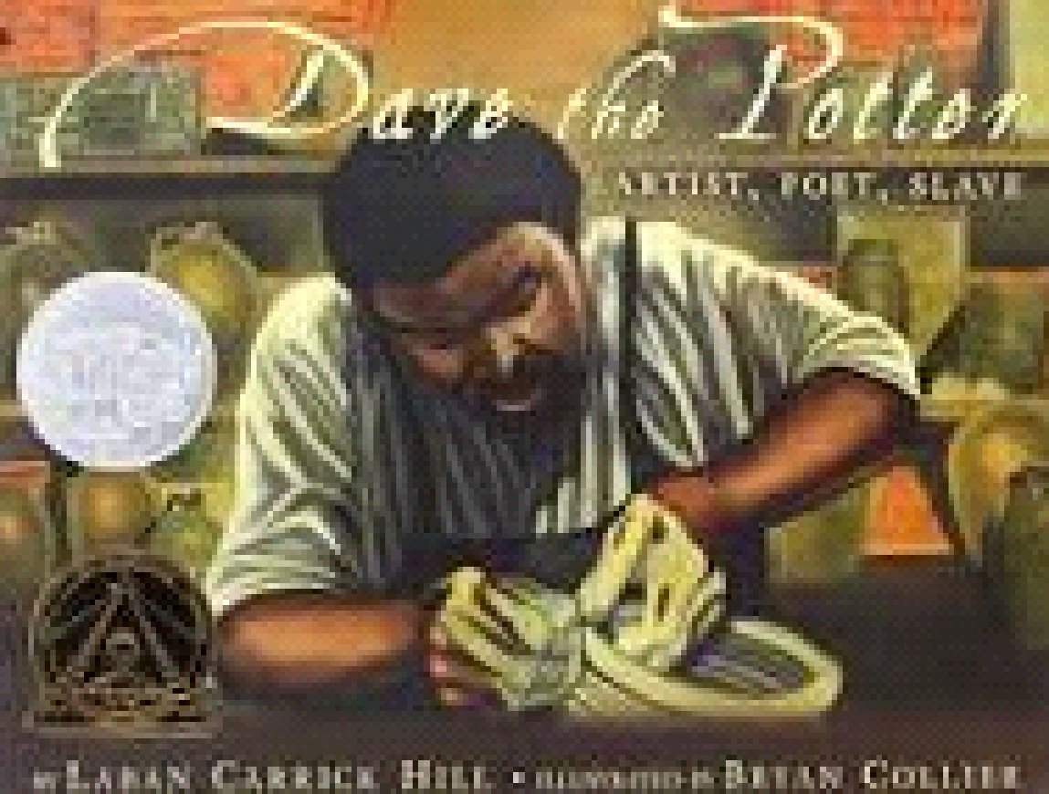  Dave the artist
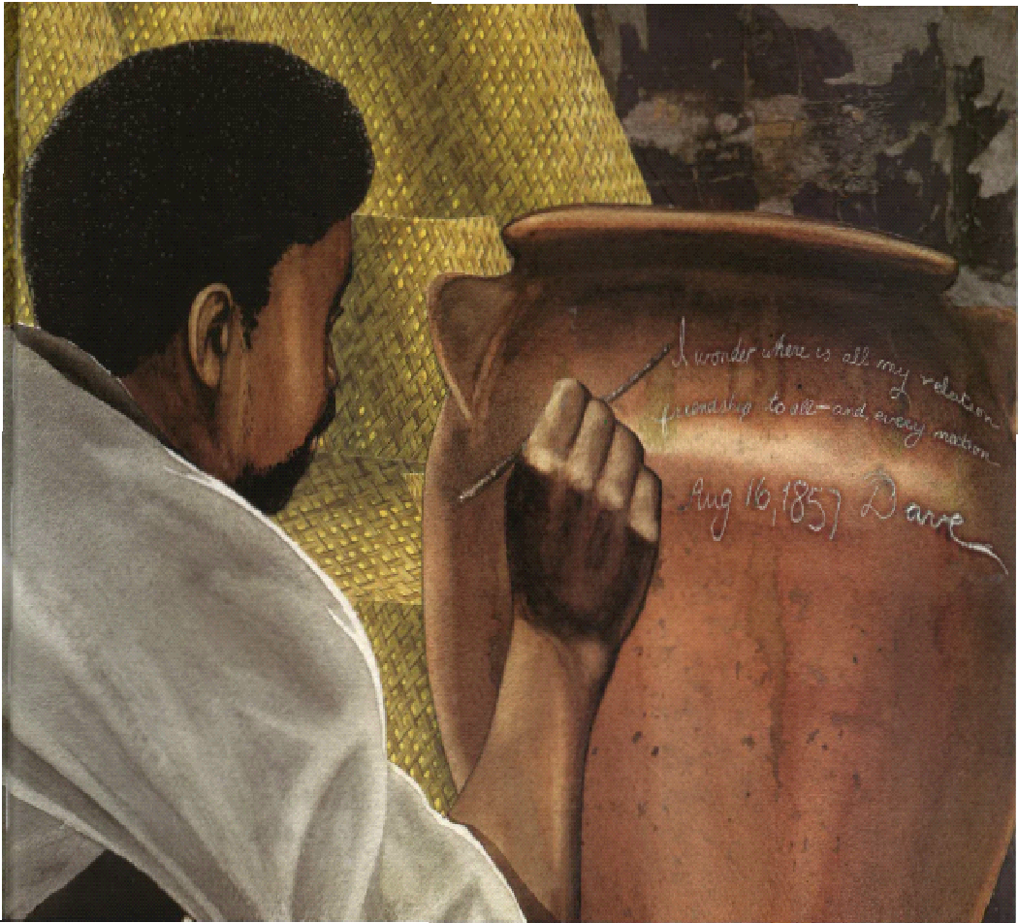 | Dave the poet
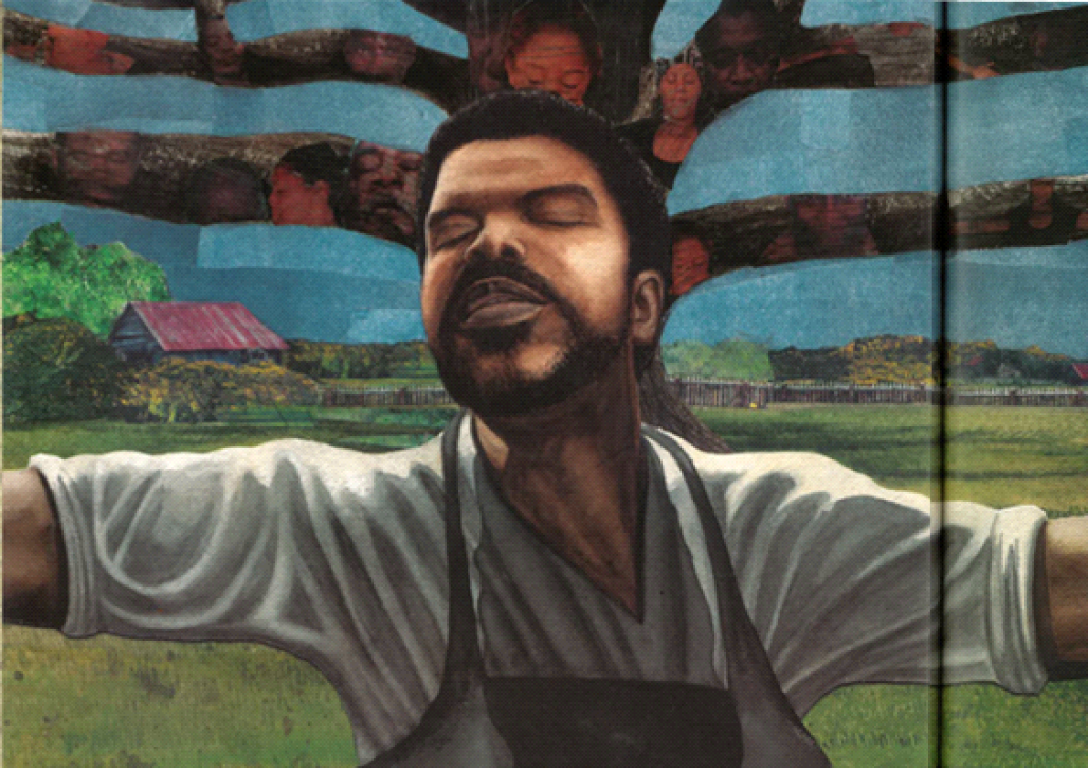 | Dave the enslaved person
Source: Dave the Potter: Artist, Poet, Slave by Laban Carrick Hill; illustrated by Bryan Collier

