Name __________________________
A Birthday Cake for George Washington
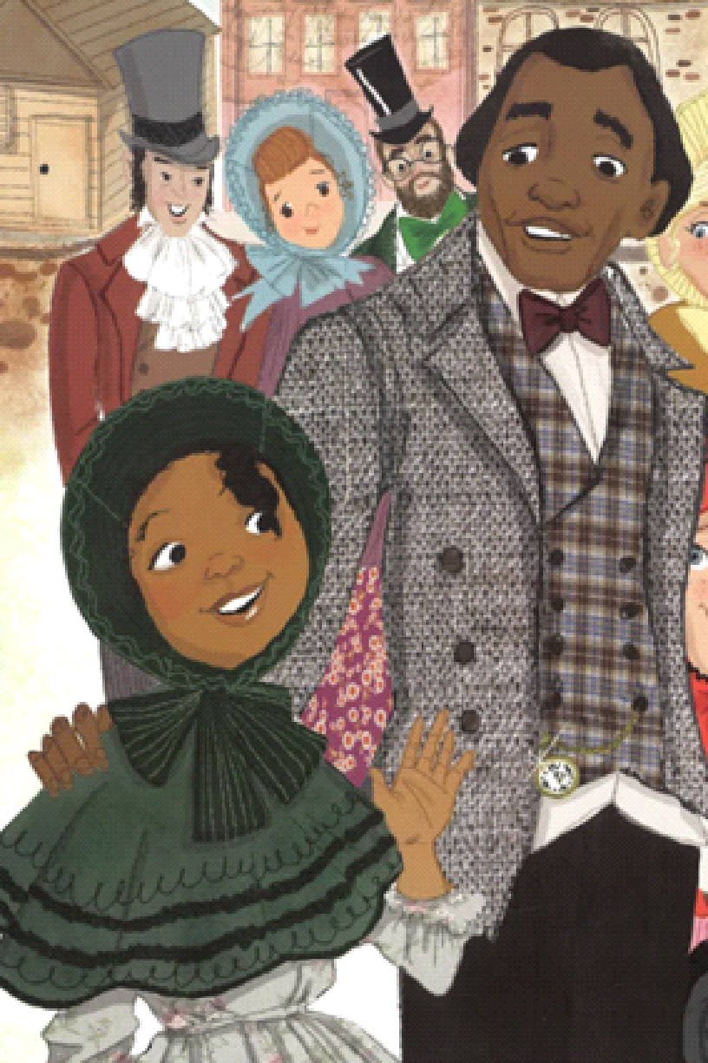 | 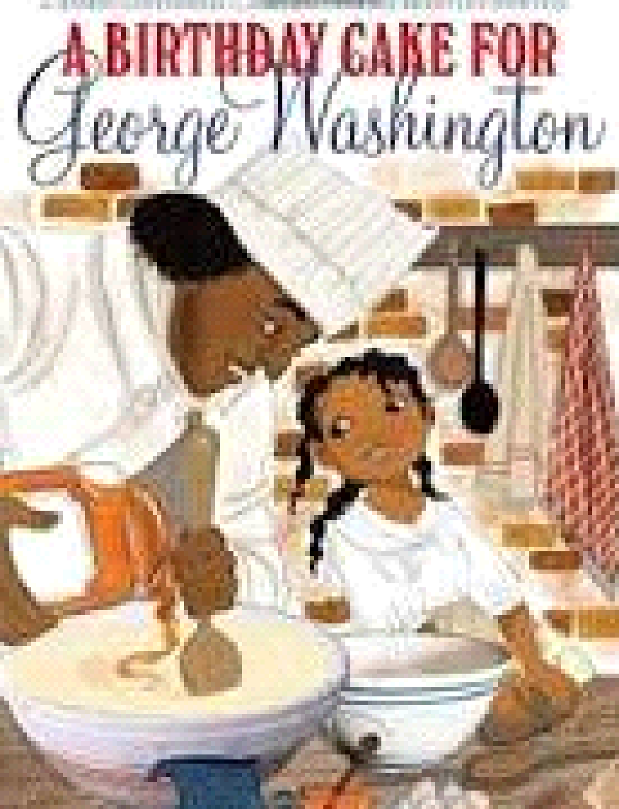  Clothing for those enslaved by George Washington
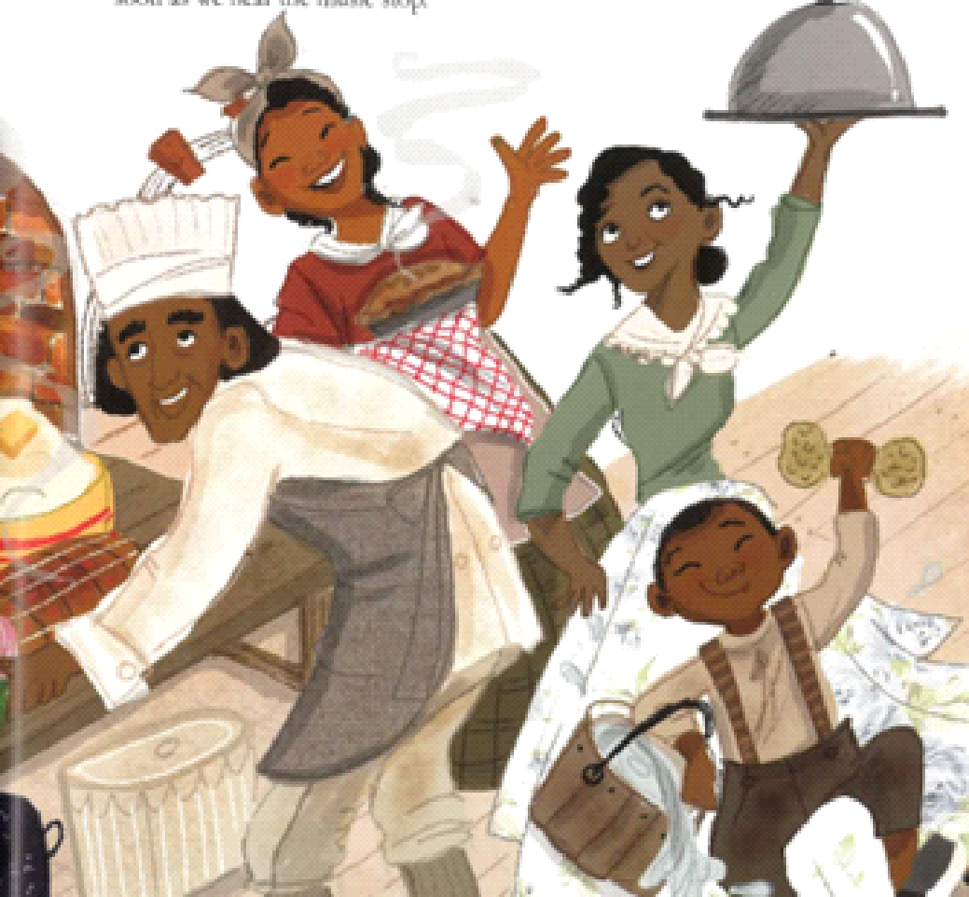 | Enslaved peoples’ feelings displayed in the picture book
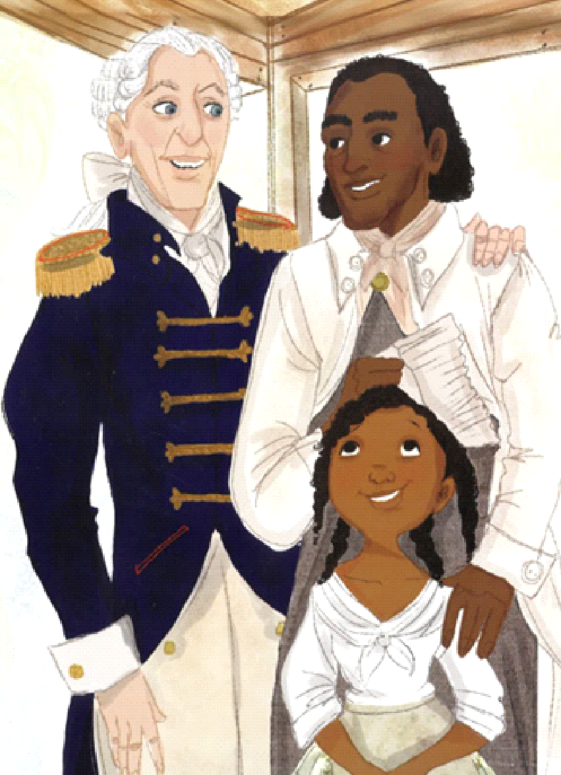 | Relationship portrayed between enslaver and enslaved people
Source: A Birthday Cake for George Washington by Ramin Ganeshram; illustrations by Vanessa Brantley-Newton

