Distance Decay
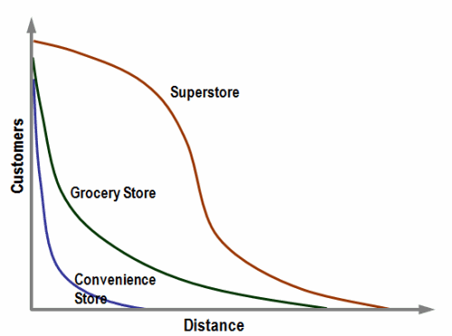
The distance decay effect states that the interaction between two locations declines as the distance between them increases. Once the distance is outside of the two locales activity space their interactions begin to decrease.
-As objects get further apart, there is less integration.
-Distance makes it more difficult to do trade, communicate, and maintain cultural connections.
Related terms include "friction of distance," -It is easier to go to nearby places.
Time-space compression
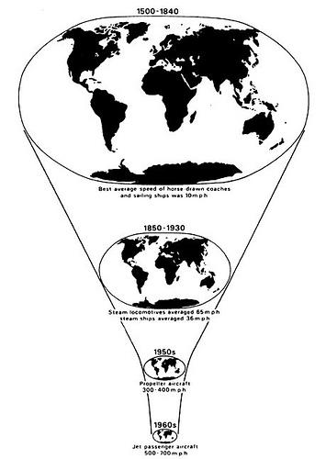

The process of coming closer together and more in contact with each other, even though the real distance remains the same.So despite long distances, people interact and communicate, trade happens and cultures influence each other.
Examples of time-space compression technologies, travel, and economics:Telegraph, Telephone, Fax Machine, Internet, Rail, Cars, Trains, Jets
*Internet, containerization, and cell phones are the best of the recent examples

