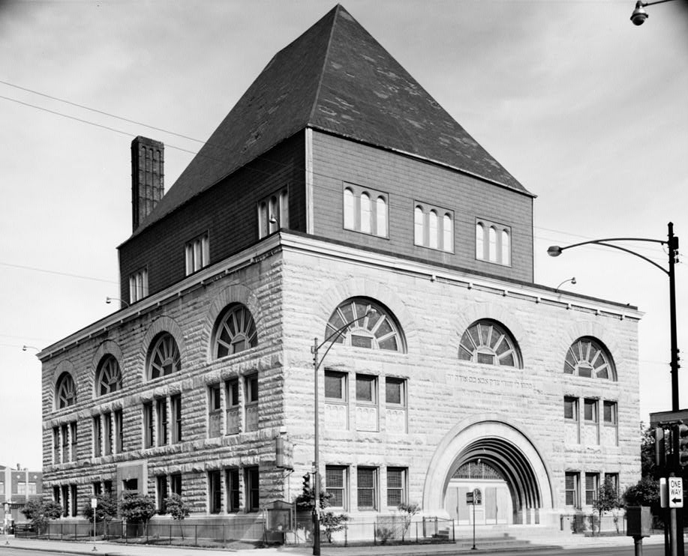
A) Pilgrim Baptist Church, formerly Kehilath Anshe Ma'ariv Synagogue
Located at 3301 S. Indiana Ave, the church is in the heart of Chicago's Bronzeville neighborhood.

- Define cultural landscape
- Explain how this building is an example of sequent occupance
- Define relocation diffusion
- Explain one way that relocation diffusion culturally changed the Bronzeville Area
- Why did this building become a Baptist church instead of another religious structure?
How did it reflect the migrants coming to Chicago

B) Slang Expressions that have become common expressions

“My bad.” This phrase is used to offer apologies for wrongdoing. If someone hits a person in error, for instance, they would say something like: “Oops, my bad.” It means: “I apologize; it was my mistake. Forgive me.”

“We straight.” In Black American English, “straight” can mean “all right.” So “we straight” [we’re straight] means “That’s OK. No worries. We are all right.”

- Explain how phrases such as the two above have spread due to contagious diffusion
- Explain how phrases can spread due to hierarchical diffusion
- Explain the difference between a pidgin and creole. Would you consider these phrases to be pidgin or creole? Why?

C) Picture of Voodoo Shop in New Orleans
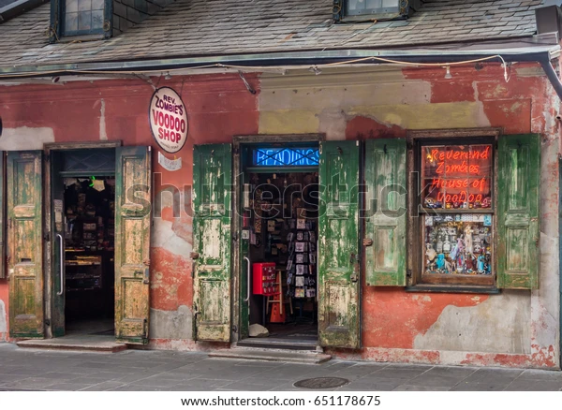
- Define syncretism
- Describe how a syncretic religion might form in a Multicultural Society
- Explain how syncretism is an effect of cultural diffusion
- Explain why this voodoo shop is an example of syncretism

D) Ethnocentrism vs. Cultural Relativism
- Explain the difference between cultural relativism and ethnocentrism
- Give 2 examples from your studies of the 1619 project about a time in history when African Americans experienced ethnocentrism

E) Multiculturalism vs.. Assimilation

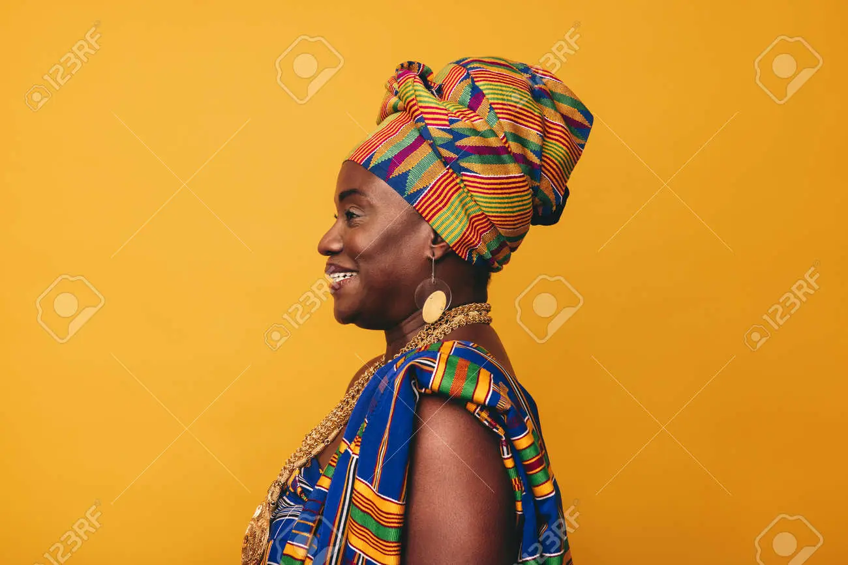
Picture 1

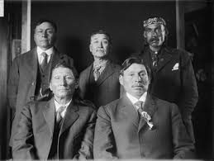
Picture 2

- Define multiculturalism and assimilation. Select the picture above that represents the concept of each
- Describe one reason why a migrant might resist assimilation into a host society
- Refer to an instance from the 1619 project in which African Americans resisted assimilation and maintained a multicultural perspective

