Sequent Occupance Activity
Sequent occupance is a concept used to describe the current cultural landscape of a region, as a combination of all the cultures which have 'sequentially' occupied the region from the past to the present. In other words, a region may be occupied by one civilization, followed by another which took its place, and so on. However, the cultural imprint of each civilization is never completely lost, and its traces can be seen to the present day. It is important to understand that this phenomenon occurs in the same region or space, but at different times. Sequent occupance regards each region as a pattern of many cultural layers laid upon each other, where each layer can be attributed to a particular civilization, which overlaps the one before it.
Below you have three pictures of Roseland’s Michigan Avenue taken 50 years apart. Examine the pictures and write a description of what you see in the picture.
You need to address the following:
- What kinds of features do you see in each picture? Write a description of each picture
- Are there any similarities between the pictures? For example, when you look at Picture C, are there any features in Picture C that were present in picture A or B?
- Based on what you see, what conclusions can you draw about the cultures occupying Roseland in each era?

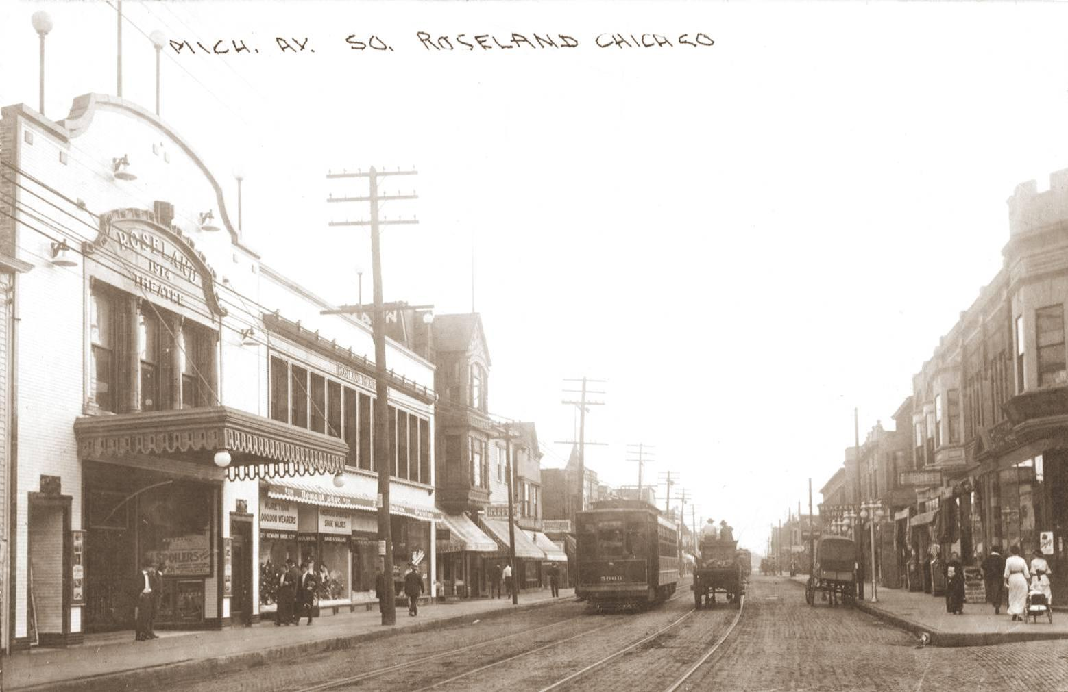
Picture A-Roseland Michigan Ave 1915

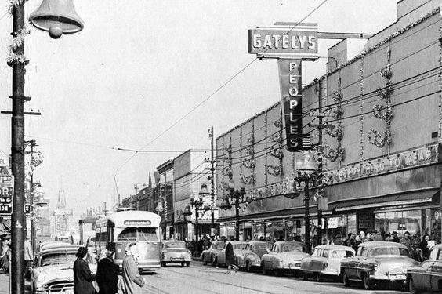
Picture B- Roseland Michigan Avenue 1955

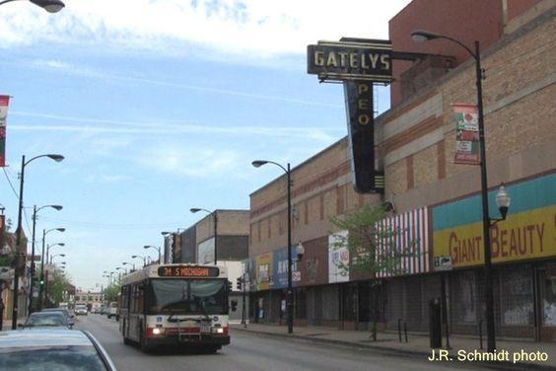
Picture C-Roseland, Michigan Avenue 2013
Sequent Occupance Activity

Picture A
Description of the picture ____________________________________________________________________________________________________________________________________________________________________________________________________________________________________________________________________________
Similarities to other pictures?

What conclusions can we draw about the culture of the period based on the picture? _________________________________________________________________________________________________________________________________________________________________________________________________________

Picture B
Description of the picture ____________________________________________________________________________________________________________________________________________________________________________________________________________________________________________________________________________
Similarities to other pictures?

What conclusions can we draw about the culture of the period based on the picture? _________________________________________________________________________________________________________________________________________________________________________________________________________

Picture C
Description of the picture ____________________________________________________________________________________________________________________________________________________________________________________________________________________________________________________________________________
Similarities to other pictures?

What conclusions can we draw about the culture of the period based on the picture? _________________________________________________________________________________________________________________________________________________________________________________________________________

