Recipes and Roadmaps for Healing
Unit by Karen Sojourner, part of the 2022-2023 Pulitzer Center Teacher Fellowship

 | FOUR | THREE | TWO | ONE
Work Quality and Effort. | The work done exceeds all expectations and shows that the learner is proud of his/her work. The effort that was put into this task is the best it can be by the learner. | The work was done with good effort that shows what the learner is capable of. It is evident that time was put into this poster and presentation. | The quality is not what the learner is capable of. It is evident that the work was rushed. | Work is done with little effort, quality is not what the learner is capable of. It is evident that the work was rushed and little time was spent on the final product. Work is incomplete.
Use of Class Time  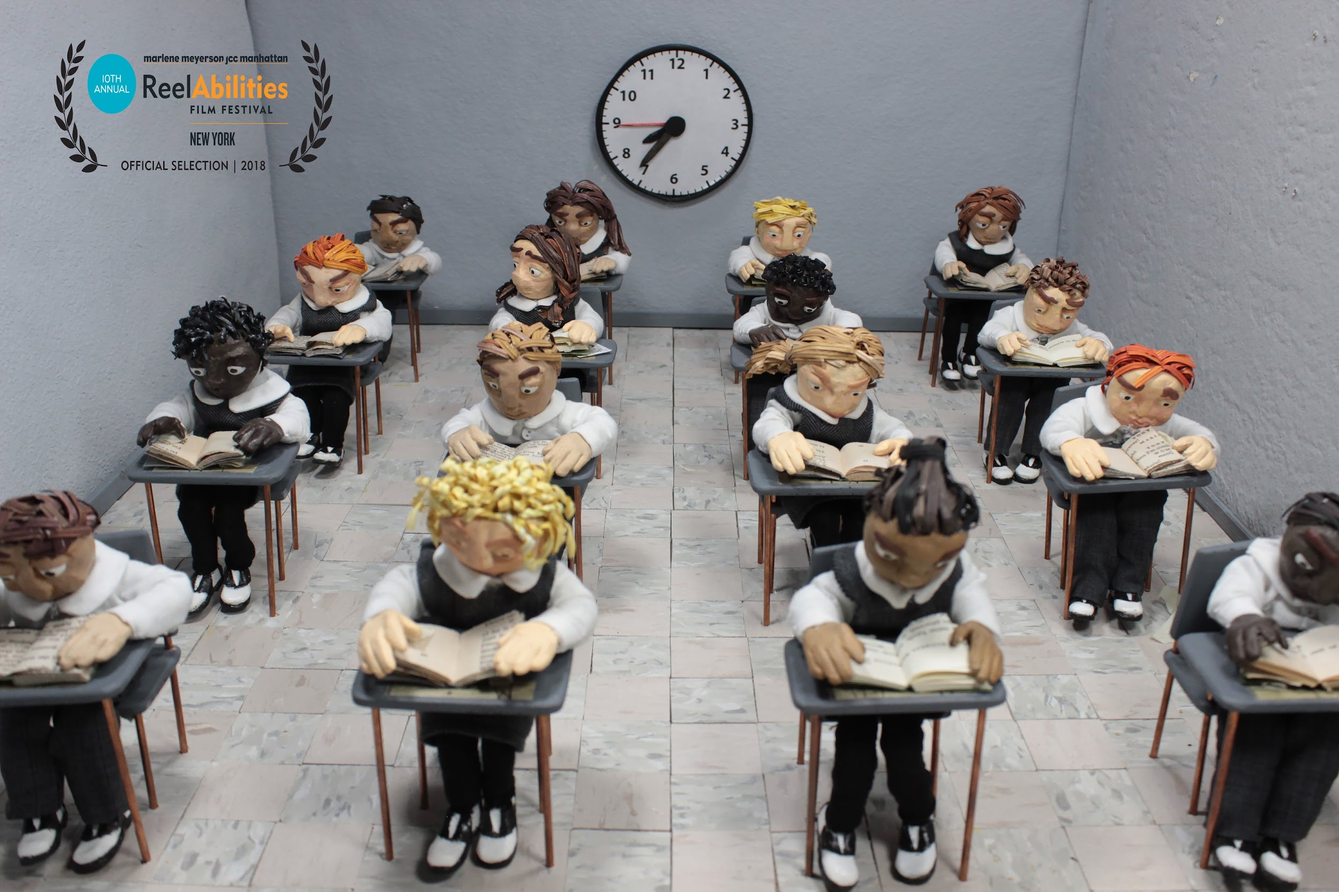 | Used class time well. Focused each time on getting the project done without distractions. | Used class time well. Usually focused on getting the project done and never distracted others. | Used some class time well. There was some focus on getting the project done but occasionally distracted others. | Did not use class time well. Did not focus on the project OR often distracted others. No final project completed.
Required Recipe Elements  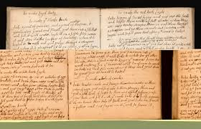 | All Elements of recipe included:  Graphics representative of recipe message.  7-10 thoughtful recipe ingredients | Most elements of the recipe included.  Graphics representative of recipe message.  5-7 thoughtful recipe ingredients | Some elements of recipe included  Graphics representative of recipe message.  1-4 thoughtful recipe ingredients | Recipe is hit or miss and is incomplete.  Vague graphics  Indecipherable OR unrelated recipe ingredients.

