**Lesson 3 - The Untold Story of Black Cowboys in America and photo project planning**

*Directions: Make a copy of this worksheet and then use the prompts and links below to explore an underreported story researched by a journalist in Florida.*

“The Untold Story of Black Cowboys in America: How One Florida Farmer Made History” by Ashonti Ford for *Spectrum News*

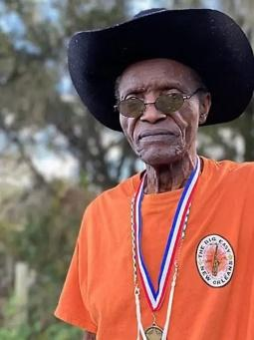

1. Review the Link to Article: <https://pulitzercenter.org/stories/untold-story-black-cowboys-america-how-one-florida-farmer-made-history>
2. Review the video that accompanies the article (scroll to the middle of the page)

[https://www.baynews9.com/fl/tampa/news/2022/02/17/black-foreman-inducted-into-the-cowboy-hall-of-fame-at-80-years-old-#](https://www.baynews9.com/fl/tampa/news/2022/02/17/black-foreman-inducted-into-the-cowboy-hall-of-fame-at-80-years-old-)

1. Video Reflection : Write a three-sentence reflection based on video

|  |
| --- |

1. ON YOUR OWN: After reading the story (link is above), answer the questions below….
2. What details stood out to you from the story the journalist reported ?

(Include 5 bullet points – details from the story

| 1. |
| --- |
| 2. |
| 3. |
| 4. |
| 5. |

1. Use those bullet points to write your own summary of the story

This MUST be in your OWN words

Summary MUST be at least 5 sentences long.

|  |
| --- |

1. Why do you think this qualifies as an underreported story?

|  |
| --- |

1. Why is this story important?

|  |
| --- |

1. What connections can you make between this story, and issues/people/places in your own community?

|  |
| --- |

1. Looking ahead….

Your final assignment in this unit is going to require YOU to research and create a presentation on an Underreported story here at Norland or in Miami Gardens.

Through a series of images, you are going to share your story.

**What story are you thinking about telling ?**

|  |
| --- |

**What type of images are you planning to include ?**

|  |
| --- |