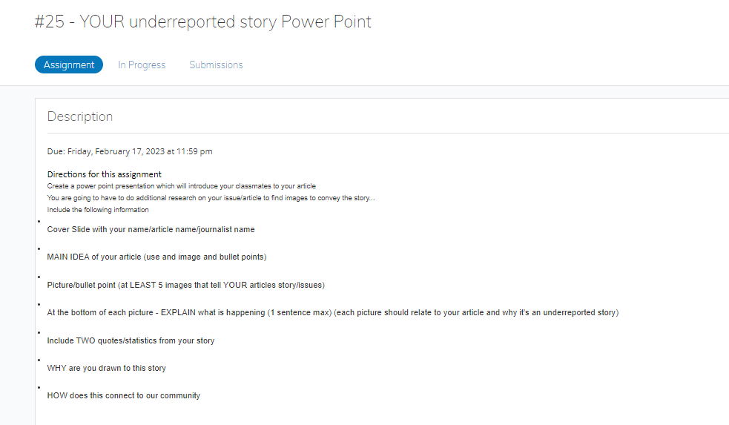

**Directions for this assignment:** Create a powerpoint presentation that will introduce your classmates to an article you explored from the [Pulitzer Center website](http://www.pulitzercenter.org). You are going to have to do additional research on your issue/article to find images to convey the story. Include the following information in your presentation:

1. Cover Slide with your name/article name/journalist name
2. MAIN IDEA of your article (use and image and bullet points)
3. Picture/bullet point (at LEAST 5 images that tell YOUR articles story/issues)
4. At the bottom of each picture - EXPLAIN what is happening (1 sentence max) (each picture should relate to your article and why it's an underreported story)
5. Include TWO quotes/statistics from your story
6. WHY are you drawn to this story
7. HOW does this connect to our community

(Also attached a copy of the story you selected for your project.)