Warm Up Question (from GCPS 2020 Unit 7 Inferences test) :

Day 2 Warm Up: Discovery High School is considering adding co-ed (boys and girls together) soccer to the sports program for the fall season. In order to get an unbiased sample of interest in soccer, who should the school survey?

A. boys in PE class

B. members of the soccer team

C. students in 10th grade homerooms

D. every fifth student entering the cafeteria

Day 2 Exit Ticket

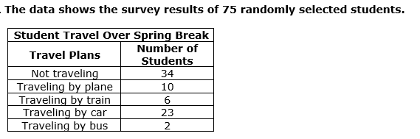

The school has 600 students total. Based on the results of the poll, how many of the school’s students should be expected to travel by plane over spring break?

A. 60

B. 80

C. 100

D. 120

Day 3 Warm Up

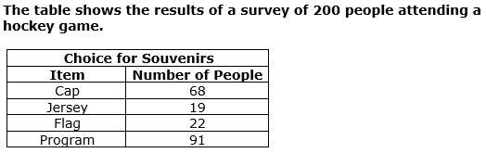

One game had an attendance of 27,000 visitors. Based on the table, how many people out of 27,000 could be expected to buy a flag?

A. 1,485

B. 1,850

C. 2,970

D. 3,200

Day 3 Exit Ticket:

Yaneli wants to determine which soccer team is the most popular at a game between the home team and the visiting team. Which of the following methods will give her the most accurate results?

A. surveying the cheerleaders for the home team

B. surveying people wearing hats for the visiting team

C. surveying a group of people standing in line for tickets

D. surveying people who do not live in the home team’s city

Day 4 Warm Up

Thirty students in a science class each perform the same experiment and measure the temperature of a solution. Which will provide the most valid inference about the temperature of the solution?

1. averaging the temperatures measured by the first six students who enter the classroom the day after the experiment
2. averaging the temperatures measured by five students whose names were picked from a stack of shuffled cards
3. averaging the temperatures measured by the six students with the highest scores on the last test
4. averaging the temperatures measured by five students who work together as a lab team