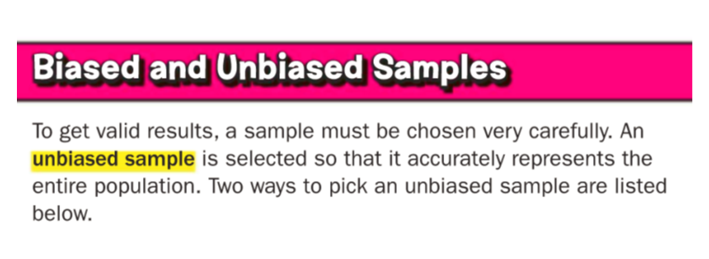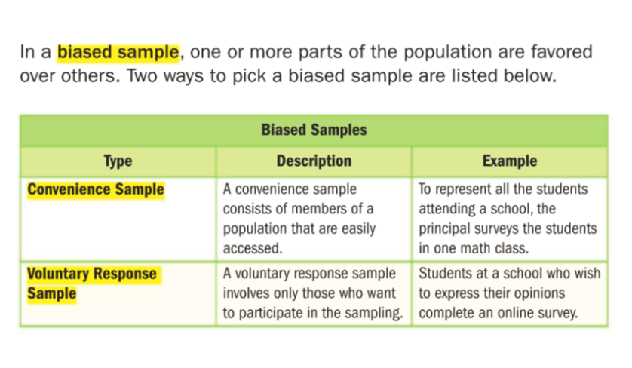
Examples from:

Glencoe Georgia Math Volume 2 Grade 7 by McGrawHill Education

