Unit Overview
Unit Title | Shattering Broken Mirrors and Windows: Exploring Youth Liberation Counter-Stories Through Photojournalism
Unit Length | One lesson per week for six weeks; 45 minutes per lesson per week
Grade Level(s)/Subject(s) | 3rd-5th Grade/Social Studies
Unit Overview | “Mirrors and windows” is a phrase that has been used to describe the ways in which students can witness the lives of others and explore similarities and differences of the human condition through literacy. During this unit, students will answer the following essential questions:  - How have underreported stories of youth-led social justice movements been represented through photojournalism?  - How have photojournalists portrayed the activism of youth domestically and abroad?  - How have youth domestically and abroad acted as agents of social change in recent times?  - How can local youth activism be visually portrayed through photography?  This unit focuses on developing students’ critical consciousness by examining how young people have led liberation movements across the U.S. and the world. Students will utilize photojournalism to examine underreported stories about youth resistance movements over the last five years. They will begin by examining the characteristics of underreported stories and learn about how they can identify these stories in their communities. Next, students will explore the discipline of photojournalism and the various techniques used to document the lived experiences of youth activists in domestic and global settings. Finally, students will spend time creating their own photography projects that witness the lived experiences of youth activists in their own communities. This recursive process of “windows and mirrors” will allow students the possibility to critically examine what social activism looks like through the prism of both/and.
Objectives & Outcomes | Students will be able to…  - Describe the characteristics of underreported stories and explain how journalists locate them in communities.  - Describe the characteristics of photojournalism.  - Analyze the various ways that photojournalists use photography to document activism in local and global communities.  - Identify youth activists in their local communities.  - Create a photography project that documents the lived experiences of activists in their local communities.
Standards | Texas Essential Knowledge and Skills (TEKs)  - Social Studies  - 4.21 The student applies critical-thinking skills to organize and use information acquired from a variety of valid sources, including electronic technology.  - 4.21D-The student is expected to identify different points of view about an issue, topic, historical event, or current event.  - 4.22D- The student is expected to create written and visual material such as journal entries, reports, graphic organizers, outlines, and bibliographies.  - English Language Arts  - 4.6B- The student is expected to generate questions about text before, during, and after reading to deepen understanding and gain information.  - 4.6E- The student is expected to make connections to personal experiences, ideas in other texts, and society.  - 4.6H- The student is expected to synthesize information to create new understanding.  - 4.7B- The student is expected to write responses that demonstrate understanding of texts, including comparing and contrasting ideas across a variety of sources.  - 4.7E- The student is expected to interact with sources in meaningful ways such as note taking, annotating, freewriting, or illustrating.  Common Core Standards  - English Language Arts  - RI.41- Refer to details and examples in a text when explaining what the text says explicitly and when drawing inferences from the text.  - RI.4.2- Determine the main idea of a text and explain how it is supported by key details; summarize the text.  - RI.4.9 - Integrate information from two texts on the same topic in order to write or speak about the subject knowledgeably.  - RI.3.7- Use information gained from illustrations (e.g., maps, photographs) and the words in a text to demonstrate understanding of the text (e.g., where, when, why, and how key events occur).  - RI.5.6- Analyze multiple accounts of the same event or topic, noting important similarities and differences in the point of view they represent.  - Writing  - W.4.2- Write informative/explanatory texts to examine a topic and convey ideas and information clearly.  - W.4.7- Conduct short research projects that build knowledge through investigation of different aspects of a topic.  - Speaking and Listening  - SL.4.1- Engage effectively in a range of collaborative discussions (one-on-one, in groups, and teacherled) with diverse partners on grade 4 topics and texts, building on others’ ideas and expressing their own clearly.  - SL.4.2- . Paraphrase portions of a text read aloud or information presented in diverse media and formats, including visually, quantitatively, and orally.
Unit Resources | Texts:  Young Climate Activists Warn Their Elders: Stop Destroying the Planet by Emily Baumgaertner, Kate Linthicum, and Parth MN for the Los Angeles Times  Chased And Jailed: No Rest And Much Danger For Asia’s Young Revolutionaries by David Pierson for the Los Angeles Times  The Pandemic Plunged Millions of Latin Americans Into Poverty. Its Youth Are Inheriting the Consequences by Patrick McDonnell for the Los Angeles Times  No School, No Hair Cut: One Girl’s Journey Through One of the World’s Longest COVID Lockdowns by Irina Werning and Naomi Larsson for The Guardian  Rainforest Defenders by Francesc Badia i Dalmases and Pablo Albarenga for The Washington Post  Portraits of a Pandemic by Errin Haines and David Maialetti for The Philadelphia Inquirer  Afropunk Brings The 'Black Lives Matter' Ethos Abroad by Melissa Bunni Elian for NPR  Video:  Video explaining underreported stories: What are Under-Reported Stories?  Video explaining photojournalism techniques: Everyday Africa: Telling Stories with Photographs  Additional visuals to inspire performance task projects  Images of student photos from the Everyday DC project:  Virtual Gallery: The Fifth Annual Everyday DC Exhibit | Pulitzer Center  Everyday Africa Tumblr page- Everyday Africa  Teaching Materials:  See each lesson for graphic organizers and slide decks for each lesson.  Additional Resources:  Everyday DC: A Photojournalism Unit Inspired by the Everyday Africa Project | Pulitzer Center  Journalist toolbox: Photojournalism  Ivonne Solano’s unit (4th grade-texas): https://pulitzercenter.org/sites/default/files/ivonne_pdf.pdf  Pulitzer Center Everyday Africa resources: Everyday Africa: Pulitzer Center Education Programming
Performance Task(s) | Students will identify an underreported issue that matters to them. They will then produce a photo essay project to demonstrate their understanding of the objectives of the unit.  Each student will choose a peer in their community (a classmate, another student in the school, or a relative under age of 18) who demonstrates the characteristics of being a social or political activist.  Students will then compile 3-5 photographs of their chosen youth activist to tell the story of the person’s lived experiences.  Each photograph will include a brief caption or narration (1-2 sentences) that further explains the person’s story, what the person advocates for, why the person became an advocate, and what they hope will be the impact of their advocacy. The project will be created in Google Slides.
Assessment/Evaluation | Written exit tickets  Reflective dialogue journals entries  Photo Essay Rubric [.pdf][.docx]  Illustrations with brief captions and narrations

Day 1: Exploring Underreported Stories

Lesson Objective(s) or Essential Question(s)
Students will describe the characteristics of an underreported story.

What is an underreported story?
Why are underreported stories important?
How can we find underreported stories in our community?
Lesson Materials and Resources
Video explaining underreported stories: What are Under-Reported Stories?
Everyday Africa Tumblr page- Everyday Africa
Lesson Activities
Warm Greeting and Community Norms (5 minutes)- Take this time to review the established community norms. Examples of agreed upon norms can be found below:
- Be respectful while other people are talking.
- Respect the mic and be mindful of your talking time.
- Be a respectful listener by giving the speaker your full attention.

Turn and Talk Provocation ( 5-10 minutes)- Begin the lesson by showing students a picture pulled directly from a provocative article from that day’s news headline. Example below:

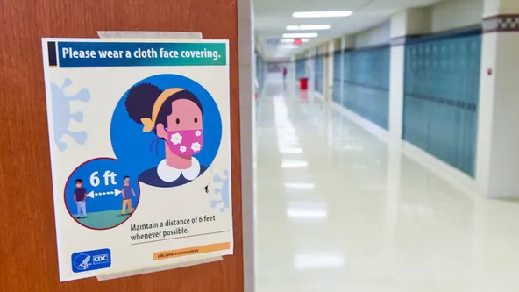

North Texas school districts make changes to COVID-19 protocols as cases surge by Peyton Yager for Fox 4

Have students turn and talk with their partner about one of the following:
- What do you see in this image?
- What questions do you have about this image?
- What do you think is going on in this image?
Underreported Stories Exploration (25 minutes)- After the provocation and discussion, students will then spend some time exploring underreported stories through photography examples. Images for this lesson will be gathered from the Everyday Africa project. Ask students the following probing questions tied to the image above:
- What do you think the pandemic is looking like in other parts of the world? (students then brainstorm images)
- What do you think this past year of the pandemic is looking like in Africa? How might it compare to here?

Share images of Everyday Africa from the past year (reflecting everyday moments during the pandemic) Here is an example slide deck. You can also show images directly from the Everyday Africa Instagram page.

- How do these images compare to what you thought? Stories that are not getting enough attention, which includes stories that might challenge our assumptions and stereotypes, are called “underreported stories.”
Show students the following video explaining underreported stories.
- What are Under-Reported Stories?
Print each image from the slideshow above and post it on chart paper as well to capture the student-generated hashtags at the end of the exploration.
- Students view the posted or projected images. Allow them to view the images up close and provide time for them to notice details and jot notes for each image into the graphic organizer. In partners, groups, or as a whole class, students share their initial (direct) observations. Then, question students about the deeper (inferential) meaning behind their initial observations.
- After discussion, students think of one keyword or short phrase that encapsulates each image and write it on a sticky note with a hashtag (#) before it, the same way they might tag a photo on social media.
- Students come up to the image and post their hashtags around the image, creating a frame.
- When the frame is finished and students have had a chance to read all of the hashtags, reflect as a whole class on similarities, differences, surprises, context, or anything else that they noticed about the words they assigned to the images.
Closing Reflection Journaling (5-10 minutes)- Students will end the day 1 lesson by writing in their journals and reflecting on the following questions:
- What is an underreported story?
- Why are underreported stories important?
- How can we find underreported stories in our community?
Lesson Materials

Questions Provocation Graphic Organizer [.pdf] [.docx]
Hashtag Graphic Organizer [.pdf] [.docx]
Everyday Africa slide deck [.pdf]
Student journals or notebook paper
Writing utensils

Day 2: Photojournalism Techniques

Lesson Objective(s) or Essential Question(s)
Students will be able to describe the characteristics of photojournalism.

Students will be able to analyze the various ways that photojournalists use photography to document activism in local and global communities.

What do photojournalists do?
What are the tools photojournalists use to tell underreported stories?
How do photojournalists choose the images they use?
Focus text(s) / resource(s) for today’s lesson
Journalist toolbox lesson plan: Photojournalism
Photojournalism | Journalist's Toolbox
Lesson Activities
Warm Greeting and Community Norms (5 minutes)- Take this time to review the established community norms. Examples of agreed upon norms can be found below:
- Be respectful while other people are talking.
- Respect the mic and be mindful of your talking time.
- Be a respectful listener by giving the speaker your full attention.

Brainstorm Walk (15 minutes)- During this activity, students will:
- move in groups to chart paper in different locations of the room labeled with subtopics;
- discuss prior knowledge about subtopic with peers; and
- write related words, facts, and questions on chart paper.

Prepare and post sheets of chart paper around the room, each with one of the following subtopics:
(1) photojournalism; (2) activism; (3) empathy; (4) storytelling.

Briefly review the subtopics above with students. Place students into groups and assign each group a subtopic. Ask students questions to activate background experiences, such as
- Have you read about this before?
- Have you ever heard about it?
- Have you ever experienced it?
- What does it mean to you?
Give students a signal to move with their group to the next subtopic on chart paper. Rotate until each group has discussed each subtopic. When students are finished, lead a class discussion so that students can share their ideas about each subtopic.
Whole Group Discussion of “A Journalist’s Toolbox: Photojournalism” (20 minutes)- Students will watch the video “A Journalist’s Toolbox: Photojournalism” about how photojournalists, Melissa Bunni Elian and Pablo Albarenga produce captivating stories about diverse communities through the use of photography. Teachers can use the resource “Notes for Teacher from Photojournalism Video Resource” to guide the whole group discussion. A copy of this document, Tips From Pulitzer Center Photojournalist, should be provided to students as they reflect on the following questions during their independent journal writing time.

- Discussion questions:
  - What underreported stories did Melissa and Pablo investigate? Why?
  - When Melissa and Pablo begin their photography journeys, they don't start by taking photos. How do they begin their process and why?
    - What are some questions that they ask their subjects before taking pictures?
  - What is a portrait? Why did Melissa choose to take portraits for her project?
  - Pablo says that photojournalists have a great "responsibility"—what does he mean by that?
  - According to Pablo and Melissa, what are some ways that you can make your images look more interesting?

Independent Journal Reflection Time (5-10 minutes)- Students will close today’s lesson by reflecting on the following prompts in their writing journals:
- What questions can you ask yourself as you're planning the story you want to tell through photographs?
- What questions do Melissa and Pablo mention that you can ask yourself to help brainstorm stories to tell in your own home? Make a list.
Lesson Materials

Notes for Teachers on Photojournalism Video Resource [.pdf] [.docx]
Tips from Pulitzer Center Photojournalists.docx resource for students [.pdf] [.docx]
Student journals or notebook paper
Writing utensils

Day 3: Evaluating Photojournalism from Different Parts of the World

Lesson Objective(s) or Essential Question(s)
Students will be able to analyze the various ways that photojournalists use photography to document activism in local and global communities.

What do photojournalists do?
What are the tools photojournalists use to tell underreported stories?
How do photojournalists choose the images they use?
Focus text(s) / resource(s) for today’s lesson
Young Climate Activists Warn Their Elders: Stop Destroying the Planet by Emily Baumgaertner, Kate Linthicum, and Parth MN for the Los Angeles Times
Chased And Jailed: No Rest And Much Danger For Asia’s Young Revolutionaries by David Pierson for the Los Angeles Times
No School, No Hair Cut: One Girl’s Journey Through One of the World’s Longest COVID Lockdowns by Irina Werning and Naomi Larsson for The Guardian
Rainforest Defenders by Francesc Badia i Dalmases and Pablo Albarenga for The Washington Post

Lesson Activities
Warm Greeting and Community Norms (5 minutes)- Take this time to review the established community norms. Examples of agreed upon norms can be found below:
- Be respectful while other people are talking.
- Respect the mic and be mindful of your talking time.
- Be a respectful listener by giving the speaker your full attention.

Turn and Talk Provocation ( 5-10 minutes)- Begin the lesson by showing students an illustration of youth activism. Do NOT show them the caption yet. Example below:

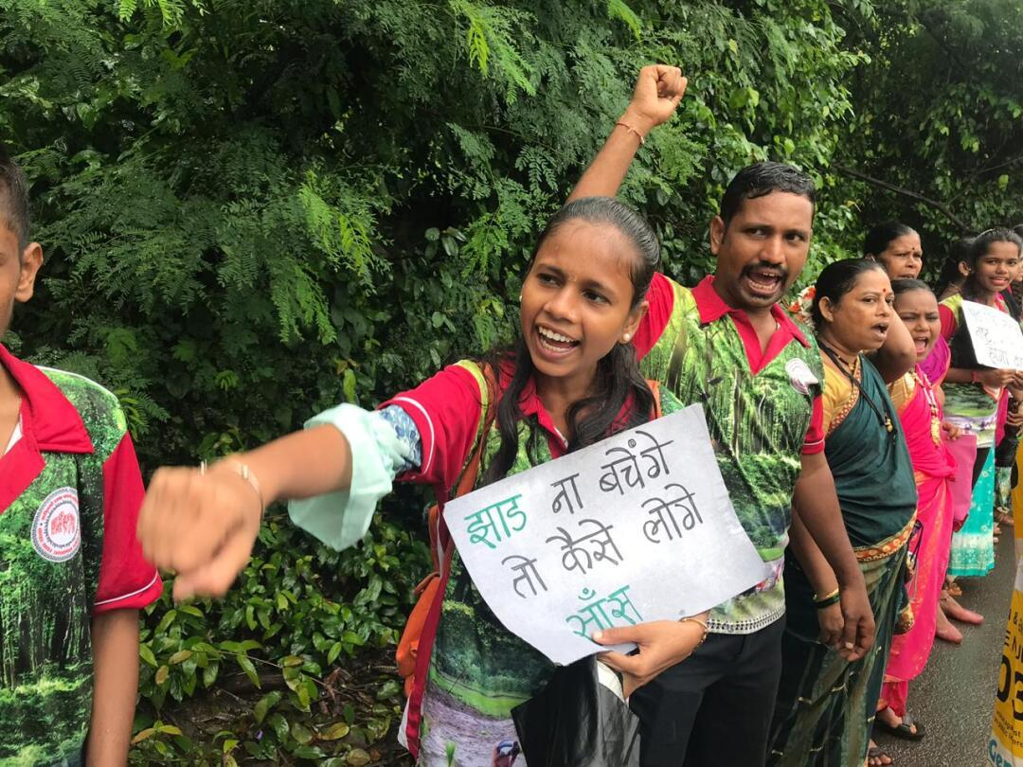
Young Climate Activists Warn Their Elders: Stop Destroying the Planet by Emily Baumgaertner, Kate Linthicum, and Parth MN for the Los Angeles Times
Have students turn and talk with their partner about one of the following:
- What do you see in this image?
- What questions do you have about this image?
- What do you think is going on in this image?
- What underreported news story might this image be sharing?

Share caption with the class after the discussion:
- “It is my duty to save tress, “ Manisha Dhinde says.”
Small Group Exploration (25 minutes)- After the provocation and discussion, students will then choose which group to join based on the underreported stories offered for that week. Please note that students will need to click on the photos to see the captions. Students may choose from the following stories:
- Provocation # 1- Young Climate Activists Warn Their Elders: Stop Destroying the Planet
- Provocation # 2- No School, No Hair Cut: One Girl’s Journey Through One of the World’s Longest COVID Lockdowns
- Provocation # 3- Chased And Jailed: No Rest And Much Danger For Asia’s Young Revolutionaries
- Provocation #4- Rainforest Defenders
Students will create groups of four to six. Each group of students will use their Chromebooks (if available) to explore the photojournalism projects on the Pulitzer Center’s website. If technology is not available, students will be given a packet with the photographs. Each group will be instructed to record their thoughts and feelings in their dialogue journals as they explore.
Dialogue journals have two columns for responses – column one is their personal thoughts, column two includes the thoughts of their peers. Students can use the questions from the provocation above to guide their reflections in column one as they look at the images from the article they selected.
Next, have students divide into pairs within their groups to begin their dialogue journals or written conversations. Instruct students to open a blank page in their journal or provide a blank piece of paper to each student. Have students write about their self-selected provocation image. Tell students to focus on what they took away from the images as well as how it may or may not connect to their own experiences.

Give students approximately three or four minutes to trade dialogue journals with a partner. When time is up, direct students to trade journals or papers, read their partner's comments, and write a response to them. Give students three to four minutes to respond. Repeat twice, depending on time you have allotted. Have each group share their thoughts between partners.
Lesson Materials
Student dialogue journals
Dialogue Journal Template [.pdf] [.docx]
Writing utensils

Day 4: Photojournalism Techniques
Lesson Objective(s) or Essential Question(s)
Students will be able to analyze the various ways that photojournalists use photography to document activism in local and global communities.

What do photojournalists do?
What are the tools photojournalists use to tell underreported stories?
How do photojournalists choose the images they use?
Focus text(s) / resource(s) for today’s lesson
Rainforest Defenders by Francesc Badia i Dalmases and Pablo Albarenga for The Washington Post
Afropunk Brings The 'Black Lives Matter' Ethos Abroad by Melissa Bunni Elian for NPR
“Why 94-Year-Old Activist Opal Lee Marched to Make Juneteenth a National Holiday” by Angelique Jackson for Variety
Lesson Activities
Warm Greeting and Community Norms (5 minutes)- Take this time to review the established community norms. Examples of agreed upon norms can be found below:
- Be respectful while other people are talking.
- Respect the mic and be mindful of your talking time.
- Be a respectful listener by giving the speaker your full attention.

Turn and Talk Provocation ( 5-10 minutes)- Begin the lesson by showing students an image from Melissa Bunni Elian’s Afropunk project and a portrait of Dr. Opal Lee. Examples below:
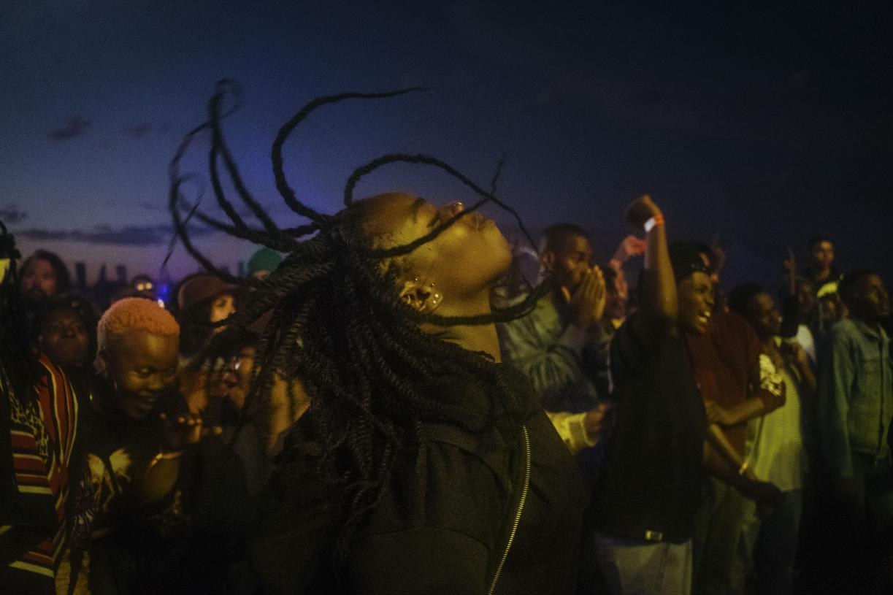
Afropunk Brings The 'Black Lives Matter' Ethos Abroad | Pulitzer Center
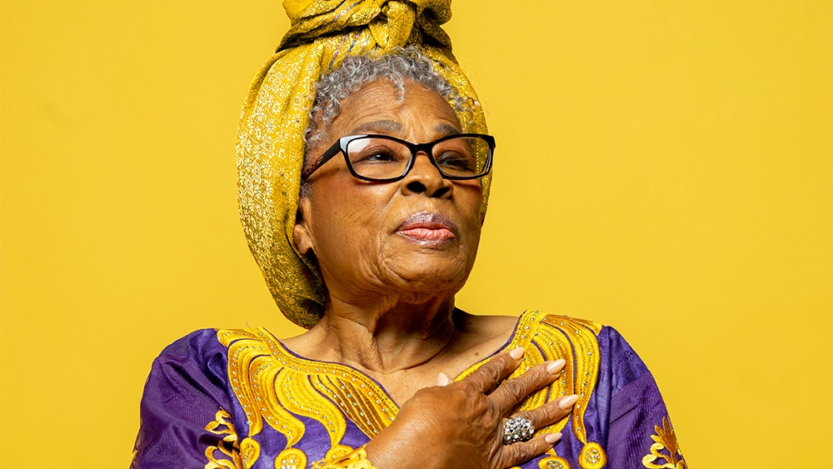
https://images.squarespace-cdn.com/content/5f400ba576b6df30021cb856/1615592592755-AC9MGTLQNPFT971RBOM7/7%2B-%2BMs.%2BOpal%2BLee.jpg?format=1500w&content-type=image%2Fjpeg
Have students turn and talk with their partner about one of the following:
- What do you see in this image?
- What questions do you have about this image?
- What do you think is going on in this image?
- What emotions are conveyed in this image?
Share that both images represent portraits. Then, share that the second portrait is of Dr. Opal Lee. Guide students in exploring the story of Dr. Opal Lee, and her work advocating to make Juneteenth a national holiday, using details from the article “Why 94-Year-Old Activist Opal Lee Marched to Make Juneteenth a National Holiday.” Let students know that they are now going to think about photojournalism strategies they can be using to share the stories of activists in their own communities

Option 1: Photojournalism Analysis (20 minutes)
Lead students in a compare and contrast activity where they explore the similarities and differences between Melissa Bunni Elian’s work (a portrait series) and Pablo Albareng’s work (a composite series).
- Students can use a Venn diagram to compare and contrast the results of Melissa and Pablo’s photojournalism work from Day two.
- Students should consider how the photos were composed, how the composition of the photos reflected the stories of the people profiled in those images, and what photojournalism techniques most interest them.

Option 2: Virtual Journalist Visit (20 minutes)- Students will engage in a virtual visit with a preselected photojournalist from the Putlizer center. Teachers can schedule a visit with a photojournalist here.
- Students will have had the opportunity to preview the photographer’s body of work in the preview lesson during the small group exploration.
- Students will prepare questions ahead of time for the journalist.

Closing Journal Reflection Time (5-10 minutes)- Students will close today’s lesson by reflecting on the following prompts in their writing journals:
- What stories in your community are you interested in learning more about?
- How can you tell these stories? Should you use photo essays or composite photo collages?
Lesson Materials
Student writing journals
Writing utensils
Days 5 and 6:
Telling Underreported Stories of Youth Activists through Photojournalism

Lesson Objective(s) or Essential Question(s)
Students will identify youth activists in their local community.

Students will be able to create a photo essay that documents the lived experiences of an activist in their local community.

What is an activist?
Who are the youth activists in my community?
How do young people in my community engage in social and political activism?
Focus text(s) / resource(s) for today’s lesson
Everyday Africa: Telling Stories with Photographs
Lesson Activities
Warm Greeting and Community Norms (5 minutes)- Take this time to review the established community norms. Examples of agreed upon norms can be found below:
- Be respectful while other people are talking.
- Respect the mic and be mindful of your talking time.
- Be a respectful listener by giving the speaker your full attention.

“What Makes A Photo Stand Out” (5-10 minutes)- During this warm up activity, students will review the techniques photojournalists use to make their photographs stand out. They watch this short video as class and have students reflect with their thought partners on the following questions:

- What story does this picture tell?
- What feeling is communicated through the image? How?
- How do different kinds of photos (portraits, landscapes, detailed images) tell different stories?

What Does Activism Look Like In Our Community? (5-10 minutes)- The teacher will facilitate a discussion about what activism looks like in everyday life. Students will brainstorm the ways that young people engage in social and political activism in their local communities (i.e. school, home, neighborhoods). Students are also encouraged to reflect the stories from the reporting they explored in lesson three.

Youth Activism Photo Essay Planning and Implementation- Over the next two lessons, students will choose a peer to be the subject of their photo essay on local youth activism. The peer could be a classmate or a student in another grade level. The peer could also be a sibling or relative.
- Students will choose a peer to highlight in their photo essay.
- Students will get the consent of the chosen subject and spend some time getting to know this person.
  - Reflect on the tips from photojournalists and ask the person about their lived experiences as it relates to their activism.
- Students will then take three-five photos of this person and compile them into a photo essay that includes a short caption or narration for each image.
  - Photos can be a mix of portraits and images of other things that tell the youth activist’s story.
  - Each caption or narration (1-2 sentences) should give some insight to the viewer about what part of the person’s story is being represented in the image.
  - Captions should also include information about what the person advocates for, why the person became an advocate, and what they hope will be the impact of their advocacy.
  - The project will be created in Google Slides and shared during a hallway exhibition.
- Review the elements of the photo essay rubric before the project begins to ensure success.
Lesson Materials

Photo Essay Rubric [.pdf][.docx]

