Unit Overview
Unit Title | How Can We Use Surveys to Advocate for Ourselves?
Unit Length | Five 55-minute class periods
Grade Level(s)/Subject(s) | 7th Grade Mathematics
Unit Overview | The pedagogical vision for this unit plan is that students will analyze how data can be manipulated depending on how the population was sampled in order to suggest certain results. Students will then be able to use data to advocate for themselves.  Students will start by examining samples of a population in order to analyze how statistics can be used to gain information about a population. By comparing and contrasting different examples of samples, they will recognize that rationalizations about a population from a sample are valid only if the sample is representative of that population. Specifically, students will recognize that random sampling tends to produce representative samples and support valid inferences. They will also be able to determine evidence of bias in surveys.  Students will then explore news stories that center statistics in order to communicate the underreported causes and impacts or pressing global issues. They will subsequently be able to create their own surveys that reflect their understanding of the concepts above and focus on their interests and concerns.
Objectives & Outcomes | Students will be able to…  - Recognize sampling techniques such as convenience, random, systematic and voluntary.  - Understand that random samplings produce the most representative samples of a population and support valid inferences.  - Apply statistics to gain information about a population from a sample of the population, understanding that the information is only valid if the sample is representative of that population.  - Consider the following questions to evaluate whether or not a survey is biased:  - Is the survey voluntary? (Voluntary surveys usually get respondents who feel strongly about the topic only and are not representative of the entire population.)  - Does the survey exclude any group?  - Is the sample size appropriate?  - Is the sample size appropriate?  - Use surveys to evaluate an underreported topic in their communities.
Standards | Common Core Standards:  MGSE7.SP.1 understand that statistics can be used to gain information about a population by examining a sample of the population; generalizations about a population from a sample are valid only if the sample is representative of that population; understand that random sampling tends to produce representative samples and support valid inferences
Unit Resources | Texts:  Reporting From Outside South Sudan: How a Phone Survey Helped Us Get to the Truth by Carolyn Thompson for Pulitzer Center  “First Antibody Surveys Draw Fire for Quality, Bias” by Gretchen Vogel for Science  “Who are Middle Schoolers Following o n Instagram?” from Wellesley Centers for Women  Videos:  What are underreported Stories? From Pulitzer Center  Teaching Materials:  Day 1 Cloze Notes: Inference notes on sample and population, adapted from materials by tothesquareinch.com [.pdf] [.docx]  Estimating Populations notes [.pdf] [.docx]  Optional Warm Up and Exit Ticket Resources [.pdf] [.docx]  Sample concept cartoon for Exit Ticket [.pdf]  Exit Ticket for Inferences Day 2 using quizizz.com  Additional scenarios from the article, “First Antibody Surveys Draw Fire for Quality, Bias” by Gretchen Vogel for Science [.pdf] [.docx]  Biased or Not Biased Samples using quizizz.com  Graphic organizer: Biased and Unbiased Samples, which includes examples from Glencoe 7th Grade Mathematics Volume 2 [.pdf] [.docx]  Journalist Visits to Classrooms | Pulitzer Center  Full Project Description and Rubric [.pdf] [.docx]  Optional Warm Up and Exit Ticket Resources [.pdf] [.docx]
Performance Task(s) | In groups of four, students will plan a survey about an underreported topic in their communities. As they come up with their surveys, students consider how this survey will surface an important topic, center an underrepresented voice/story, challenge an injustice, or present a solution. Once they identify a topic, students design their survey by writing a short statement explaining why they want to conduct their survey, what they hope their survey will answer, and how they identified the questions and population for their survey. They will also determine how they want to present their survey (written form, digital form, poster, etc.)  Students write three-five questions that center what they want to learn while also eliminating any bias in the questions. They then create a data collection form, determine their sampling method, and create a plan for conducting their survey with a good representation of the population.  The main goal is to design the survey that can be executed. After being graded on their design, students can determine if you actually want to conduct their survey at a later date. As part of their process, students should use the rubric below to guide their planning. They can also decide to take on the following roles:  Wordsmith: This person develops the purpose of the survey and writes the questions (wording it without bias).  Data Analyst: This person determines the population and a valid sample, and decides what amount of students surveyed will be a good representation of the population you want to reach.  Logistics Manager: This person develops a realistic plan to get the sample and conduct the survey, also assists in overall design when needed.  Creative Director: This person will be in charge of arranging pictures, art, poetry, or music lyrics, or other creative expressions that will enhance the appeal of the purpose of the survey.  Full Project Description and Rubric [.pdf] [.docx]
Assessment/Evaluation | Formative Assessments:  Students will engage with daily exit tickets and create lumio videos to demonstrate learning throughout the unit.  Summative Assessment:  Students’ final projects will be evaluated using the following rubric, which is also attached to the project description.
Survey Design Rubric:

Category | 4 | 3 | 2 | 1
Purpose of Survey | Purpose is stated clearly and addresses a particular concern in the students’ community | Purpose is stated somewhat clearly and addresses a concern in the students’ community | Purpose is not stated clearly and/or does not address a particular concern in the students’ community | Purpose is not stated.
Data Analysis | Designates a specific population;  Sample is unbiased and size represents the population well. Prediction is accurate. | Population is not clear OR  Sample is unbiased, but size is too small or too large for the population.  Prediction is accurate. | Population is not clear AND  Sample is biased, size is too small or too large for the population. Prediction is somewhat accurate. | Population is not specified;  Sample size is biased and/or not specified  Prediction is incorrect.
Clarity of  Questions | Questions are excellent, aligned to the purpose,  unbiased, and a person would not have to ask for clarification. | Questions are satisfactory,  aligned to the purpose, unbiased, and a person might  have to ask for  clarification. | Questions are  partially aligned to the purpose, somewhat biased, and a person  would have to  ask for  clarification. | Questions are  not aligned to the purpose, confusing and biased.
Conducting the Survey | Survey can be conducted smoothly; only possible minor setbacks | The plan to conduct the survey is mostly realistic | The plan to conduct the survey is unrealistic | There is not a clear plan for conducting the survey
Creative Expression Quality | The selection of creative expression(s) is impressive and enhances the meaning of the survey. | The selection of creative expression(s) mostly enhances the meaning of the survey. | The selection of creative expression(s) somewhat enhances the meaning of the survey. | The selection of creative expression(s) does not enhance the meaning of the survey.

Day 1

Lesson Objective(s) or Essential Question(s)
After this lesson students will be able to:
- Define the term “under-reported story” and explain the importance of under-reported stories in journalism.
- Contrast populations versus samples, understanding that the information is only valid if the sample is representative of that population.
- Discuss biased vs unbiased forms of questioning in surveys.
- Identify a survey topic and group roles in their survey design projects.
Focus text(s) / resource(s) for today’s lesson
What are underreported Stories? From Pulitzer Center
Lesson Activities
Warm up:
- (5 - 7 minutes) Students will use the Lumio app to answer the question below:
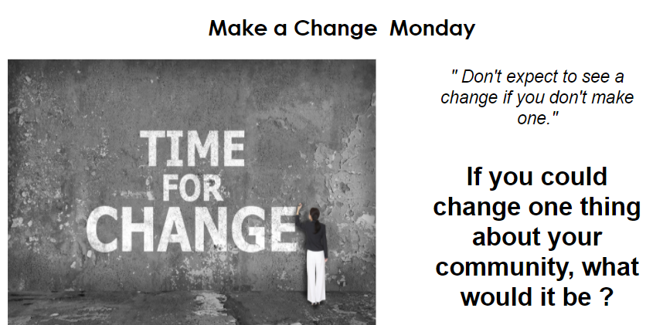
- Students will then discuss answers and how to address concerns as a group.

Opening: (5-7 minutes)
- Introduce students to the survey project. Explain that they will learn different ways to collect data to use in addressing their concerns and sharing their research with others.
- Then, show the video, What are underreported Stories? to introduce the concept of an under-reported story to students.

In-class Activity: (30-32 minutes)
- (5 minutes) After the video, the class will discuss: What are under-reported issues that students could potentially explore in their survey projects?
- (10 minutes) Students discuss the differences between population and sample for surveys by completing cloze notes on Populations and Samples. The notes document also the responses to the cloze notes.
- Students can solve the problems themselves, but have the notes already printed). Problems will be projected on the board for them to solve.
- Students will also review biased and unbiased terms, and how bias may influence surveys (these terms are introduced in the notes).
- Finally, students will discuss the ways that surveys can be used to share important stories about pressing issues that aren’t getting enough attention
- (5 - 7 minutes) After the notes and discussion, students will use the responses from the warm up as a brainstorming session to determine a survey topic that represents an underreported story in their communities. The teacher will send one to the group board anonymously to get the suggestions started if need be.
- (10 mins) Groups of four will be assigned to determine project roles. Today’s project goal is that the groups will identify a survey topic. They will write their names and survey topic on one copy of the project instructions to turn in.
Lesson Materials

Day 1 Cloze Notes: Inference notes on sample and population, adapted from materials by tothesquareinch.com [.pdf] [.docx]
Full Project Description and Rubric [.pdf] [.docx]

Day 2

Lesson Objective(s) or Essential Question(s)
After this lesson, students will be able to:
- Use proportions to make predictions about a population from a sample.
- Identify their survey population and draft survey questions.
Focus text(s) / resource(s) for today’s lesson
Reporting From Outside South Sudan: How a Phone Survey Helped Us Get to the Truth by Carolyn Thompson for Pulitzer Center

“Who are Middle Schoolers Following o n Instagram?” from Wellesley Centers for Women
Lesson Activities
Warm up:

(5-7 minutes) Project the news story Reporting From Outside South Sudan: How a Phone Survey Helped Us Get to the Truth by Carolyn Thompson for Pulitzer Center onto the board (providing hard copies for the students). Summarize the story and then ask students to determine the population and sample used.

Introducing the lesson (themes, background, context, significance):

(3-5 mins) Students will examine “Who are Middle Schoolers Following o n Instagram?” from Wellesley Centers for Women and reflect on whether or not the finding from the statistic is true for them or not. From there students, will reflect on the following questions:
- Where do statistics come from?
- How do you know whether or not to trust a statistic?
- Fill in and discuss: There are _______ students at our school. Based on the body image statistic, how many students are predicted to feel body dissatisfaction triggered by celebrity photos?
In-class activity: including discussion questions and comprehension questions for resource(s)

(10-15 mins) Students will be given the Estimating Populations notes that are already filled in with the answers. We will read them together. Then, students will be given 5-10 minutes to show the work that goes with the answers on the practice page. Next, four students will come to the board to show their work, while the questions are projected onto it.

(15- 20 mins) Project project the graphic organizer that is on the last page of the project instructions onto the board. Students will work in their project groups. Today’s goal is to identify their survey population and draft survey questions.
Evaluation
(last 5 minutes of class) Exit ticket will be from Optional Warm Up and Exit Ticket Resources. Students will see 1) a concept cartoon to determine who to agree with based on if the sample is representative of the population, and 2) use proportions to predict the outcome based on the survey results from a sample.
Students can complete the Exit Ticket for Inferences Day 2 using quizizz.com. The questions can also be on Lumio or a small slip of paper that they can show their work on and put in a basket as they walk out of the classroom (depending on digital resources).
Lesson Materials

Estimating Populations notes [.pdf] [.docx]
Full Project Description and Rubric [.pdf] [.docx]
Optional Warm Up and Exit Ticket Resources [.pdf] [.docx]
Sample concept cartoon for Exit Ticket [.pdf]
Exit Ticket for Inferences Day 2 using quizizz.com

Day 3

Lesson Objective(s) or Essential Question(s)
After this lesson students will be able to:
- Compare/contrast the four types of sampling.
- Consider the following questions when determining if a survey is biased :
- Is the sample random and representative of the population?
- Is the survey voluntary?
- Does the survey exclude any group?
- Is the sample convenient to the surveyor?
- Create thoughtful questions to ask a journalist about their career and how surveys are used to strengthen a news story.
Focus text(s) / resource(s) for today’s lesson
Reporting From Outside South Sudan: How a Phone Survey Helped Us Get to the Truth by Carolyn Thompson for Pulitzer Center
“First Antibody Surveys Draw Fire for Quality, Bias” by Gretchen Vogel for Science
Lesson Activities
Warm-up:

(5-7 minutes) Project the attached news story from the Pulitzer Center Reporting From Outside South Sudan: How a Phone Survey Helped Us Get to the Truth onto the board (providing hard copies for the students). Then, discuss the questions used in the survey and how the survey was used to investigate a pressing issue by citing the following quote, “We asked people if they considered themselves displaced, whether they had been forced off their land, whether they were forced out by government, opposition soldiers, both, or other armed groups. We wanted to know whether they believed their home had been looted, damaged or destroyed, and whether they thought it was being illegally occupied. We also asked them whether they planned to return if their country were to experience peace.”

Introducing the lesson (themes, background, context, significance)

(7 - 10 minutes) Collaborating in their project groups of four, students will review the Graphic organizer: Biased and Unbiased Samples to compare and contrast the four types of samples: Simple Random Sample, Systematic Random Sample, Convenience Sample, Voluntary Response Sample.

In-class activity: including discussion questions and comprehension questions for resource(s)
10 - 15 mins) Activity 1: Students will work together in pairs (either with their survey partners or an available neighbor) to practice determining Biased or Not Biased Samples using quizizz.com. Students then review the responses together as a class.

(5-7 mins) Activity 2: Using Lumio, project additional scenarios from the article, “First Antibody Surveys Draw Fire for Quality, Bias” by Gretchen Vogel for Science onto the board for the students to determine what types of samples are illustrated (multiple choice with the 4 types of samples. They will also analyze the goal of the survey, and how the survey was determined to be biased. Hard copies will be available at every group.

(10 mins) Say to the students: “Tomorrow we will meet with a journalist (via Zoom) who has shared and analyzed surveys as a part of their reporting on an underreported issue. Make a list of 3-5 questions for the journalist. Try to consider questions that might help you with your final project, but also feel free to include questions you have about the journalist's career and reporting.” If there is time, introduce students to reporting from the journalist. Students from Richards Middle School in Lawrenceville, GA who engaged with this unit connected with journalist Jamaija Rhoades. To schedule a virtual visit with a Pulitzer Center-supported journalist, click here.

Give students a Lumio link so that they can send their responses as the questions come to them. Next, pick the best questions to have presented to the journalist(s).They may discuss with their project group mates or a nearby available neighbor.

Evaluation

(last 5 minutes of class) Exit ticket will be from Optional Warm Up and Exit Ticket Resources, in which the students will use proportions to predict the outcome based on the survey results from a sample. The question will be on Lumio or a small slip of paper that they can show their work on and put in a basket as they walk out of the classroom (depending on digital resources).

*However, if more time is needed for the students to make their list of questions for the journalists, we will continue this instead of the exit ticket.
Lesson Materials

Additional scenarios from the article, “First Antibody Surveys Draw Fire for Quality, Bias” by Gretchen Vogel for Science [.pdf] [.docx]
Biased or Not Biased Samples using quizizz.com
Graphic organizer: Biased and Unbiased Samples, which includes examples from Glencoe 7th Grade Mathematics Volume 2 [.pdf] [.docx]
Journalist Visits to Classrooms | Pulitzer Center
Full Project Description and Rubric [.pdf] [.docx]
Optional Warm Up and Exit Ticket Resources [.pdf] [.docx]

Day 4

Lesson Objective(s) or Essential Question(s)
By the end of the lesson, students will be able to:
- Respectfully enjoy the gained knowledge about conducting surveys to strengthen a news story from a professional journalist in order to help them with their survey design.
- Interact with the journalist and ask questions about her background.
- Revise survey questions
Focus text(s) / resource(s) for today’s lesson
Lesson Activities
Warm Up

(5 minutes) Students will be reminded about behavior expectations with our guest speaker/journalist and given an agenda of how the class will go, with possible time at the end to work on projects.

In-class activity: including discussion questions and comprehension questions for resource(s)

(30 - 45 mins) Students will listen to the journalist present on their process developing and delivering surveys. They will also take notes on the journalist’s responses to their questions from the previous lesson.

Evaluation
(last 5- 7 minutes of class) Students will be asked to give a reflection about the experience with the journalist; if they enjoyed the discussion, or any lingering questions they have that maybe they wished they asked. The question will be on Lumio or a small slip of paper that they can put in a basket as they walk out of the classroom (depending on digital resources).
Lesson Materials

Journalist Visits to Classrooms | Pulitzer Center
Jamaija Rhoades | Pulitzer Center - Potential journalist speaker for this lesson whose reporting included survey collection and data analysis.

Day 5
Lesson Objective(s) or Essential Question(s)
Today is a project work session. During this class students will prepare their survey designs. By the end of class, students will be able to complete their survey designs and plans for delivering their surveys.
Focus text(s) / resource(s) for today’s lesson
Lesson Activities
Warm-up

(5 - 7 minutes) Students will use Lumio (or sticky notes while the question is being projected) to answer the question below:
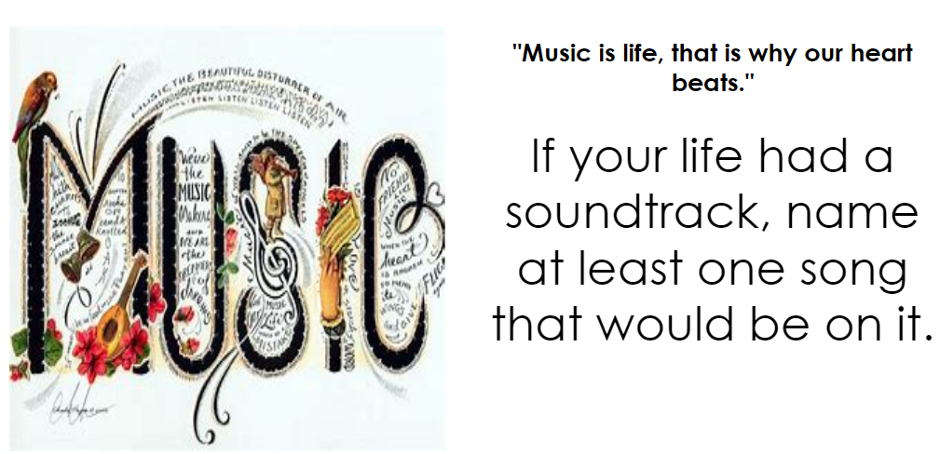
After about 3-4 minutes, we will discuss answers as a group.

(5 mins) Next. students will review the rubric and project directions with the class. They will also reflect on how their projects reflect them and what they are passionate about.

Project Work Session

(45 mins) The class period will be dedicated to finishing survey designs, adding creative touches, and answering questions and concerns before turning the project in. A timer and the rubric will be projected onto the board. Students will communicate questions/concerns through Lumio through the Handout option.

Evaluation

Students will complete their survey designs and display them around the classroom. Students will then do a gallery walk in the upcoming days so that other students may then give feedback on their surveys using the project rubric.

Extension

After students receive feedback and grades for their designs, students can determine if they actually want to conduct their survey to their sample. If they conduct their survey (at a later date) and then analyze the results (graphs, measures of central tendency, variation, depending on the type of data) they can earn an additional 50 - 100 points on this assignment. A strong design must be created first.

*I gave some additional time for groups to get their projects together before they turned in the final project if needed, but this was the last day of dedicated class time to work together*
Lesson Materials

Full Project Description and Rubric [.pdf] [.docx]

