________________ deal with collecting, organizing, and interpreting data.

A _____________ is a method of collecting information.

The group being studied is the ________________.

Sometimes the ________________ is large. To save time and money, part

of the group, called a _____________, is surveyed.

Example 1:
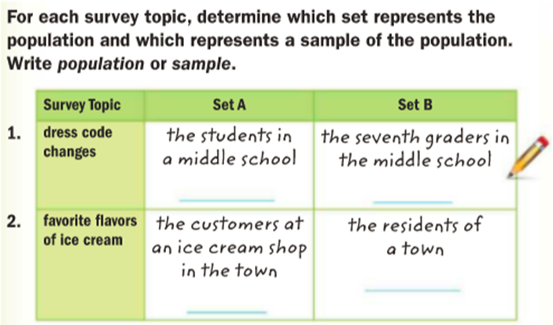
Example 2:
Uriel wants to survey students in his school about their favorite and least favorite ice cream flavors. Describe a possible sample Uriel could survey instead of surveying the entire school

