

How Can We Use Surveys to Advocate for Ourselves?

In groups of four, you will plan a survey about an underreported topic in your community. As you come up with your survey, consider how this survey will surface an important topic, center an underrepresented voice/story, challenge an injustice, or present a solution. You will need to identify a topic of concern that your group would like to get information about. Determine the population you want to collect data about. You could survey your peers on this team, all 7th graders, or all grades of Richards Middle School. Or you might have a completely different idea for a population.

Once you identify your topic, it’s time to design your survey. Your group will need to write a short statement explaining why they want to conduct their survey, what they hope their survey will answer, and how they identified the questions and population for their survey. Your group has the option to use a digital format or a poster for the survey design. Be creative in how your group will present your survey design. *Hint: Don’t just turn the instructions packet back in with filled in answers, make a presentation!

You will need to write 3-5 questions. Think carefully about what kind of data you need for your survey and make sure to eliminate any bias in the questions you plan to ask. You will also need to create a data collection form. You may wish to ask questions verbally and record the answers on a survey sheet, or you may wish to print/digitally create copies of a survey sheet and have respondents fill out your survey sheet. If you choose the second option, you will then need to fill out your own form to record the answers in a way that is easily readable.

Finally, you will need to choose a sampling method. Think carefully about what method will work best to create a good representation of your population. Make sure your sampling method will not create a biased sample.

Your main goal is to design a survey that can be executed. After being graded on your design, you and your group can determine if you actually want to conduct your survey to your sample. If you conduct your survey (at a later date) and then analyze the results, you can earn an additional 50 - 100 points on this assignment. But a strong design must be created first.

Your survey design is due ___________________________________________________.

Every student in your group will play an equally important role. Decide who will be in each role:

Wordsmith: this person develops the purpose of the survey and writes the questions (wording it without bias)
Data Analyst: this person determines the population and a valid sample, and decides what amount of students surveyed will be a good representation of the population you want to reach.
Logistics Manager: this person develops a realistic plan to get the sample and conduct the survey, also assists in overall design when needed.
Creative Director: this person will be in charge of arranging pictures, art, poetry, or music lyrics, or other creative expressions that will enhance the appeal of the purpose of the survey.

Group #________

Wordsmith:_______________________________ Data Analyst:____________________________________

Logistics Manager:______________________________________

Creative Director: ______________________________________

Survey Design Rubric:

Category | 4 | 3 | 2 | 1
Purpose of Survey | Purpose is stated clearly and addresses a particular concern in the students’ community | Purpose is stated somewhat clearly and addresses a concern in the students’ community | Purpose is not stated clearly and/or does not address a particular concern in the students’ community | Purpose is not stated.
Data Analysis | Designates a specific population;  Sample is unbiased and size represents the population well. Prediction is accurate. | Population is not clear OR  Sample is unbiased, but size is too small or too large for the population.  Prediction is accurate. | Population is not clear AND  Sample is biased, size is too small or too large for the population. Prediction is somewhat accurate. | Population is not specified;  Sample size is biased and/or not specified  Prediction is incorrect.
Clarity of  Questions | Questions are excellent, aligned to the purpose,  unbiased, and a person would not have to ask for clarification. | Questions are satisfactory,  aligned to the purpose, unbiased, and a person might  have to ask for  clarification. | Questions are  partially aligned to the purpose, somewhat biased, and a person  would have to  ask for  clarification. | Questions are  not aligned to the purpose, confusing and biased.
Conducting the Survey | Survey can be conducted smoothly; only possible minor setbacks | The plan to conduct the survey is mostly realistic | The plan to conduct the survey is unrealistic | There is not a clear plan for conducting the survey
Creative Expression Quality | The selection of creative expression(s) is impressive and enhances the meaning of the survey. | The selection of creative expression(s) mostly enhances the meaning of the survey. | The selection of creative expression(s) somewhat enhances the meaning of the survey. | The selection of creative expression(s) does not enhance the meaning of the survey.
Here is an EXAMPLE of how to organize your survey design. Remember you need to create 3-5 unbiased questions.

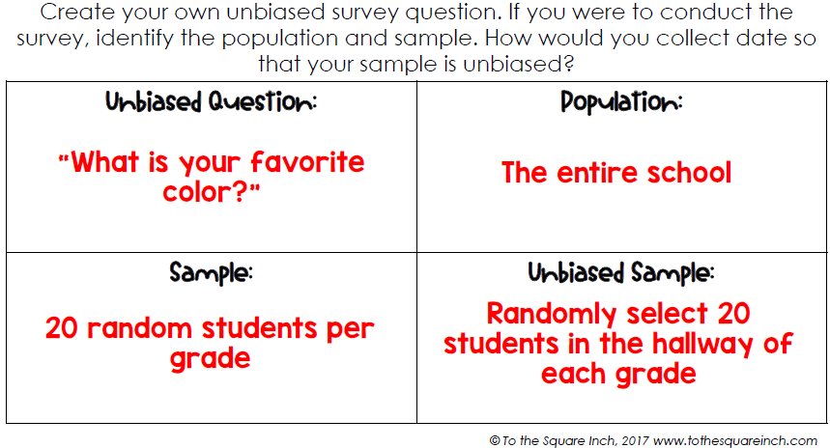

3 - 5 Unbiased Questions for your group’s survey: | Population:
Sample: | Unbiased Sample:
Purpose Statement for this survey (Questions to think about and answer in your purpose statement: Why did your group want to conduct their survey? What do you all hope your survey will answer? Who would you want to share the results of your survey to in order to bring about awareness and change?):

