**Day 8 Packet**

Name:________________________ Date: ___________________

**Do Now**

Match the vocabulary word to its definition!

| Precarious  Futile  Incessant  Furnish  Desert  Gregarious  Succumb  Malignant  Vapid  Disingenuous | Provide  Give up, submit  Abandon  Lacking flavor, zest, interest.  Insincere or misleading  Likely to collapse  Pointless  Constant  Deadly, dangerous  Social, a liking for companionship |
| --- | --- |
| Imagine a ten-year old relative sees your Humanities work and asks what your vocabulary words mean. Pick three and describe how you would explain the words to your relative. ____________________________________________________________________________________________________________________________________________________________________________________________________________________________________________________________________________________________________________________________________________________________________________________________________________________________ | |

**CAR Claims:**

Context:

Argument:

Reasoning:

**Labeling:**

Label the Context, Argument, and Reasoning in the CAR Claim below.

| *During the Age of Exploration, Christopher Columbus was not a hero because he brutalized Native Americans and was not even the first European to arrive in the Americas.* |
| --- |

**Matchmaker**

Each claim below has one problem. For each claim, identify its CAR parts (some will be missing). Match the claim to the correct problem.

| 1. During the coronavirus pandemic, everyone should wear a mask because it is safer. 2. It is necessary because meat spoils so quickly. 3. Doing push-ups everyday is good because it will improve upper-body strength in just a few weeks. 4. This weekend, Mr. Jue had to change the tire of his car. 5. Of all desserts, ice cream is the best tasting because at birthday parties it is always there. 6. Call of Duty Warzone is not appropriate for children under 12. | 1. Missing context 2. Vague argument 3. Vague reason 4. Missing reason 5. Reasons don’t match argument 6. Not a claim |
| --- | --- |

**CAR Claim Writing Practice**

Why is sleep important?

Should we care about the world besides the United States?

Are dogs better than cats?

**COVID-19 Inquiry**

**Document 1: Latino COVID Health Disparities**

| **Publication** (type of source, date of source) | **Point of View** (who is the author, and what is their perspective?) |
| --- | --- |
|  |  |
| **Intended Audience** | **Predicted Purpose** (what is doc’s purpose?) |

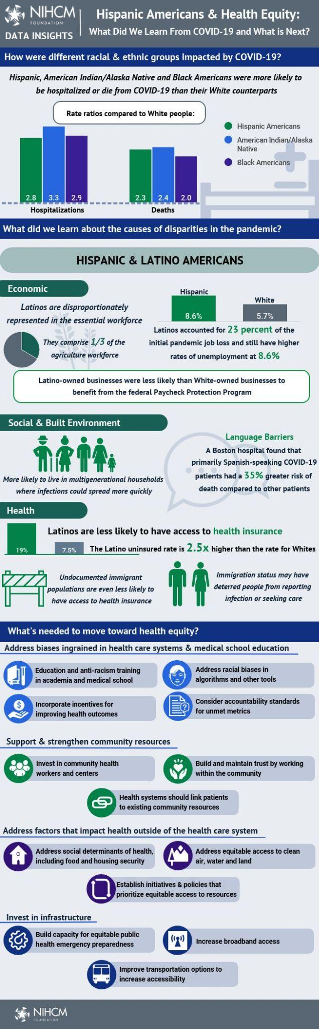

**Source**: National Institute for Healthcare Management. “Hispanic Americans and Health Equity” 25 June 2021. [Link](https://nihcm.org/publications/hispanic-americans-health-equity).

(*NIHCM is a non-profit that researches problems and inequities in healthcare and develops solutions.)*

| **Debrief Questions** | |
| --- | --- |
| Based on this document, in what ways are COVID-19 and the Yellow Fever similar? Different? | Name 3 important facts or findings from this document. |

**Document 2: COVID-19 Panic**

| **Publication** (type of source, date of source) | **Point of View** (who is the author, and what is their perspective?) |
| --- | --- |
|  |  |
| **Intended Audience** | **Predicted Purpose** (what is doc’s purpose?) |

Since the coronavirus began spreading across the world, we’ve learned a lot about the lengths to which people will go for a roll of toilet paper, a tube of hand sanitizer or a face mask. As the number of confirmed coronavirus cases increases and states and countries lock down large gatherings or shops to promote social distancing, these uncertainties are driving the so-called “panic-buying” that’s emptying store shelves quicker than they can be restocked.

“When you’re seeing extreme responses, it’s because people feel like their survival is threatened and they need to do something to feel like they’re in control,” explains Karestan Koenen, professor of psychiatric epidemiology at the Harvard T.H. Chan School of Public Health. Panic-buying supplies is one way humans have coped with uncertainty over epidemics since at least 1918 during the Spanish flu—when people in Baltimore raided drug stores for anything that would prevent the flu or relieve its symptoms—all the way up to the 2003 SARS outbreak.

In certain scenarios, panic can be life-saving. When we’re in immediate danger of being mauled by a lion or run over by a car, the most rational response may be flight, fight, or freeze. We don’t want our brains to spend too much time debating that. But panic comes with serious drawbacks as well: “Panic, rather than being antisocial, is a nonsocial behavior,” Quarantelli wrote. “This disintegration of social norms… sometimes results in the shattering of the strongest primary group ties.” Panic doesn’t help much with long-term threats either.

**Source**: Mckeever, Amy. “Coronavirus is spreading panic. Here’s the science behind why” National Geographic Magazine, 17 March 2020. [Link](https://www.nationalgeographic.com/history/article/why-we-evolved-to-feel-panic-anxiety).

| **Debrief Questions** | |
| --- | --- |
| Based on this document, in what ways are COVID-19 and the Yellow Fever similar? Different? | What are the benefits and drawbacks of panic? |

**Document 3: Coronavirus Misinformation**

| **Publication** (type of source, date of source) | **Point of View** (who is the author, and what is their perspective?) |
| --- | --- |
|  |  |
| **Intended Audience** | **Predicted Purpose** (what is doc’s purpose?) |

The article that appeared online on Feb. 9 began with a seemingly innocuous [*innocent*] question about the legal definition of vaccines. Then over its next 3,400 words, it declared coronavirus vaccines were “a medical fraud” and said the injections did not prevent infections, provide immunity or stop transmission of the disease. Instead, the article claimed, the shots “alter your genetic coding, turning you into a viral protein factory that has no off-switch.”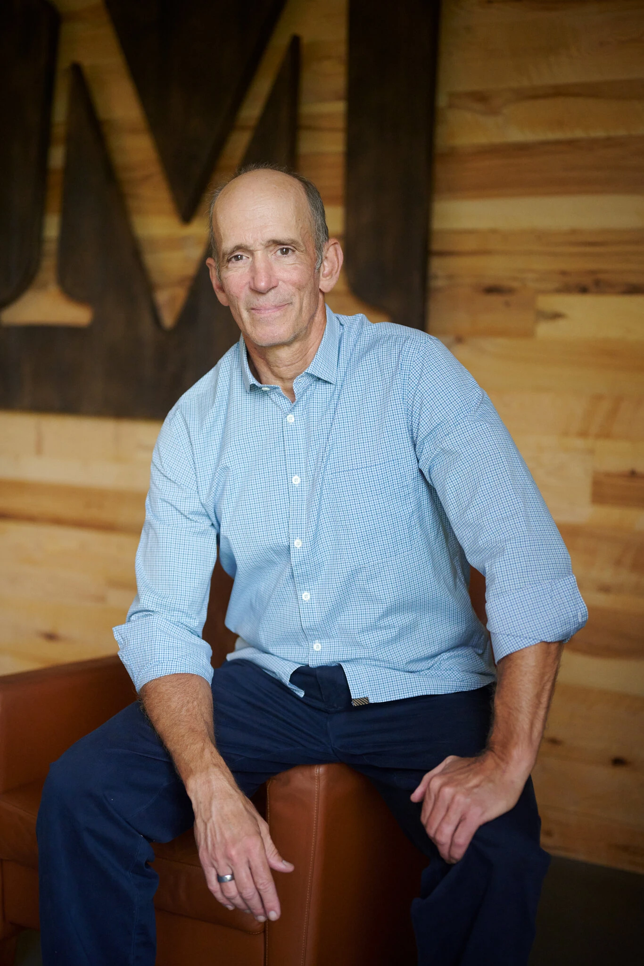

Its assertions were easily disprovable. No matter. Over the next few hours, the article was translated from English into Spanish and Polish. It appeared on dozens of blogs and was picked up by anti-vaccination activists, who repeated the false claims online. The article also made its way to Facebook, where it reached 400,000 people, according to data from CrowdTangle, a Facebook-owned tool. The entire effort traced back to one person: Joseph Mercola.

Dr. Mercola, 67, a physician in Cape Coral, Fla., has long been a subject of criticism and government actions for his promotion of unproven or disingenuous treatments. But most recently, he has become the chief spreader of coronavirus misinformation online, according to researchers. An internet-savvy entrepreneur who employs dozens, Dr. Mercola has published over 600 articles on Facebook that cast doubt on Covid-19 vaccines since the pandemic began, reaching a far larger audience than other vaccine skeptics, an analysis by The New York Times found. His claims have been widely echoed on Twitter, Instagram and YouTube.

The activity has earned Dr. Mercola the dubious distinction of the top spot in the “Disinformation Dozen,” a list of 12 people responsible for sharing 65 percent of all anti-vaccine messaging on social media, said the nonprofit Center for Countering Digital Hate. Over the last decade, Dr. Mercola has built a vast operation to push natural health cures, disseminate [*spread*] anti-vaccination content and profit from all of it, said researchers who have studied his network. In 2017, he filed his net worth as “in excess of $100 million.”

**Source**: Frenkel, Sheera. “The Most Influential Spreader of Coronavirus Misinformation Online” The New York Times 26 July, 2021. [Link](https://www.nytimes.com/2021/07/24/technology/joseph-mercola-coronavirus-misinformation-online.html).

| **Debrief Questions** | |
| --- | --- |
| Based on this document, in what ways are COVID-19 and the Yellow Fever similar? Different? | Find an unknown word from the article and explain its definition below using context clues! |

**Document 4: Coronavirus Blame**

| **Publication** (type of source, date of source) | **Point of View** (who is the author, and what is their perspective?) |
| --- | --- |
|  |  |
| **Intended Audience** | **Predicted Purpose** (what is doc’s purpose?) |

First comes the disease. Then the scapegoating. Whether it's Ebola, cholera and now COVID-19, Jesse Verschuere has witnessed "a pattern of stigma against others in every disease outbreak" he has responded to as part of the international medical humanitarian organization Doctors Without Borders.

The victims of prejudice have included health-care workers, minorities, immigrants, indeed any outsider or other who looks or acts different from those in the local community, says the Belgium-based Verschuere, who works to improve the ability of communities to obtain health care. This bias occurs around the world. And it's not anything new.

Villainizing an unknown other as guilty of spreading, causing or exploiting disease has a long, hate-filled history, says Debora MacKenzie, author of the new book *Covid-19: The Pandemic That Should Never Have Happened and How to Stop the Next One*. Back in 14th-century Europe, Jews were blamed — and thousands of them slaughtered — by Christian mobs who baselessly accused them of spreading the deadly bubonic plague by poisoning wells and streams. In 19th-century America, immigrants from Ireland, Italy and China were censured, variously and also baselessly, for bringing with them cholera and polio, among other feared infections.

So perhaps it shouldn't be a surprise that in the wake of COVID-19, the blame game is playing out once again. In the United States, where some leaders have used the racist term "Kung flu" to describe COVID-19, increased verbal and physical assaults against Asian Americans have been linked to the virus. In one documented incident, a woman who is originally from Taiwan and has lived in New York City for 16 years filmed a video on the subway of a man accusing her of spreading "Kung flu." Responding to the surge in anti-Asian verbal and physical assaults, the New York Police Department has this month announced the formation of an Asian Hate Crime Task Force.

Even those who come specifically to help in a medical crisis can be blamed, stigmatized, distrusted as outsiders who hurt rather than heal. In the same way that prejudice manifests in every setting, the goal in counter-acting it is also the same: to bring out the humanity. By contrast, stigma does just the opposite, he says: It strips people's humanity away.

**Source:** Cole, Diana. “Why Scapegoating Is A Typical Human Response To A Pandemic” National Public Radio (NPR) 29 Aug 2020. [Link](https://www.npr.org/sections/goatsandsoda/2020/08/29/906225199/why-scapegoating-is-a-typical-human-response-to-a-pandemic).

| **Debrief Questions** | |
| --- | --- |
| Based on this document, in what ways are COVID-19 and the Yellow Fever similar? Different? | According to the document, why do humans tend to falsely blame others for causing disease? |