Day 16 Packet

Name:________________________ Date: __________________

Do Now

Define each vocabulary word! Then, answer the prompt below.

Disparity  Ambivalence  Onerous  Legislate  Unequivocal |  | Compromise  Agriculture  Amend  Abolish  Secede
Should we trust science? What is your relationship to science?
_______________________________________________________________________________________________________________________________________________________________________________________________________________________________________________________________________________________________________________________________________________________________________________________________________________________________________________________________________________________________________________________________________________________________________________________________________________________________________________________________

Scientific Racism Mini Lecture

What do you think of when you think of science?

What is scientific racism?

Watch this clip.

Why is race not a scientific concept?

Why is race a social concept?

Scientific Racism Inquiry

Document #1: PBS History of Race Video (1:26 - 6:15)

Why did European colonists begin to enslave African people? | How was African slavery different than English indentured servitude?
Why did racial pseudoscience become popular and widespread starting in the 17th century (1600s)? | How did the Enlightenment, a 16-17th century movement emphasizing reason, impact definitions of race?

Source: “The Origin of Race in the USA” The Origin of Everything PBS, 3 April 2018. Youtube. Link.

Document #2:Thomas Jefferson’s “Notes on the State of Virginia
America would come to be defined by the language of freedom and the acceptance of slavery. How does one justify holding a human as property in a land where according to Thomas Jefferson, “all men are created equal”? On Feb. 27, 1787, more than a decade after he helped write the Declaration of Independence, future president Jefferson published his book “Notes on the State of Virginia,” an extensive study of subjects including his state’s geography, climate, religion and its enslaved black population. The book made clear that when the revered [celebrated] Founding Father said it was “self-evident, that all men are created equal,” he was not including black people. It was one of the best selling non-fiction books of its time. His support of inferior races justified the dispossession of American Indians and the enslavement of Africans in the era of revolution.

"I advance it, therefore, as a suspicion only, that the blacks, whether originally a distinct race, or made distinct by time and circumstance, are inferior to the whites in the endowment [qualities] both of body and mind."

"Comparing them by their faculties [abilities] of memory, reason, and imagination, it appears to me, that in memory they are equal to the whites; in reason much inferior...and that in imagination they are dull, tasteless, and anomalous [abnormal]. But never yet could I find that a black had uttered [spoken] a thought above the level of plain narration; never see even an elementary trait, of painting or sculpture."

As a slave owner, why might Jefferson come to these racist conclusions? | What are your reactions to reading this text from a ‘Founding Father’ of the United States?

Source: Jefferson, Thomas. Notes on the State of Virginia, 1781. Book.

Document #3: Cartwright’s Theory of Drapetomania

The mysterious and chronic sickness had been afflicting slaves for years, working its way into their minds and causing them to flee from their plantations. Unknown in medical literature, its troubling symptoms were familiar to masters and overseers, especially in the South, where hundreds of enslaved people ran from captivity every year.
On March 12, 1851, the noted physician Samuel A. Cartwright reported to the Medical Association of Louisiana that he had identified the malady [sickness] and, by combining two Greek terms, given it a name: Drapetomania. Drapetes, a runaway, and mania, madness. He also announced that it was completely curable. African Americans, with their smaller brains and blood vessels, and their tendency toward indolence [laziness] and barbarism, Cartwright told fellow doctors, had only to be kept benevolently [kindly] in the state of submission [obedience], awe and reverence that God had ordained [ordered].
Cartwright’s presentation a decade before the Civil War was part of the long, insidious [evil] practice of what historians call scientific racism — the spread of bogus theories of supposed black inferiority in an attempt to rationalize slavery and centuries of social and economic domination and plunder. In Cartwright’s mind, enslaved people were beneath even the human desire for freedom. They had to be diseased. This thinking would thrive in the 18th and especially the 19th centuries. It would mutate and persevere for 400 years right up to the present day. Starting with theories of physical and intellectual inferiority that likened blacks to animals — monkeys and apes especially — or helpless children, it would evolve to support black cultural and then social inferiority.
Cartwright claimed in 1851 that, among other things, a black person withstood the rays of the sun better because of an eye feature like one found in apes. Cartwright also speciously [incorrectly] observed that the black man’s neck was shorter than a white person’s, his “bile” [stomach acid] was a deeper color, his blood blacker, his feet flatter, his skull different. Yet, in addition to his keen eyesight, he had other animal-like senses, smelling better and hearing better than the white man. “Like children, [they] require government in everything . . . or they will run into excesses,” Cartwright said. Slavery, he concluded unsurprisingly, was for the enslaved person’s own good.

What was Cartwright’s invented medical condition, Drapetomania? | How did this medical theory support white supremacy and racism?

Source: Ruane, Michael. “A brief history of the enduring phony science that perpetuates white supremacy” The Washington Post (article), 30 April 2019. Link.

Document #4: Agassiz’s Theory of Polygenism

In 1619, when the first enslaved people were brought to what would become the United States, justifications for their enslavement were brought here too. In the 400 years since then, as those enslaved and their descendants have continued to call this country home, the justifications for their abuse and mistreatment have stayed with us as well.
One of the most effective tactics used to justify anti-Black racism and white supremacy has been scientific racism. Through the years, scientific racism has taken many forms, all with the goal of using the authority of science as objective[unbiased, factual] knowledge to justify racial inequality.
Some 19th-century scientists, like Harvard’s Louis Agassiz, were proponents [supporters] of “polygenism,” which posited that human races were distinct species. This theory was supported by pseudoscientific methods like craniometry, the measurement of human skulls, which supposedly proved that white people were biologically superior to Blacks. Early statistical health data was weaponized against Black Americans in the late 1800s, as it was used to claim they were predisposed to disease and destined for extinction.
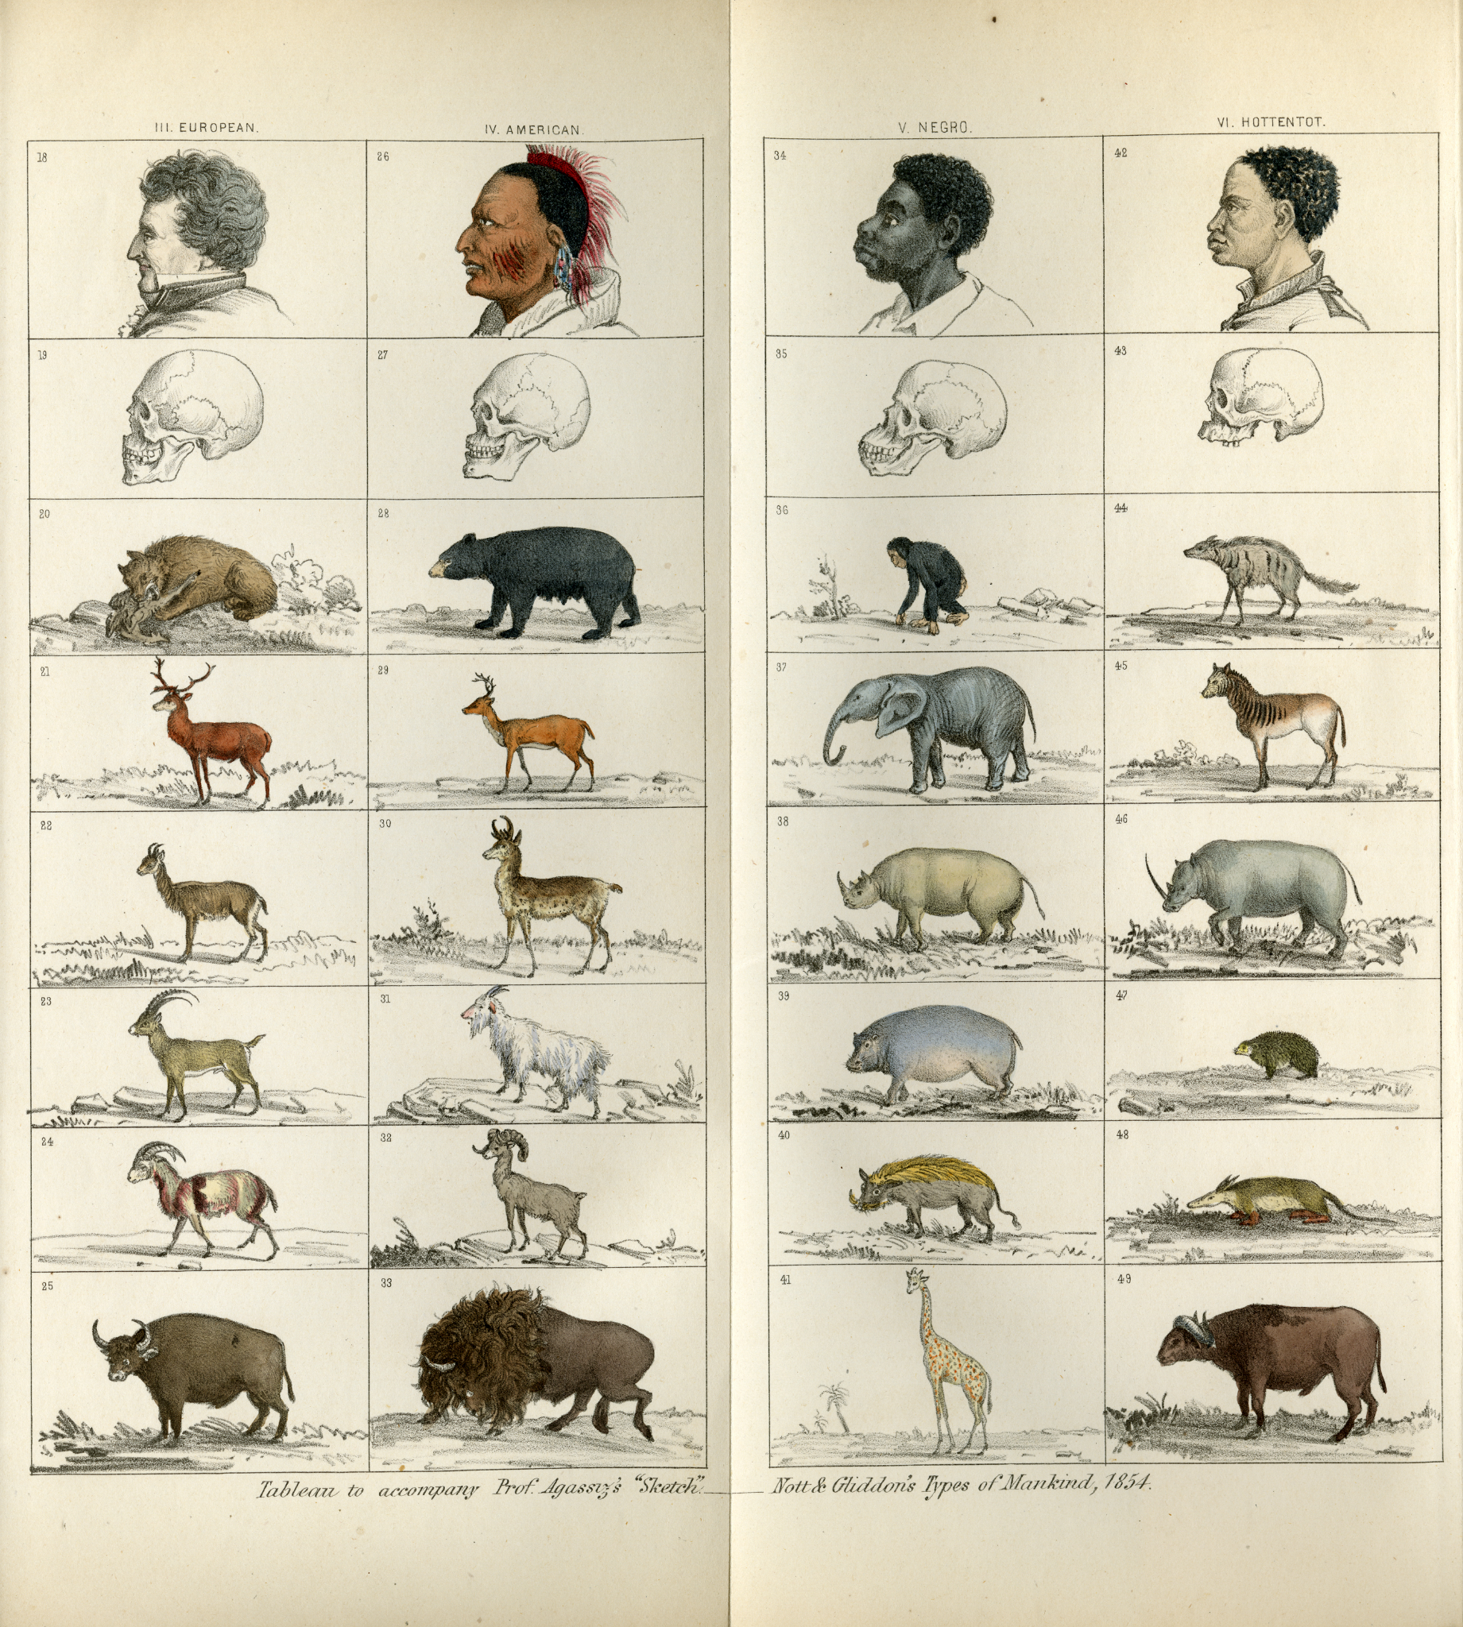

What was the theory of polygenism, and what evidence was used to support it? | How did this theory support white supremacy and racism?

Source: “Scientific Racism” Harvard University Library (Webpage) 2021. Link.

Document #5: Tuskegee Medical Experiment

The “Tuskegee Study of Untreated Syphilis in the Negro,” conducted in the mid-20th century in Macon County, Alabama, is one of the most infamous medical experiments in American history. Conductors of the study allowed hundreds of unwitting black men to suffer needlessly for decades and sometimes die in agony, despite the availability of proven and effective medical treatments.
The federally funded Tuskegee study followed the lives of about 600 largely poor black males, the majority of whom had syphilis, from 1932 to 1972. The goal was to trace the course of untreated syphilis. Researchers never told the test subjects the true aim of the study, asserting instead that they were helping the men and telling some they had been diagnosed with “bad blood.” Medical researchers not only deliberately withheld from the men proven treatments, such as penicillin, but also actively discouraged the test subjects from seeking medical advice elsewhere. In exchange for hot meals and promises to pay for their burial expenses, for 40 years, the subjects allowed the study’s principals to examine them, draw blood, conduct spinal taps and ultimately perform autopsies.
In 1972, Tuskegee the study came to an abrupt halt after its disclosure by news media sparked public shock and outrage. Modern studies have found that the suffering associated with this experiment extended far beyond the tragic test subjects. They find that public revelations in 1972 of the study’s existence led to a deep mistrust of the medical community among black males, many of whom afterward shunned hospital and physician interactions. The researchers estimate that life expectancy at 45 for black men fell sharply and that the life-expectancy gap between black and white males significantly widened.

What was the Tuskegee medical experiment? | What are the implications (effects) of this medical experiment on our world today?

Source: “Why life expectancy for black men fell following the infamous Tuskegee experiment” PBS Newshour, 8 Aug 2016. Link.

Debrief and Reflection

What is my own emotional, personal reaction to reading this?

Is science objective [unbiased, factual] ? How can we make sure science is objective?

Why did these scientists believe these things?

Do you think these people were doing science? Why or why not?

How do you see these ideas affecting our society and people of color today?

