**Day 13 Packet**

Name:________________________ Date: __________________

**Do Now**

| Is healthcare a human right? In other words, should our country provide free medical care for everybody? If so, who should pay for it?  __________________________________________________________________________________________________________________________________________________________________________________________________________________________________________________________________________________________________________________________________________________________________  Why do you think the U.S. doesn’t provide free medical care for everyone?  __________________________________________________________________________________________________________________________________________________________________________________________________________________________________________________________________________________________________________________________________________________________________ | |
| --- | --- |

**Vocabulary**

| **#1** | **Definition:** |
| --- | --- |
| **Synonyms:** | **Used in a sentence:** |
| **#2** | **Definition:** |
| **Synonyms:** | **Used in a sentence:** |
| **#3** | **Definition:** |
| **Synonyms:** | **Used in a sentence:** |
| **#4** | **Definition:** |
| **Synonyms:** | **Used in a sentence:** |
| **#5** | **Definition:** |
| **Synonyms:** | **Used in a sentence:** |

**Healthcare Today**

What do you know about the American healthcare system?

|  |
| --- |

What benefits or problems have you heard about our healthcare system?

|  |
| --- |

**Healthcare Definition:**

**Health Insurance Definition:**

**4 Types of Health Insurance**

Private:

Medicare:

Medicaid:

Uninsured:

What is the Affordable Care Act?

**Healthcare Today Inquiry**

Document 1: History of Healthcare and Race

| The smallpox virus hopscotched across the post-Civil War South, invading the makeshift camps where many thousands of newly freed African-Americans had taken refuge [*shelter*] but leaving surrounding white communities comparatively unscathed. This pattern of affliction [*suffering*] was no mystery: In the late 1860s, doctors had yet to discover viruses, but they knew that poor nutrition made people more susceptible [*vulnerable*] to illness and that poor sanitation contributed to the spread of disease. They also knew that quarantine and vaccination could stop an outbreak in its tracks; they had used those very tools to prevent a smallpox outbreak from ravaging [*destroying*] the Union Army. |
| --- |
| **How is this related to what you read about yesterday in the Day 11 Packet?** |
|  |
| Smallpox was not the only health disparity facing the newly emancipated, who at the close of the Civil War faced a considerably higher mortality rate than that of whites. Despite their urgent pleas for assistance, white leaders were deeply ambivalent about intervening. They worried about black epidemics spilling into their own communities and wanted the formerly enslaved to be healthy enough to return to plantation work. But they also feared that free and healthy African-Americans would upend the racial hierarchy, the historian Jim Downs writes in his 2012 book, “Sick From Freedom.”  Federal policy, he notes, reflected white ambivalence at every turn. Congress established the medical division of the Freedmen’s Bureau — the nation’s first federal health care program — to address the health crisis, but officials deployed just 120 or so doctors across the war-torn South, then ignored those doctors’ pleas for personnel [*staff*] and equipment. They erected more than 40 hospitals but prematurely shuttered [*closed*] most of them. White legislators [*politicians*] argued that free assistance of any kind would breed dependence [*reliance*] and that when it came to black infirmity [*sickness*], hard labor was a better salve [*treatment*] than white medicine. |
| **What was the attitude of many white legislators during Reconstruction?** |
|  |
| Professional societies like the American Medical Association barred black doctors; medical schools excluded black students, and most hospitals and health clinics segregated black patients. Federal health care policy was designed, both implicitly and explicitly, to exclude black Americans. As a result, they faced an array of inequities — including statistically shorter, sicker lives than their white counterparts. What’s more, access to good medical care was predicated [*based*] on a system of employer-based insurance that was inherently difficult for black Americans to get. “They were denied most of the jobs that offered coverage,” says David Barton Smith, a historian of health care policy at Temple University. “And even when some of them got health insurance, as the Pullman porters did, they couldn’t make use of white facilities.”  In the shadows of this exclusion, black communities created their own health systems. Lay black women began a national community health care movement that included fund-raising for black health facilities; campaigns to educate black communities about nutrition, sanitation and disease prevention; and programs like National Negro Health Week that drew national attention to racial health disparities. Black doctors and nurses — most of them trained at one of two black medical colleges, Meharry and Howard — established their own professional organizations and began a concerted war against medical segregation. |
| **Name two ways African Americans were excluded from America’s healthcare system. Name two ways African Americans resisted this exclusion.** |
|  |
| Medicare and Medicaid were part of a broader plan that finally brought the legal segregation of hospitals to an end in 1964. But they still excluded millions of Americans. Those who did not fit into specific age, employment or income groups had little to no access to health care.  In 2010, the Affordable Care Act brought health insurance to nearly 20 million previously uninsured adults. The biggest beneficiaries were people of color, many of whom obtained coverage through the law’s Medicaid expansion. That coverage contributed to a measurable decrease in some racial health disparities, but the success was neither as enduring nor as widespread as it might have been. Several states, most of them in the former Confederacy, refused to participate in Medicaid expansion. And several are still trying to make access to the program contingent [dependent] on onerous new work requirements. The results of both policies have been unequivocal. States that expanded Medicaid saw a drop in disease-related deaths, according to the National Bureau of Economic Research. But in Arkansas, the first state to implement work requirements, nearly 20,000 people were forced off the insurance plan. |
| **Has the ACA been successful, according to this paragraph?** |
|  |
| One hundred and fifty years after the freed people of the South first petitioned the government for basic medical care, the United States remains the only high-income country in the world where such care is not guaranteed to every citizen. In the United States, racial health disparities have proved as foundational as democracy itself. “There has never been any period in American history where the health of blacks was equal to that of whites,” Evelynn Hammonds, a historian of science at Harvard University, says. “Disparity is built into the system.” Medicare, Medicaid and the Affordable Care Act have helped shrink those disparities. But no federal health policy yet has eradicated them. |
| **How is the Affordable Care Act and modern health insurance linked to the whole history of African American healthcare?** |
|  |

**Source**: Interlandi, Jeneen. “A Broken Healthcare System” *The New York Times*, August 14, 2019

**Document 2: Uninsured Graph**

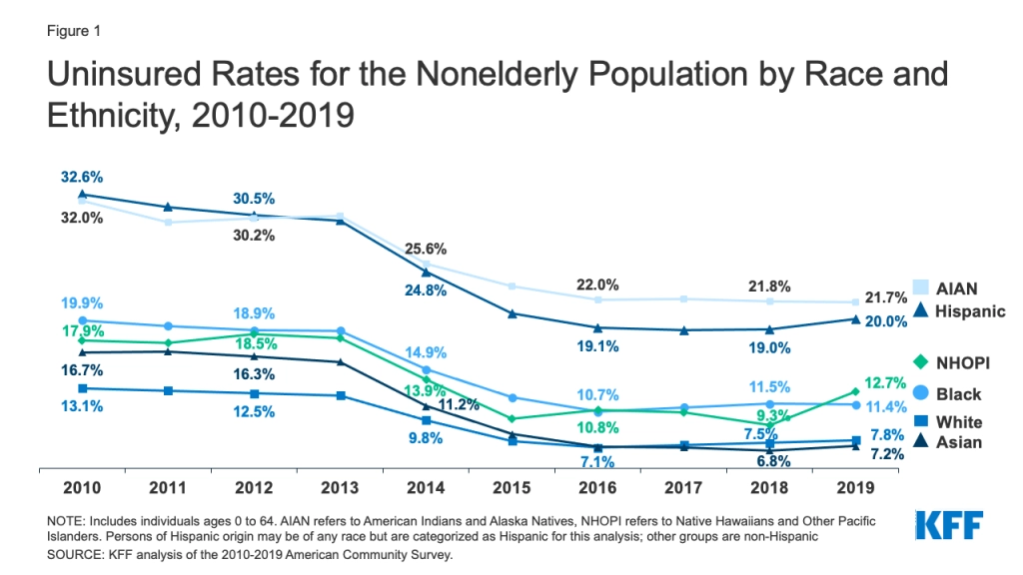

Prior to the Affordable Care Act (ACA), people of color were more likely to be uninsured than their White counterparts. The ACA created new health coverage options that helped to narrow, but did not eliminate, these disparities in health coverage. Between 2010 and 2016, there were large gains in coverage across all racial/ethnic groups under the ACA. Hispanic people experienced the largest percentage point decline in their uninsured rate over the period, which fell 32.6% to 19.1%. Despite these gains in coverage, people of color remained more likely to be uninsured than their White counterparts as of 2016. Beginning in 2017, coverage gains began reversing and the number of uninsured increased for three consecutive years. This likely reflects a range of policy changes made by the Trump administration that contributed to reduced access to and enrollment in coverage.

| **According to this graph, has the ACA been successful?** | **How are Trump and Andrew Johnson similar?** |
| --- | --- |
|  |  |

**Document 3: PBS Documentary Clip (2:20 - End)**

*This video begins with President Obama and his team waiting for Congress to vote on the ACA--if it passed it would become law, if it didn’t pass it would fail.*

*Tea Party: an American political movement inside of the Republican party (people who support Trump) who oppose Obamacare and many other policies that try to address racial disparities.*

**Source:** “How "Obamacare" Became a Symbol of America's Divide” PBS Frontline, 16 Jan 2017. [Youtube Link](https://youtu.be/jy2DEJcm9PU).

| **What was unusual about the ACA and the support it got in government?** | **How are the Tea Party and the ACA connected?** |
| --- | --- |
|  |  |
| **Think back to the Freedmen’s Bureau sources--what connections can you make between the video and the Freedmen’s Bureau?** | |
|  | |

**Document 4: Uninsured Population**

**Who are the uninsured?**

Most uninsured people have at least one worker in the family. Families with low incomes are more likely to be uninsured. Reflecting the more limited availability of public coverage in some states, adults are more likely to be uninsured than children. People of color are at higher risk of being uninsured than non-Hispanic White people.

**Why are people uninsured?**

Even under the ACA, many uninsured people cite the high cost of insurance as the main reason they lack coverage. In 2019, 73.7% of uninsured adults said that they were uninsured because the cost of coverage was too high. Many people do not have access to coverage through a job, and some people, particularly poor adults in states that did not expand Medicaid, remain ineligible for financial assistance for coverage. Additionally, undocumented immigrants are ineligible for Medicaid or Marketplace coverage.

**How does not having coverage affect health care access?**

People without insurance coverage have worse access to care than people who are insured. Three in ten uninsured adults in 2019 went without needed medical care due to cost. Studies repeatedly demonstrate that uninsured people are less likely than those with insurance to receive preventive care and services for major health conditions and chronic diseases.

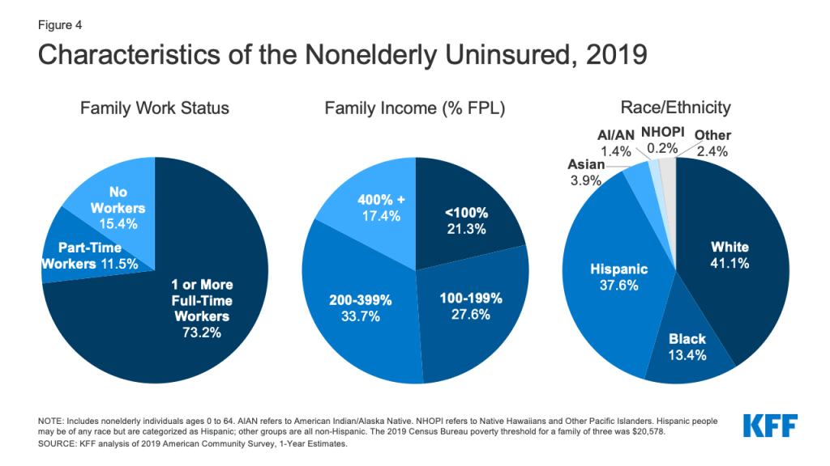

**Source**: Tolbert, Jennifer. “Key Facts about the Uninsured Population” Kaiser Family Foundation 6 Nov 2020. [Link](https://www.kff.org/uninsured/issue-brief/key-facts-about-the-uninsured-population/).

| **Who is the ACA failing to insure?** | **What does this source suggest about the success or failure of the ACA?** |
| --- | --- |
|  |  |

**Document 5: Medicaid Video (Beginning - 2:11, and 5:11 - End)**

**Source**: “Medicaid, explained: why it's worse to be sick in some states than others” Vox News 1 Aug 2017. Youtube [Link](https://youtu.be/sOo_aw-xgHQ).

| **How does Medicaid vary between states like California and Texas?** | **What does this source suggest about the success or failure of the ACA?** |
| --- | --- |
|  |  |

**Project Planning Space**

| **Successes of the Freedmen’s Bureau** | **Successes of the ACA** |
| --- | --- |
|  |  |
| **How are these successes related? Is there a pattern?** | |
| **Failures of the Freedmen’s Bureau** | **Failures of the ACA** |
|  |  |
| **How are these failures related? Is there a pattern?** | |