Unit 1 DBQ: Race, Power, and Health

Over the past four weeks, we have examined three topics related to how people of color, specifically African Americans, have been treated in the American medical system throughout history and in the present. We have studied:

Medical Crises
Yellow Fever Epidemic of 1793 | Covid-19 Pandemic
Healthcare
Freedmen’s Bureau | Affordable Care Act
Medical Myths
Scientific Racism | Modern Scientific Racism

DBQ QUESTION
To demonstrate the knowledge and skills you have learned, you will complete a five paragraph Document-Based Question (DBQ) essay. Use what you learned in class, as well as evidence from the documents to answer the question below.

Given the history of racism we have learned about so far, to what extent should people of color have trust and faith in the US healthcare system?

DEADLINES
All assignments below are due on Google Classroom and must be submitted by 11:59pm. If you need an extension, you must email Mr. Jue at least 24 hours in advance.
- Draft Thesis Statement due 9/7 (Exit Ticket #5)
- DBQ Outline due 9/8
- DBQ Rough Draft due 9/9
- DBQ Final Draft due 9/10

GRADING
Your DBQ essay will be graded as a Summative assessment worth 40% of your total grade using this rubric. The major skills you will be graded on are:
- Craft clear, relevant, and detailed CAR claims
- Summarize the main idea of texts
ESSAY STRUCTURE
While you can ultimately choose how you want to structure your essay, below is the recommended way to structure your essay. In this structure, each body paragraph answers the DBQ question by comparing one historical event to a modern event.

Introduction | Introduce topic and thesis statement
Body Paragraph #1 | Medical Crises
Body Paragraph #2 | Healthcare
Body Paragraph #3 | Medical Myths
Conclusion | Review your argument, explain why it matters.

ESSAY SUPPORT
Check out the Key Skills section of Google Classroom to review your CAR claims and 1 sentence summaries.

If you would like help from Mr. Jue, office hours this week will be held:
- Tuesday 9/6 from 3:30-4pm
- Friday 9/10 8:25-9:17am (1st Period)

If you cannot attend these times, please communicate with Mr. Jue!

DBQ DOCUMENTS:
While you may use any document we have studied in class, here are the recommended documents for you to use on your DBQ.
Here is where you can find all the documents we have studied:
- Yellow Fever - Day 5 and Day 6 Packets
- COVID 19 - Day 8 Packet
- Freedmen’s Bureau - Day 11 Packet
- Obamacare - Day 13 Packet
- Historic Scientific Racism - Day 16 Packet
- Modern Scientific Racism - Day 18 Packet

Document 1: Carey Pamphlet (Day 6 Packet)
Matthew Carey was a publisher in Philadelphia, which means he created and sold writing for a living. During the epidemic, Carey fled the city for several weeks. Upon his return, he wrote a 12 page pamphlet and sold it widely around the country. Below is an excerpt (short section) from that pamphlet.

The consternation [anxiety, dismay] of the people of Philadelphia, at this period, was carried beyond all bounds. Dismay and affright were visible in almost every person's countenance. Most of those who could by any means, make it convenient, fled from the city. Of those who remained, many shut themselves up in their horses, being afraid to walk the streets.

The elders of the African church met, and offered their assistance to the Mayor, to procure nurses for the sick, and aid in burying the dead. Their offers were accepted; and Absalom Jones, Richard Allen, and William undertook the management of these two services. The great demand for nurses, afforded an opportunity for imposition [taking advantage], which was eagerly seized by some of those who acted in that capacity [role]. They extorted [get something through force or pressure] two, three, four, and even five dollars a night for such attendance, as would have been well paid for, by a single dollar. Some of them were even detected in plundering [looting] the houses of the sick.

A hardened villain from a neighbouring state, formed a plot [plan] with some black people to plunder houses. He was a master rogue and formed a large partnership for the more successful execution of his schemes. However, he was soon seized [arrested], and the company [group] dissolved.

Source: Mathew Carey, A Short Account of the Malignant Fever which Prevailed in Philadelphia, 1793. Pamphlet.

Document 2: Historian’s Analysis of the Jones Pamphlet (Day 6 Packet)
Q: Why did Jones and Allen choose to respond to Matthew Carey's charges of profiteering [making unfair amounts of money]?

A: (Julie Winch) They could very easily not have responded, because after all, Jones and Allen are praised in Matthew Carey's account of the yellow fever epidemic. But they clearly felt a need to vindicate their community; that a charge against one member of the community was a charge against the community as a whole. And they are making the point that occasionally maybe people did ask for high wages, but generally, the black nurses were responding as white families desperate to get nurses offered them money. They could also point to many cases where black Philadelphians refused money, or would take only what had been agreed upon, because they felt that that was fair; and in a way, that maybe by not price gouging [overcharging], they were winning divine favor; that God would maybe strike them down with the disease if they did victimize people.

Jones and Allen could point to many episodes of inhumanity on the part of whites in the city. And again and again, they could highlight cases of black nurses who had really done more than they had been hired to do, who had served faithfully. And they could point to whites who recognized that.

And of course, there were the employment possibilities for after the epidemic. Supposing one was known to have been a nurse during the epidemic, and the word spread in the white community that all the black nurses had profiteered, or had stolen. And there you were, trying to present yourself, as many in the black community had to, as a domestic worker. Maybe you'd be refused employment because people would assume that you were a thief or in some way dishonest.

So I think that Jones and Allen were really trying to assert their roles as defenders of their community. And after all, they knew that Matthew Carey was a very powerful writer. He was a publisher. His account of the yellow fever epidemic, if it wasn't contradicted, would be what people were reading, not just in Philadelphia but in other cities in America.

Source: Julie Winch, Professor of History at University of Massachusetts, Boston. PBS Modern Voices (Online Museum Exhibit). Link

Document 3: Coronavirus Misinformation (Day 8 Packet)
The article that appeared online on Feb. 9 began with a seemingly innocuous [innocent] question about the legal definition of vaccines. Then over its next 3,400 words, it declared coronavirus vaccines were “a medical fraud” and said the injections did not prevent infections, provide immunity or stop transmission of the disease. Instead, the article claimed, the shots “alter your genetic coding, turning you into a viral protein factory that has no off-switch.”

Its assertions were easily disprovable. No matter. Over the next few hours, the article was translated from English into Spanish and Polish. It appeared on dozens of blogs and was picked up by anti-vaccination activists, who repeated the false claims online. The article also made its way to Facebook, where it reached 400,000 people, according to data from CrowdTangle, a Facebook-owned tool. The entire effort traced back to one person: Joseph Mercola.

Dr. Mercola, 67, a physician in Cape Coral, Fla., has long been a subject of criticism and government actions for his promotion of unproven or disingenuous treatments. But most recently, he has become the chief spreader of coronavirus misinformation online, according to researchers. An internet-savvy entrepreneur who employs dozens, Dr. Mercola has published over 600 articles on Facebook that cast doubt on Covid-19 vaccines since the pandemic began, reaching a far larger audience than other vaccine skeptics, an analysis by The New York Times found. His claims have been widely echoed on Twitter, Instagram and YouTube.

The activity has earned Dr. Mercola the dubious distinction of the top spot in the “Disinformation Dozen,” a list of 12 people responsible for sharing 65 percent of all anti-vaccine messaging on social media, said the nonprofit Center for Countering Digital Hate. Over the last decade, Dr. Mercola has built a vast operation to push natural health cures, disseminate [spread] anti-vaccination content and profit from all of it, said researchers who have studied his network. In 2017, he filed his net worth as “in excess of $100 million.”

Source: Frenkel, Sheera. “The Most Influential Spreader of Coronavirus Misinformation Online” The New York Times 26 July, 2021. Link.

Document 4: History.com Article (Day 11 Packet)

The Freedmen’s Bureau was organized into districts covering the 11 former rebel states, the border states of Maryland, Kentucky and West Virginia and Washington, D.C. Each district was headed by an assistant commissioner. The bureau’s achievements varied from one location to another and from one agent to the next. Over its course of existence, the bureau was underfunded and understaffed, with just 900 agents at its peak.

Bureau agents, who acted essentially as social workers and were frequently the only federal representatives in Southern communities, were subjected to ridicule and violence from whites (including terrorist organizations such as the Ku Klux Klan), who viewed the agents as interfering in local affairs by trying to assist blacks. While some agents were corrupt or incompetent, others were hardworking and brave people who made significant contributions.

During its years of operation, the Freedmen’s Bureau fed millions of people, built hospitals and provided medical aid, negotiated labor contracts for ex-slaves and settled labor disputes. It also helped former slaves legalize marriages and locate lost relatives, and assisted black veterans. The bureau also was instrumental in building thousands of schools for blacks, and helped to found such colleges as Howard University in Washington, D.C.

Additionally, the bureau tried, with little success, to promote land redistribution. However, most of the confiscated or abandoned Confederate land was eventually restored to the original owners, so there was little opportunity for black land ownership, which was seen as a means to success in society.

Source: “Freedmen’s Bureau” History.com, 3 Oct 2018. Link.

Document 5: History of Healthcare and Race (Day 13 Packet)

The smallpox virus hopscotched across the post-Civil War South, invading the makeshift camps where many thousands of newly freed African-Americans had taken refuge [shelter] but leaving surrounding white communities comparatively unscathed. This pattern of affliction [suffering] was no mystery: In the late 1860s, doctors had yet to discover viruses, but they knew that poor nutrition made people more susceptible [vulnerable] to illness and that poor sanitation contributed to the spread of disease. They also knew that quarantine and vaccination could stop an outbreak in its tracks; they had used those very tools to prevent a smallpox outbreak from ravaging [destroying] the Union Army.

Smallpox was not the only health disparity facing the newly emancipated, who at the close of the Civil War faced a considerably higher mortality rate than that of whites. Despite their urgent pleas for assistance, white leaders were deeply ambivalent about intervening. They worried about black epidemics spilling into their own communities and wanted the formerly enslaved to be healthy enough to return to plantation work. But they also feared that free and healthy African-Americans would upend the racial hierarchy, the historian Jim Downs writes in his 2012 book, “Sick From Freedom.”

Federal policy, he notes, reflected white ambivalence at every turn. Congress established the medical division of the Freedmen’s Bureau — the nation’s first federal health care program — to address the health crisis, but officials deployed just 120 or so doctors across the war-torn South, then ignored those doctors’ pleas for personnel [staff] and equipment. They erected more than 40 hospitals but prematurely shuttered [closed] most of them. White legislators [politicians] argued that free assistance of any kind would breed dependence [reliance] and that when it came to black infirmity [sickness], hard labor was a better salve [treatment] than white medicine.

Professional societies like the American Medical Association barred black doctors; medical schools excluded black students, and most hospitals and health clinics segregated black patients. Federal health care policy was designed, both implicitly and explicitly, to exclude black Americans. As a result, they faced an array of inequities — including statistically shorter, sicker lives than their white counterparts. What’s more, access to good medical care was predicated [based] on a system of employer-based insurance that was inherently difficult for black Americans to get. “They were denied most of the jobs that offered coverage,” says David

Barton Smith, a historian of health care policy at Temple University. “And even when some of them got health insurance, as the Pullman porters did, they couldn’t make use of white facilities.”

In the shadows of this exclusion, black communities created their own health systems. Lay black women began a national community health care movement that included fund-raising for black health facilities; campaigns to educate black communities about nutrition, sanitation and disease prevention; and programs like National Negro Health Week that drew national attention to racial health disparities. Black doctors and nurses — most of them trained at one of two black medical colleges, Meharry and Howard — established their own professional organizations and began a concerted war against medical segregation.

Medicare and Medicaid were part of a broader plan that finally brought the legal segregation of hospitals to an end in 1964. But they still excluded millions of Americans. Those who did not fit into specific age, employment or income groups had little to no access to health care.

In 2010, the Affordable Care Act brought health insurance to nearly 20 million previously uninsured adults. The biggest beneficiaries were people of color, many of whom obtained coverage through the law’s Medicaid expansion. That coverage contributed to a measurable decrease in some racial health disparities, but the success was neither as enduring nor as widespread as it might have been. Several states, most of them in the former Confederacy, refused to participate in Medicaid expansion. And several are still trying to make access to the program contingent [dependent] on onerous new work requirements. The results of both policies have been unequivocal. States that expanded Medicaid saw a drop in disease-related deaths, according to the National Bureau of Economic Research. But in Arkansas, the first state to implement work requirements, nearly 20,000 people were forced off the insurance plan.

One hundred and fifty years after the freed people of the South first petitioned the government for basic medical care, the United States remains the only high-income country in the world where such care is not guaranteed to every citizen. In the United States, racial health disparities have proved as foundational as democracy itself. “There has never been any period in American history where the health of blacks was equal to that of whites,” Evelynn Hammonds, a historian of science at Harvard University, says. “Disparity is built into the system.” Medicare, Medicaid and the Affordable Care Act have helped shrink those disparities. But no federal health policy yet has eradicated them.

Source: Interlandi, Jeneen. “A Broken Healthcare System” The New York Times, August 14, 2019

Document 6: Cartwright’s Theory of Drapetomania (Day 16 Packet)

The mysterious and chronic sickness had been afflicting slaves for years, working its way into their minds and causing them to flee from their plantations. Unknown in medical literature, its troubling symptoms were familiar to masters and overseers, especially in the South, where hundreds of enslaved people ran from captivity every year.
On March 12, 1851, the noted physician Samuel A. Cartwright reported to the Medical Association of Louisiana that he had identified the malady [sickness] and, by combining two Greek terms, given it a name: Drapetomania. Drapetes, a runaway, and mania, madness. He also announced that it was completely curable. African Americans, with their smaller brains and blood vessels, and their tendency toward indolence [laziness] and barbarism, Cartwright told fellow doctors, had only to be kept benevolently [kindly] in the state of submission [obedience], awe and reverence that God had ordained [ordered].
Cartwright’s presentation a decade before the Civil War was part of the long, insidious [evil] practice of what historians call scientific racism — the spread of bogus theories of supposed black inferiority in an attempt to rationalize slavery and centuries of social and economic domination and plunder. In Cartwright’s mind, enslaved people were beneath even the human desire for freedom. They had to be diseased. This thinking would thrive in the 18th and especially the 19th centuries. It would mutate and persevere for 400 years right up to the present day. Starting with theories of physical and intellectual inferiority that likened blacks to animals — monkeys and apes especially — or helpless children, it would evolve to support black cultural and then social inferiority.
Cartwright claimed in 1851 that, among other things, a black person withstood the rays of the sun better because of an eye feature like one found in apes. Cartwright also speciously [incorrectly] observed that the black man’s neck was shorter than a white person’s, his “bile” [stomach acid] was a deeper color, his blood blacker, his feet flatter, his skull different. Yet, in addition to his keen eyesight, he had other animal-like senses, smelling better and hearing better than the white man. “Like children, [they] require government in everything . . . or they will run into excesses,” Cartwright said. Slavery, he concluded unsurprisingly, was for the enslaved person’s own good.

Source: Ruane, Michael. “A brief history of the enduring phony science that perpetuates white supremacy” The Washington Post (article), 30 April 2019. Link.

Document 7: Past and Present (Day 18 Packet)

The excruciatingly painful medical experiments went on until his body was disfigured by a network of scars. John Brown, an enslaved man on a Baldwin County, Ga., plantation in the 1820s and ’30s, was lent to a physician, Dr. Thomas Hamilton, who was obsessed with proving that physiological [biological, physical] differences between black and white people existed. Hamilton used Brown to try to determine how deep black skin went, believing it was thicker than white skin. Hamilton tortured Brown for 9 months until Brown escaped and published an autobiography about his experiences.
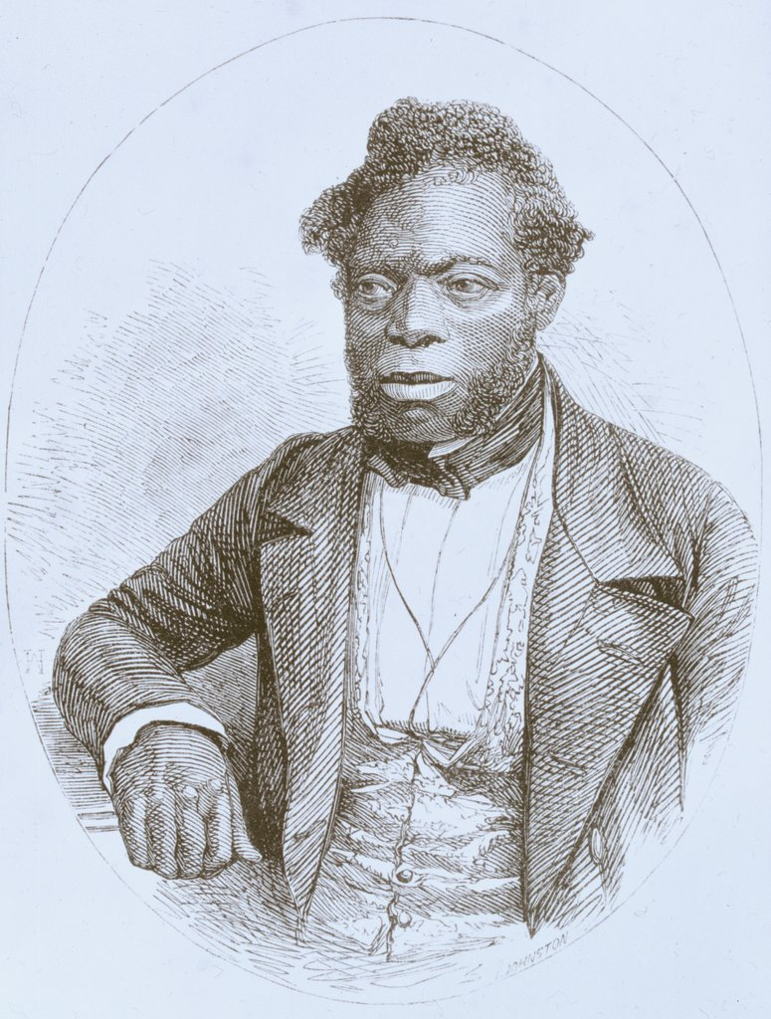

John Brown, 1855

Throughout his career as a Southern doctor in the 1800s, Dr. Hamilton was respected in the medical field. And like many other doctors during the era of slavery, he was also a wealthy plantation owner who tried to use science to prove that differences between black people and white people went beyond culture and were more than skin deep. He insisted that black bodies were composed and functioned differently than white bodies.

He believed that black people had small skulls — which translated [led] to a lack of intelligence — and higher tolerance for heat. A commonly held medical myth was that black people didn’t feel pain and were immune to some illnesses. These unproven fallacies [false beliefs] were presented as facts in medical journals. They bolstered [supported] society’s view that enslaved people were fit for little besides forced labor and provided support for racist ideology [beliefs] and discriminatory public policies [laws].

Over the centuries, the two most persistent [lasting] racist biological myths — that black people were impervious [immune] to pain and had weak lungs that could be strengthened through forced work — wormed their way into scientific consensus [agreement], and they remain rooted in modern-day medical education and practice. Thomas Jefferson, in “Notes on the State of Virginia,” listed what he proposed were “the real distinctions which nature has made,” including a lack of lung capacity.

In the years that followed, physicians and scientists embraced Jefferson’s unproven theories, none more aggressively than physician and professor Samuel Cartwright. He published a popular paper in May 1851 that cataloged supposed physical differences between whites and blacks, including the claim that black people had lower lung capacity. Cartwright, conveniently, saw forced labor as a way to “vitalize”[give energy to] the blood and correct the problem. Most outrageous, Cartwright maintained that enslaved people were prone to a “disease of the mind” called drapetomania, which caused them to run away from their enslavers. Willfully ignoring the inhumane conditions that drove desperate men and women to attempt escape, he insisted that enslaved people contracted this ailment when their enslavers treated them as equals, and he prescribed “whipping the devil out of them” as a preventive measure.

More than 150 years after the end of slavery, fallacies [mistaken beliefs] of black immunity to pain and weakened lung function continue to show up today. Recent data shows that present-day doctors fail to sufficiently treat the pain of black adults and children for many medical issues. A 2013 review of studies examining racial disparities in pain management published in The American Medical Association Journal of Ethics found that black and Hispanic people — from children to the elderly — received inadequate pain management compared with white counterparts.

A 2016 survey of 222 white medical students published in The Proceedings of the National Academy of Sciences showed that half of them endorsed [supported] at least one myth about biological differences between black people and white people, including that black people’s nerve endings are less sensitive than white people’s. When asked to imagine how much pain white or black patients experienced in hypothetical situations, the medical students insisted that black people felt less pain and were less likely to recommend appropriate treatment. A third of these doctors to be also still believed the lie that Thomas Hamilton tortured John Brown to prove nearly two centuries ago: that black skin is thicker than white skin.

Source: Villarosa, Linda. “Medical Inequality” The New York Times, 2019.

